Easy Read Service
Pricing Policy

Introduction 2
How our Easy Read service works 4
Prices 8
About Disability Equality Scotland 11
Contact Us 11

Introduction

This document explains the process and prices for the Disability Equality Scotland (DES) Easy Read translation and checking services.

For over a decade, we have provided a high-quality, professional Easy Read service to organisations across all sectors. Our team of dedicated and skilled creators can take your report, factsheet, survey, minutes, or strategy and turn it into Easy Read. This makes your documents much more accessible and helps you reach more people.

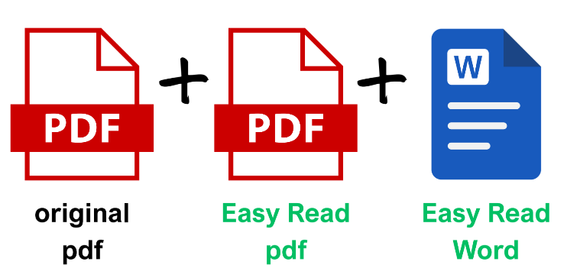

What is Easy Read and why does it matter?

Easy Read is an accessible format used by lots of people who want clear and straightforward information. It combines simple language, short sentences, helpful images, and a clean layout. Together, these make information easier to understand, like the example below.

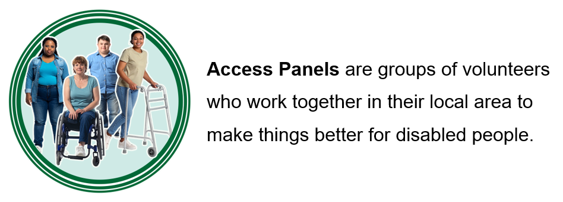

Easy Read removes barriers so more people can access and use information. The Equality Act 2010 requires organisations to provide information in accessible formats. Using Easy Read supports equal access for disabled people.

Easy Read documents can reach:

- People with learning disabilities
- People with cognitive issues, like dementia
- Neurodivergent people, for example with dyslexia, dyscalculia or autism
- People who are learning English
- People who find reading difficult or who are easily overwhelmed
- People with a hearing impairment whose first language is British Sign Language (BSL).

DES Easy Read team

Members of the DES Easy Read team are experts in inclusive communication and skilled at creating accessible Easy Read documents. We also play a leading role in the Easy Read community in the UK and abroad. We are a founding member of a UK working group that has developed standards for how Easy Read should be written, designed and tested, and an international Easy Read Community of Practice.

Our Easy Read service is also shaped by ongoing input from DES’ Easy Read User Feedback Group. Members of this group are people who use Easy Read. They help us test new ideas, layouts and approaches to make sure our work is clear, effective and works in practice. This means our work is grounded in real user experience.

Satisfied customers

DES’ Easy Read clients include public bodies, third sector organisations, and private businesses. Recent customers include Scottish Government, Transport Scotland, Inclusion Scotland, Loch Lomond and the Trossachs National Park Authority, the Independent Scottish Covid-19 Inquiry, Glasgow Women’s Library, and Audit Scotland.

Our clients are overwhelmingly positive about our service. They say:

“It was a perfect translation, thank you so much. So glad this exists.”

“Thank you for the thorough service that you offer and the speed to which you get back to us when working on projects.”

“This has been a really smooth process – thank you!”

How our Easy Read service works

We provide Easy Read creation and checking services. We can translate basic and more complex original documents and provide fast turnaround.

Request a quote and timescale
Email easyread@disabilityequality.scot or call 0141 370 0968 to discuss your needs or request a quote.

We need your original document to provide an accurate quote and timescale, and the shorter it is, the better.
Top tip: Summarise your content
Providing a shortened, summary or highlighted version of your original document helps with the speed and cost.
When requesting a quote, please provide one main contact who will coordinate at your end. This helps keep communication clear and the process running smoothly. Your contact person can gather feedback and be available throughout. If they might not be available at any point, please provide an alternative contact.

Confirming price and timescale

Top tip: Client project management
We ask clients to nominate one contact person to liaise with us directly. They will gather and share feedback from colleagues. This keeps the project on track and helps us respond clearly and quickly. Consider who needs to review drafts and approve the Easy Read version before it is finalised. It helps if they are also involved from the start to avoid delays or last-minute changes later in the process.
We will confirm the price after we have reviewed your original document.

We will also indicate when we can have a first draft ready. We schedule the work into our calendar, working around existing commitments and deadlines.

We always strive to meet your deadlines, but timescales can vary depending on how complex your original document is.

As a rough guide it takes us:

- 2-3 weeks to create a shorter Easy Read (up to 1000 original words)
- 3-4 weeks for a medium Easy Read (around 1000-2000 original words)
- 5 or more weeks for a longer Easy Read (more than 2500 original words).

We strongly recommend that our clients schedule the production of their Easy Read documents at the same time as planning the original document. However, we know that this sometimes does not happen and we do our best to meet a tight timeline. We can sometimes begin the Easy Read translation using a draft of the original document, if you don’t think the final version will differ too much.

Our team can work with you to meet your timescales, so it’s always worth getting in touch sooner rather than later. If a very fast turnaround is needed, there may be an additional charge. Please just ask us!

Translation process

Top tip: Changing your document
We understand that documents can change during the process, and we will be as flexible as we can. If you provide an updated version of your original document, we will review the changes and make updates to the Easy Read version where possible. If the changes are significant and require extra work, we may need to agree an additional cost to reflect the extra time involved.

First draft and your feedback

We produce a first draft in a document that is ideally 20 pages or less. This length is good Easy Read practice to ensure that the document is manageable for those using it.

We aim to get you a first draft as soon as we can. It will show your document rewritten in accessible language. At this stage, we ask for your feedback to check we are on the right track.

We will not be experts in your original document or its content, but we can advise on the best use of language to make it accessible. To help keep the process on schedule, we ask clients to provide feedback on the first draft in good time.

Second draft – text and images

Top tip: How are you going to share your Easy Read?
We send final Easy Read documents in PDF format. This is best for printing, websites and general use. We also send a Word version because many Easy Read users who rely on screen readers tell us they prefer this.

Next, we provide a second draft with both text and images. We use a range of image sources and aim for real-life photos and clear graphics, as feedback shows these are helpful for many Easy Read users.

Images are chosen carefully to support understanding, reflect recognised Easy Read standards, and based on feedback from our User Feedback Group. We match images to the meaning of the text to make the document as clear and engaging as possible.

At this stage, we ask for your feedback on the second draft. Again, to help keep the process on track, we ask clients to provide feedback in good time.

Final version

We review any further feedback and provide you with a final version, checked by our experienced team. Your completed Easy Read document will ideally be 20 pages or fewer. It will follow UK Easy Read Standards guidance, making it as accessible as possible.

Easy Read checking service

We also offer a checking service, if you have an Easy Read document you want reviewed by experts. One of our professional team can check existing documents and assess against Easy Read standards. Or we can arrange for members of our User Feedback Group to make sure your document works in practice.

These additional services are charged separately. We will always agree any extra costs with you in advance.

Prices
Email easyread@disabilityequality.scot or call 0141 370 0968 for a quote.

DES pricing is competitive and reflects the time, care and expertise needed to produce high-quality Easy Read. We have prices for:

- Translation of basic original documents
- Fast turnaround service
- Translation of complex original documents
- Checking service.

We calculate the price based on the total word count or length of your document and the time required. We do not charge VAT.

Translation of basic original documents

The price of our Easy Read translation service from basic original documents is based on the word count of the original that is provided. We round up to the nearest 500 words.

Current prices for our basic Easy Read translation service are:

Up to 1,000 words – £290.00  1,500 words – £436.00  2,000 words – £581.00  2,500 words – £726.00  3,000 words – £871.00  3,500 words – £1,016.00  4,000 words – £1,162.00  4,500 words – £1,307.00  5,000 words – £1,452.00 | 5,500 words – £1,597.00  6,000 words – £1,742.00  6,500 words – £1,888.00  7,000 words – £2,033.00  7,500 words – £2,178.00  8,000 words – £2,323.00  8,500 words – £2,468.00  9,000 words – £2,614.00  9,500 words – £2,759.00  10,000 words – £2,904.00

What our price includes

Our price includes staff time, editing, layout and quality checks. It also supports:

- The development of robust Easy Read standards
- Subscription charges for our Easy Read image banks
- Ongoing improvement of our Easy Read approach.

This ensures your document is clear, effective and based on real user experience.

Translation of complex original documents

It takes significantly longer to create Easy Read versions of more complex original documents like consultations and surveys. This is due to a more complicated layout and additional options and instructions for an Easy Read user.

Our additional cost for translating complex documents is 30% on top of our basic Easy Read Service price.

Current prices for our complex Easy Read translation service are:

Up to 1,000 words – £377.00  1,500 words – £566.80  2,000 words – £755.30  2,500 words – £943.80  3,000 words – £1.132.30 | 3,500 words – £1,320.80  4,000 words – £1,510.60  4,500 words – £1,699.10  5,000 words – £1,887.60  5500 words or more – price calculated using the same rate

Basic Easy Read fast turnaround service

We know that sometimes Easy Read versions are needed fast. If your deadline is very short and we need to bring in additional staff or allocate more hours, we apply an additional 25% to our basic Easy Read price.

Current prices for our fast turnaround of basic Easy Read translation are:

Up to 1,000 words – £362.50  1,500 words – £545.00  2,000 words – £726.25  2,500 words – £907.50  3,000 words – £1.088.75 | 3,500 words – £1,270.00  4,000 words – £1,452.50  4,500 words – £1,633.75  5,000 words – £1,815.00  5,500 words or more – price calculated using the same rate

Checking service

We can check documents that have already been translated into Easy Read.

DES check

The price for a DES professional to check an Easy Read document and provide bullet point feedback is £80 per hour. Many Easy Read checks can be done quite quickly – prices available on request.

Easy Read User Feedback Group check

The price to check your Easy Read document with our User Feedback group is £150 per hour. We provide you with a list of their feedback and we edit your document to reflect their insights.

About Disability Equality Scotland

Disability Equality Scotland (DES) is a registered Scottish charity and national member-led Disabled Peoples Organisation (DPO). We are committed to the social model of disability and the motto “nothing about us without us”.

Our vision is to work towards equality, inclusion and participation for disabled people in Scotland. Our mission is to give all disabled people in Scotland a voice with trust, care and empathy. We advocate for and enable change to improve lives. We achieve this through working with our members, Access Panels, partners and stakeholders.

Our work is focused on three principles that help guide us in what we want to achieve. These are: a positive approach; promoting equality; and being partnership focused.

Contact Us

Our friendly, supportive team of Claire, Marit and Shona are available to discuss your Easy Read requirements and would be happy to hear from you.

Disability Equality Scotland
Norton Park
57 Albion Road
Edinburgh
EH7 5QY

Telephone: 0141 370 0968
Email: easyread@disabilityequality.scot
Website: www.disabilityequality.scot

