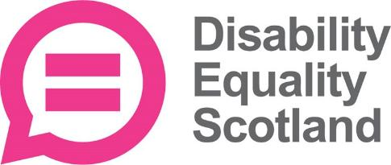
Scottish Election survey
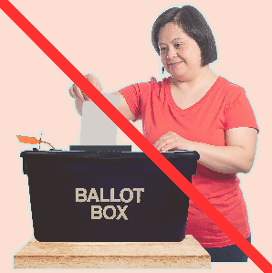
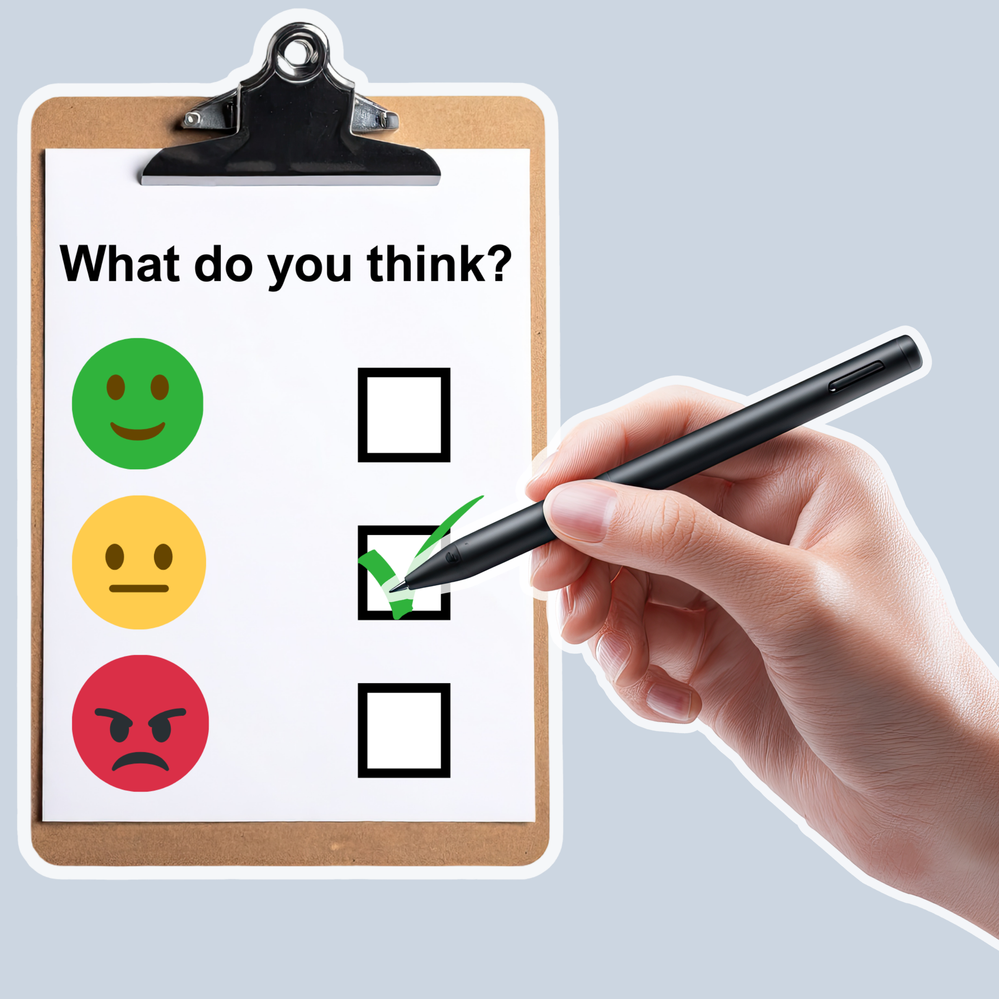
Questions for people who did not vote
Easy Read
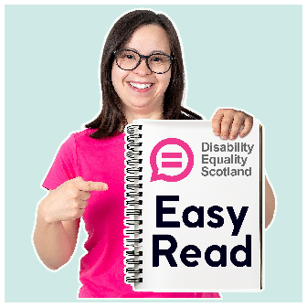

About this document
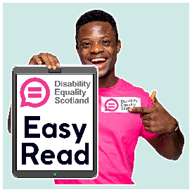 | This is an Easy Read document.
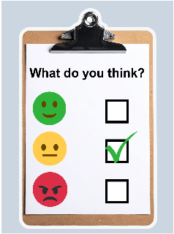 | It is a survey.  A survey means a set of questions.
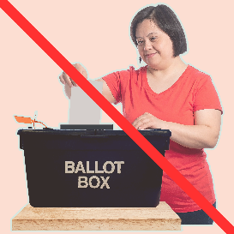 | This survey asks you about not voting in the Scottish Parliament election.
 | The Scottish Parliament election is where everyone in Scotland is asked to vote.  Vote means choose the people you think should become Members of the Scottish Parliament, or MSPs.
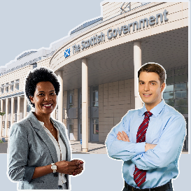 | The people who get the most votes become MSPs.  It is their job to work with the Scottish Government to make laws and support people in their local area.
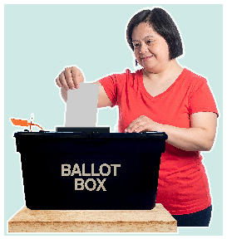 | The places where people go to vote are called polling stations.
 | Please fill in this survey if you did not vote in the Scottish Parliament election.

Our questions
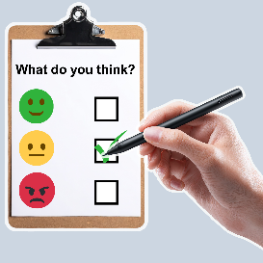 | Answer our questions to tell us what you think.
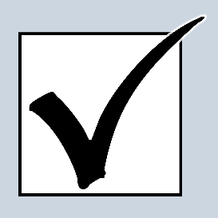 | If you are answering on a screen, you can click the little box next to your answer.  A tick will appear.  If you change your mind you can click it again.
 | If you are typing your answers the space will grow as you type.
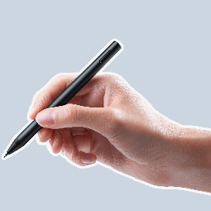 | If you are writing your answers on a paper copy use the Enter button to grow the spaces before you print the pages.

Question 1
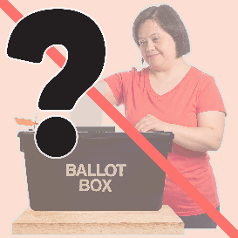 | Why did you not vote vote in this election?  Tick as many boxes as you need.
 | I do not think voting will make a difference. | ☐
 | I could not get to the polling station. | ☐
 | My polling station is in a building that is not accessible to me. | ☐
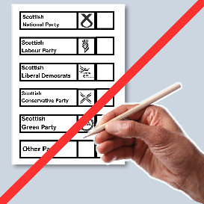 | I am not able to fill in the ballot papers.  Ballot papers are pieces of paper which list who you can vote for and have boxes for you to mark your choices. | ☐
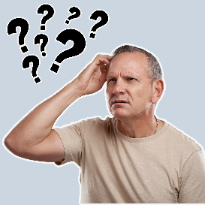 | I would not be able to keep my vote a secret. | ☐
 | Registering to vote is too confusing. | ☐
 | Applying for a postal vote is too confusing. | ☐
 | I am not allowed to vote in Scottish elections. | ☐
 | I would rather not say | ☐
 | Something else  Type or write it below: | ☐

Question 2
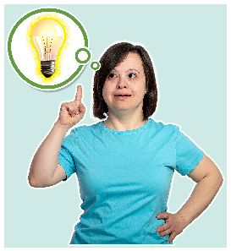 | Which of these things about voting in polling stations do you know about?  Tick as many boxes as you need.
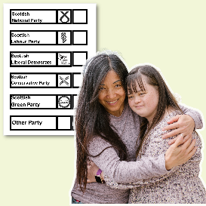 | I can bring somebody over 18 to help me. | ☐
 | I can ask the person in charge of the polling station to help me fill in my ballot papers | ☐
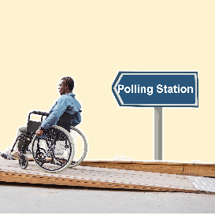 | Polling stations must have ramps. | ☐
 | There must be a wheelchair accessible voting booth. | ☐
 | Polling stations must have equipment available to support disabled people. | ☐

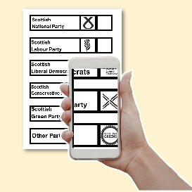 | I can ask to use my phone as a:  - torch  - magnifier  - text-to-speech app | ☐
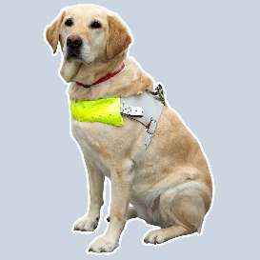 | I can bring a service animal with me | ☐
 | I did not know about any of these things | ☐

Question 3
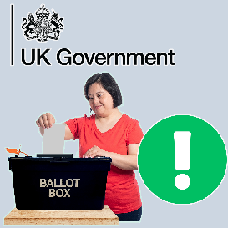 | The UK Government is thinking about making changes to voting at polling stations in England.  They want to make it easier to vote.  Do you think you might vote in future if any of these changes happened in Scotland?  Tick as many boxes as you need.
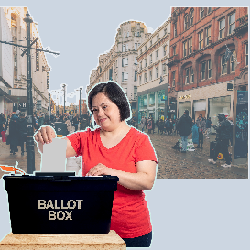 | Being able to vote at the polling station before the election day, including on the weekend. | ☐
 | Being able to vote in a busy local place like a shopping centre. | ☐

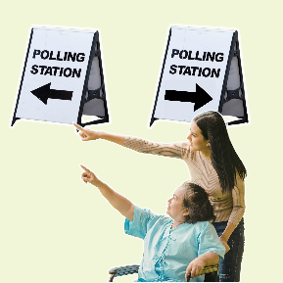 | Being able to vote at any polling station I want. | ☐
 | Being able to vote at a moving polling station that travels to a nearby place. | ☐
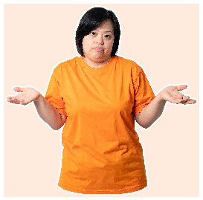 | No, I still would not vote. | ☐
 | I am not sure. | ☐

Question 4
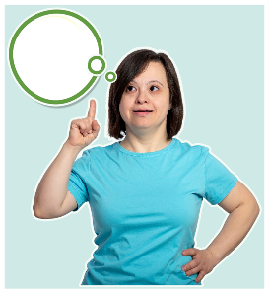 | Can you think of anything that would help you vote in future elections?  Type or write your answer below.

What to do next
 | Thank you for answering our questions.
 | Please send your answers to us by choosing 1 of these ways.
 | You can email them to research@disabilityequality.scot
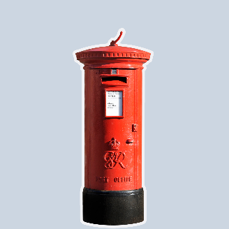 | You can send them by post to:  DES Research  Norton Park  57 Albion Road  Edinburgh  EH7 5QY


