
Survey
For people who voted
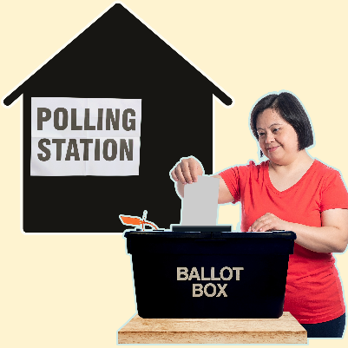
at the polling station
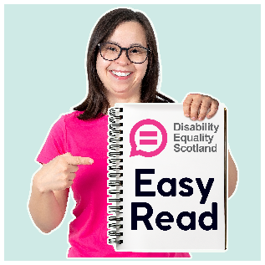
Easy Read
About this document
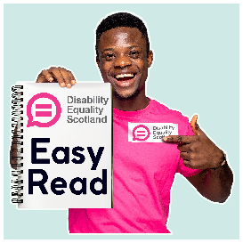 | This is an Easy Read document.
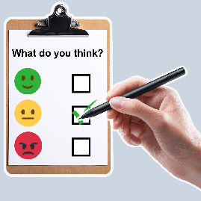 | It is a survey.  A survey means a set of questions.
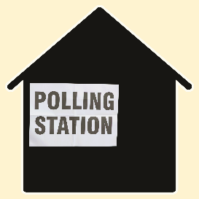 | This survey asks you what it was like voting at a polling station in the Scottish Parliament election.
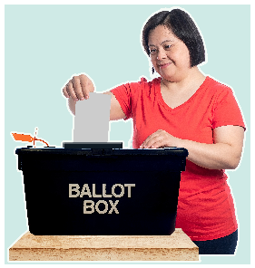 | A polling station is a place where people go to vote on the day of the election.  The Scottish Parliament election is where everyone in Scotland is asked to vote.
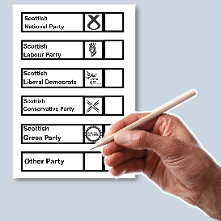 | Vote means choose the people you think should become Members of the Scottish Parliament, or MSPs.
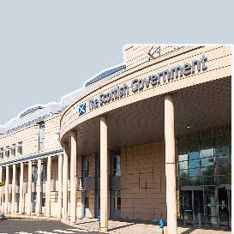 | The people who get the most votes become MSPs.  It is their job to work with the Scottish Government to make laws and support people in their local area.
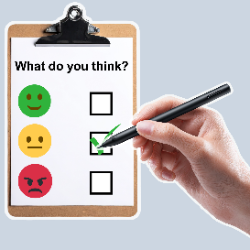 | Please fill in this survey if you voted at a polling station.
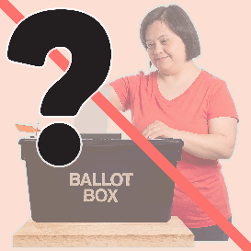 | This survey does not ask you which party you voted for.  That is private to you.

Our questions
 | Answer our questions to tell us what you think.
 | If you are answering on a screen, you can click the little box next to your answer.  A tick will appear.  If you change your mind you can click it again.
 | If you are typing your answers the space will grow as you type.
 | If you are writing your answers on a paper copy use the Enter button to grow the spaces before you print the pages.

Question 1
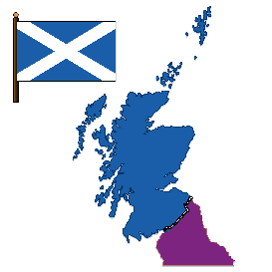 | What is your constituency?  Your constituency is the name of the area that you voted in.  It is written on letters you get about the election.  Type or write it below:

Question 2
 | How did you travel to the building where you voted?
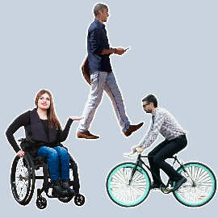 | I walked | ☐
 | I used a wheelchair | ☐
 | I cycled | ☐
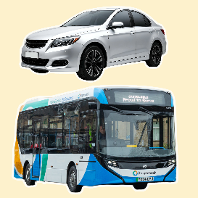 | I travelled by car or taxi | ☐
 | I got a bus or other public transport | ☐
 | I would rather not say. | ☐

Question 3
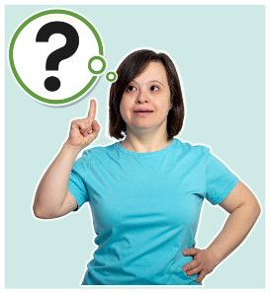 | If you travelled by car or taxi, were you able to park or get dropped off in a suitable space close to the entrance?
 | Yes | ☐
 | No | ☐
 | I did not travel by car or taxi | ☐

Question 4
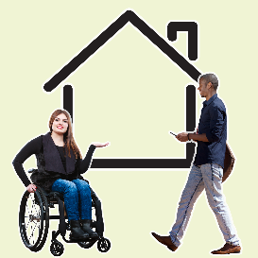 | If you walked or used a wheelchair, did you have any of these problems?  Tick as many boxes as you need to.
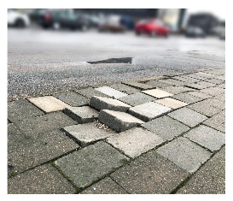 | I had to cross a busy road without a crossing. | ☐
 | I had to go over bumpy or uneven pavements. | ☐
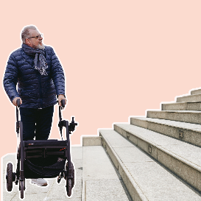 | I had to find a way around things or roadworks blocking the path. | ☐
 | I had to find a way around stairs. | ☐
 | None of these. | ☐
 | I did not walk or use a wheelchair. | ☐

Question 5
 | What type of building did you vote in?
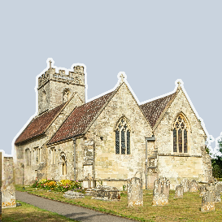 | A place of worship, like a church. | ☐
 | A nursery or school. | ☐
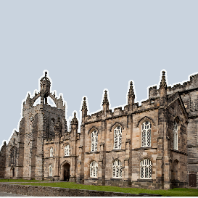 | A college or university. | ☐
 | A public hall, like a town hall or scout hall. | ☐
 | A library. | ☐
 | A temporary building, like a caravan. | ☐
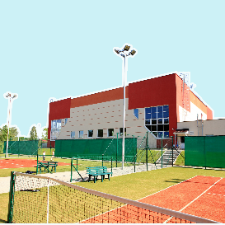 | A leisure or community centre. | ☐
 | A sports venue, like a bowls or cricket club. | ☐
 | I would rather not say. | ☐
 | Other  Type or write your answer below: | ☐

Question 6

 | What was it like getting into the building to vote?
 | It was very easy. | ☐
 | It was quite easy. | ☐
 | It was quite difficult. | ☐
 | It was very difficult. | ☐
 | I am not sure. | ☐

Question 7
 | What was it like finding where you needed to go inside the building?
 | It was very easy | ☐
 | It was quite easy | ☐
 | It was quite confusing | ☐
 | It was very confusing | ☐
 | I am not sure. | ☐

Question 8
 | Were the staff friendly and helpful?
 | Yes, very friendly and helpful. | ☐
 | Yes, quite friendly and helpful. | ☐
 | No, quite unfriendly and unhelpful. | ☐
 | No, very unfriendly and unhelpful. | ☐
 | I am not sure. | ☐

Question 9
 | Did you need to tell someone else which party you were voting for so that they could help you fill it in?
 | Yes, I needed to tell someone else so they could help me. | ☐
 | No, I could fill it in by myself. | ☐
 | I am not sure. | ☐
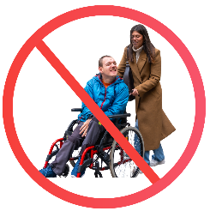 | I did tell someone which party I was voting for, but I did not need their help. | ☐

Question 10
What adjustments or equipment do you need to vote at elections?
Tick as many boxes as you need to.
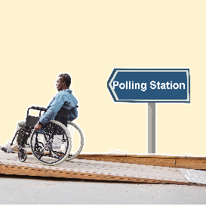 | A lower voting booth. | ☐
 | Access ramps. | ☐
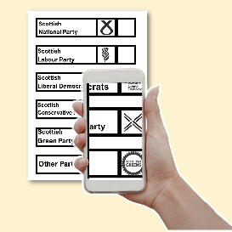 | A magnifier, torch or light. | ☐
 | My mobile phone. | ☐
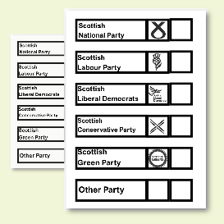 | A larger copy of the ballot papers. | ☐
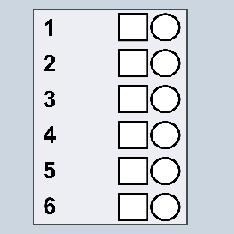 | A tactile voting device.  A tactile voting device is a sheet of plastic placed over a ballot paper to help blind and partially sighted people vote. | ☐
 | I do not need any adjustments or equipment. | ☐
 | I would rather not say. | ☐
 | Other  Type or write your answer below | ☐

Question 11
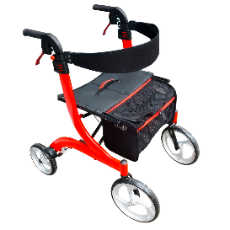 | Did you get all the adjustments or equipment you needed at this election?
 | Yes, I got all the adjustments or equipment I needed. | ☐
 | No, I did not get all the adjustments or equipment I needed. | ☐
 | No, I did not know I could ask for adjustments or equipment. | ☐
 | I do not need any adjustment or equipment. | ☐

Question 12
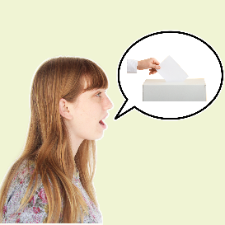 | If you want to tell us more about getting to the building or voting, type or write it here.

Question 13
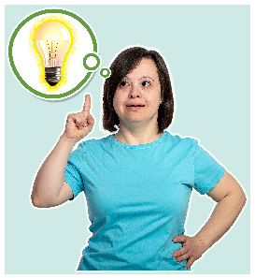 | Which of these things did you know about before voting at this election?  Tick as many boxes as you need.
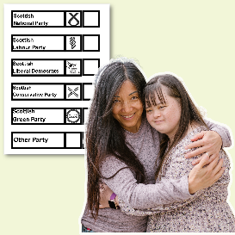 | I can bring somebody over 18 to help me. | ☐
 | I can ask the person in charge of the polling station to help me fill in my ballot papers | ☐
 | Polling stations must have ramps. | ☐
 | There must be a wheelchair accessible voting booth. | ☐
 | Polling stations must have equipment available to support disabled people. | ☐

 | I can ask to use my phone as a:  - torch  - magnifier  - text-to-speech app | ☐
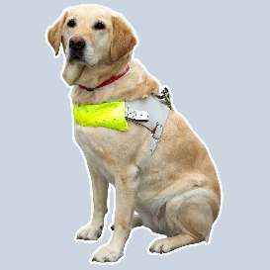 | I can bring a service animal with me | ☐
 | I did not know about any of these things | ☐

Question 14
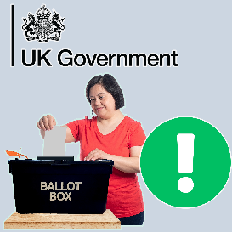 | The UK Government is thinking about making changes to voting at polling stations in England.  They want to make it easier to vote.  Would any of these changes be helpful to you if they happened in Scotland?  Tick as many boxes as you need.
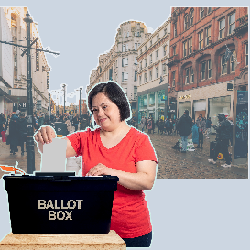 | Being able to vote at the polling station before the election day, including on the weekend. | ☐
 | Being able to vote in a busy local place like a shopping centre. | ☐

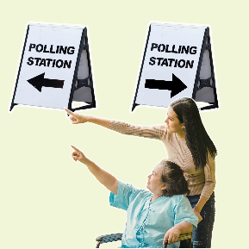 | Being able to vote at any polling station I want. | ☐
 | Being able to vote at a moving polling station that travels to a nearby place. | ☐
 | I am not sure. | ☐

Question 15

 | Thinking about voting in this election, was it a good experience for you?  Tick 1 box.
 | Yes, it was very good. | ☐
 | Yes, it was mostly good. | ☐
 | It was not good or bad. | ☐
 | No, it was quite bad. | ☐
 | No, it was really bad. | ☐

What to do next
 | Thank you for answering our questions.
 | Please send your answers to us by choosing 1 of these ways.
 | You can email them to research@disabilityequality.scot
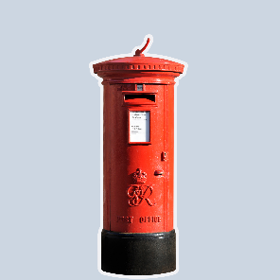 | You can send them by post to:  DES Research  Norton Park  57 Albion Road  Edinburgh  EH7 5QY
In this Easy Read Survey we used images from:


