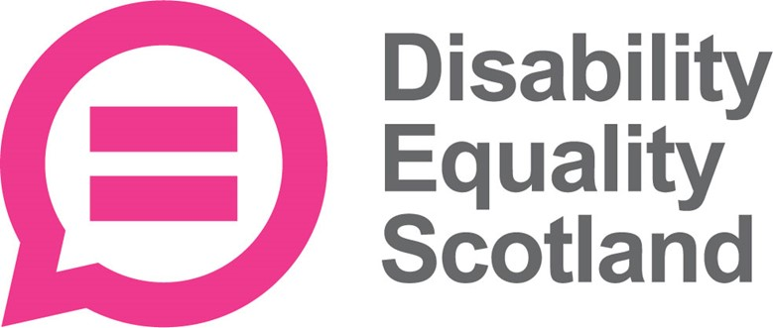

Employment and education survey

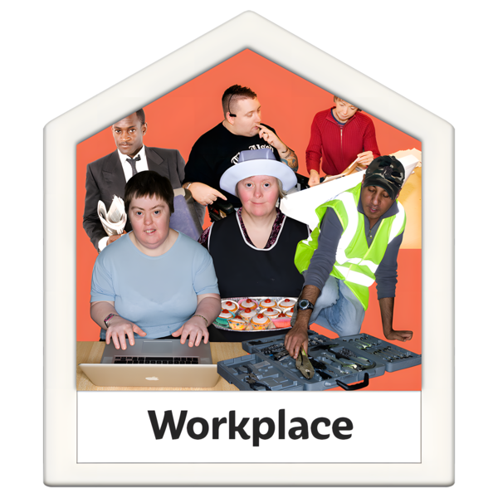


Easy Read
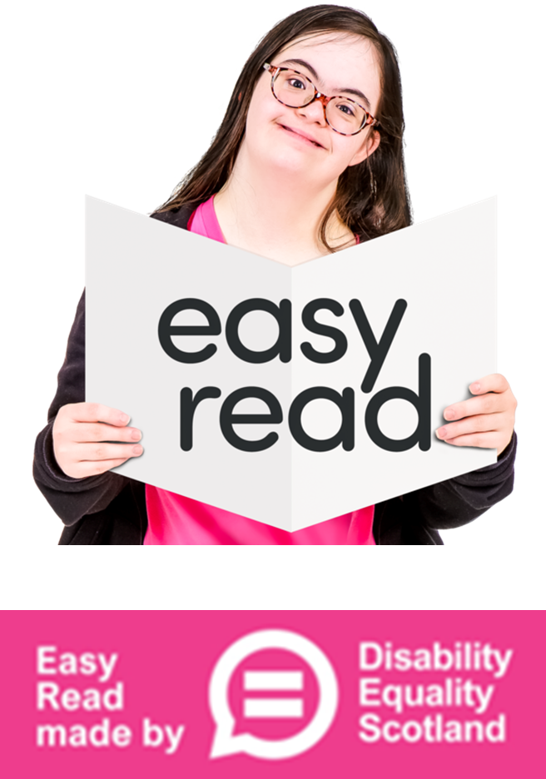

About this document

 | This is an Easy Read document.
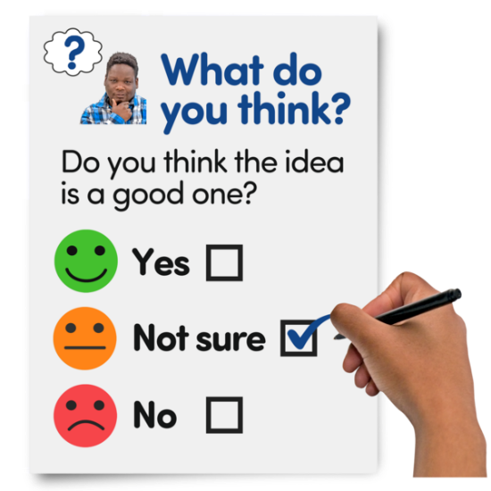 | It is a survey.  A survey means a set of questions.
 | This survey is about employment and education.  Your answers will help us to understand the experiences of disabled people at work and in education.

Our questions

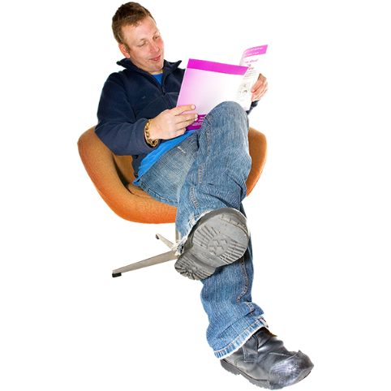 | Answer our questions to tell us what you think.
 | If you are answering on a screen, you can click the little box next to your answer.  A tick will appear.  If you change your mind you can click it again.
 | If you are typing your answers the space will grow as you type.
 | If you are writing your answers on a paper copy use the Enter button to grow the spaces before you print the pages.

Question 1

 | Are you answering this survey for yourself or for someone else?
 | For myself | ☐
 | For someone else | ☐

Question 2

 | Which of these is true for you?
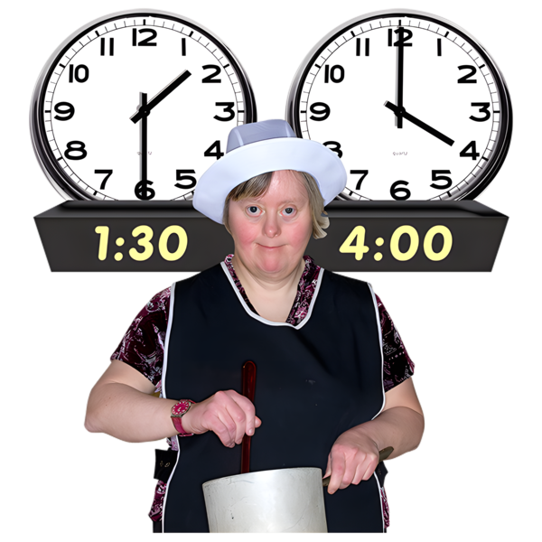  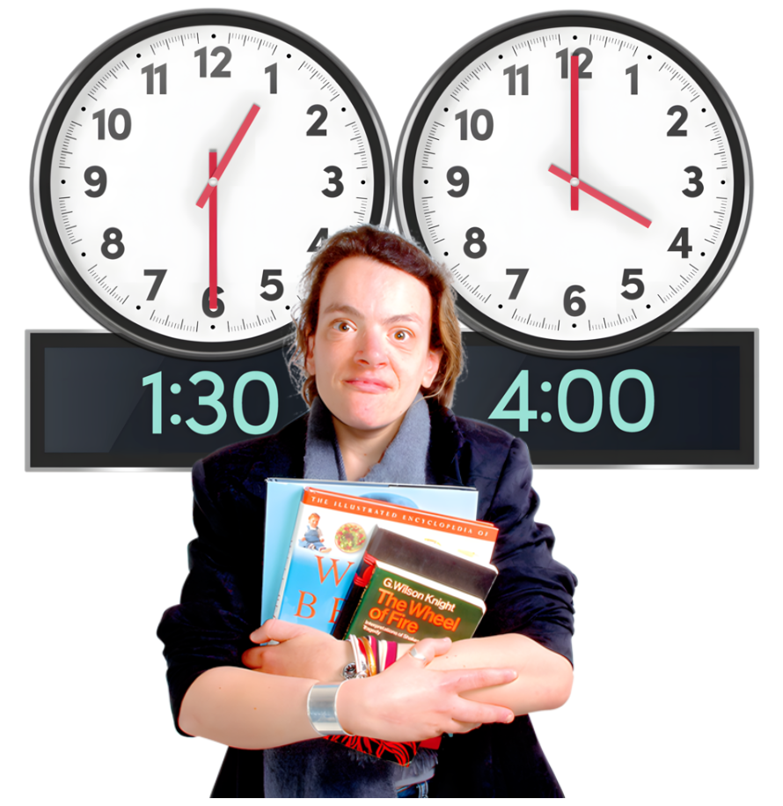     | I work full time - full time means all day, every week day. | ☐
 | I work part time - part time means some hours or days each week. | ☐
 | I study at university full time. | ☐
 | I study at university part time. | ☐
 | I study at college part time. | ☐
 | I am studying an apprenticeship - when you are paid by an organisation who train you while you are working. | ☐
 | I am retired. | ☐
 | I cannot work because of my illness, disability or health. | ☐
 | I am not working at the moment. | ☐

Employment questions

Question 3
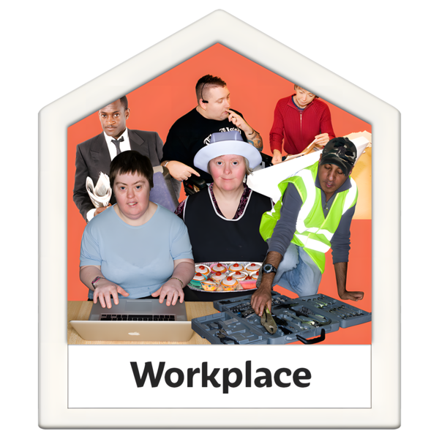 | What job do you do?  Write or type your answer below:

Question 4

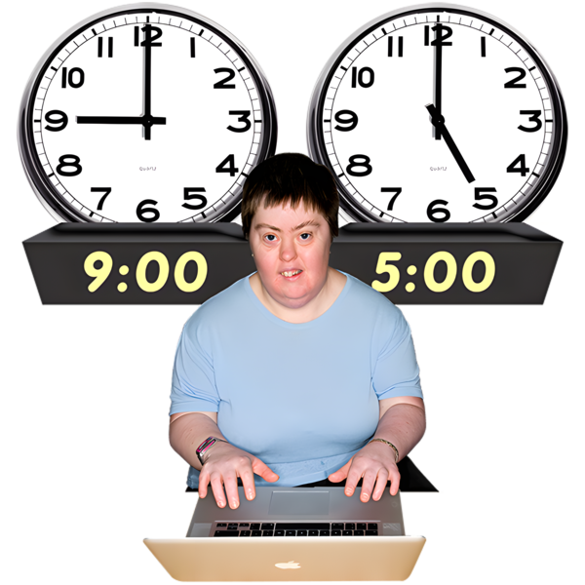 | How many hours a week do you work?
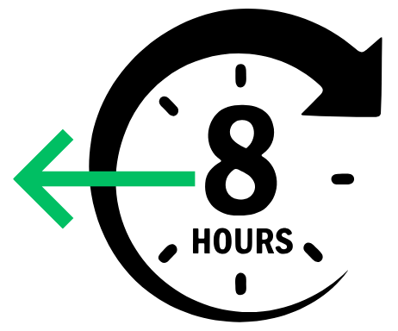  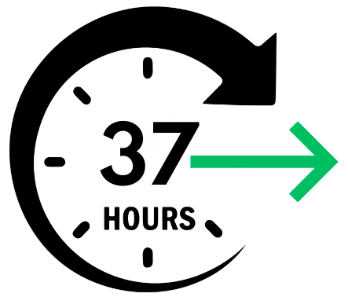 | Less than 8 hours | ☐
 | 8 to 16 hours | ☐
 | 17 to 25 hours | ☐
 | 26 to 37 hours | ☐
 | More than 37 hours | ☐

Question 5

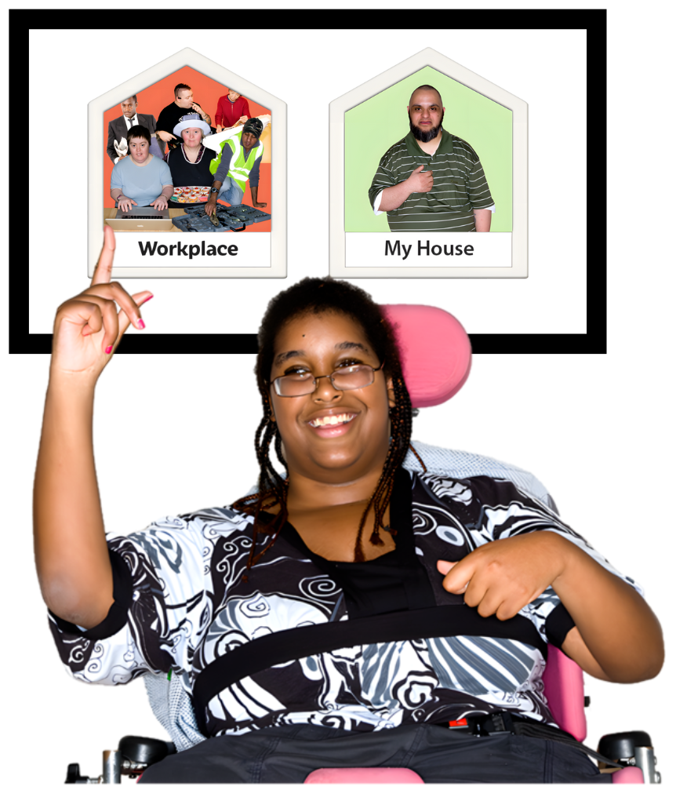 | Where do you work?
 | I work at my workplace. | ☐
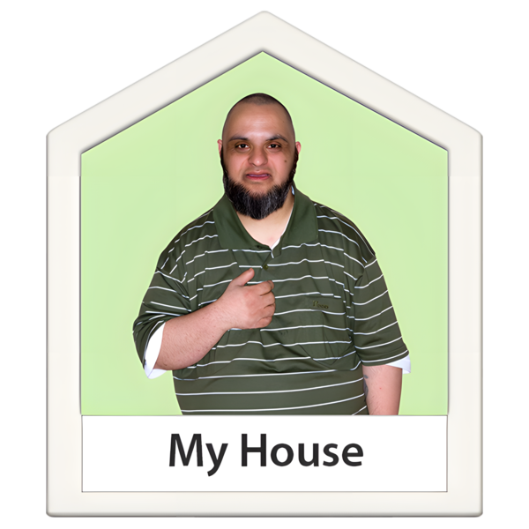 | I work from home. | ☐
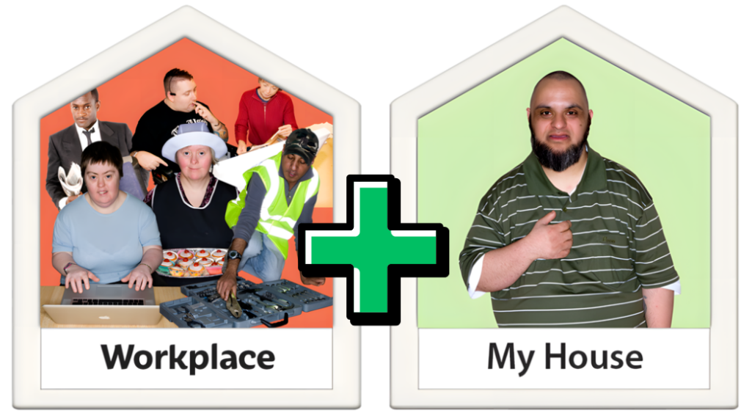 | I work at both my home and my workplace. | ☐

Question 6

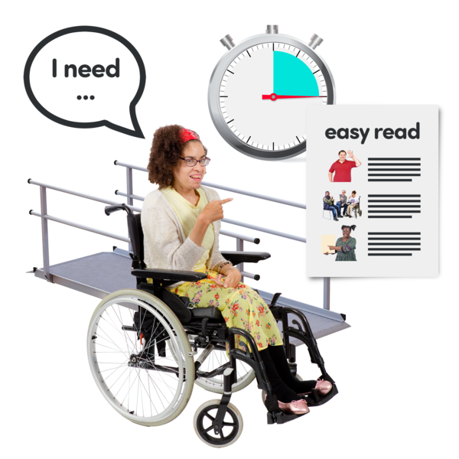 | Do you need any reasonable adjustments to help you do your job?  Reasonable adjustments are changes employers must make to give a disabled person the same chance as anyone else to get and do a job.
 | Yes | ☐
 | No | ☐
 | I am not sure | ☐

Question 7

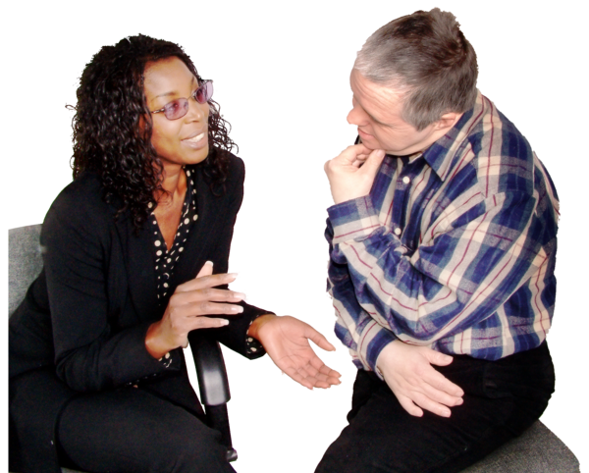 | What was your experience asking your workplace for a reasonable adjustment?  Write or type your answer below:

Question 8

 | Have you applied to the Access to Work Scheme?
 | Yes | ☐
 | No | ☐
 | I am not sure | ☐

Question 9

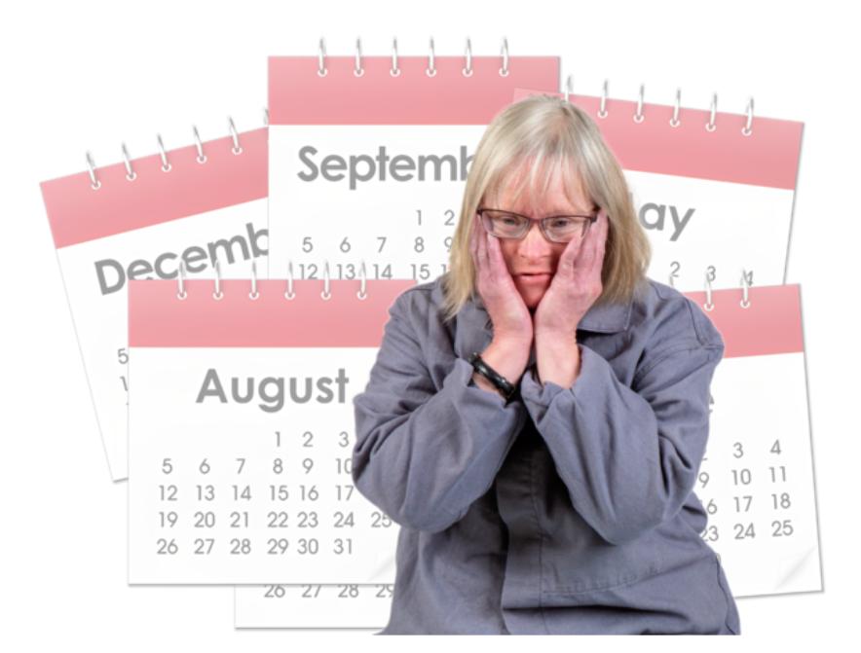 | How long did it take the Department for Work and Pensions (DWP) to make a decision about your application?
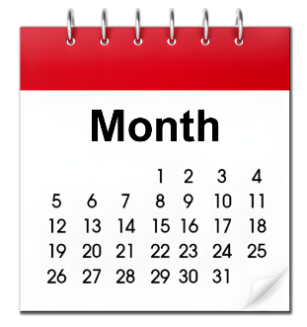  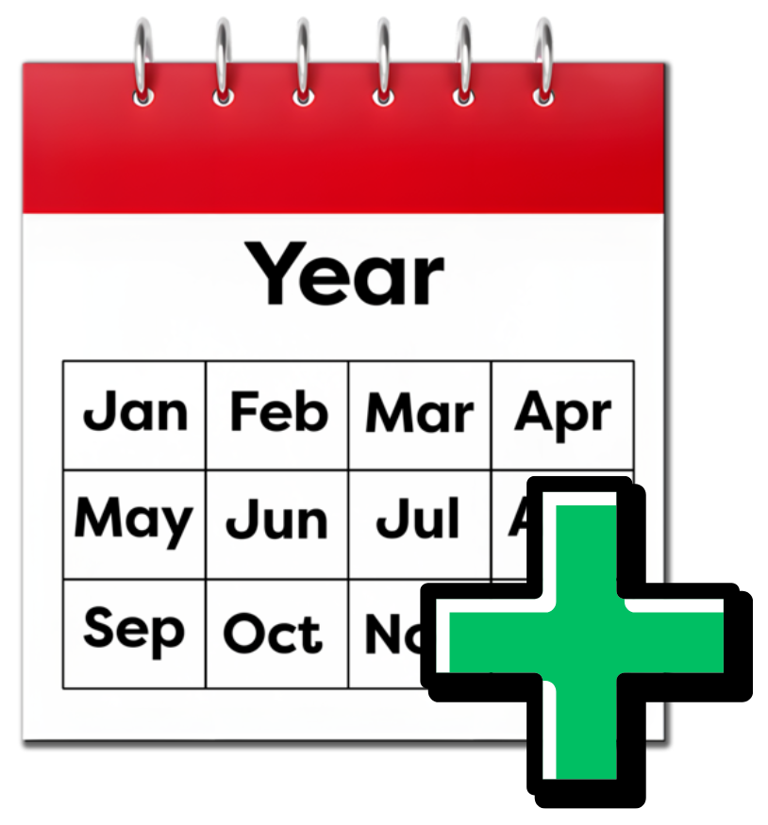  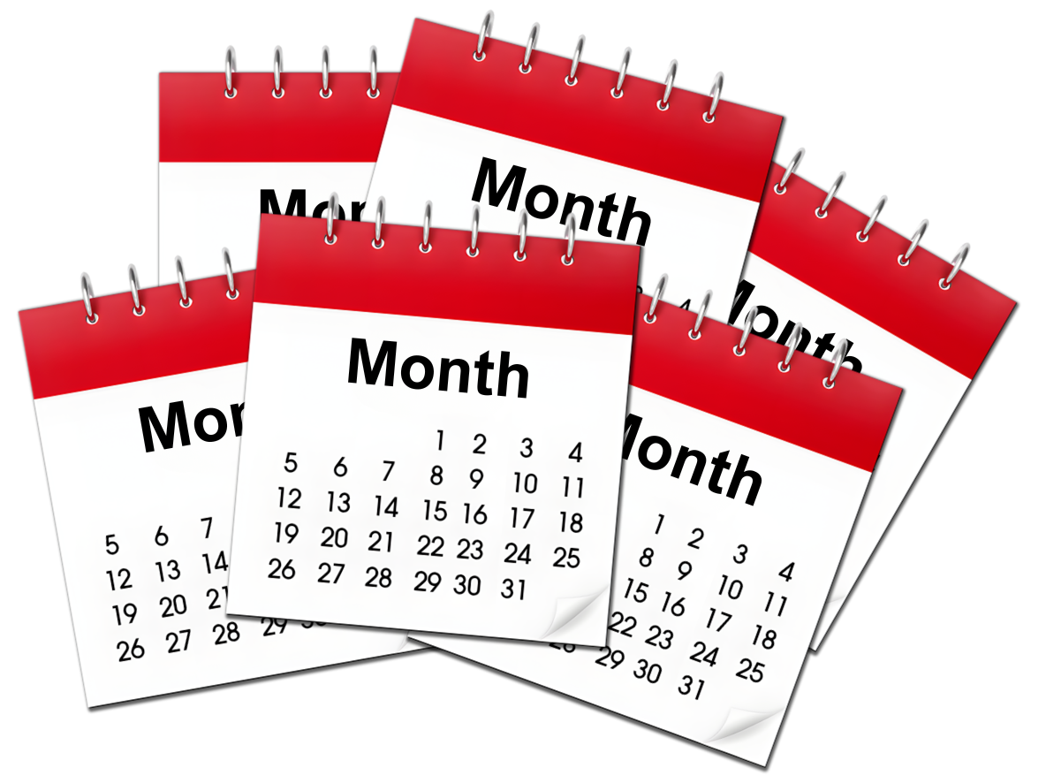 | Less than a month | ☐
 | One month to 3 months | ☐
 | 3 months to 6 months | ☐
 | 6 Months to a year | ☐
 | More than a year | ☐

Question 10

 | What was your experience when applying for the Access to Work scheme?  Write or type your answer below:
Questions for students - please only answer these questions:
- if you are currently studying

- if you have studied at college or university in Scotland in the last 5 years

Question 11

 | What subject or subjects did you study?  Write or type you answer below:

Question 12

 | Where did you study?  Write or type you answer below:

Question 13
 | Did you know disabled students can get support to cover the extra costs of studying?
 | Yes | ☐
 | No | ☐

Question 14

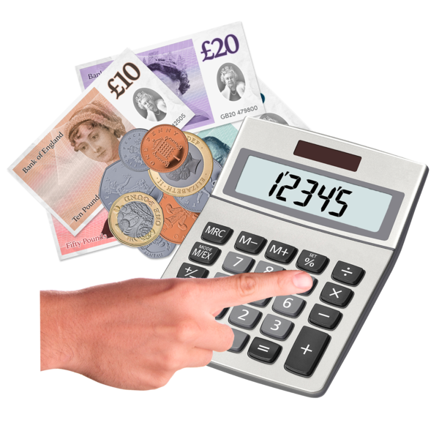 | Did you get Disabled Students Allowance at university?
 | Yes | ☐
 | No | ☐
 | I am not sure | ☐

Question 15

 | As a student, how often did you worry that you were not going to be able to complete your course?
 | Very often | ☐
 | Sometimes | ☐
 | Not at all | ☐

Question 16

 | What made it difficult for you to finish your course?
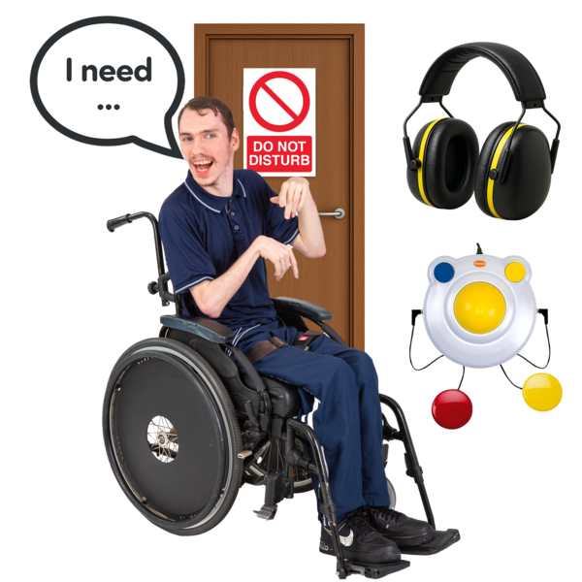     | I found it difficult to get support with my mental health. | ☐
 | My university or college did not make the accessibility adjustments  I needed. | ☐
 | I could not get the help I needed with my studying. | ☐
 | I did not have enough money to live on. | ☐
 | I did not have enough money to cover the extra costs associated with my disability. | ☐
 | Something else. | ☐


