

Essential Services Survey

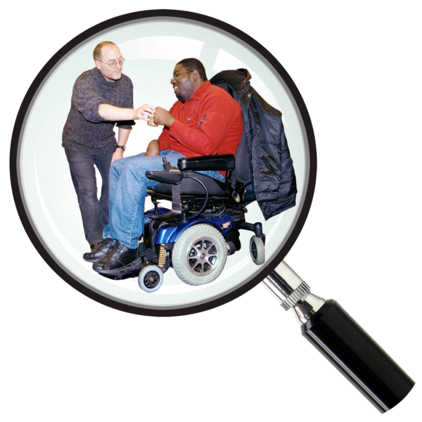

Easy Read


About this document
 | This is an Easy Read document.
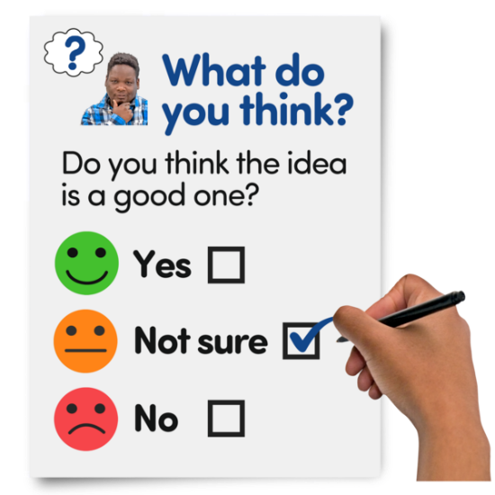 | It is a survey.  A survey means a set of questions.
 | The questions ask about the services you use and your experiences when using them.
 | We want to understand any problems and how waiting for services affects your time and independence.

Our questions
 | Answer our questions to tell us what you think.
 | If you are answering on a screen, you can click the little box next to your answer.  A tick will appear.  If you change your mind you can click it again.
 | If you are typing your answers the space will grow as you type.
 | If you are writing your answers on a paper copy use the Enter button to grow the spaces before you print the pages.

Question 1
 | Are you answering this survey for yourself or for someone else?
 | For myself | ☐
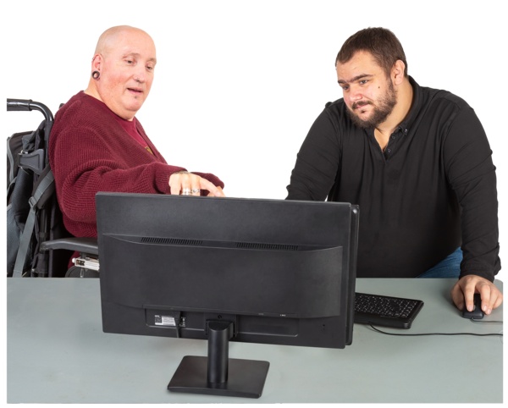 | For someone else | ☐

Question 2
 | Who do you live with?
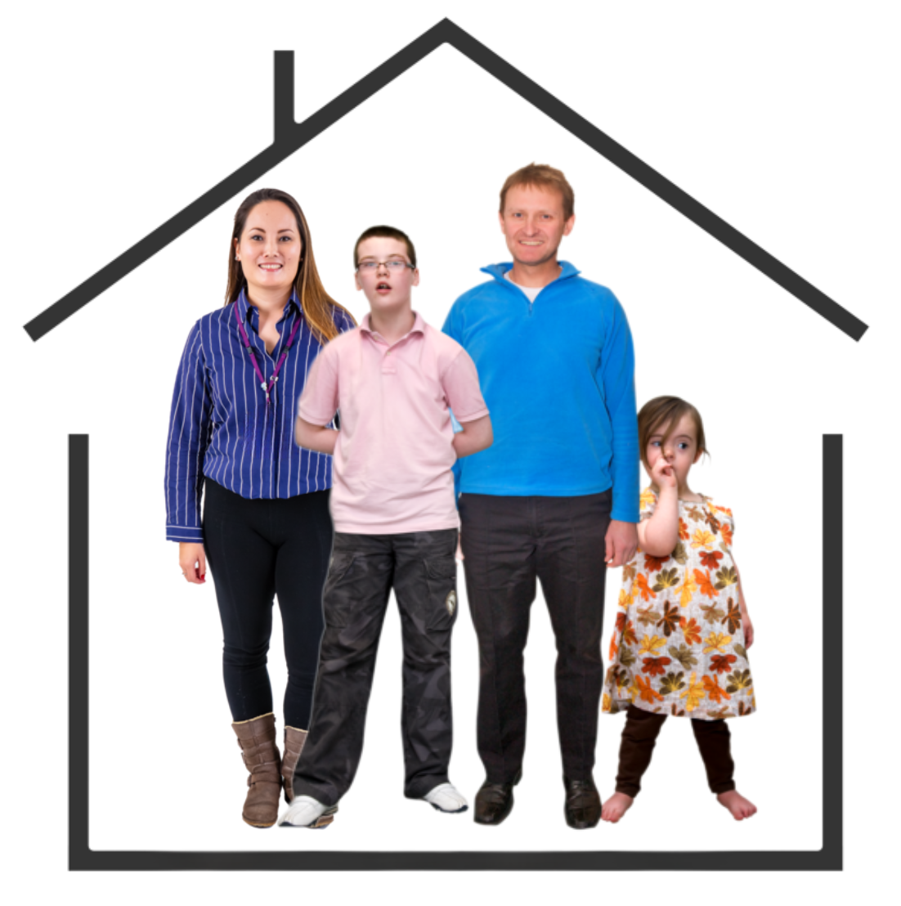  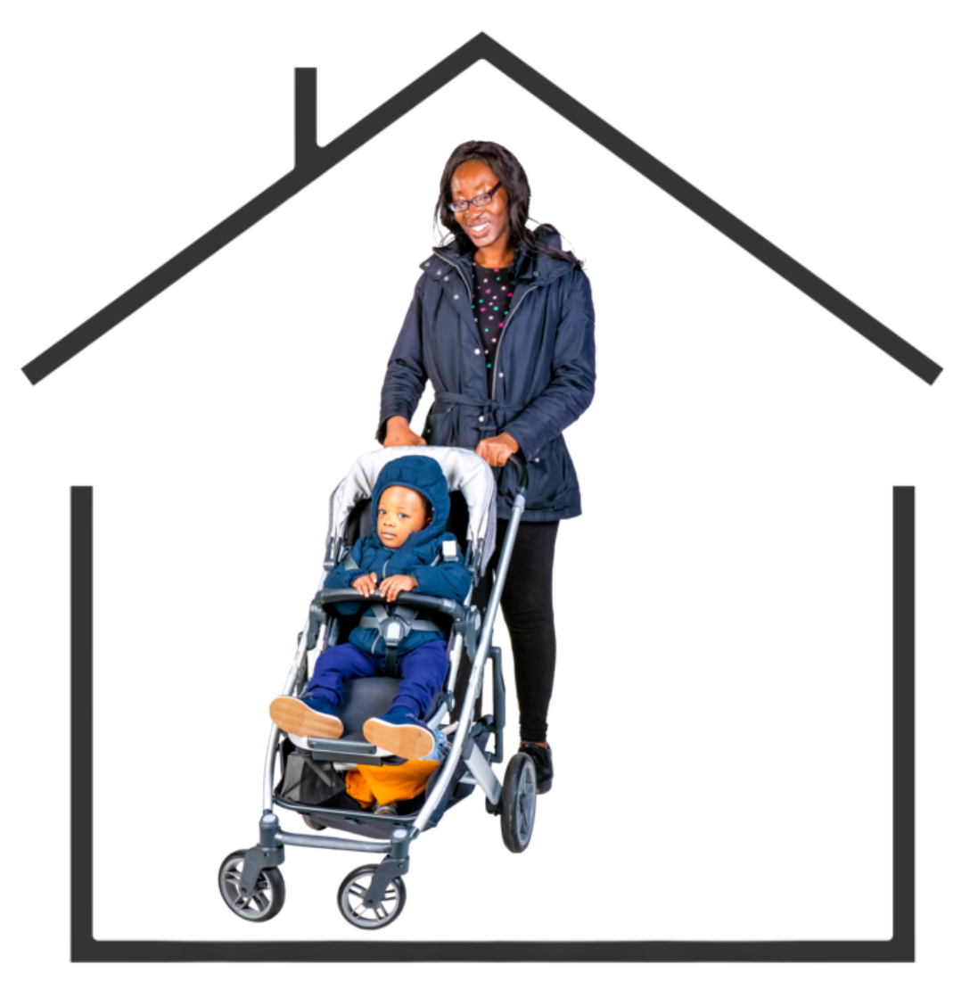   | I live alone | ☐
 | I live with my partner, husband or wife | ☐
 | I live with my partner, husband, wife and child | ☐
 | I live with my partner, husband or wife and children | ☐
 | I live with my parents | ☐
 | I live with my friend or flatmate | ☐
 | I am a single parent | ☐

Question 3
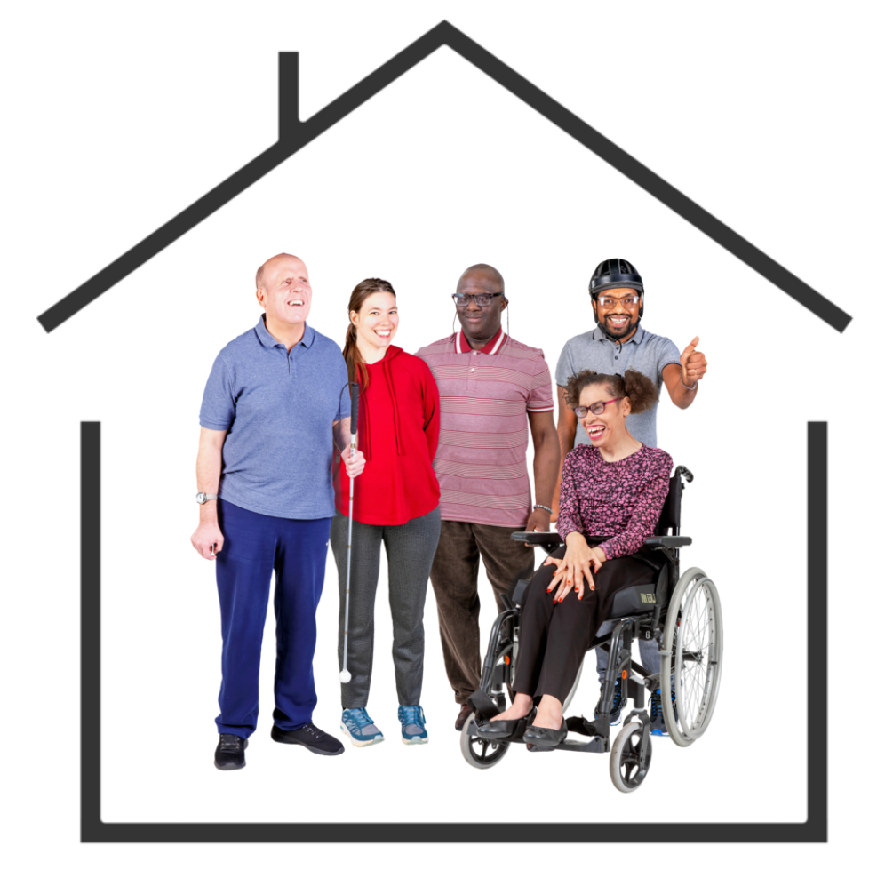 | How many people in your home are disabled people?  Tick as many answers as you need.
  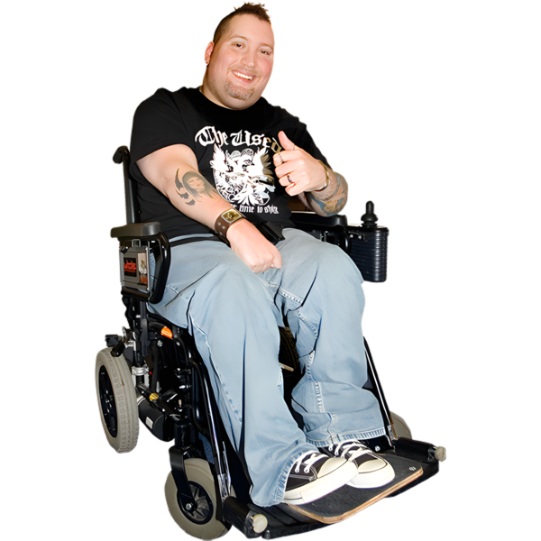 | I am a disabled person. | ☐
 | My partner, husband or wife is a disabled person. | ☐
 | One child is a disabled person. | ☐
 | More than one child is a disabled person. | ☐
 | My friend or flatmate is a disabled person. | ☐

Question 4
 | Which council area do you live in?  Type or write your answer below:

Question 5
 | What location best describe where you live?
   | I live in a city. | ☐
 | I live in a town. | ☐
 | I live in a rural area. | ☐
 | I live in a village. | ☐
 | I live on an island. | ☐

Question 6
 | What is your local health board?  If you are not sure you can tell us the first half of your postcode.  Type or write your answer below:

Question 7
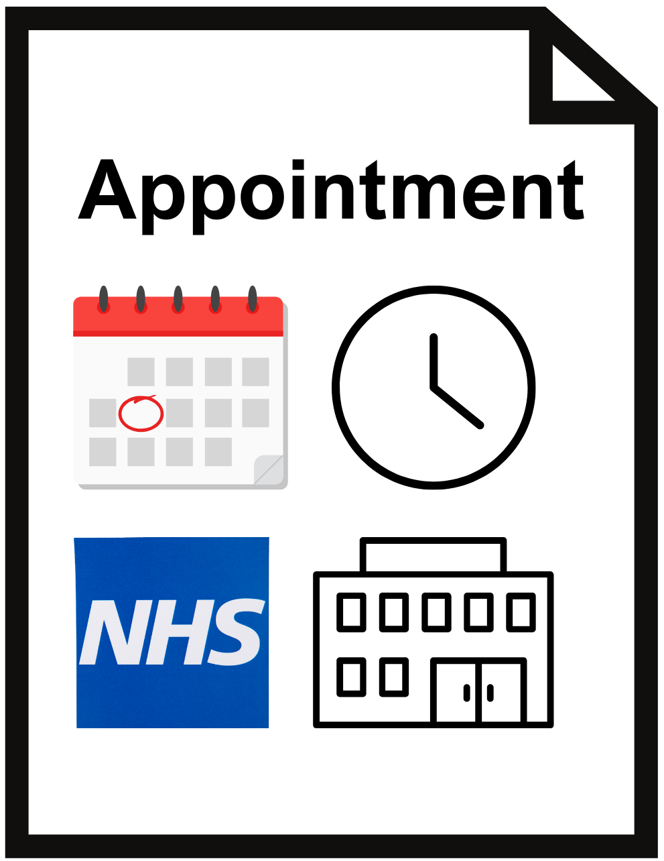 | What type of health care appointments do you need to go to?  Tick as many boxes as you need
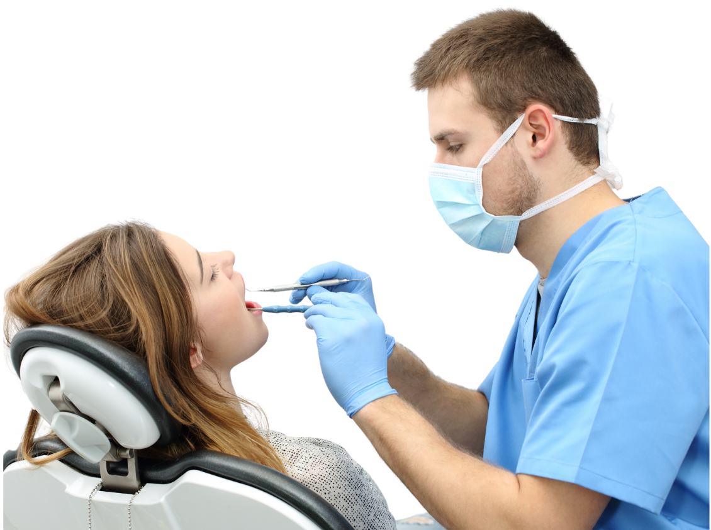     | GP appointments | ☐
 | Dentist appointments | ☐
 | Hospital appointments | ☐
 | Mental health appointments | ☐
 | Vaccination appointments | ☐
 | Optician appoiments | ☐
 | Appointmens for my ears or hearing | ☐
 | Physiotherapy appointments | ☐

Question 8
 | How do you usually book an appointment with your GP or dentist?
  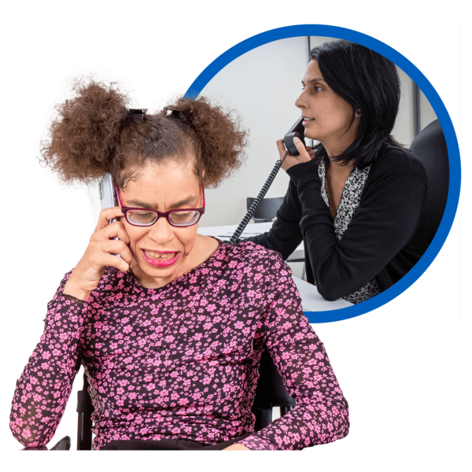 | I phone the surgery | ☐
 | I use a service that lets me text | ☐
 | I get a letter | ☐
 | I book online | ☐

Question 9
 | How do you usually book a vaccine appointment?
 | I book online | ☐
 | I get a letter from the NHS | ☐
 | I phone the surgery | ☐

Question 10
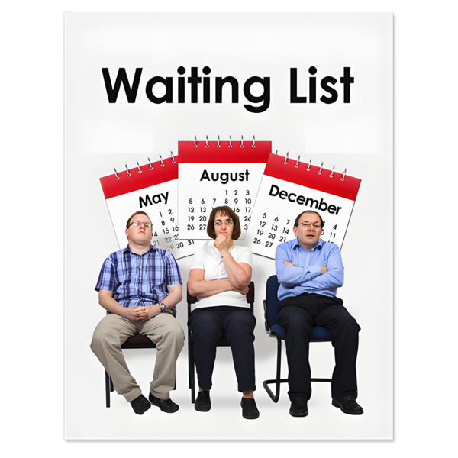 | Are you on a waiting list for NHS treatment?
 | Yes | ☐
 | No | ☐
Only answer question 11 if you answered yes on question 10

Question 11
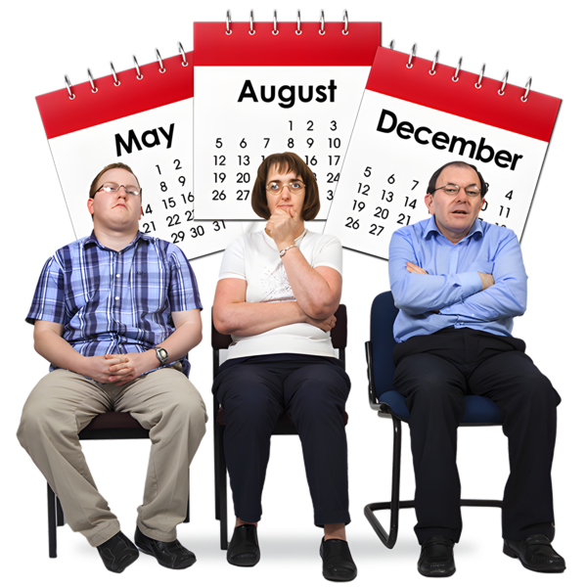 | If your doctor has said you need to see a specialist doctor - also called a consultant - how long have you been waiting for your consultant appointment so far?
  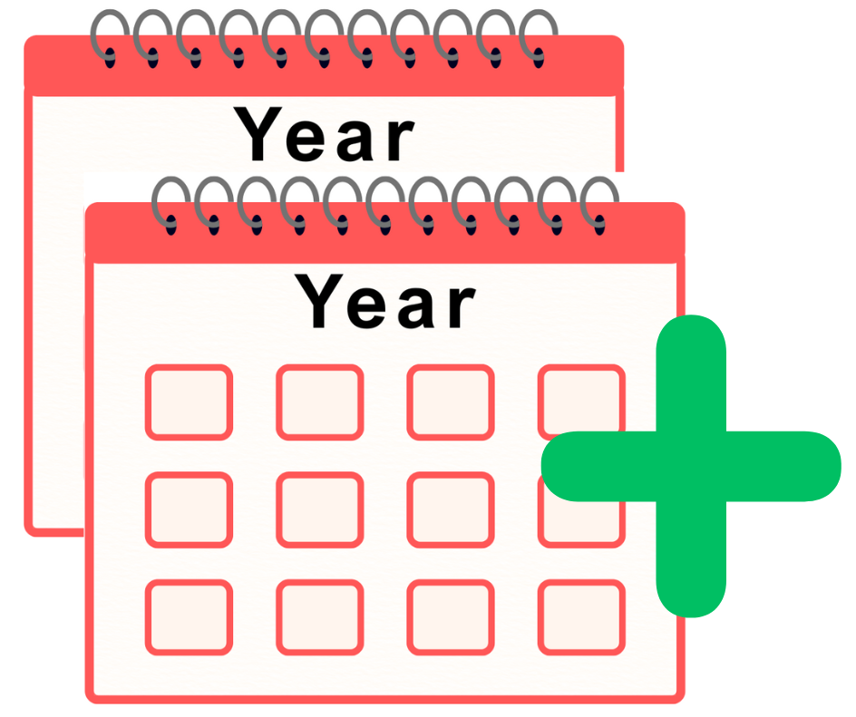   | Less than 1 month | ☐
 | Between 1 and 3 months | ☐
 | Between 3 months and 6 months | ☐
 | More than 6 months but less than 1 year | ☐
 | 1 year | ☐
 | Up to 1 and a half year | ☐
 | 1 and a half to 2 years | ☐
 | More than 2 years | ☐
 | I am not on a waiting list for NHS treatment | ☐

Question 12
 | How long have you been waiting for your operation or medical care?
 | Less than 1 month | ☐
 | Between 1 and 3 months | ☐
 | Between 3 months and 6 months | ☐
 | More than 6 months but less than 1 year | ☐
 | 1 year | ☐
 | Up to 1 and a half year | ☐
 | 1 and a half to 2 years | ☐
 | More than 2 years | ☐
 | I am not on a waiting list for this | ☐

Question 13
 | If you are on a waiting list for mental health treatment or support, how long have you been waiting?
 | Less than 1 month | ☐
 | Between 1 and 3 months | ☐
 | Between 3 and 6 months | ☐
 | More than 6 months but less than 1 year | ☐
 | 1 year | ☐
 | Up to 1 and a half year | ☐
 | 1 and a half to 2 years | ☐
 | More than 2 years | ☐
 | I am not on a waiting list for this | ☐

Question 14
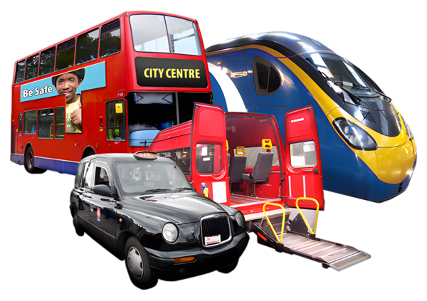 | How do you usually travel to your healthcare appointments?
  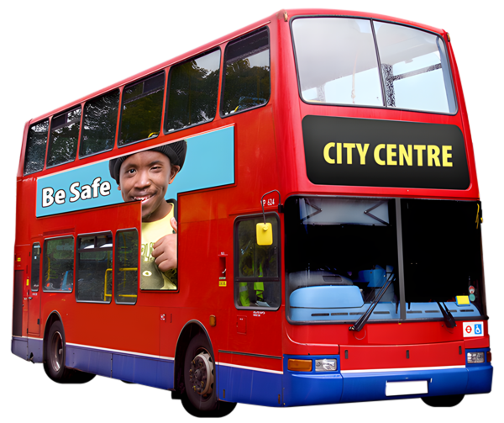  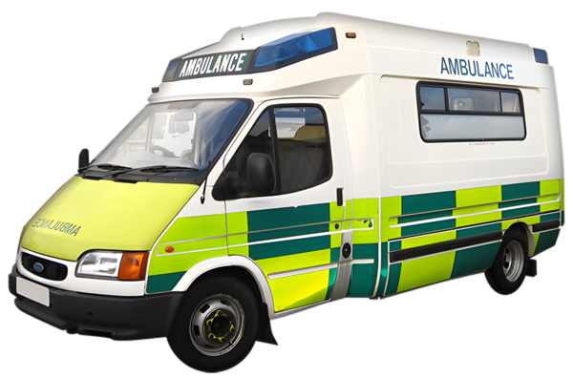 | By car | ☐
 | By bus | ☐
 | By train | ☐
 | Walking | ☐
 | Wheeling | ☐
 | Cycling | ☐
 | By community transport | ☐
 | By patient transport | ☐
 | Ambulance | ☐
 | Something else | ☐

Question 15
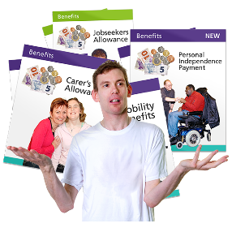 | Does your household get any of these benefits?  Tick as many answers as you need.
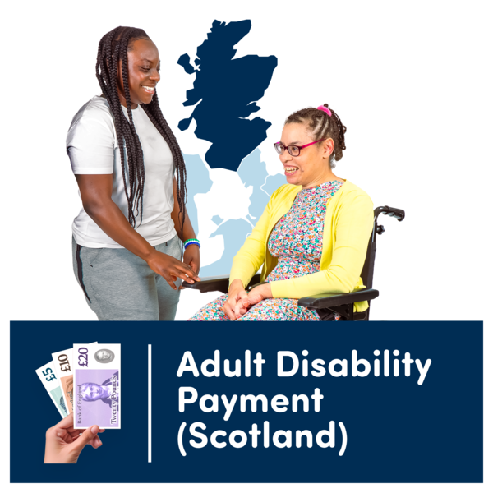   | Adult Disability Payment | ☐
 | Child Disability Payment | ☐
 | Pension Age Winter Heating Payment or Winter Fuel Allowance | ☐
 | Universal Credit | ☐
 | Employment and Support Allowance | ☐
 | Income Support | ☐
 | Cold Weather Payment | ☐
 | State Pension | ☐
 | Pension Credit | ☐
 | Attendance Allowance | ☐
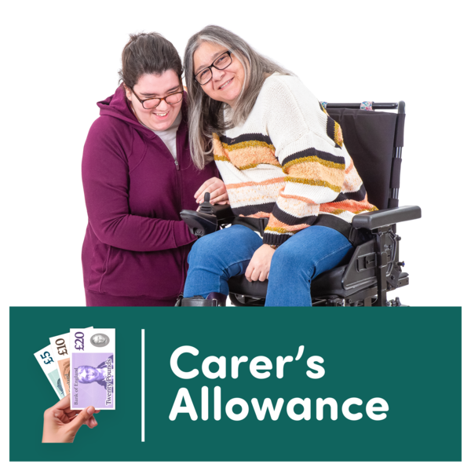 | Carer’s Allowance or Carer Support Payment | ☐
 | Scottish Child Payment | ☐
 | Child Winter Heating Payment | ☐

Question 16
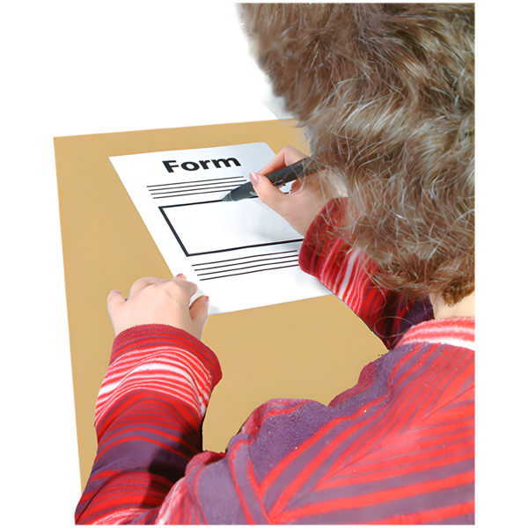 | Where did you apply the last time you made an application?
 | Social Security Scotland | ☐
 | Department for Work and Pensions | ☐

Question 17
 | How did you fill in your application?
  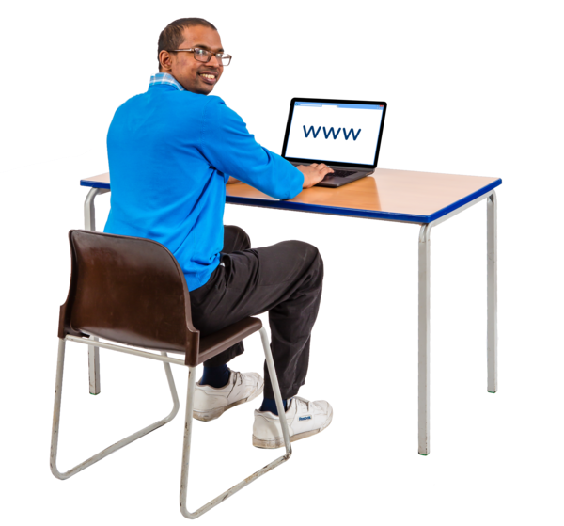 | I filled it out online myself | ☐
 | I filled in a paper form myself | ☐
 | Someone else helped me fill it out online | ☐
 | Someone else helped me fill out a paper form | ☐

Question 18
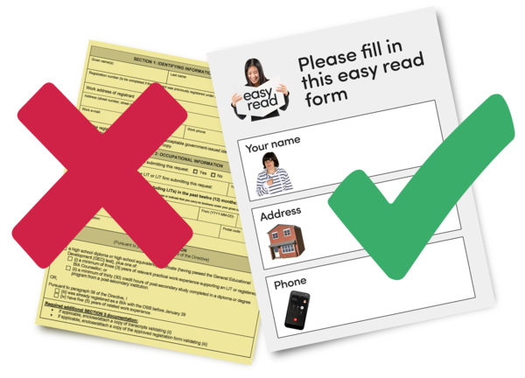 | How accessible did you think the application was?  Accessible means easy to use and understand.
   | It was very accessible | ☐
 | It was quite accessible | ☐
 | It was not very accessible | ☐
 | It was not accessible at all | ☐

Question 19
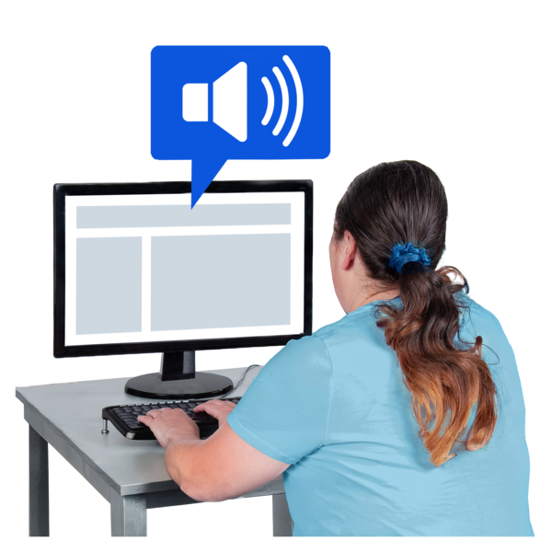 | Was there anything else you used or needed to help make the application more accessible?  Tell us about it by writing or typing below

Question 20
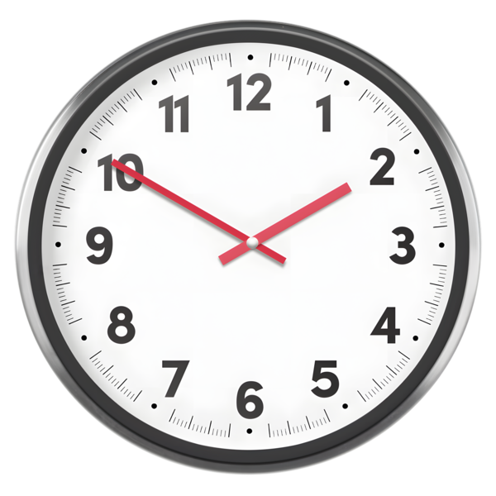 | How long did it take to get an answer about your application?
   | Less than 1 month | ☐
 | Less than 2 months | ☐
 | Less than 3 months | ☐
 | Between 3 and 6 months | ☐
 | More than 6 months | ☐

Question 21
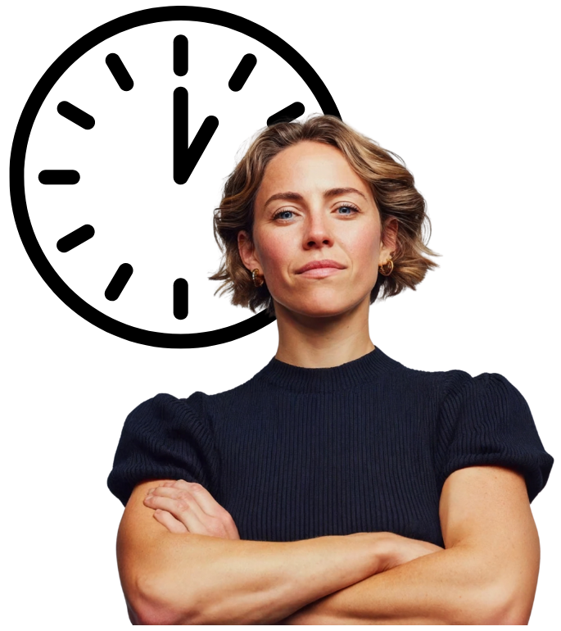 | How was your independence and standard of living affected whilst waiting for an answer about your application?  Write or type your answer below

Question 22
 | Have you had a letter about reassessment?  Reassessment means your application is looked at and considered again.
 | Yes | ☐
 | No | ☐
 | I am not sure | ☐
Only answer question 23 and 24 if you answered yes on question 22

Question 23
 | How long did you have to wait to get an answer about your reassessment?
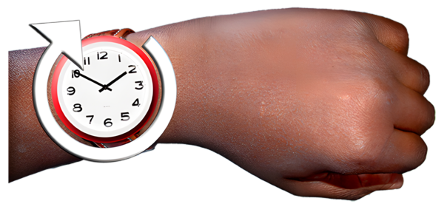 | Up to 1 month | ☐
 | Up to 3 months | ☐
 | Up to 6 months | ☐
 | More than 6 months | ☐
 | I am still waiting for an answer | ☐

Question 24
 | Tell us about your experience of the reassessment.  This could be how it made you feel and how it affected your daily life.  Write or type your answer below

Question 25
 | What type of care and support do you get at home?
  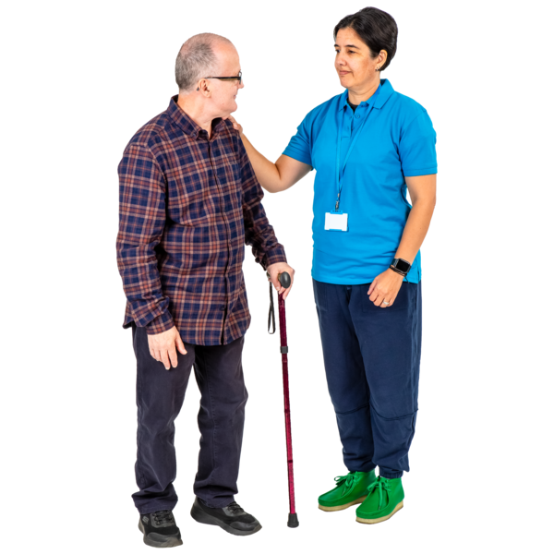 | I get social care support that I organise myself | ☐
 | I get support from an agency | ☐
 | I get support from the local council | ☐
 | I get a combination of support from different places | ☐

Question 26
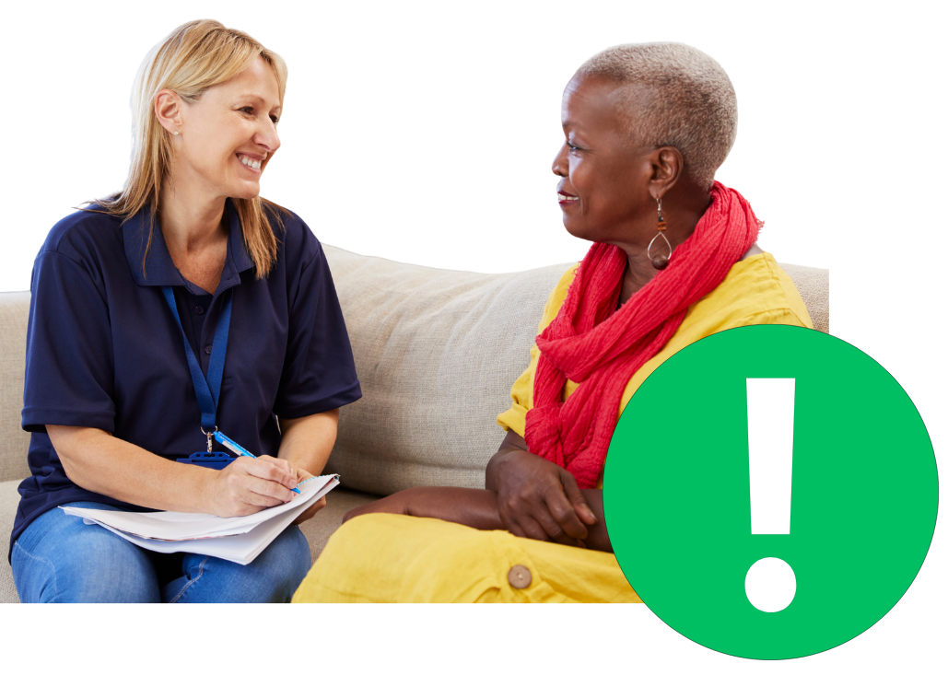 | Has there been any changes to your care package in the last year?
 | No | ☐
 | I am not sure | ☐
 | Yes | ☐
 | Tell us what changed by writing or typing below

Question 27
 | How much has the cost of social care changed in the last year?
   | It is a lot more expensive | ☐
 | It is a little more expensive | ☐
 | It has stayed the same | ☐
 | It is a little less expensive | ☐
 | It is a lot less expensive | ☐

Question 28
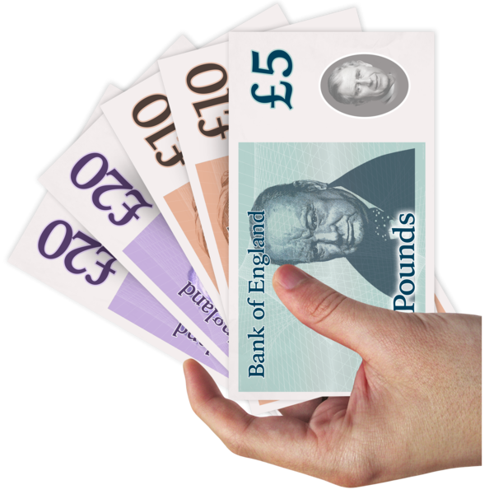 | If the cost went up how did you pay the extra money?
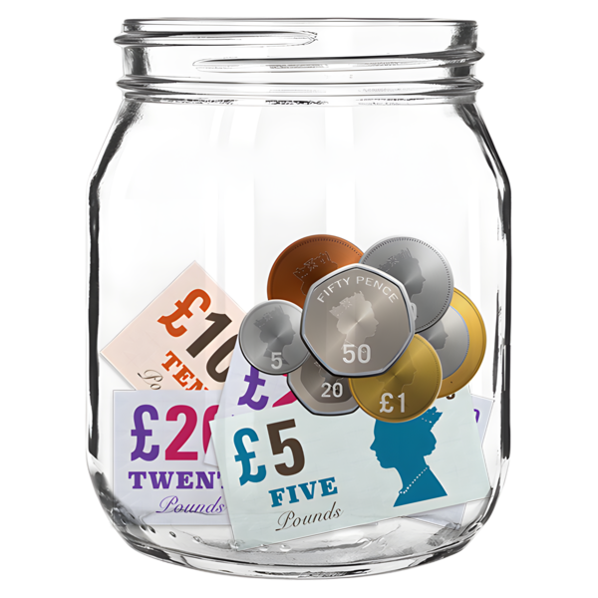   | I used my own money or savings. | ☐
 | The council paid the extra cost. | ☐
 | I took a loan or borrowed money from family or a friend. | ☐

Question 29
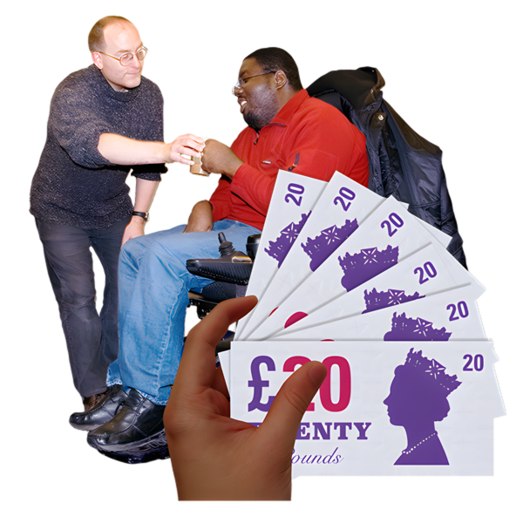 | Have you had to pay more towards your support?
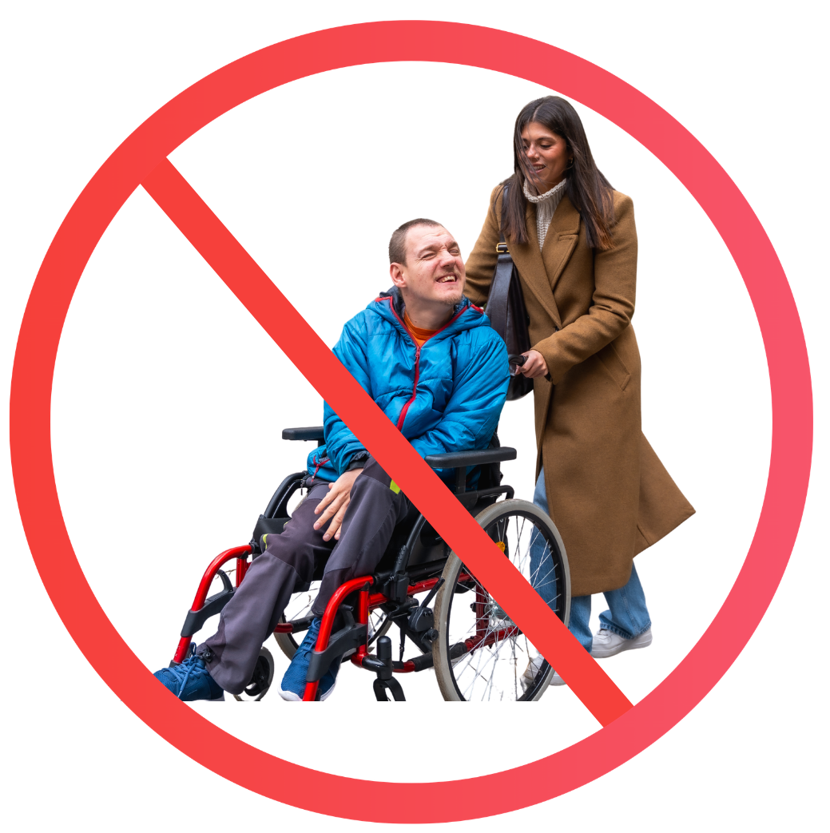 | Yes, I have paid a lot more. | ☐
 | Yes, I have paid a little more. | ☐
 | No, everything is OK. | ☐
 | I now have less support because I cannot afford it. | ☐
 | I now have no support because I cannot afford it. | ☐

Question 30
 | If you have had to pay more towards support or now have less support, how has this affected you?  Write or type your answer below


