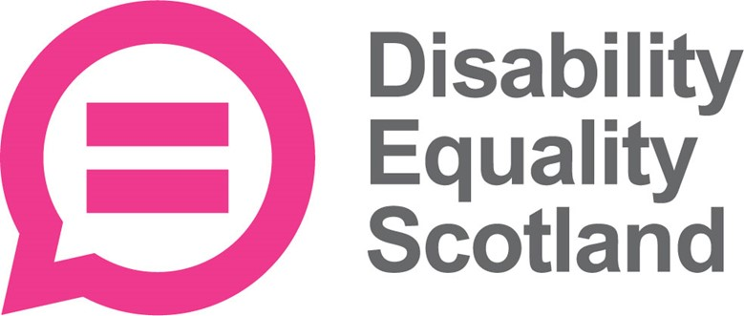

Household bills and income survey

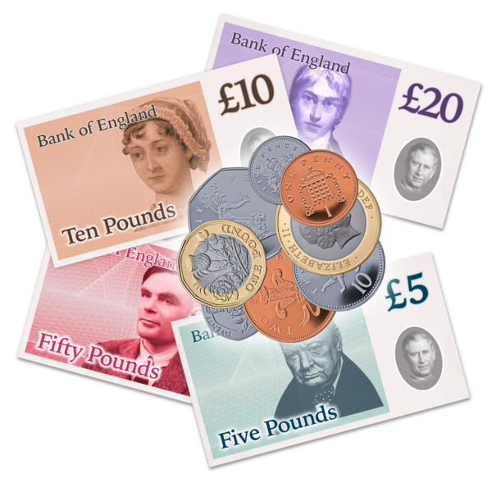
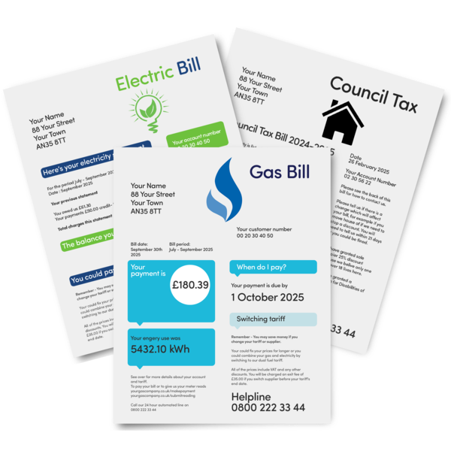
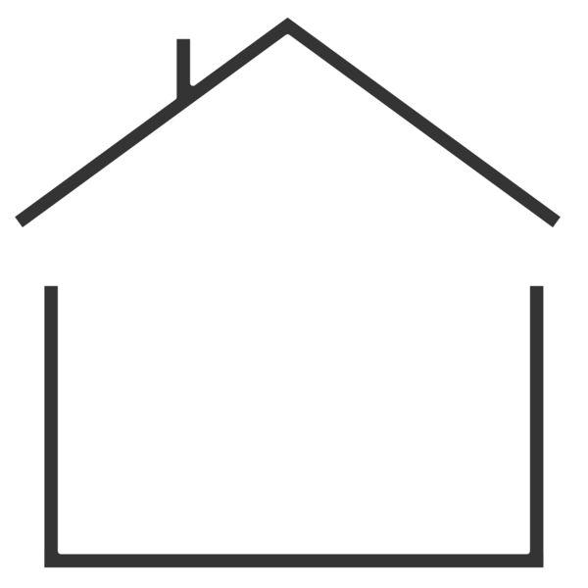

Easy Read


About this document

 | This is an Easy Read document.
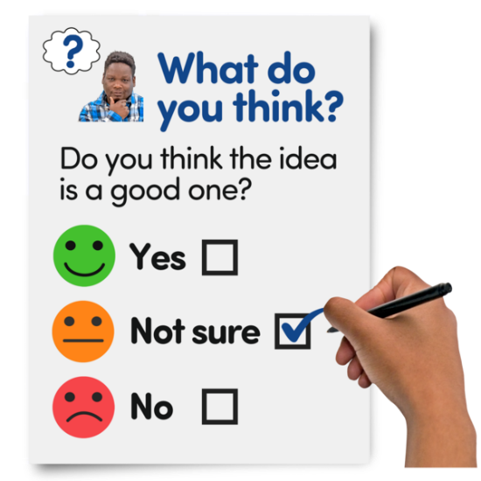 | It is a survey.  A survey means a set of questions.
 | The questions ask about paying your bills and how much money your household has coming in.
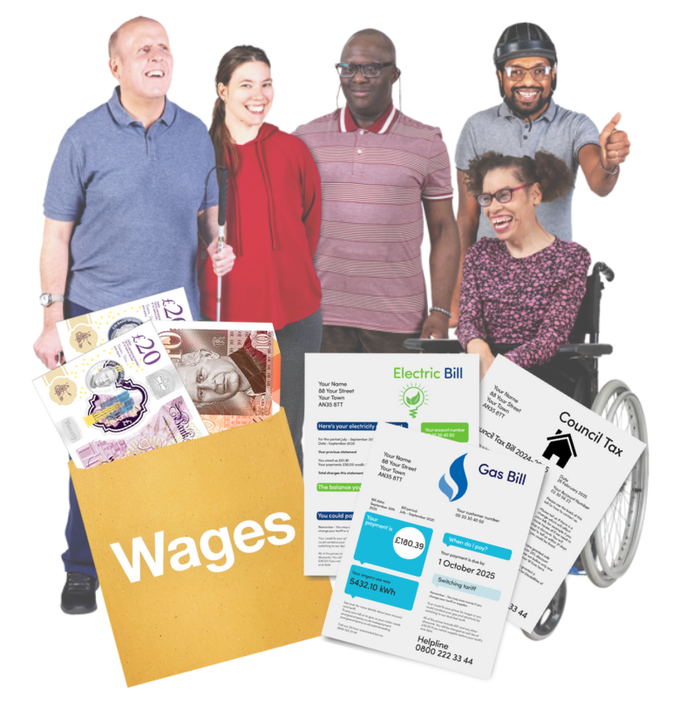 | We want to understand how being a disabled person affects the money coming into your household and the bills you need to pay.

Our questions

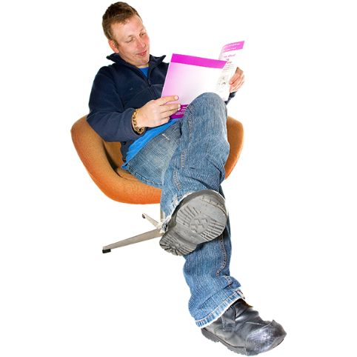 | Answer our questions to tell us what you think.
 | If you are answering on a screen, you can click the little box next to your answer.  A tick will appear.  If you change your mind you can click it again.
 | If you are typing your answers the space will grow as you type.
 | If you are writing your answers on a paper copy use the Enter button to grow the spaces before you print the pages.

Question 1

 | Are you answering this survey for yourself or for someone else?
 | For myself | ☐
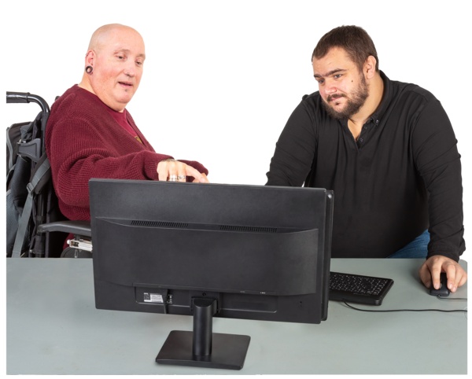 | For someone else | ☐

Question 2

 | Who do you live with?
 | I live alone | ☐
 | I live with my partner, husband or wife | ☐
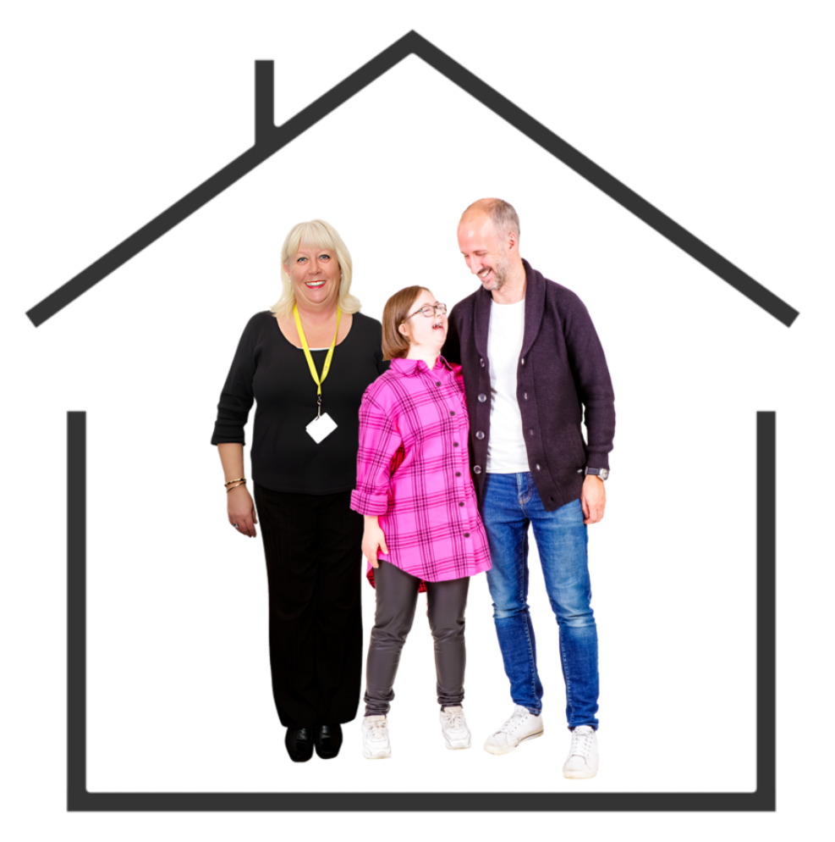 | I live with my partner, husband, wife and child | ☐
 | I live with my partner, husband or wife and children | ☐
 | I live with my parents | ☐
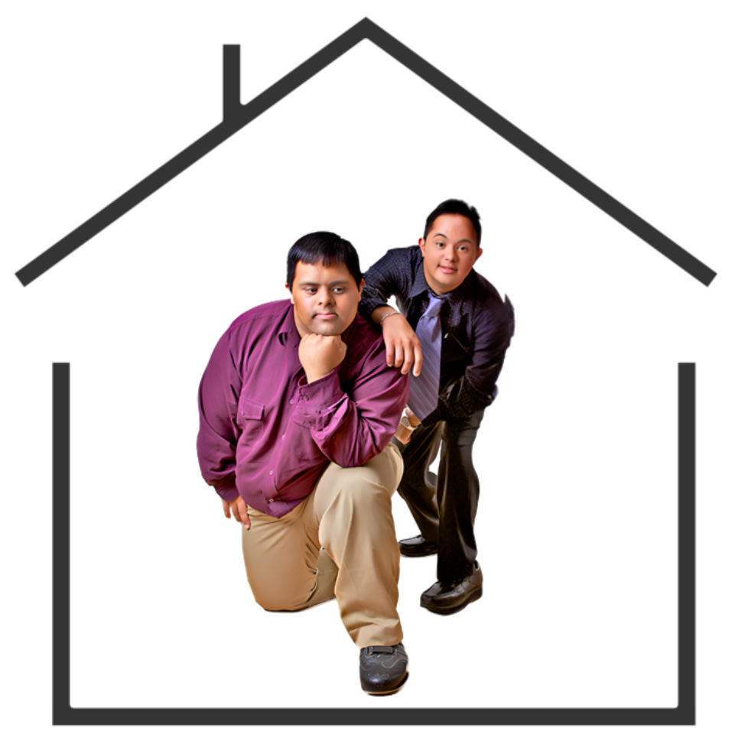 | I live with my friend or flatmate | ☐
 | I am a single parent | ☐

Question 3

 | How many people in your home are disabled people?  Tick as many answers as you need.
 | I am a disabled person. | ☐
 | My partner, husband or wife is a disabled person. | ☐
 | One child is a disabled person. | ☐
 | More than one child is a disabled person. | ☐
 | My friend or flatmate is a disabled person. | ☐

Question 4

 | Which council area do you live in?  Type or write your answer below:

Question 5

 | What location best describe where you live?
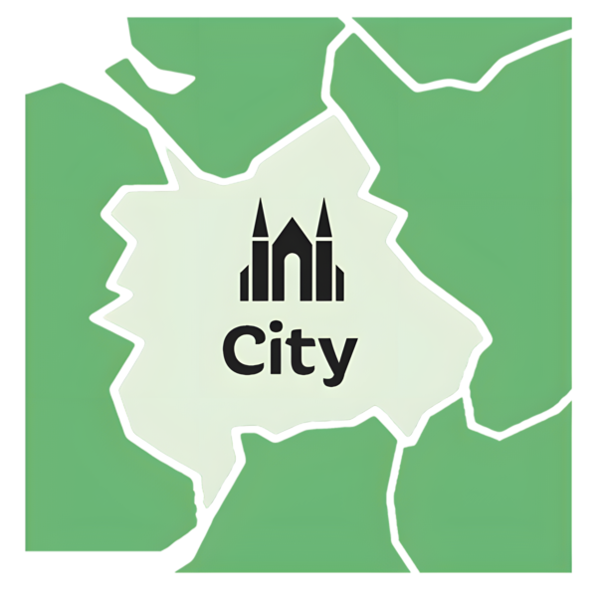 | I live in a city. | ☐
 | I live in a town. | ☐
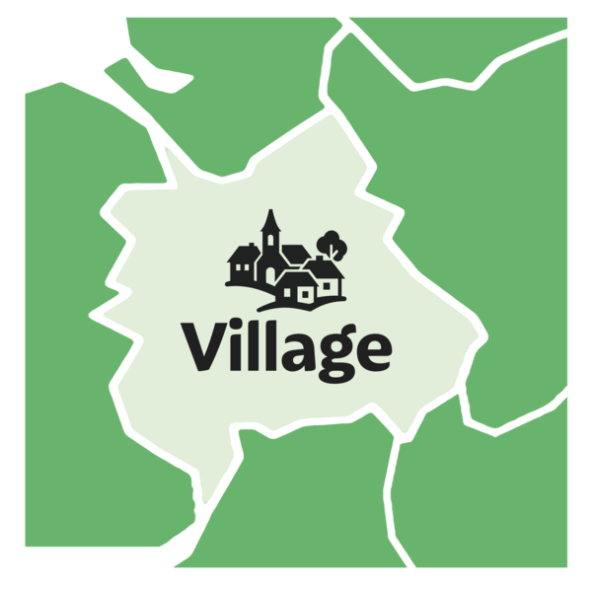 | I live in a rural area. | ☐
 | I live in a village. | ☐
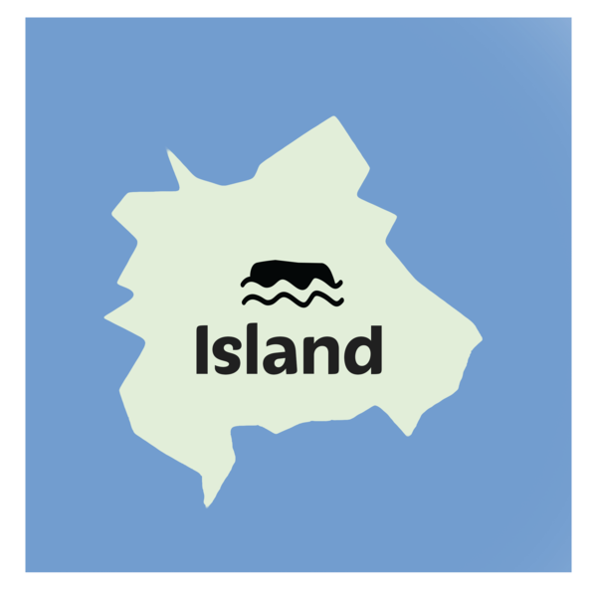 | I live on an island. | ☐

Question 6

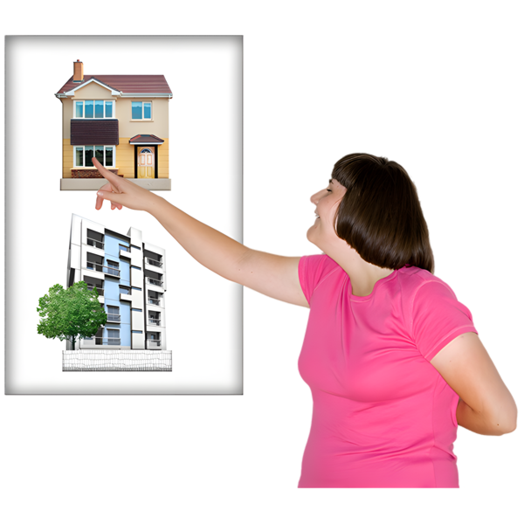 | Which of these are true about your home?
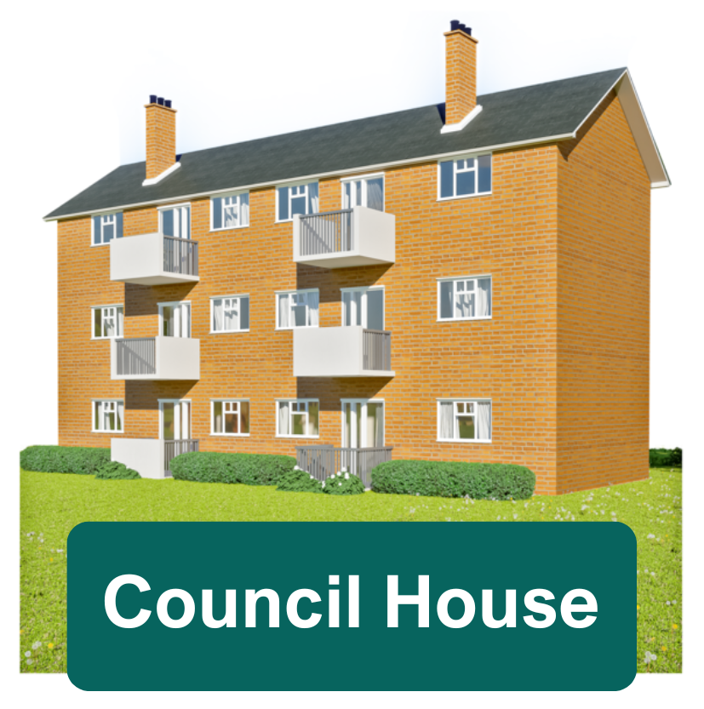 | My home is a council house. | ☐
 | My home is rented privately. | ☐
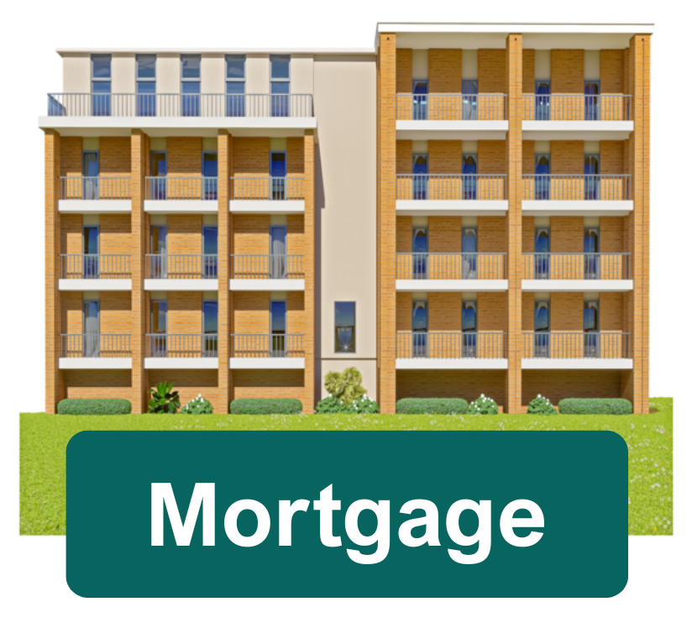 | I live in a home that I or someone else owns and there is a mortgage on the home.  A mortgage is a loan to buy a home that you need to pay back. | ☐
 | I live in a home that I or someone else owns and there is no mortgage on the home. | ☐

Question 7

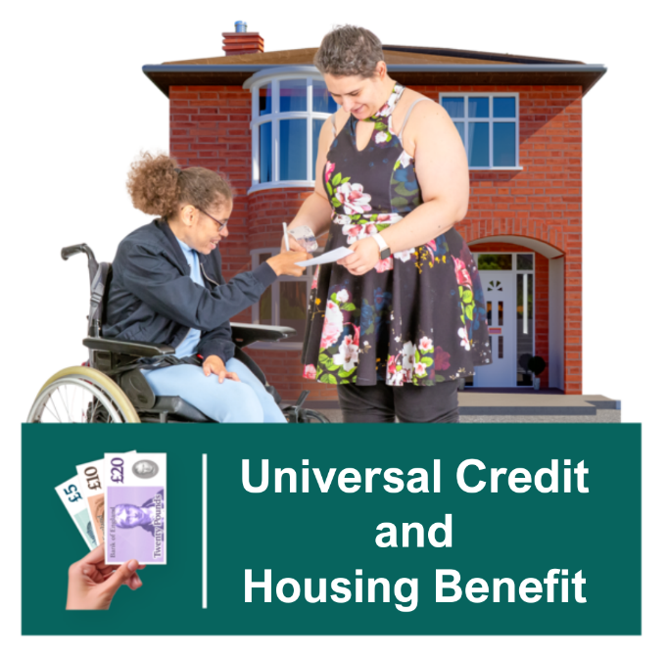 | You can get help from universal credit or housing benefit to pay your rent or mortgage.  How much of your rent or mortgage does universal credit or housing benefit cover?
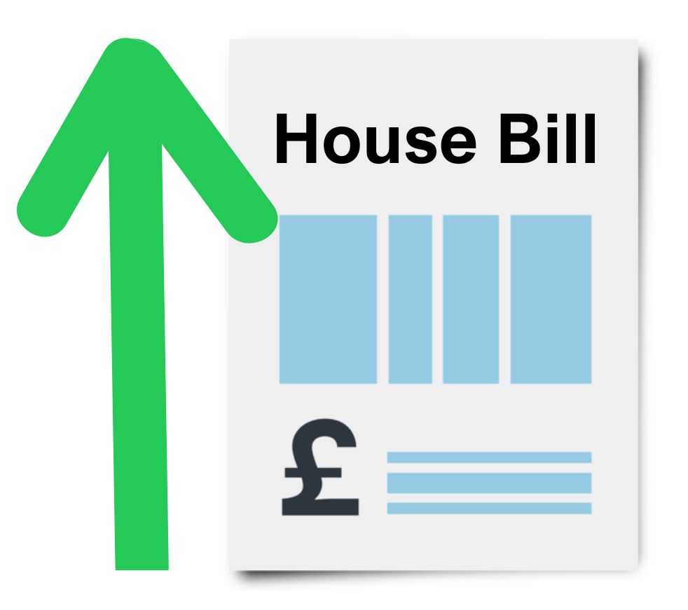  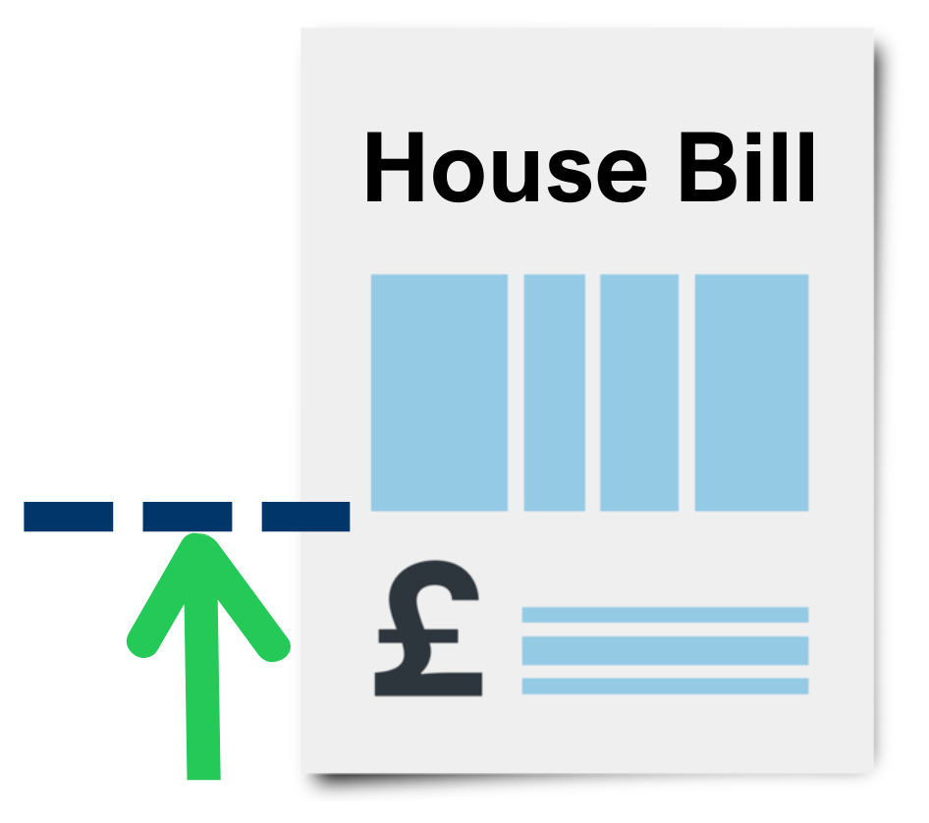   | All of my rent or mortgage. | ☐
 | Most of my rent or mortgage. | ☐
 | Some of my rent or mortgage. | ☐
 | I would rather not say. | ☐
 | I do not get universal credit or housing benefit. | ☐

Question 8

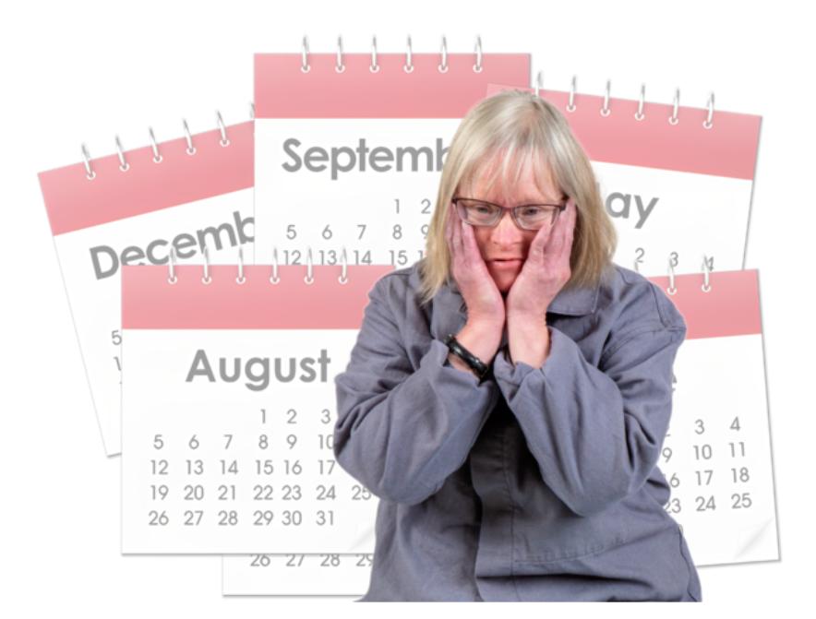 | In the last year how often have you been worried about being able to pay your rent or mortgage?
 | I have been worried about it all of the time | ☐
 | I have been worried about it most of the time | ☐
 | I have been worried about it some of the time | ☐
 | I have not been worried about it | ☐

Question 9

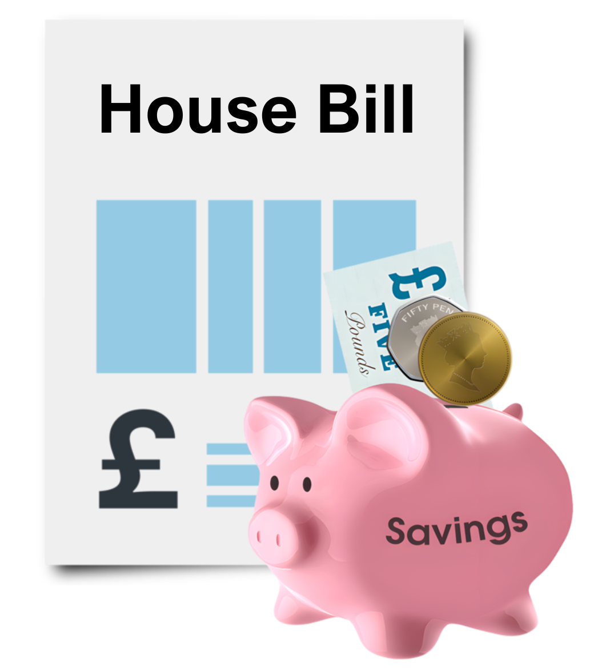 | In the last year have you had to use any of your savings to help pay your rent or mortgage?
 | Yes | ☐
 | No | ☐

Question 10

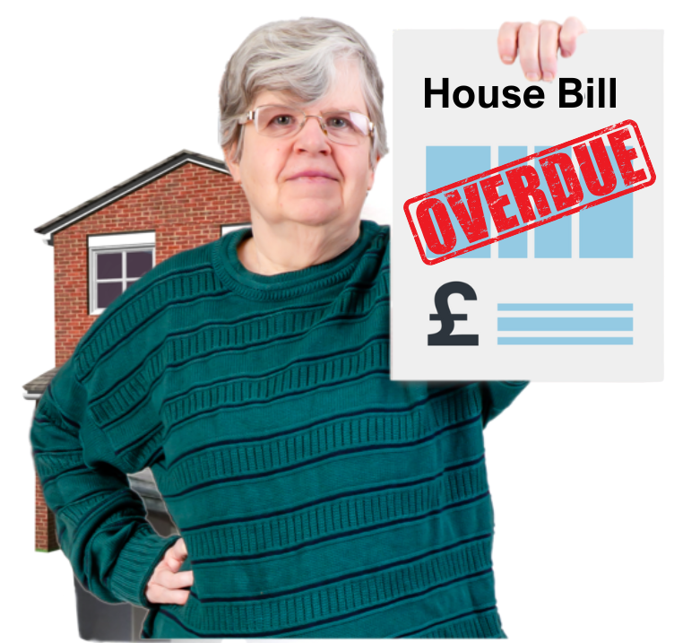 | In the last year have you been able to pay your mortgage or rent on time?
 | Yes | ☐
 | No | ☐
 | I would rather not say | ☐

Question 11

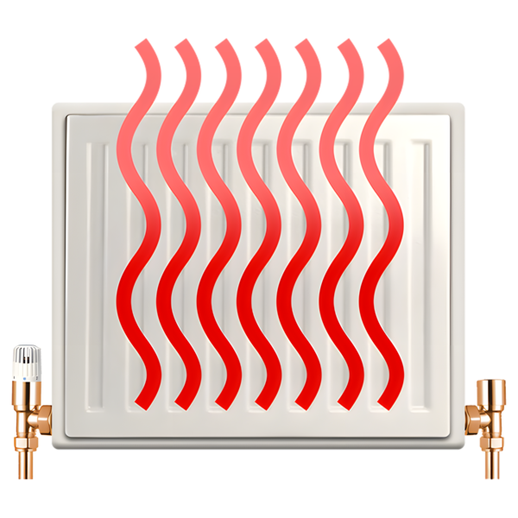 | What type of fuel do you use to heat your home?
  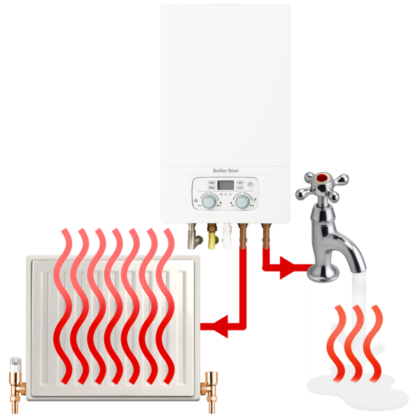 | Electricity only | ☐
 | Gas only | ☐
 | Gas and Electricity | ☐
 | Other  Please type or write what below on the next page: | ☐

Question 12

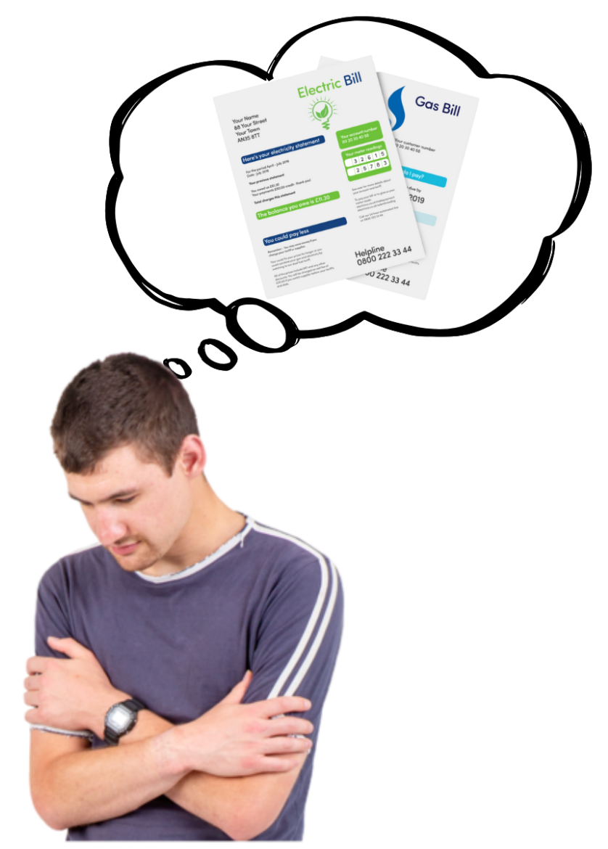 | In the last year how worried have you been about being able to afford to pay your energy bills?
 | I have been worried about it all of the time | ☐
 | I have been worried about it most of the time | ☐
 | I have been worried about it some of the time | ☐
 | I have not been worried about it at all | ☐

Question 13

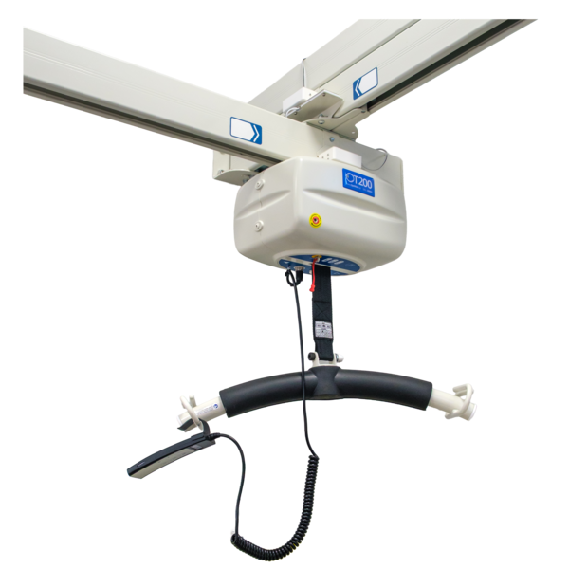  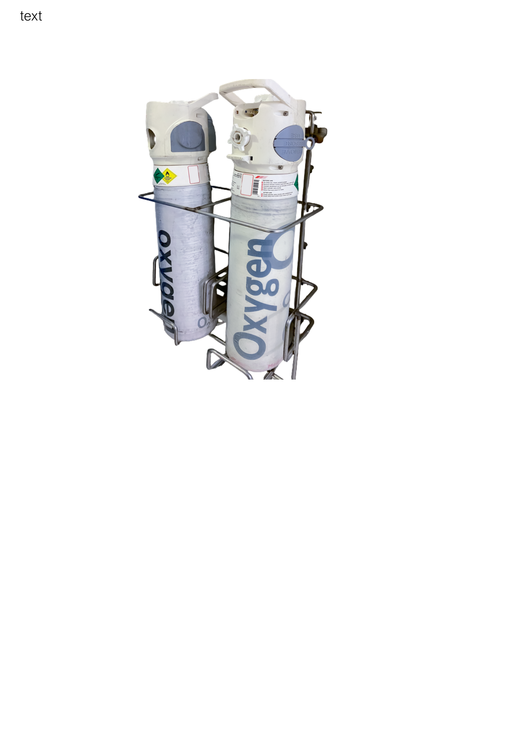  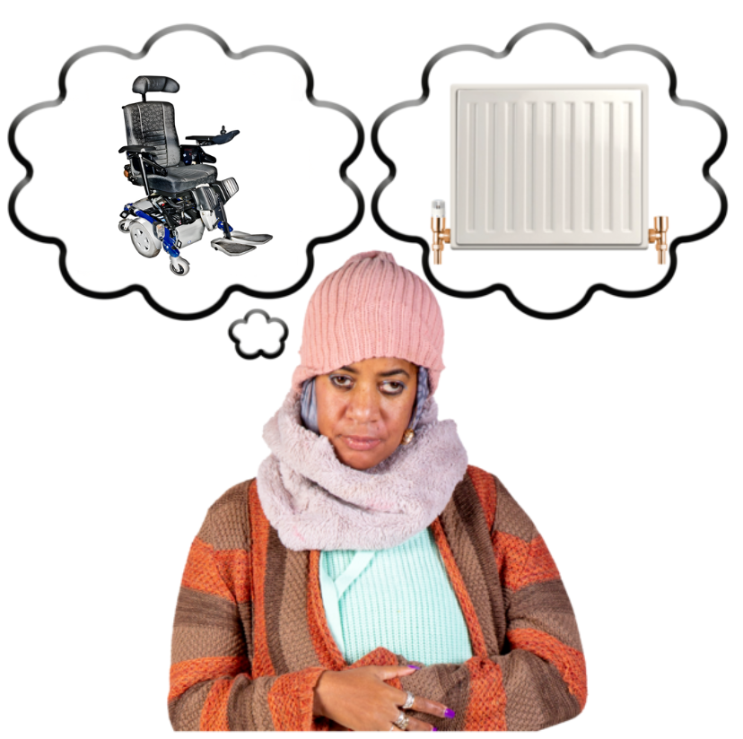 | In the last year have you had to choose between heating your home and using your independent living equipment?  Independent living equipment means things like:  • a wheelchair  • a hoist  • an electric bed  • an oxygen canister
 | Yes
 | No
 | I am not sure
If you ticked ‘yes’ please tell us what changes you made.

Write or type your answer here:

Question 14

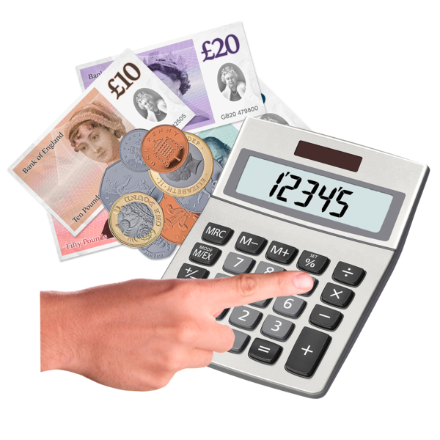 | How much extra money does it usually cost to run your equipment or keep warm because of your health condition or disabilites?
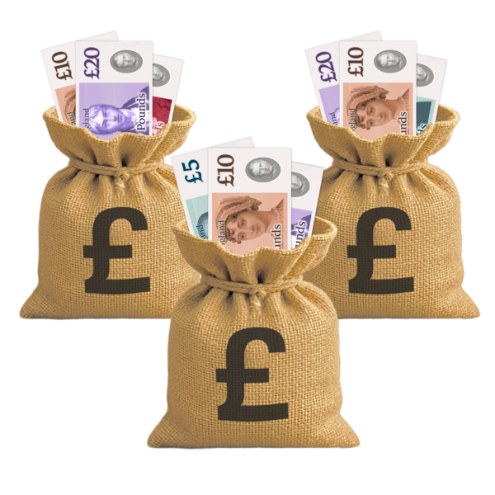 | A lot of extra money | ☐
 | Some extra money | ☐
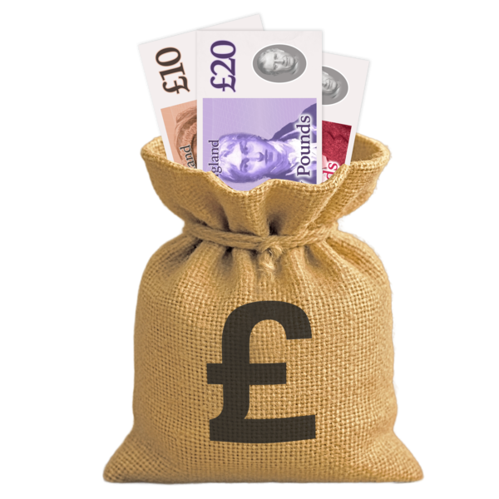 | A little extra money | ☐
 | I am not sure | ☐

Question 15

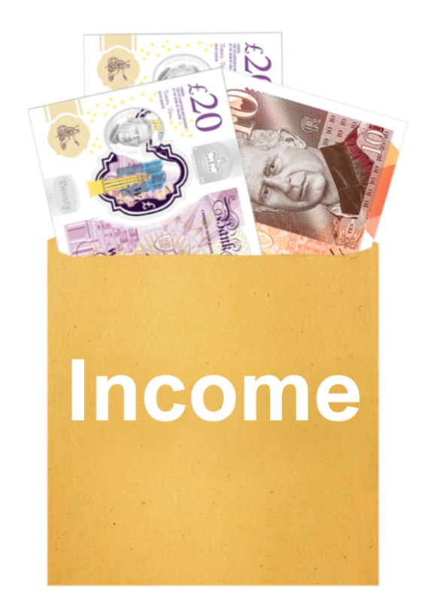 | How much of your income do you spend on paying your energy bill?
 | 20 per cent or more of my income | ☐
 | Between 10 and 20 per cent of my income | ☐
 | Less than 10 per cent of my income | ☐
 | I am not sure | ☐

Question 16

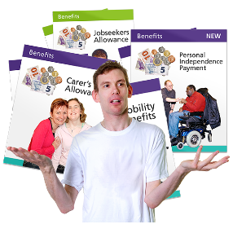 | Does your household get any of these benefits?  Tick as many answers as you need
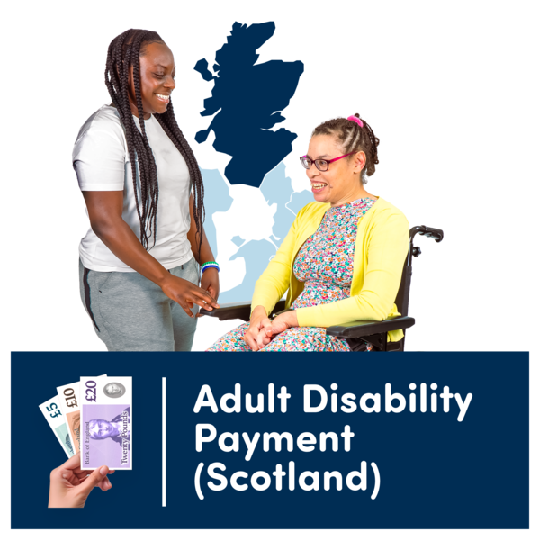 | Adult Disability Payment | ☐
 | Child Disability Payment | ☐
 | Pension Age Winter Heating Payment or Winter Fuel Allowance | ☐
 | Universal Credit | ☐
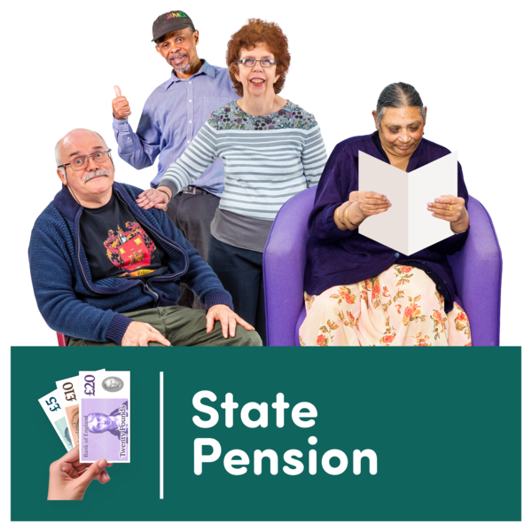 | Employment and Support Allowance | ☐
 | Income Support | ☐
 | Cold Weather Payment | ☐
 | State Pension | ☐
 | Pension Credit | ☐
 | Attendance Allowance | ☐

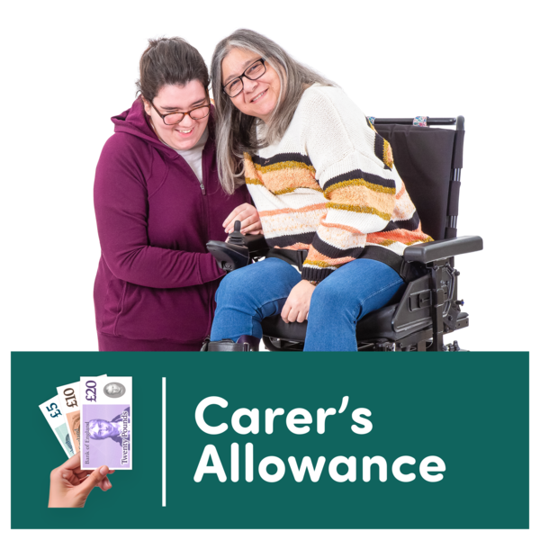 | Carer’s Allowance or Carer Support Payment | ☐
 | Scottish Child Payment | ☐
 | Child Winter Heating Payment | ☐

Question 17

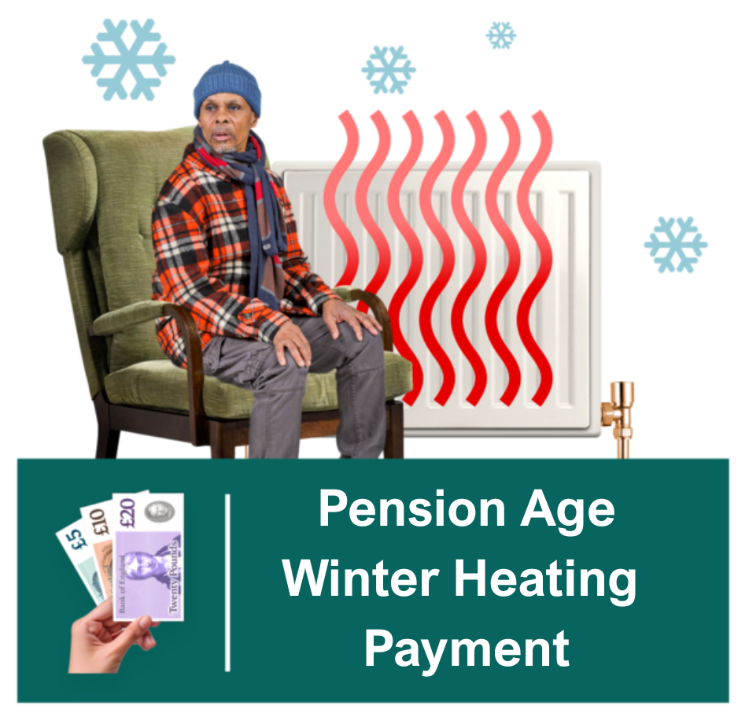 | Did you get the Pension Age Winter Heating Payment this winter?
 | Yes | ☐
 | No | ☐
 | I am not old enough to get the Pension Age Winter Heating Payment. | ☐

Only answer question 18 and 19 if you ticked yes on question 17

Question 18

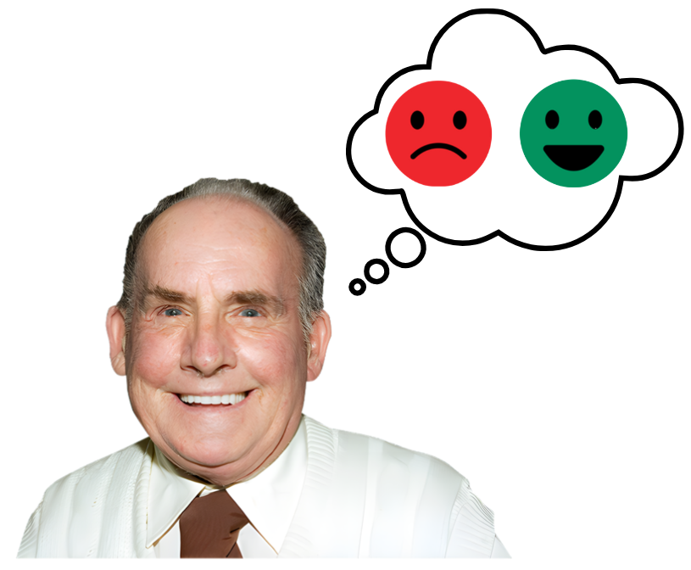 | How helpful was the Pension Age Winter Heating Payment this winter?
 | It helped a lot | ☐
 | It helped a bit | ☐
 | It did not help very much | ☐
 | It did not help at all | ☐

Question 19

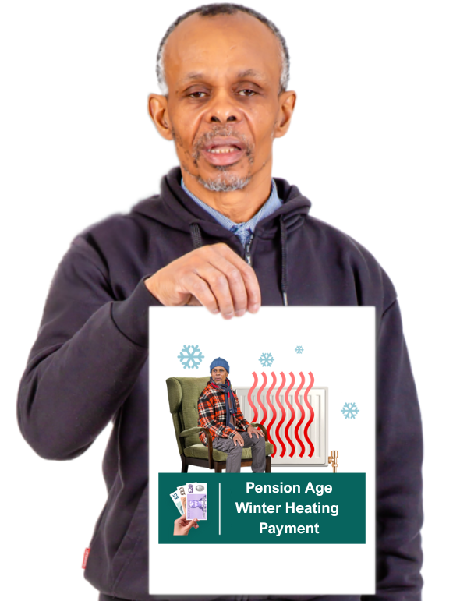 | Tell us how the Pension Age Winter Heating Payment helped you this winter.  Type or write your answer below

Question 20

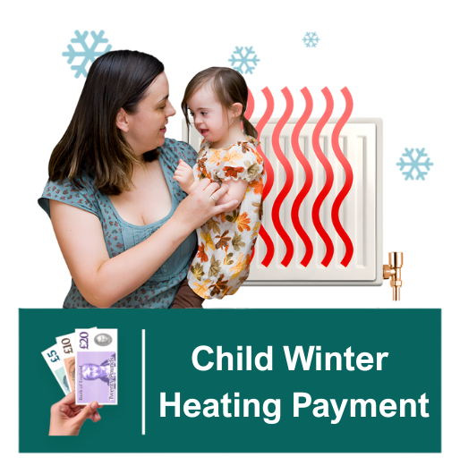 | Do you receive Child Winter Heating Payment due to having a disabled child in your household?
 | Yes | ☐
 | No | ☐
 | I am not eligible for this payment | ☐

Only answer question 21 and 22 if you ticked yes on question 20

Question 21

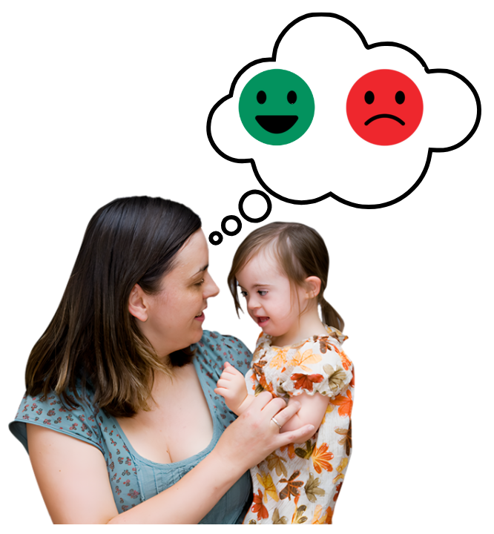 | How helpful was the Child Winter Heating Payment this winter?
 | It helped a lot | ☐
 | It helped a bit | ☐
 | It did not help very much | ☐
 | It did not help at all | ☐

Question 22

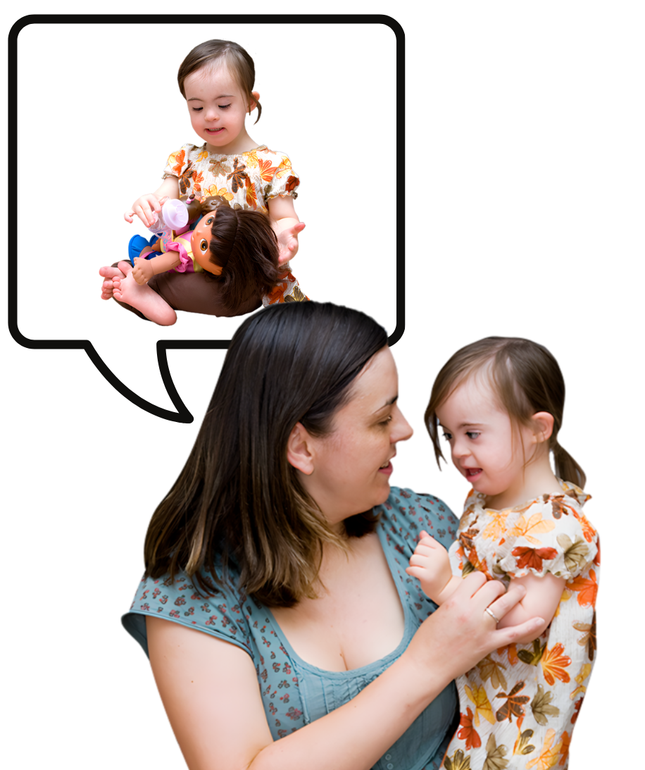 | Tell us how the Child Winter Heating Payment helped your child’s personal independence.  Type or write your answer below

Question 23

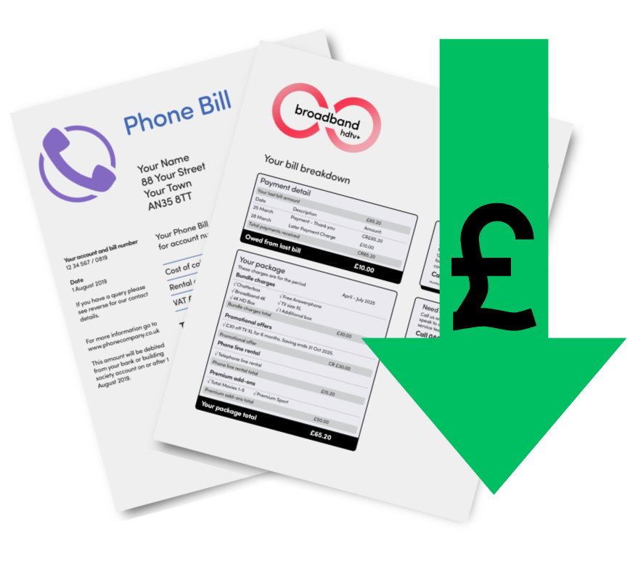 | Some phone and broadband companies offer a discount called a social tariff.  A social tariff is a cheaper price for people who do not have much money coming into their household, or who are on certain benefits.  Do you have a social tariff for your mobile phone or broadband?  Tick as many answers as you need
 | I have a social tariff for my mobile phone | ☐
 | I have a social tariff for my broadband | ☐
 | I do not have a social tariff | ☐
 | I did not know you could get a social tariff for your mobile phone or broadband | ☐

Question 24

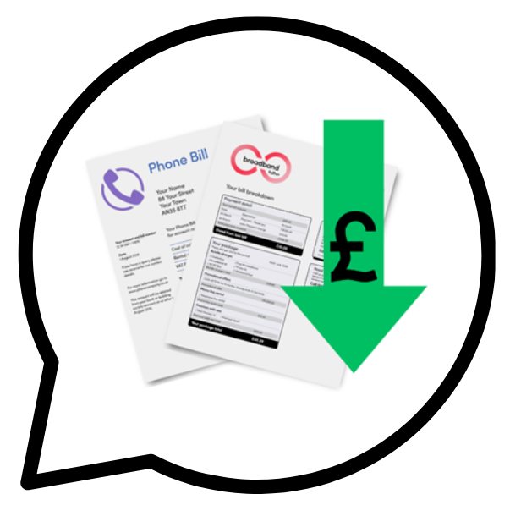 | Tell us about your experience if you have a social tariff for broadband or mobile phone.  Type or write your answer below

Question 25

 | In the last year have you asked Money Advice Service or Citizens Advice Bureau for advice about paying your bills?
 | Yes | ☐
 | No | ☐
 | I am not sure | ☐

Question 26

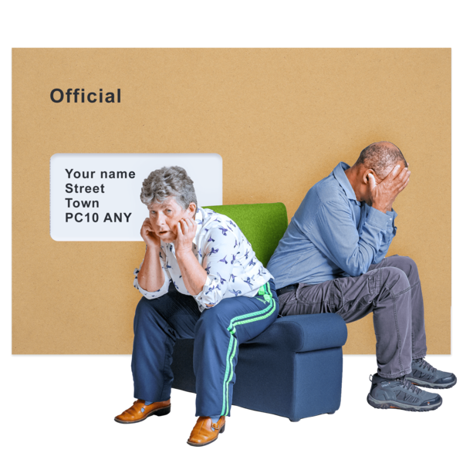 | What has been the most difficult bill to afford and pay in the last year?  Type or write your answer below

Question 27

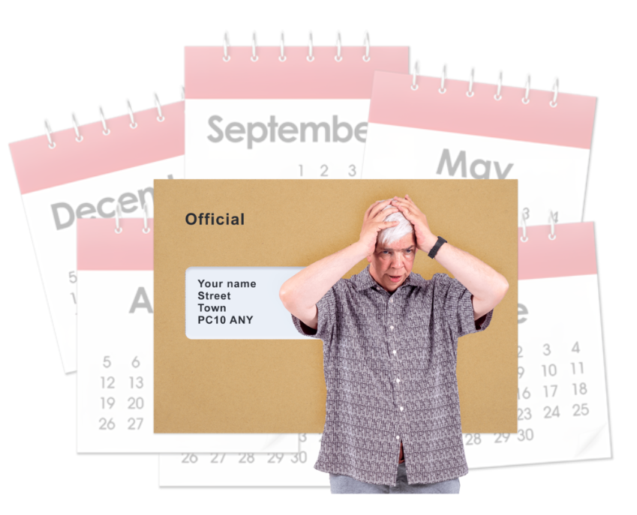 | In the last year how often have you been worried about being able to pay all your bills?
 | I have been worried about it all of the time | ☐
 | I have been worried about it most of the time | ☐
 | I have been worried about it some of the time | ☐
 | I have not been worried about it | ☐

Question 28

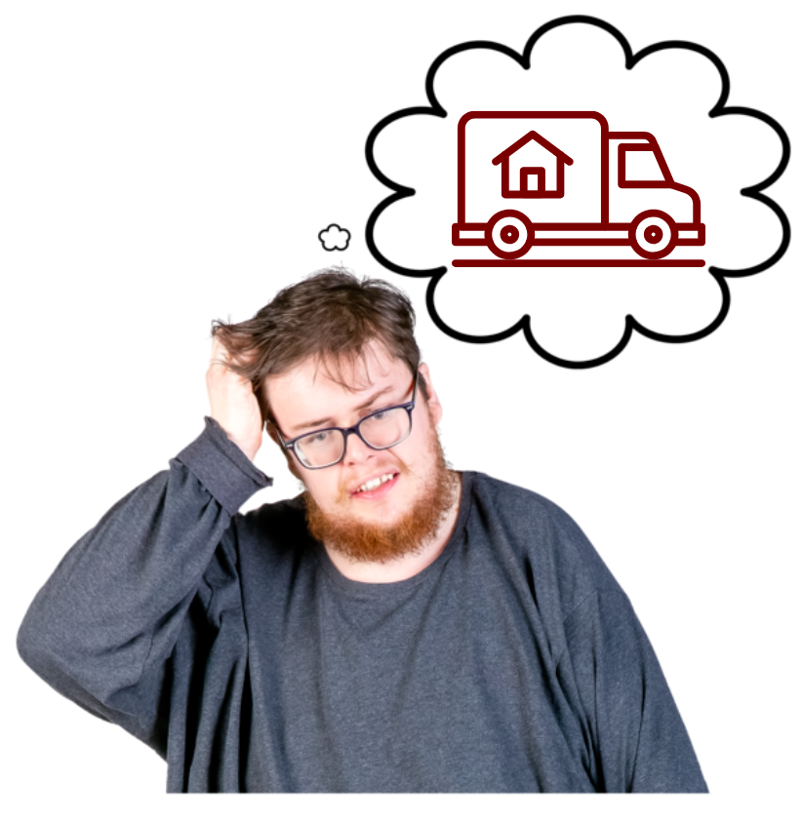 | Have you been worried in the last year that you might have to move house because housing costs were too high?  Housing costs include things like:  - bills  - rent or mortgage  - council tax
 | Yes | ☐
 | No | ☐
 | I am not sure | ☐


