

Housing survey
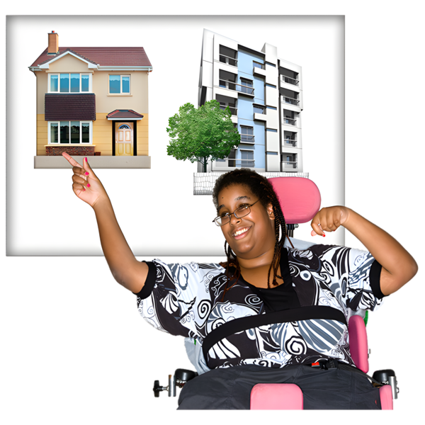
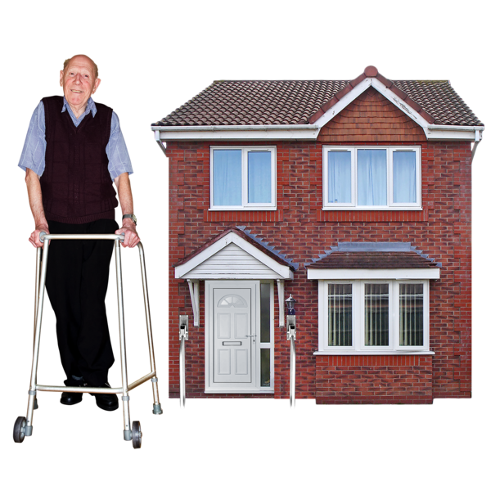

Easy Read


About this document

 | This is an Easy Read document.
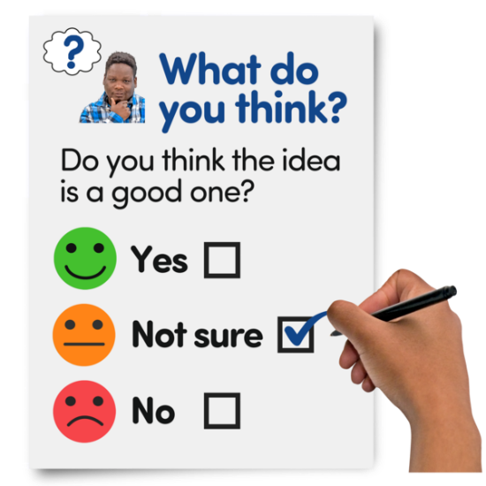 | It is a survey.  A survey means a set of questions.
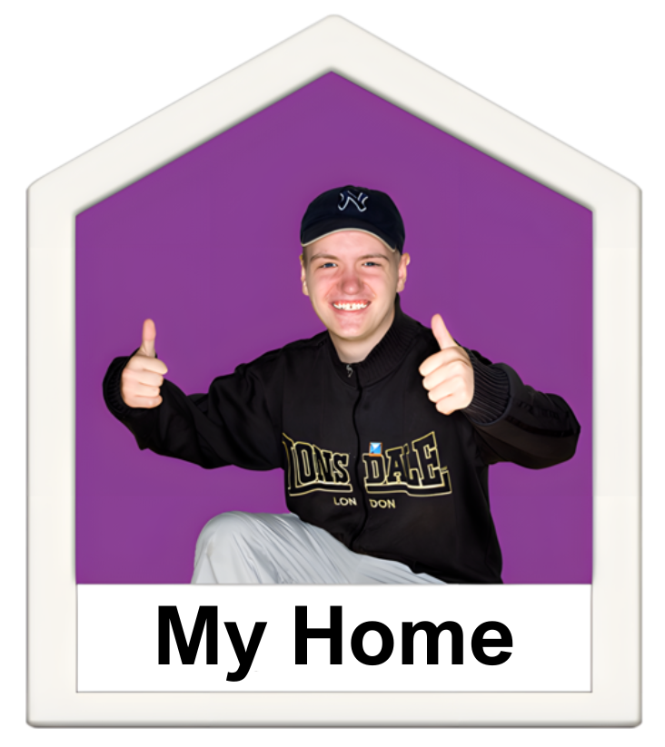 | The questions ask about your home and any changes made to meet your needs.
 | We want to understand your experiences and how having the right changes in your house helps you live independently.

Our questions

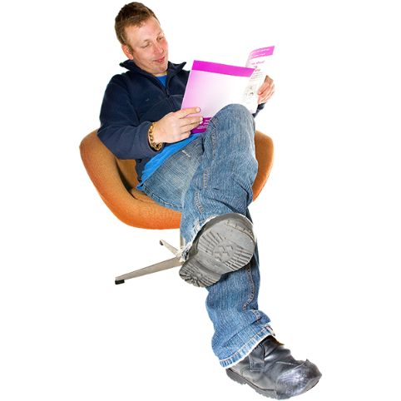 | Answer our questions to tell us what you think.
 | If you are answering on a screen, you can click the little box next to your answer.  A tick will appear.  If you change your mind you can click it again.
 | If you are typing your answers the space will grow as you type.
 | If you are writing your answers on a paper copy use the Enter button to grow the spaces before you print the pages.

Question 1

 | Are you answering this survey for yourself or for someone else?
 | For myself | ☐
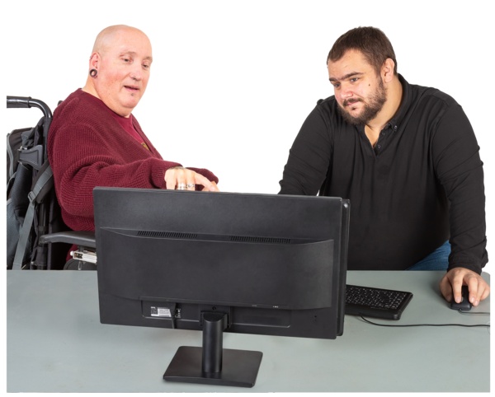 | For someone else | ☐

Question 2

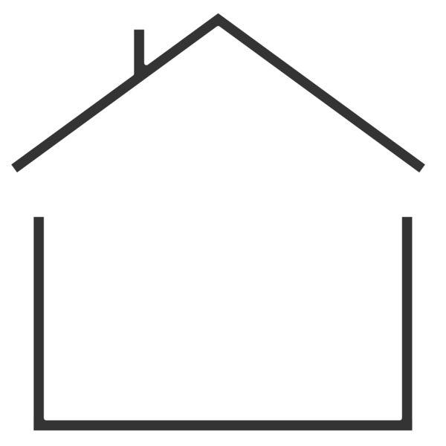 | Who do you live with?
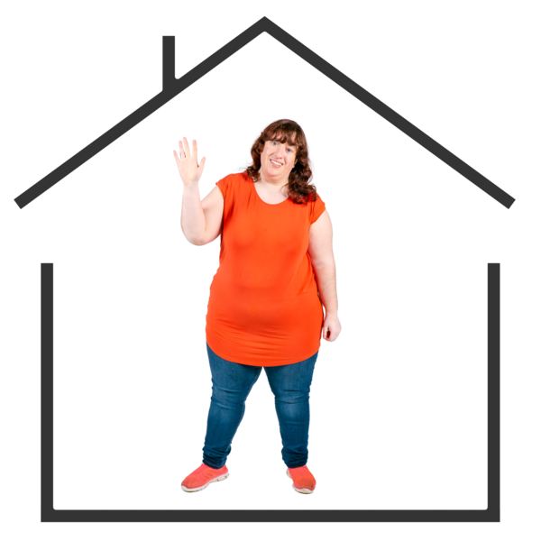  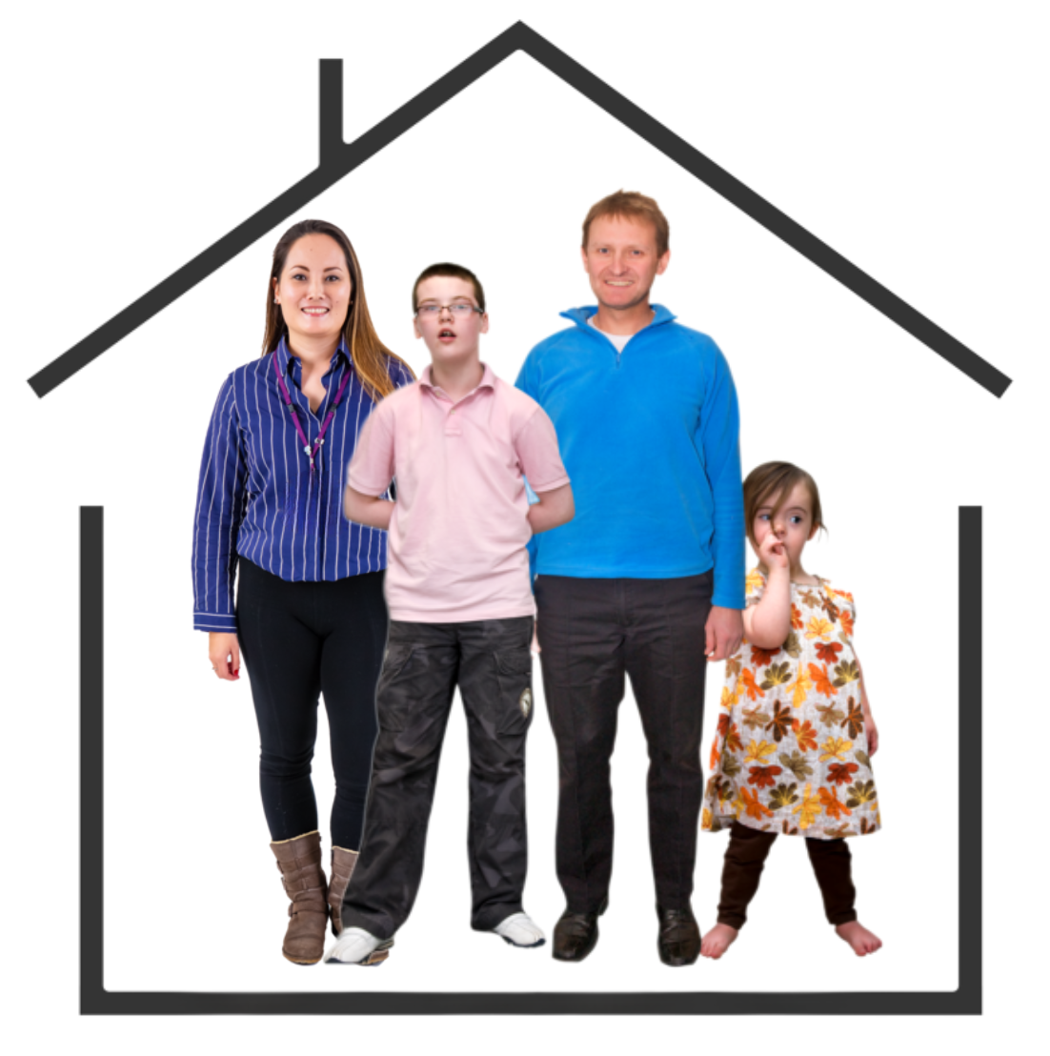  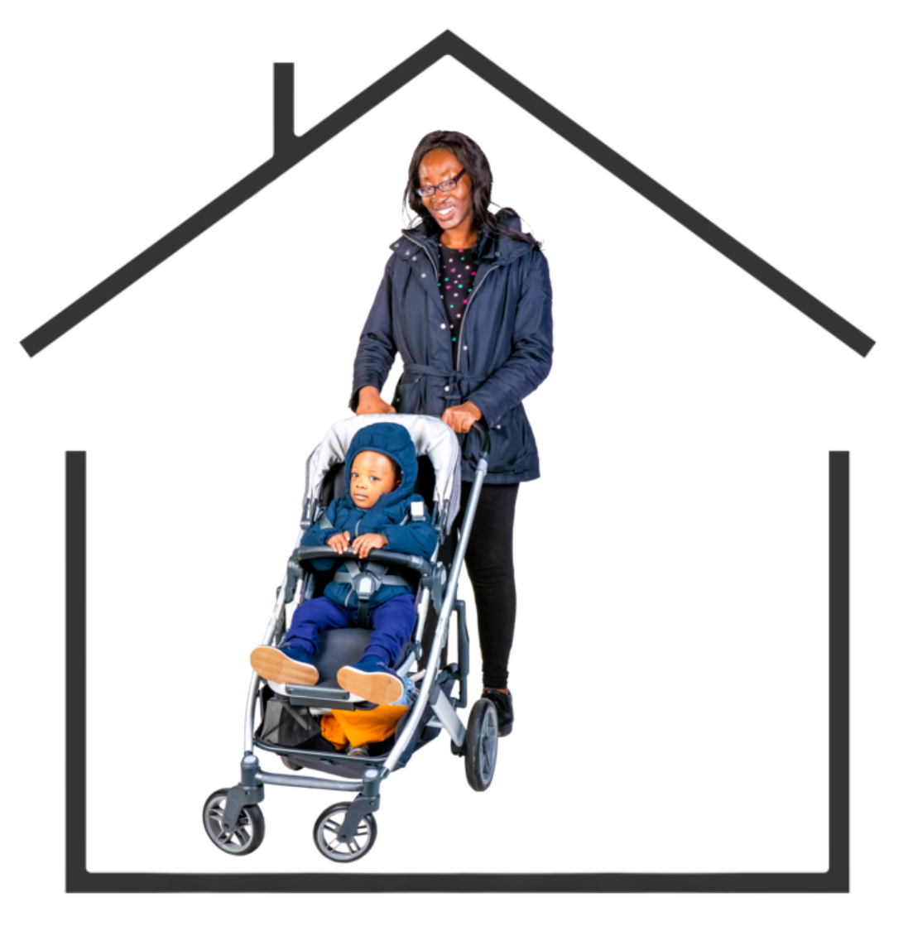 | I live alone | ☐
 | I live with my partner, husband or wife | ☐
 | I live with my partner, husband, wife and child | ☐
 | I live with my partner, husband or wife and children | ☐
 | I live with my parents | ☐
 | I live with my friend or flatmate | ☐
 | I am a single parent | ☐

Question 3

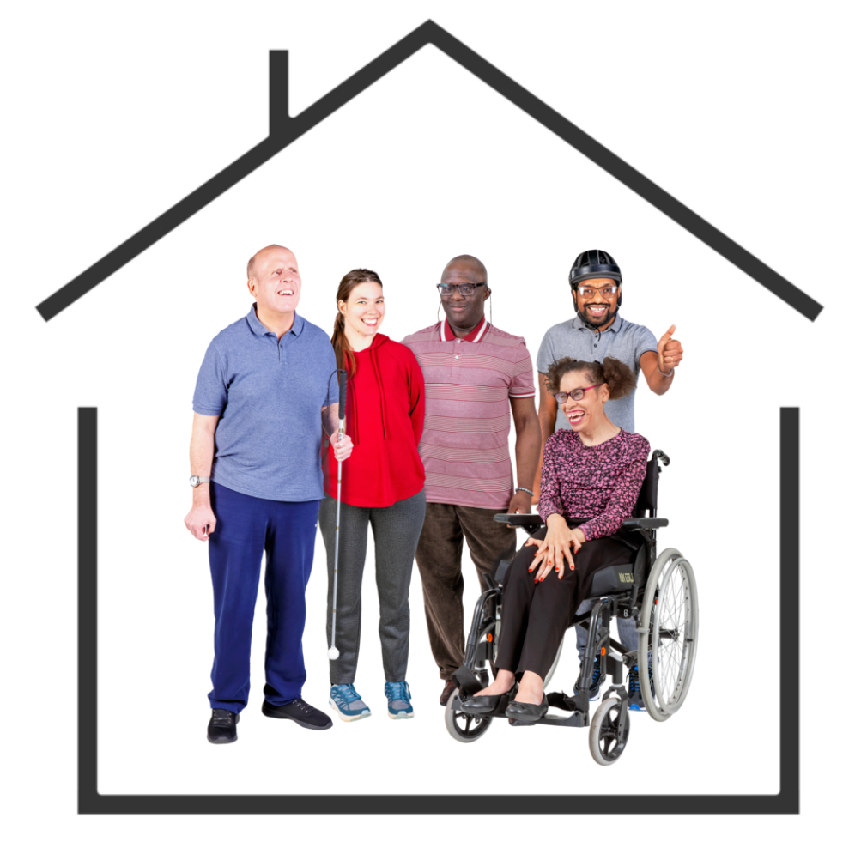 | How many people in your home are disabled people?  Tick as many answers as you need.
    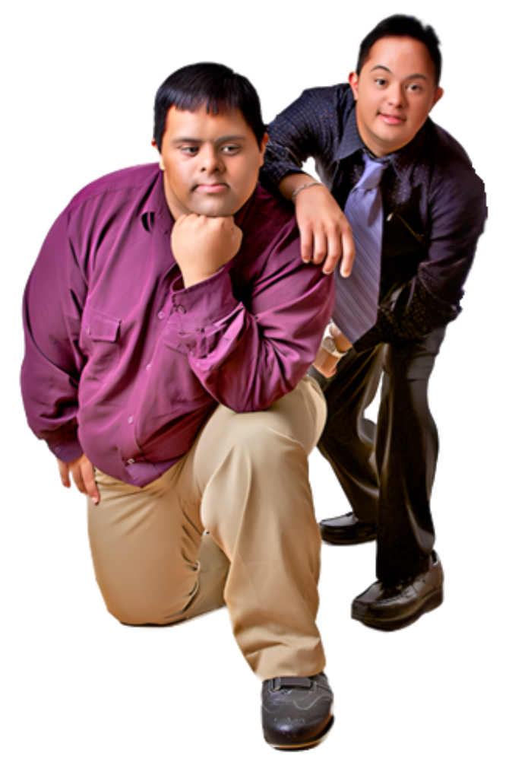 | I am a disabled person. | ☐
 | My partner, husband or wife is a disabled person. | ☐
 | One child is a disabled person. | ☐
 | More than one child is a disabled person. | ☐
 | My friend or flatmate is a disabled person. | ☐
 | I live in student halls. | ☐

Question 4

 | Which council area do you live in?  Type or write your answer below:

Question 5

 | What location best describe where you live?
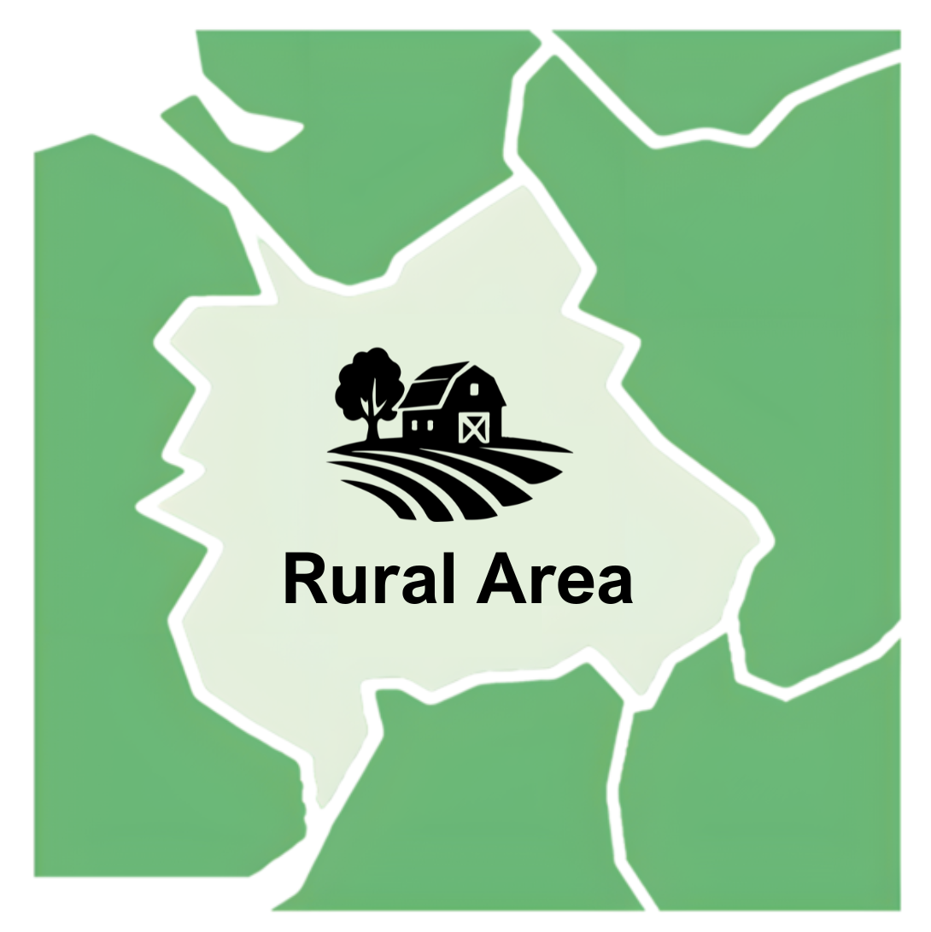   | I live in a city. | ☐
 | I live in a town. | ☐
 | I live in a rural area. | ☐
 | I live in a village. | ☐
 | I live on an island. | ☐

Question 6

 | Which of these best describe your home?
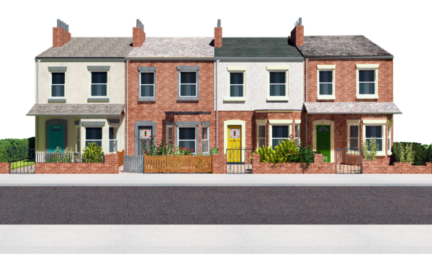  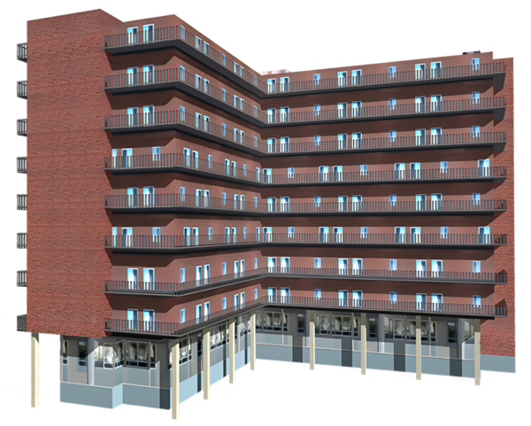  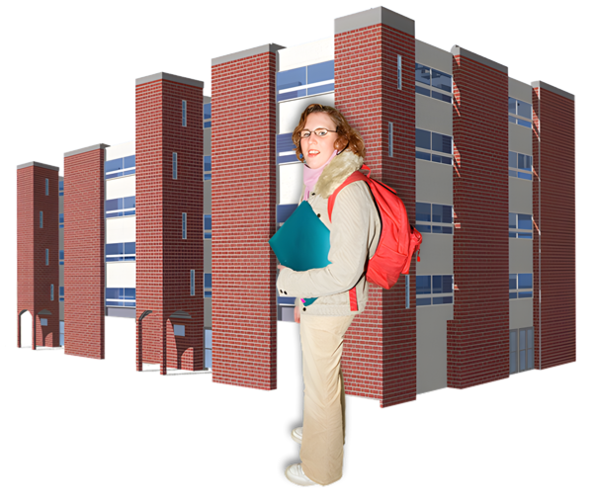 | I live in a flat. | ☐
 | I live in a single-storey house. | ☐
 | I live in a house joined to others on both sides. | ☐
 | I live in a house joined to 1 other house. | ☐
 | I live in a house that is not joined to others. | ☐
 | I live in student halls. | ☐

Question 7

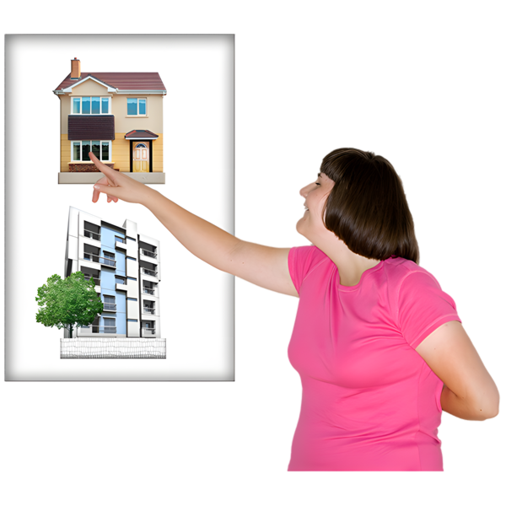 | Which of these are true about your home?
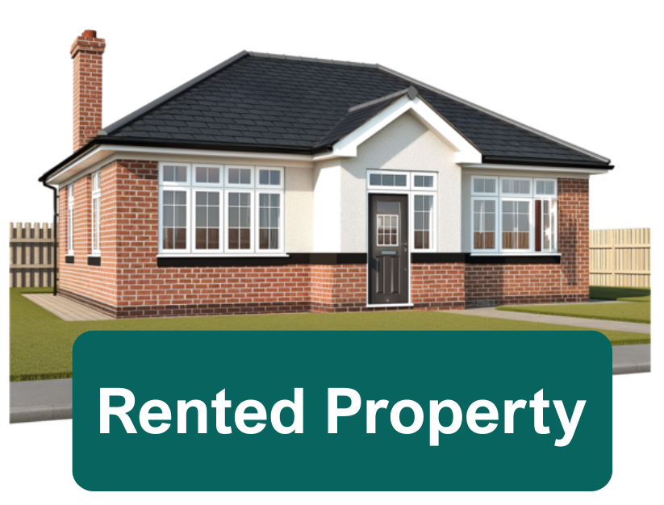  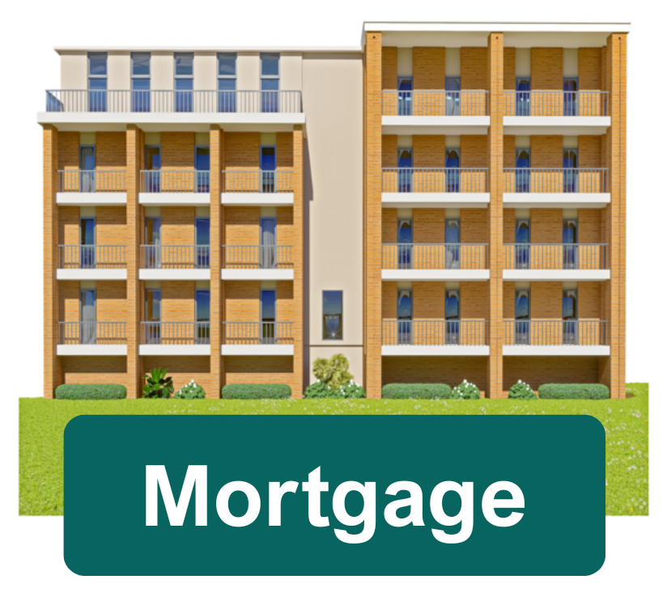 | My home is a council house. | ☐
 | My home is rented privately. | ☐
 | I rent from a housing association. | ☐
 | I rent in student halls. | ☐
 | I live in a home that I or someone else owns and there is a mortgage on the home.  A mortgage is a loan to buy a home that you need to pay back. | ☐
 | I live in a home that I or someone else owns and there is no mortgage on the home. | ☐

Question 8

 | Has your home been changed to support your needs?
 | Yes | ☐
 | No | ☐
 | I am not sure | ☐

Question 9

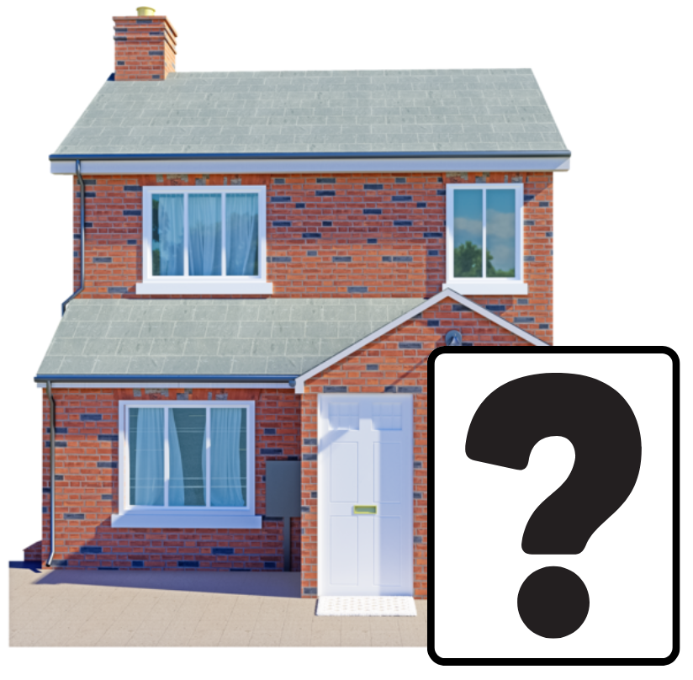 | Does your home have any of these changes to help with daily life?  Tick as many answers as you need
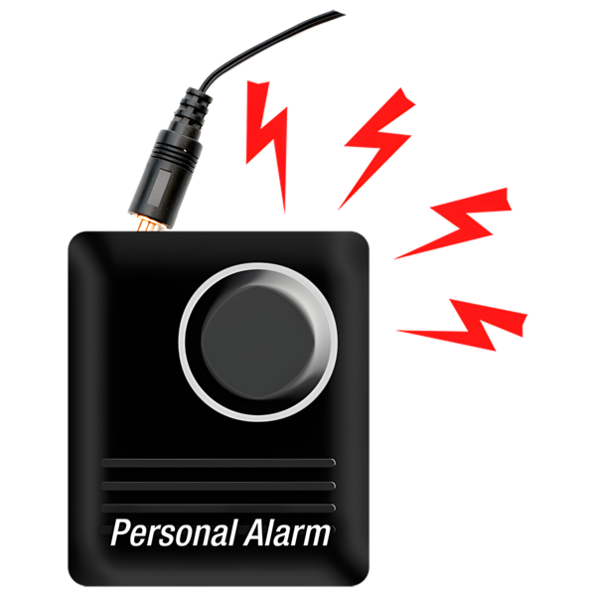  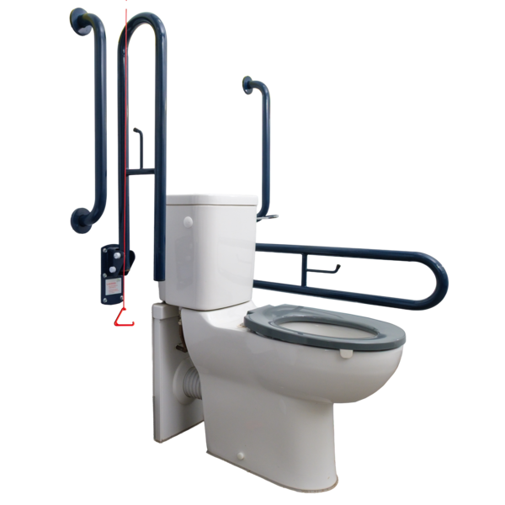 | Ramps | ☐
 | Wider doors | ☐
 | Light switches or plug sockets moved to easier places | ☐
 | Personal alarm system | ☐
 | Stairlift | ☐
 | Lift between floors | ☐
 | Handrails | ☐
 | Kitchen changed to meet your needs | ☐
 | Bathroom or shower changed to meet your needs | ☐
 | Toilet changed to meet your needs | ☐

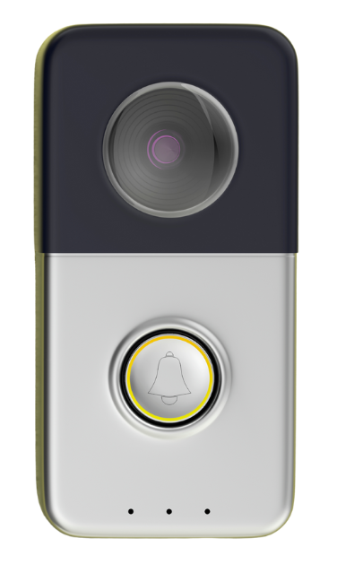 | Door entry phone | ☐
 | Extra room or extension to meet a disabled person’s needs | ☐
 | Special furniture | ☐
 | Other  Please type or write what below: | ☐

Question 10

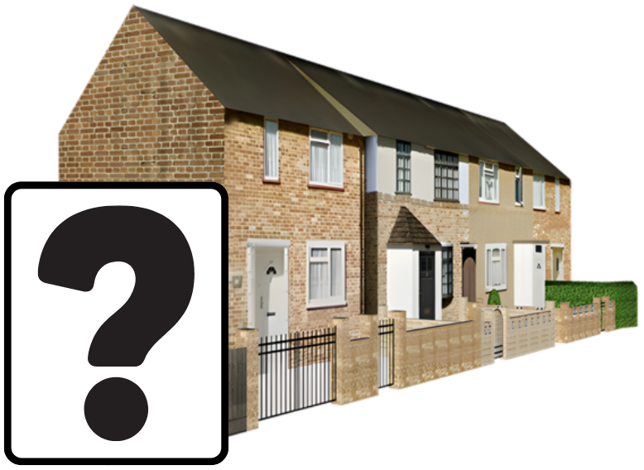 | Is your home missing any of these changes needed to help with daily life?  Tick as many answers as you need
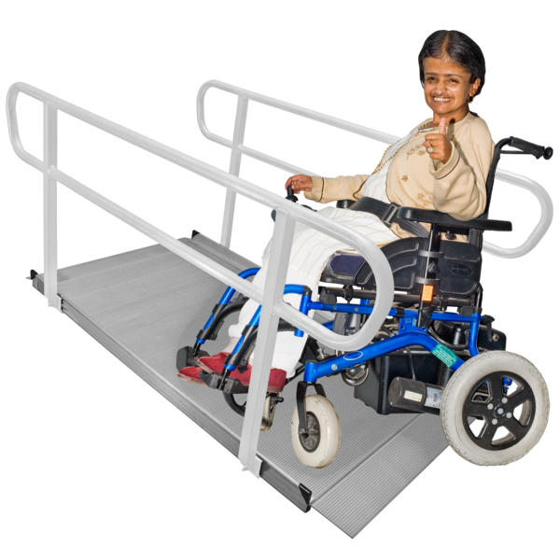 | Ramps | ☐
 | Wider doors | ☐
 | Light switches or plug sockets moved to easier places | ☐
 | Personal alarm system | ☐

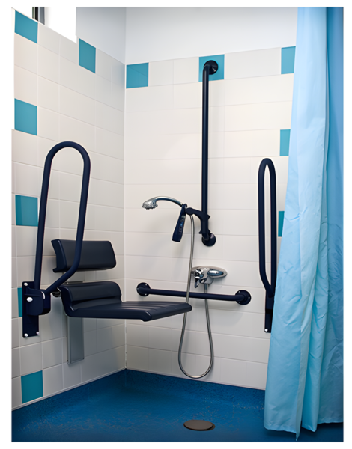    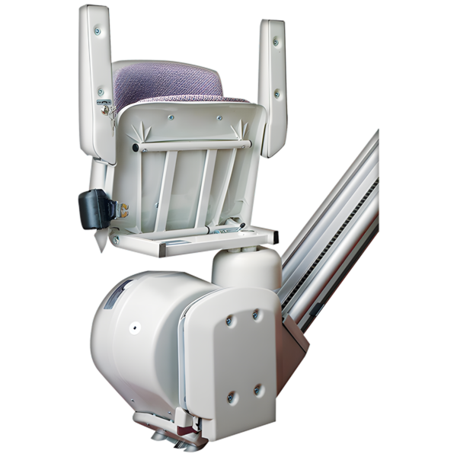 | Stairlift | ☐
 | Lift between floors | ☐
 | Handrails | ☐
 | Kitchen changed to meet your needs | ☐
 | Bathroom or shower changed to meet your needs | ☐
 | Toilet changed to meet your needs | ☐
 | Door entry phone | ☐
 | Extra room or extension to meet a disabled person’s needs | ☐
 | Special furniture | ☐
 | Other  Please type or write what below: | ☐

Question 11

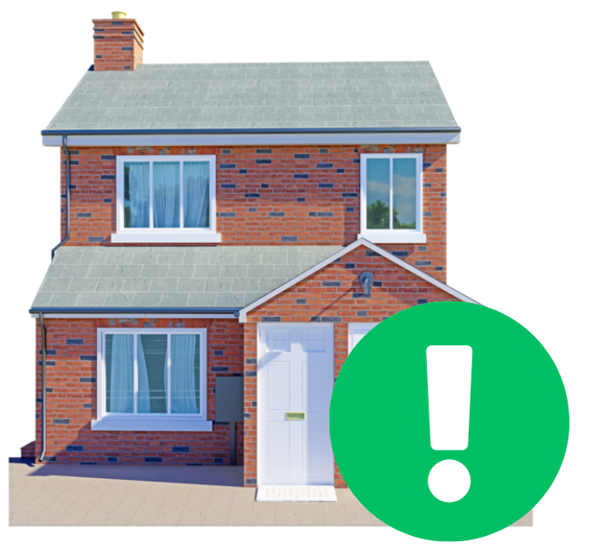 | Have you made any changes in your home to help with daily life in the last year?
 | Yes | ☐
 | No | ☐
 | I am not sure | ☐

Question 12

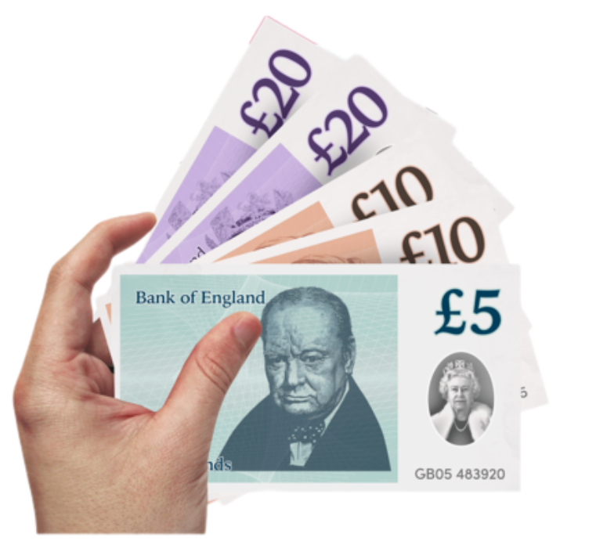 | How did you pay for these changes to your home?  Tick as many answers as you need.
   | I got a grant. | ☐
 | I used my own money. | ☐
 | I got a loan. | ☐
 | My landlord paid. | ☐
 | I would rather not say. | ☐

Question 13

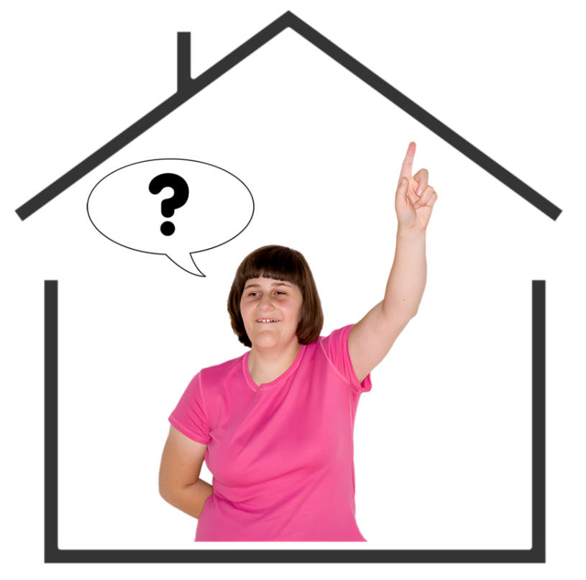 | How well does your home work for you?
 | It works very well. | ☐
 | It works quite well. | ☐
 | It does not work very well. | ☐
 | It does not work at all. | ☐



