

Local services and getting about

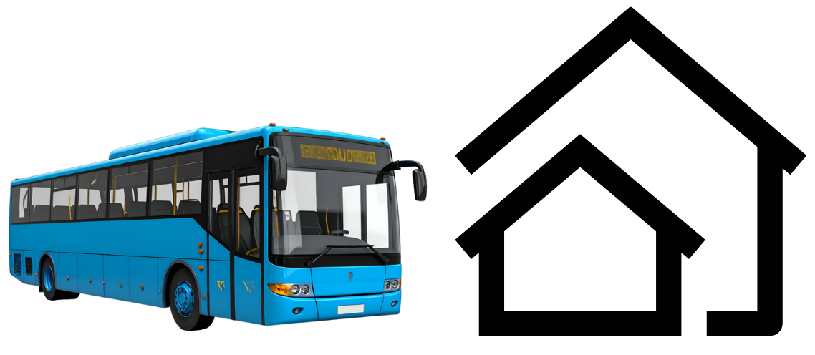

Easy Read


About this document
 | This is an Easy Read document.
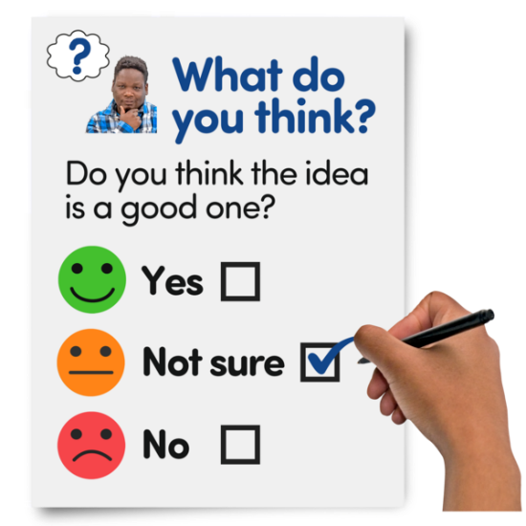 | It is a survey.  A survey means a set of questions.
 | The questions ask about the services you use where you live and your experiences when using them.
 | We want to understand any problems and how the services where you live affect you.

Our questions
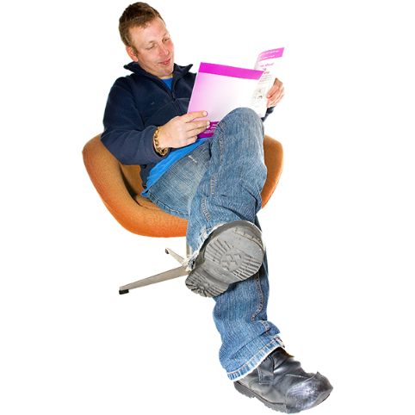 | Answer our questions to tell us what you think.
 | If you are answering on a screen, you can click the little box next to your answer.  A tick will appear.  If you change your mind you can click it again.
 | If you are typing your answers the space will grow as you type.
 | If you are writing your answers on a paper copy use the Enter button to grow the spaces before you print the pages.

Question 1
 | Are you answering this survey for yourself or for someone else?
 | For myself | ☐
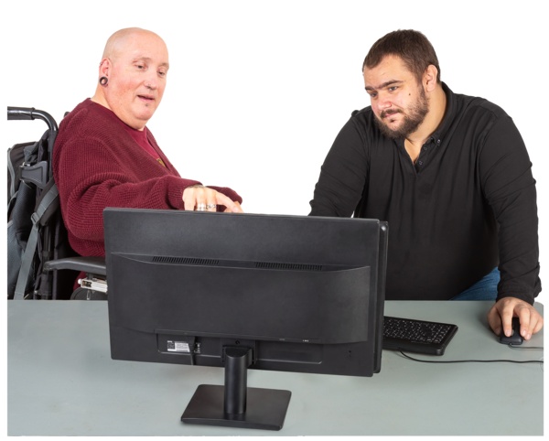 | For someone else | ☐

Question 2
 | Who do you live with?
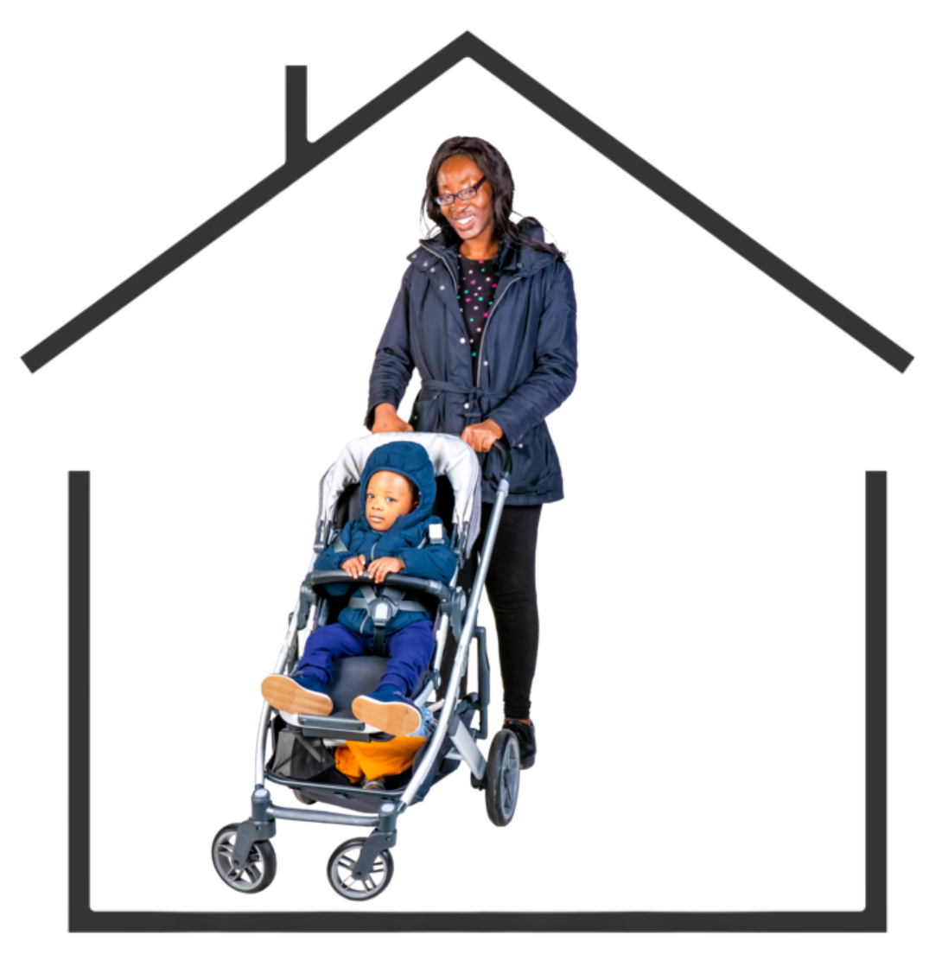  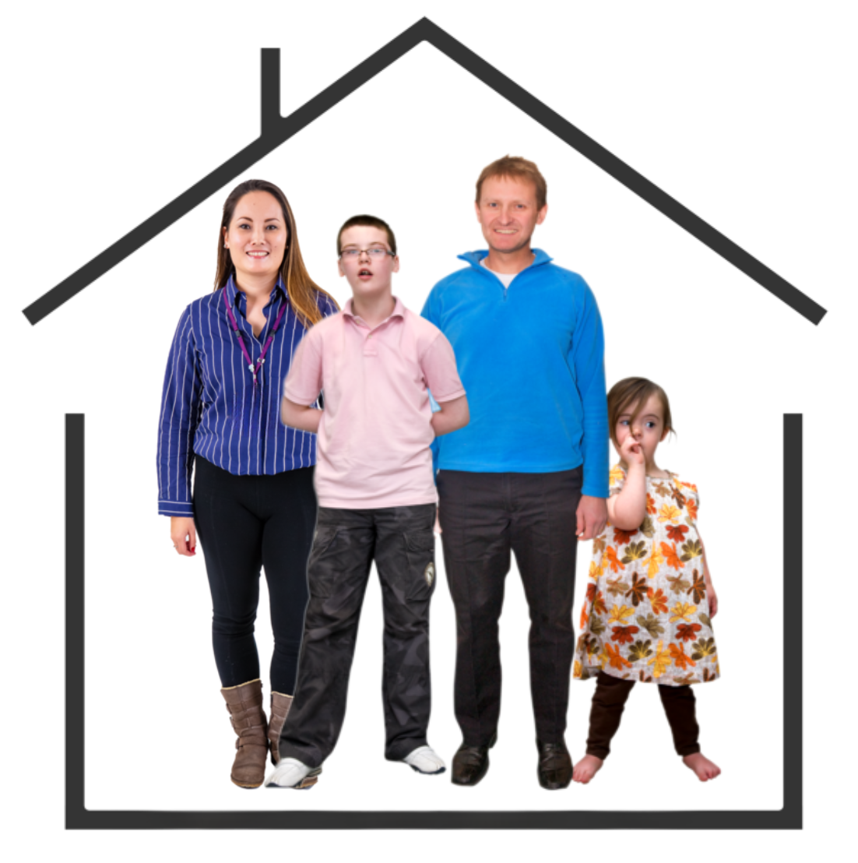   | I live alone | ☐
 | I live with my partner, husband or wife | ☐
 | I live with my partner, husband, wife and child | ☐
 | I live with my partner, husband or wife and children | ☐
 | I live with my parents | ☐
 | I live with my friend or flatmate | ☐
 | I am a single parent | ☐

Question 3
 | How many people in your home are disabled people?  Tick as many answers as you need.
   | I am the only disabled person in my home. | ☐
 | My partner, husband or wife is a disabled person. | ☐
 | One child is a disabled person. | ☐
 | More than one child is a disabled person. | ☐
 | My friend or flatmate is a disabled person. | ☐

Question 4
 | Which council area do you live in?  Type or write your answer below.

Question 5
 | What location best describe where you live?
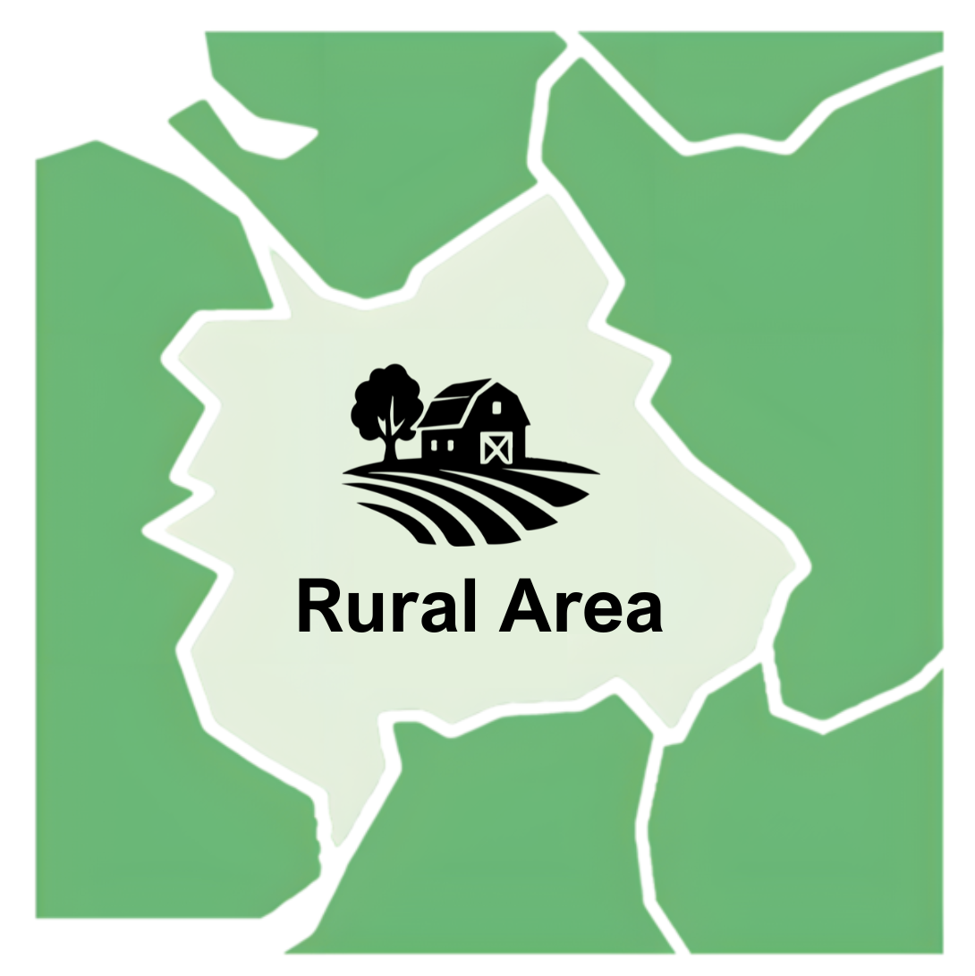  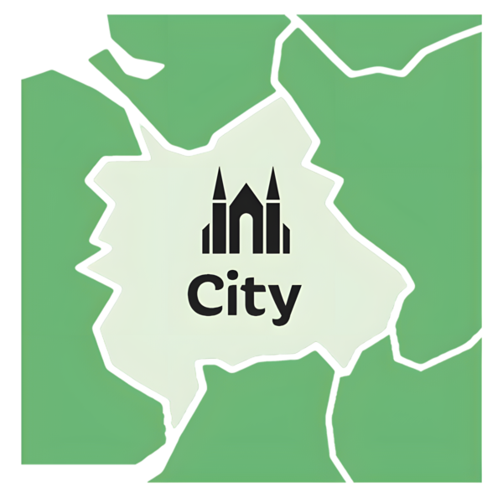 | I live in a city. | ☐
 | I live in a town. | ☐
 | I live in a rural area. | ☐
 | I live in a village. | ☐
 | I live on an island. | ☐

Question 6
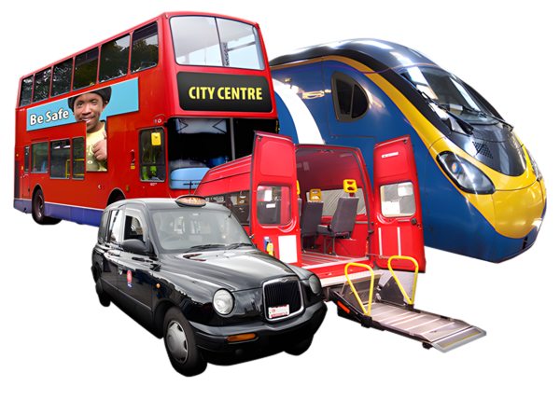 | What public transport do you usually use to get around?  Tick as many answers as you need.
  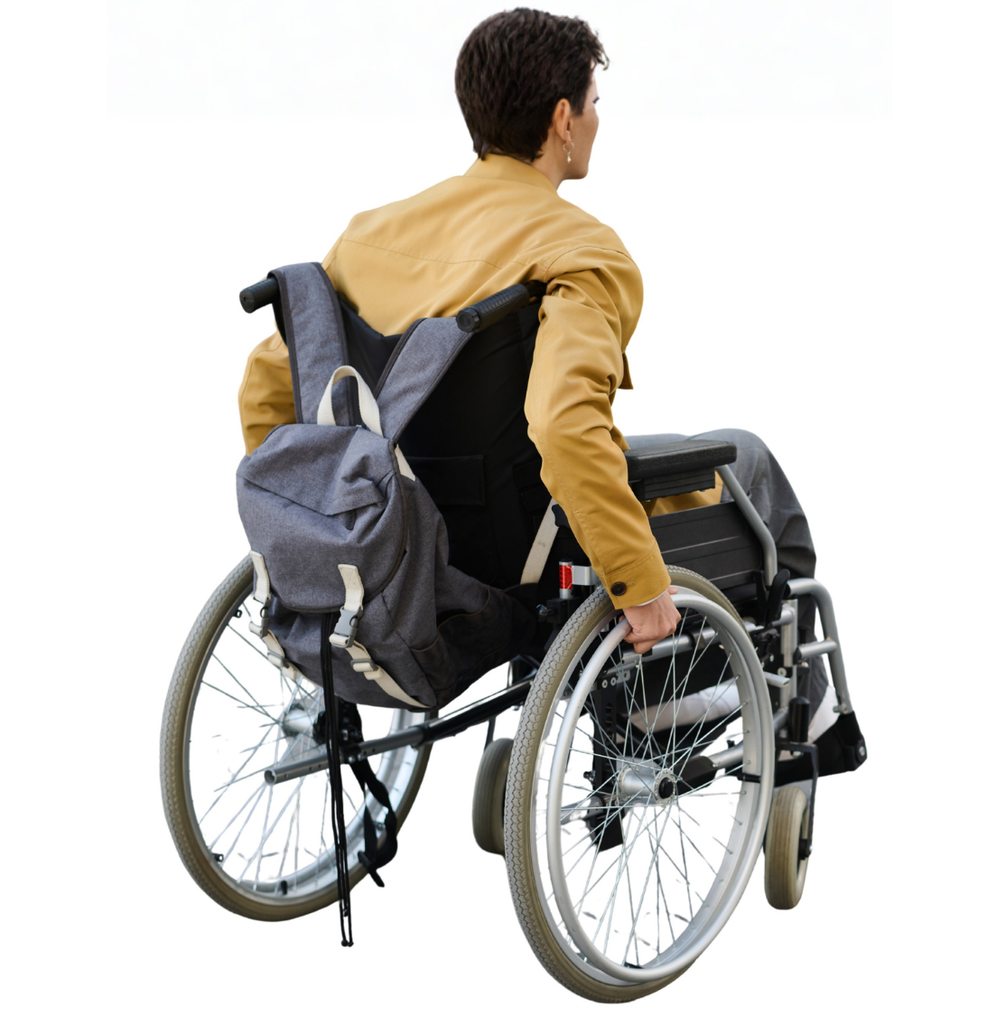  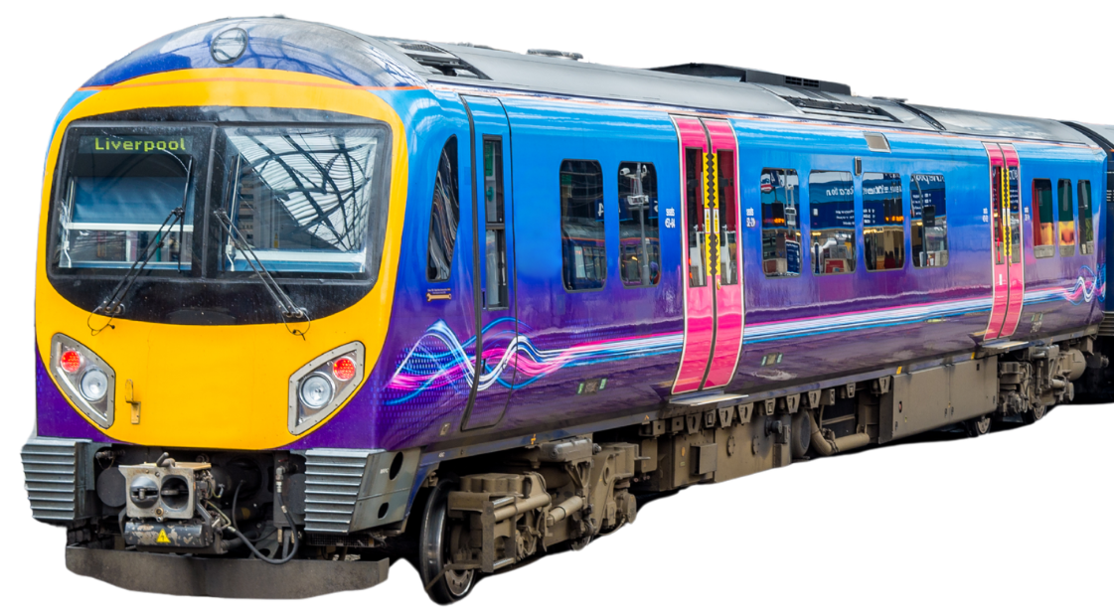 | Bus | ☐
 | Train | ☐
 | Car | ☐
 | Ferry | ☐
 | Plane | ☐
 | Walk | ☐
 | Cycle | ☐
 | Wheel | ☐

Question 7
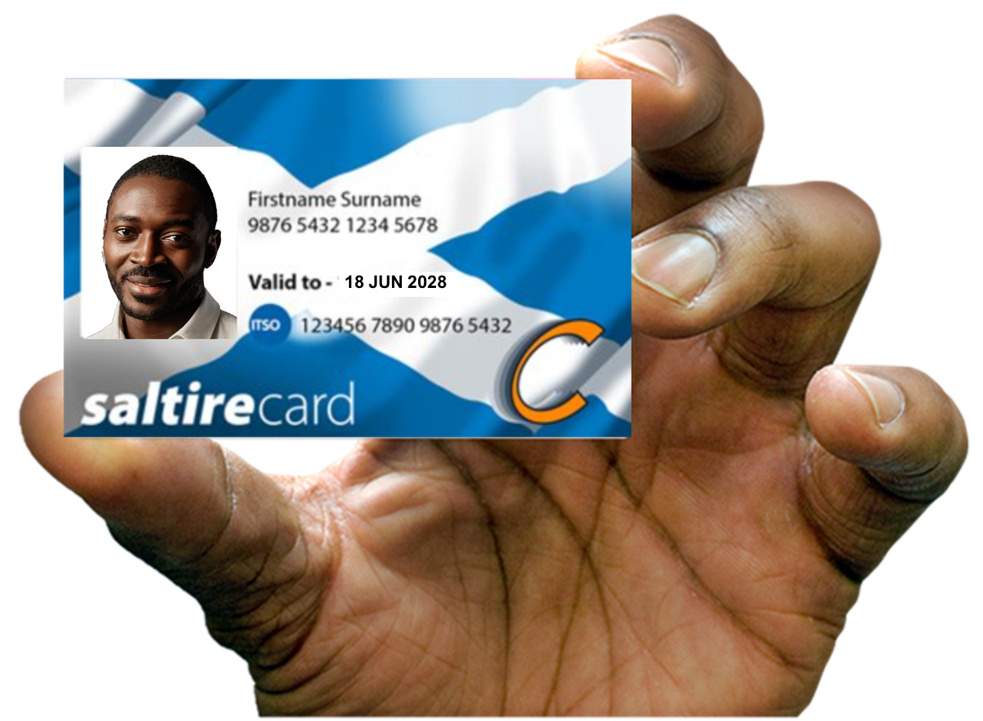 | Do you have a National Entitlement Card (NEC)?  This is also called a disabled person’s bus pass.
   | Yes | ☐
 | No | ☐
 | I am not sure | ☐

Question 8
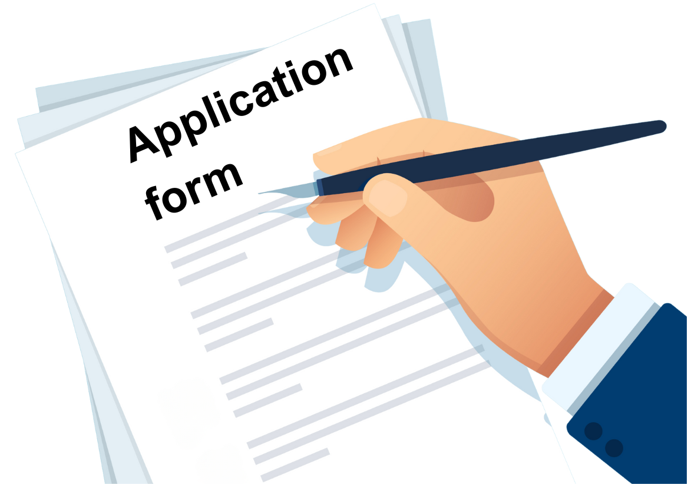 | Did you have any problems when you applied for your bus pass?  Tell us about any problems you had by typing or writing below.

Question 9
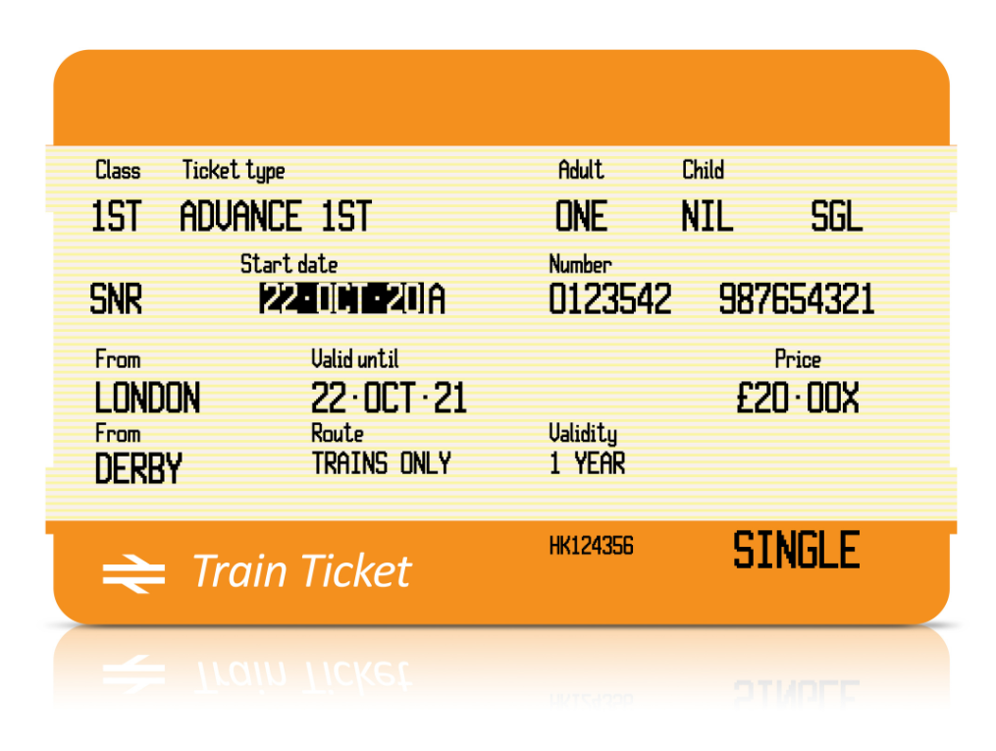 | Where do you get your train ticket when you are using your NEC card?
 | I get it on the train | ☐
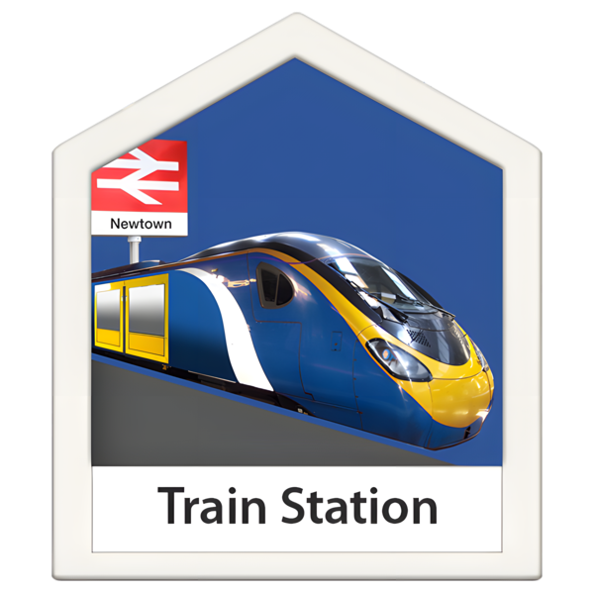 | I get it from the ticket office | ☐

Question 10
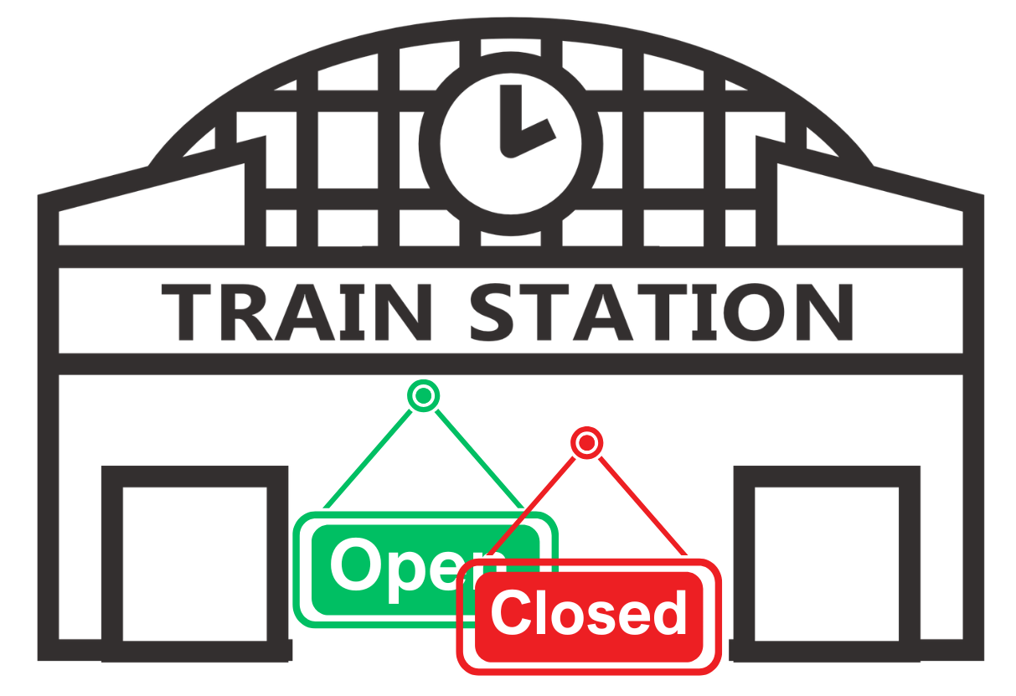 | Has the ticket office at your local train station changed opening hours in the last year?
 | Yes | ☐
 | No | ☐
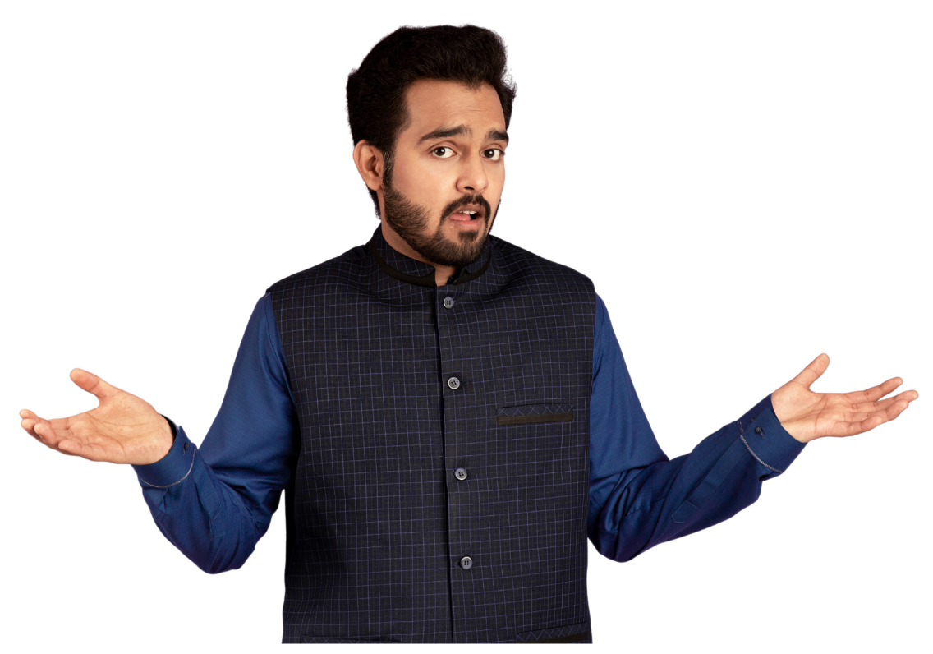 | I am not sure | ☐

Question 11
How have changes to ticket office opening hours affected your ability to buy a ticket?
Tell us by writing or typing below.

Question 12
 | Have changes to ticket office opening hours affected your ability to use passenger assist when travelling by train?
 | No | ☐
 | I do not use passenger assist | ☐
 | Yes  Tell us what happened by writing or typing below. | ☐

Question 13
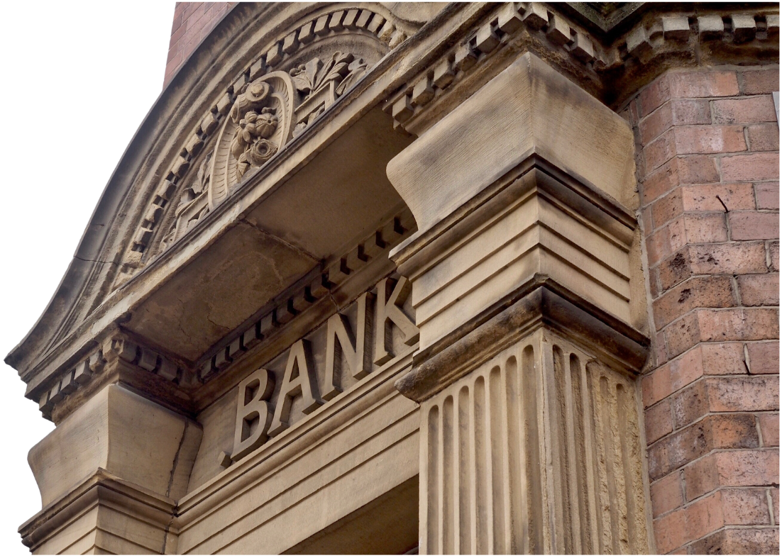 | How do you usually use your bank?
 | I go to the bank branch | ☐
 | I use online banking | ☐
 | It depends what I need to do | ☐

Question 14
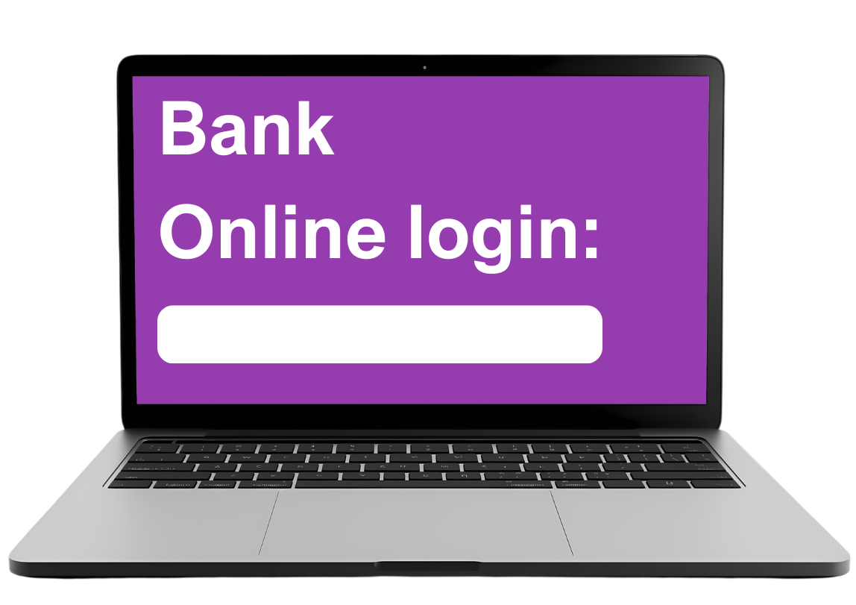 | How confident do you feel managing your money online?
   | I feel very confident | ☐
 | I feel quite confident | ☐
 | I do not feel confident | ☐

Question 15
 | Has your local bank branch closed in the last 3 years
   | It has closed in the last 3 years | ☐
 | It closed more than 3 years ago | ☐
 | It is going to close soon | ☐
 | It has not closed | ☐
 | I am not sure | ☐

Question 16
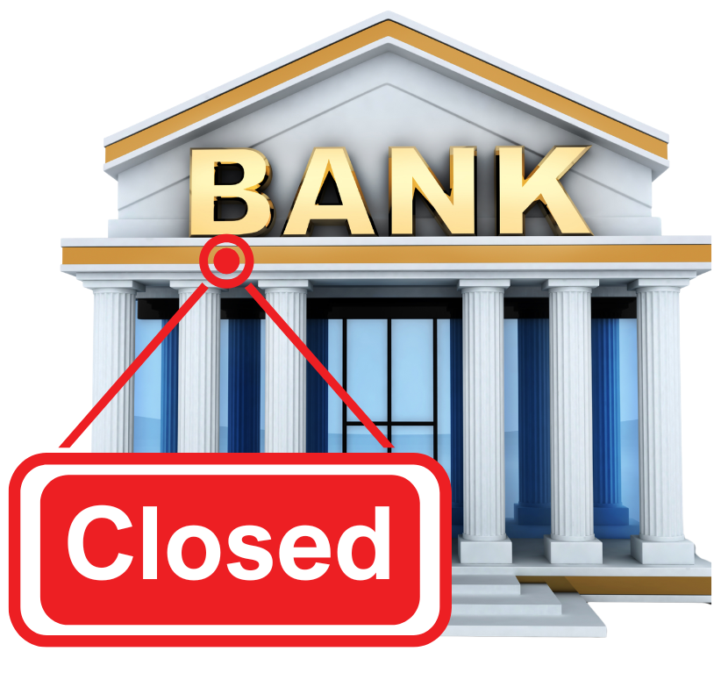 | If your local banch bank has closed how has this affected you?  Write or type your answer below.

Question 17
 | A Priority Register is a service that means you can get extra help or support with your gas and electricity when you need it.  Are you on a Priority Register?
 | Yes | ☐
 | No | ☐
 | I am not sure | ☐

Question 18
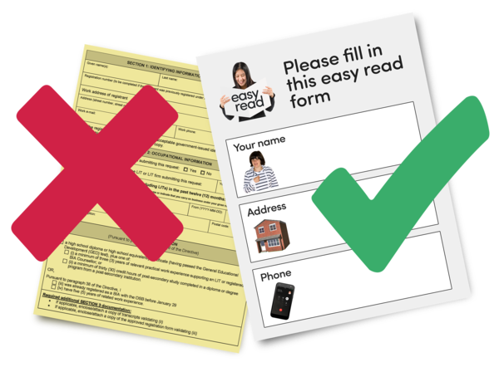 | When contacting your gas or electricity supplier do you get information in an accessible format?
 | Yes | ☐
 | No | ☐
 | I am not sure | ☐

Question 19
 | What accessible formats do you get information in?
   | Easy Read | ☐
 | Braille | ☐
 | Large Print | ☐
 | Textphone | ☐

Question 20
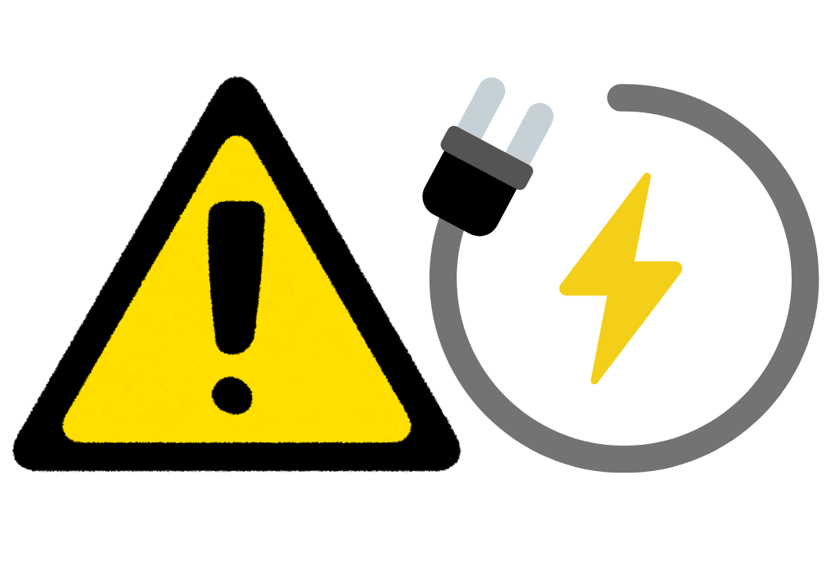 | If you have had problems with your electricity and gas were you able to get emergency power?
 | Yes | ☐
 | No | ☐
 | I am not sure | ☐

Question 21
 | A warm space is a place in your community you can go to keep warm during the winter.  Is there a warm space in your community?
 | Yes | ☐
 | No | ☐
 | I am not sure | ☐

Question 22
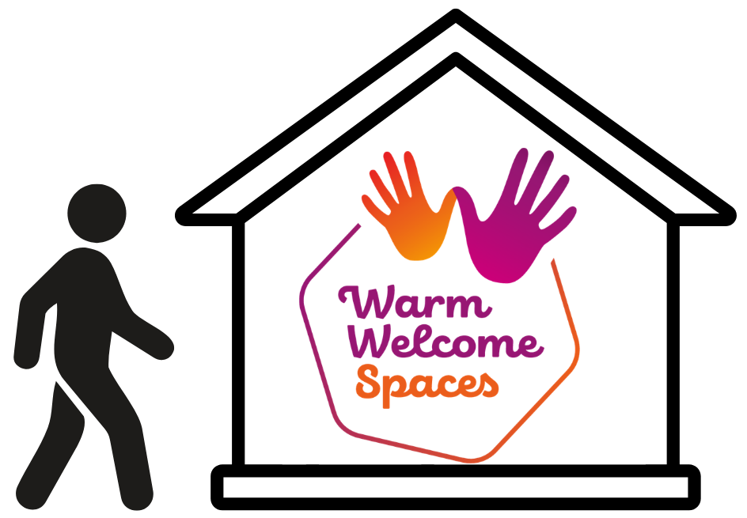 | How often do you go to the warm space in your community?
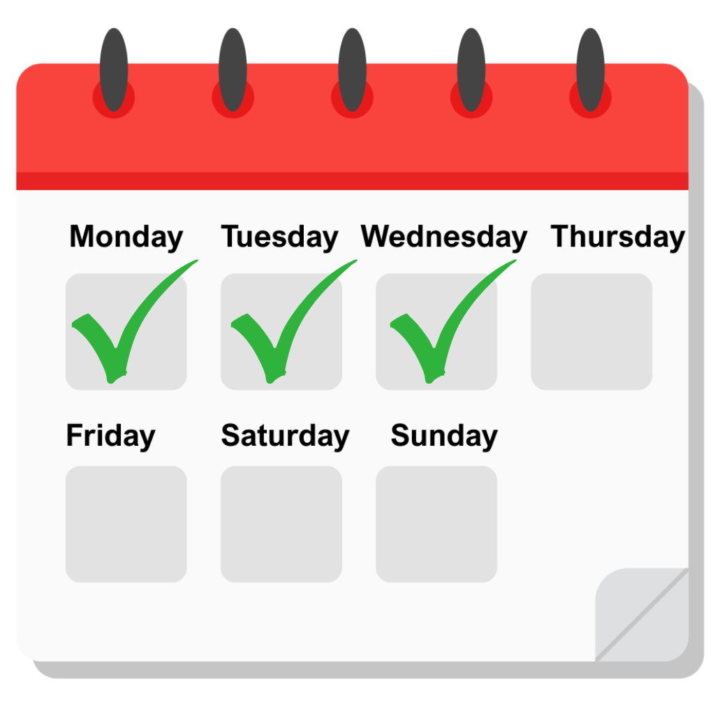 | Every day | ☐
 | A few days a week | ☐
 | 5 days a week | ☐
 | Never | ☐

Question 23
 | Why do you go to the warm space?  Tell us by writing or typing below.

Question 24
 | Are you offered food at the warm space?
 | Yes | ☐
 | No | ☐
 | I am not sure | ☐

Question 25
 | How does going to the warm space affect how lonely you feel?
 | It makes me feel a lot less lonely | ☐
 | It makes me feel a bit less lonely | ☐
 | It makes me feel a bit more lonely | ☐
 | It makes me feel a lot more lonely | ☐
 | It does not affect how loney I feel | ☐


