


Active Travel Survey


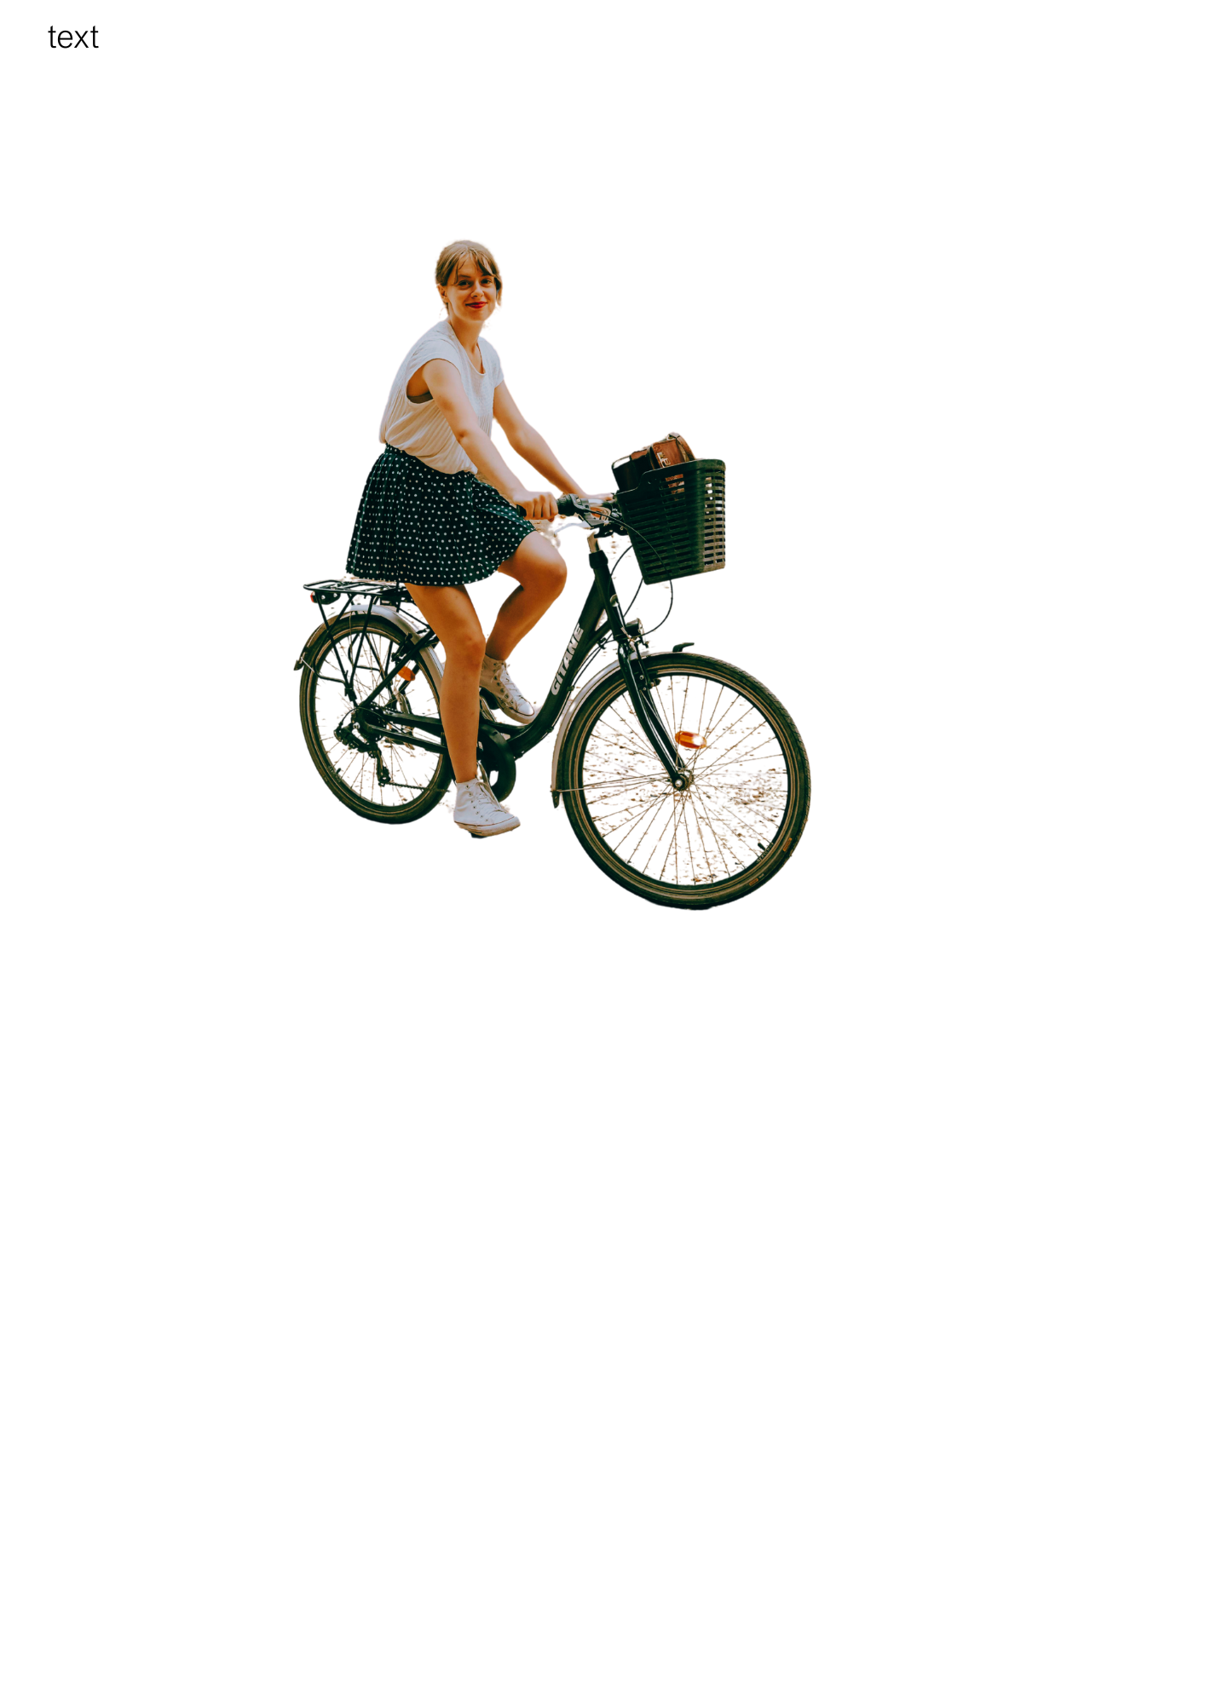
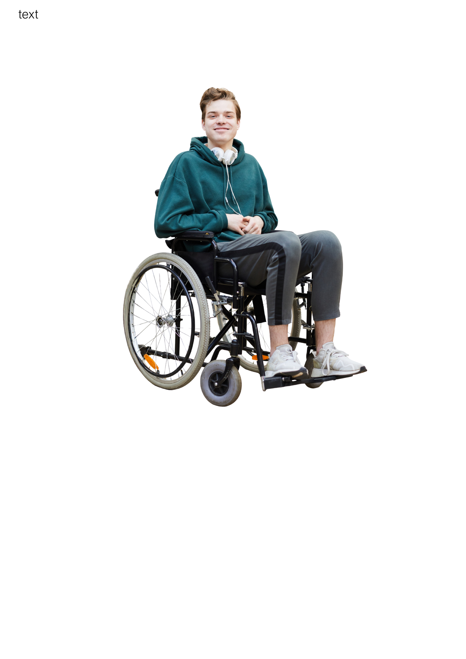

Easy Read


About this document

 | This is an Easy Read document.
 | It is a survey.  A survey means a set of questions.
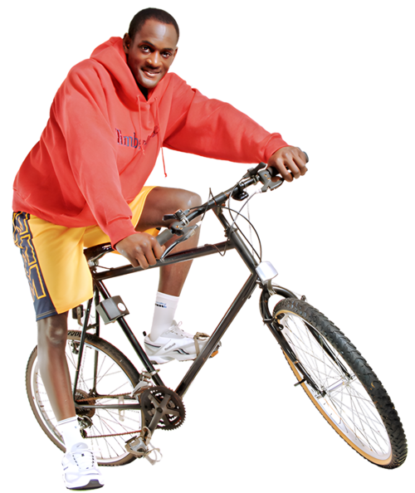  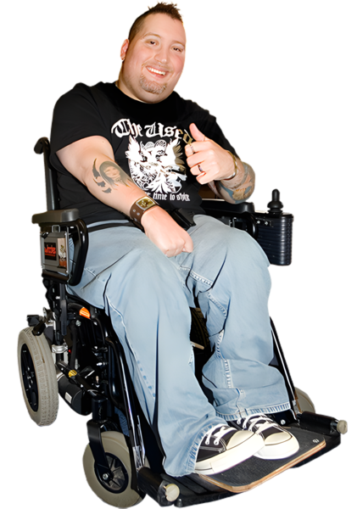  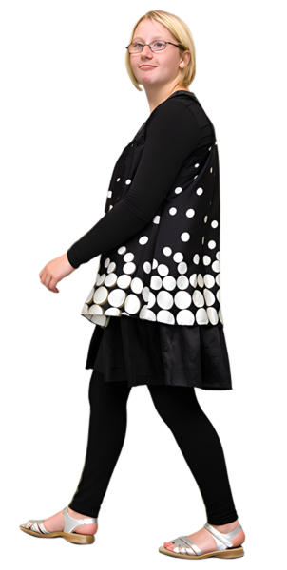 | The questions ask you about Active Travel.  Active Travel means making a journey by  - walking  - wheeling  - cycling  Active Travel is when you make a journey these ways to get where you need to go.  This is different from exercising.

Our questions

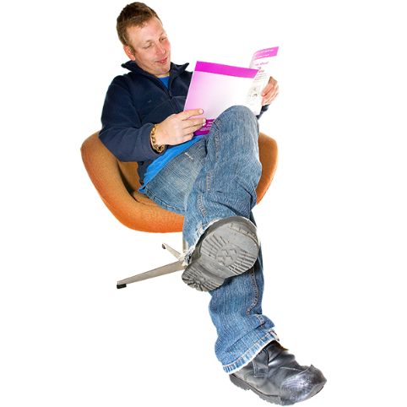 | Answer our questions to tell us what you think.
 | If you are answering on a screen, you can click the little box next to your answer.  A tick will appear.  If you change your mind you can click it again.
 | If you are typing your answers the space will grow as you type.
 | If you are writing your answers on a paper copy use the Enter button to grow the spaces before you print the pages.

Question 1

 | Are you answering this survey for yourself or for an organisation?
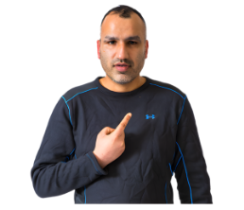 | For myself | ☐
 | For an organisation | ☐

Question 2

 | Which local council area do you live in?  If you are an organisation, please also tell us your organisation’s name.  Write or type your answer below.

Question 3

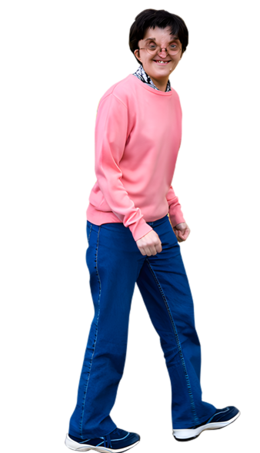 | How often do you normally walk, wheel or cycle to get where you need to go?
     | Every day | ☐
 | 5 days a week | ☐
 | A few days every week | ☐
 | Once a week | ☐
 | Once every 2 weeks | ☐
 | Once a month | ☐
 | Once every few months | ☐
 | Once a year | ☐
 | Never | ☐

Question 4

 | What types of active travel do you use?
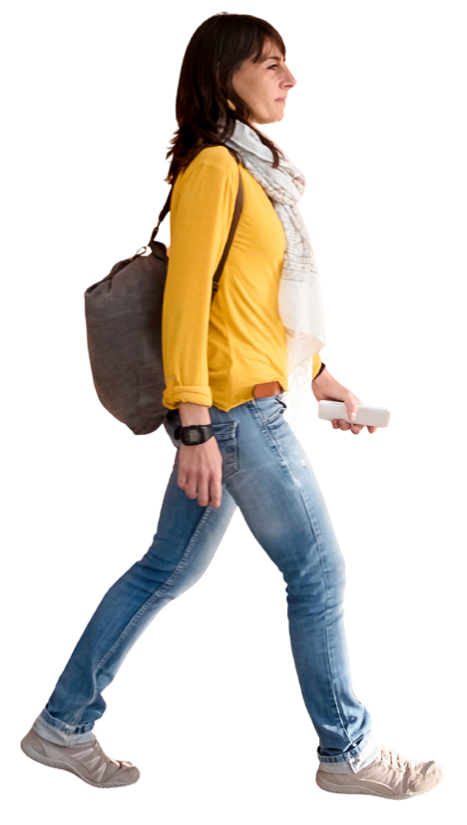 | Walking | ☐
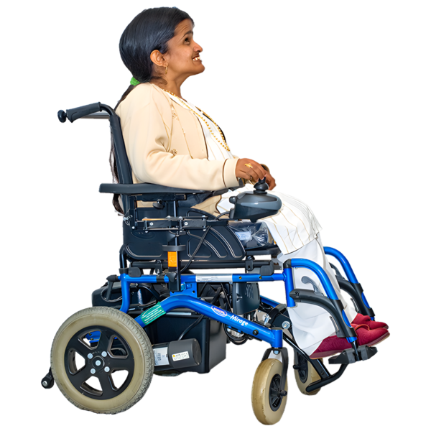 | Wheeling | ☐
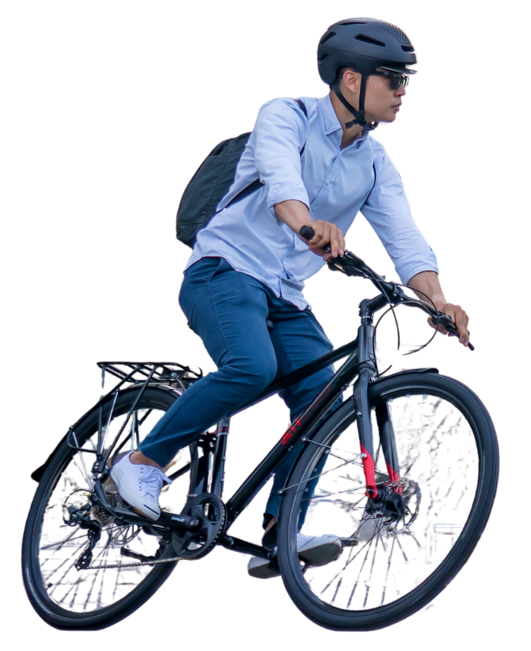 | Cycling | ☐
 | Other  Type or write it below: | ☐

Question 5

 | What are your favourite things about active travel?  Please tick your top 3 favourite things.
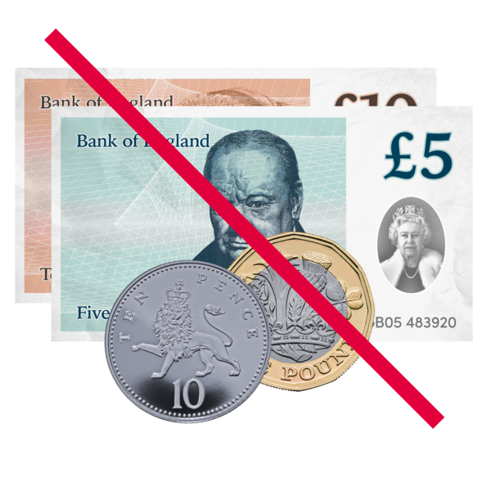 | It is free. | ☐
 | I do not have to wait for a bus or another vehicle. | ☐
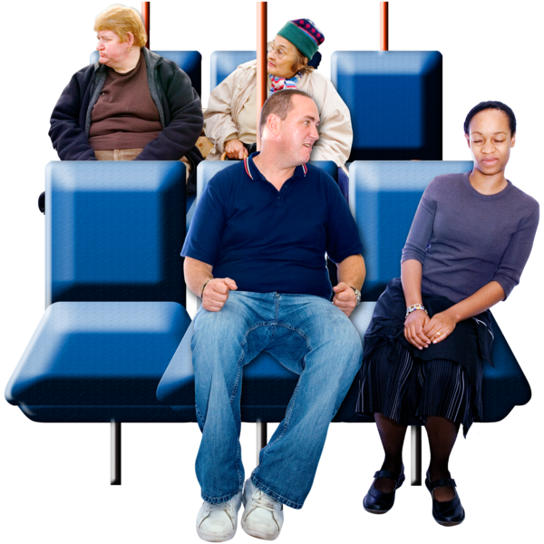 | I do not have to worry about other passengers. | ☐
 | I can be independent. | ☐
 | It is good exercise. | ☐
 | It is good for my mental health. | ☐
 | It is better for the planet. | ☐
 | I have no favourite things about active travel. | ☐
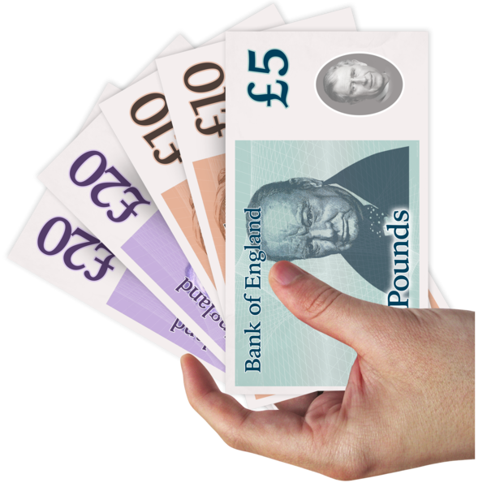 | Other.  Please type or write it below. | ☐

Question 6

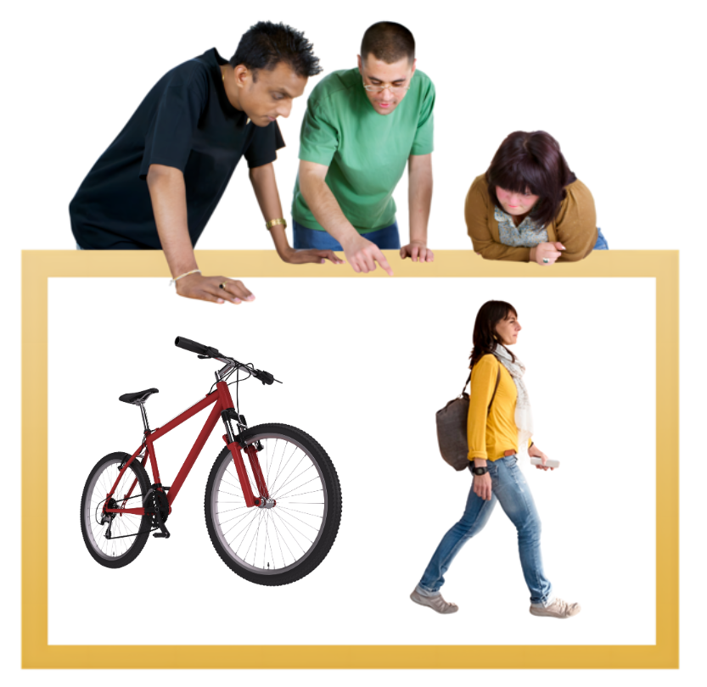 | What do you use to plan a journey by active travel?  Tick as many options as you need.
  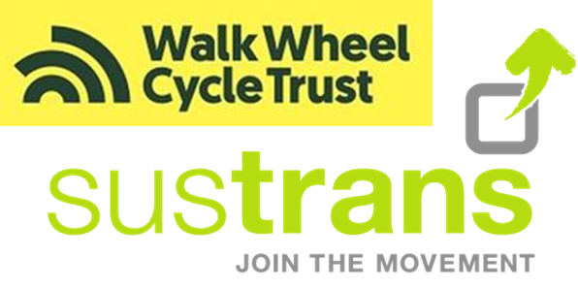 | Accessible Travel Hub website | ☐
 | Walk Wheel Cycle Trust or  Sustrans website | ☐
 | GoBike, Spokes or other  local cycling campaign | ☐
 | I just know the way | ☐
 | I am not sure | ☐

 | Other  Please type or write it below: | ☐

Question 7

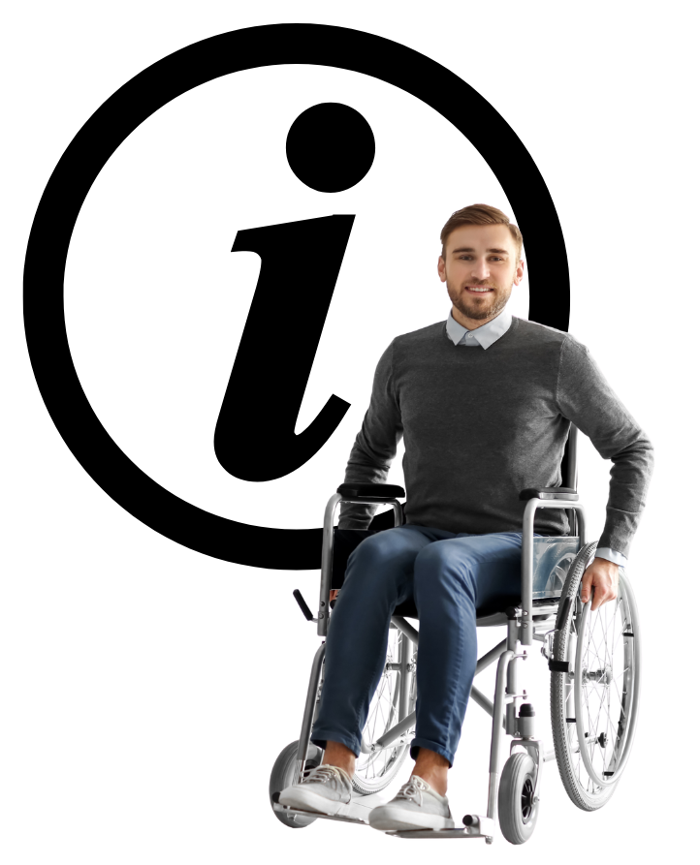 | Is information about active travel easy to use?
 | Yes, very much. | ☐
 | Yes, mostly. | ☐
 | Yes, a little. | ☐
 | No, not at all. | ☐
 | I am not sure. | ☐

Question 8

 | Do you feel comfortable and safe around other pedestrians when walking, wheeling or cycling?
 | Yes, very much. | ☐
 | Yes, mostly. | ☐
 | Yes, a little. | ☐
 | No, not at all. | ☐
 | I am not sure. | ☐

Question 9

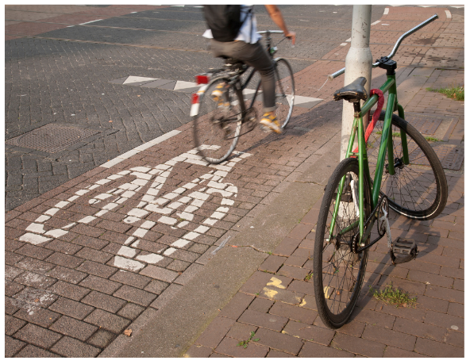 | Are the streets in your area built in a way that works well for active travel?
 | Yes, very much. | ☐
 | Yes, mostly. | ☐
 | Yes, a little. | ☐
 | No, not at all. | ☐
 | I am not sure. | ☐

Question 10

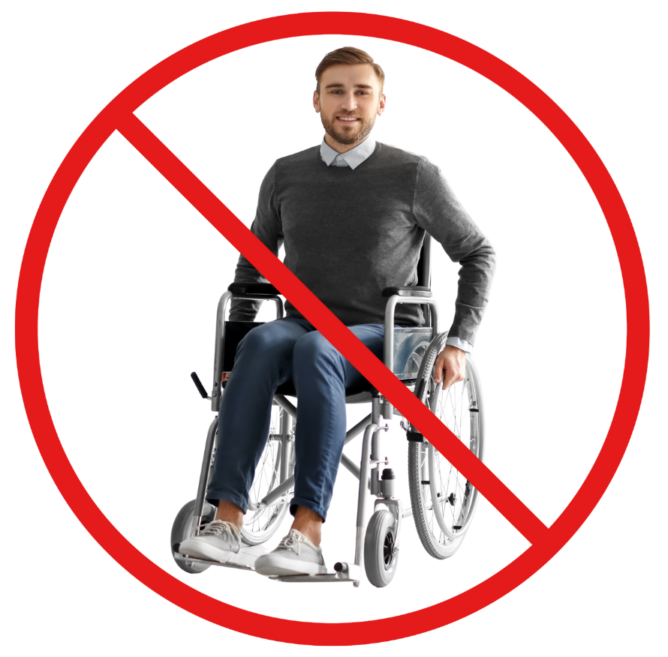 | The times when you have struggled to complete your journey by walking or wheeling, what were the reasons?  Tick as many options as you need.
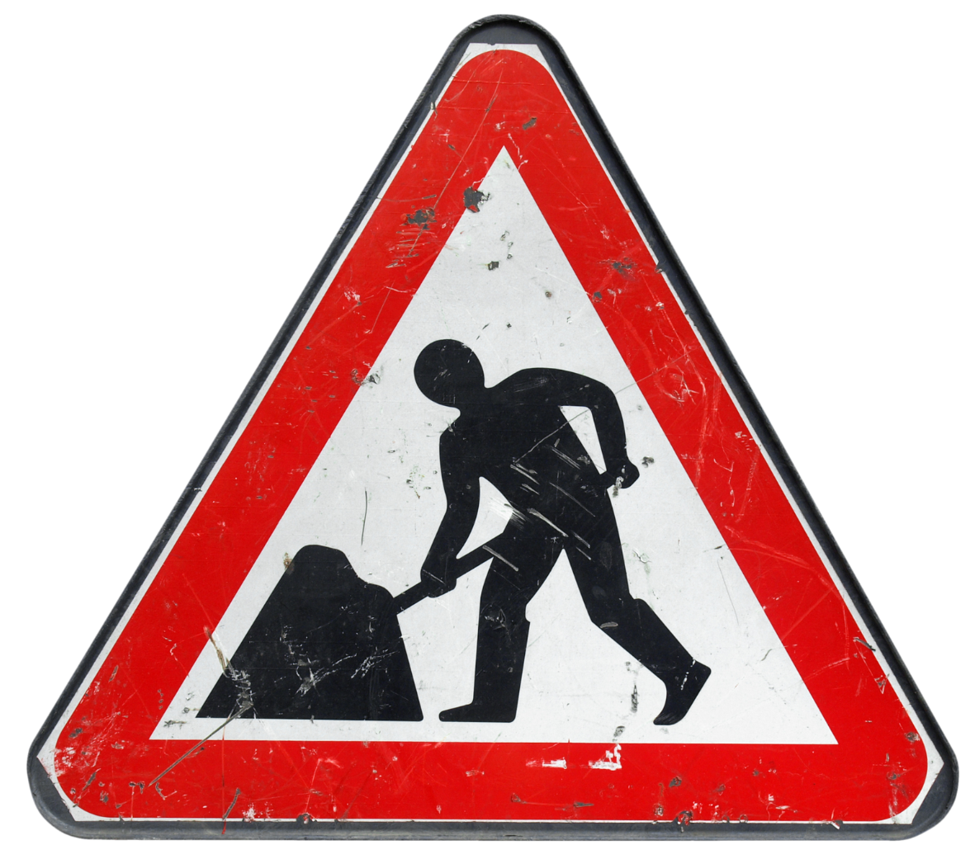  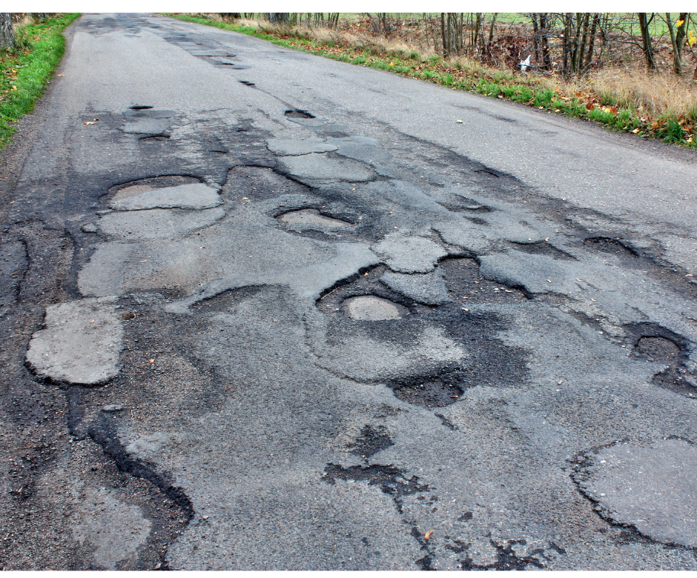 | The pavement was too uneven to walk or wheel on. | ☐
 | Roadworks or roadwork signs made it difficult for me to continue my journey. | ☐
 | There were too many things in the way on the road or pavement. | ☐
 | Somebody was abusive or unkind to me. | ☐
 | The place I was going turned out to be too far away. | ☐
 | There were not enough seats for me to rest. | ☐
 | There was not enough shelter to take a break under. | ☐

 | I would rather not say. | ☐
 | I have never struggled to complete a journey by walking or wheeling. | ☐
 | I never make journeys by walking or wheeling. | ☐
 | Other.  Please tell us by typing or writing below: | ☐

Question 11

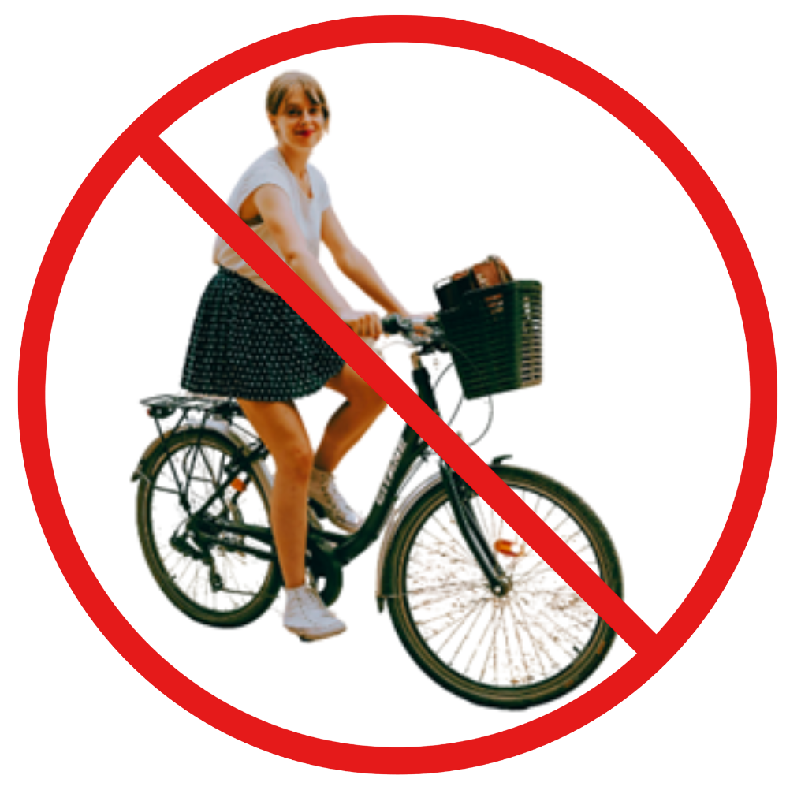 | The times when you have struggled to complete your journey by cycling, what were the reasons?  Tick as many options as you need.
 | The road or bike lane was too uneven to cycle on. | ☐
 | Roadworks or roadwork signage made it difficult for me to continue my journey. | ☐
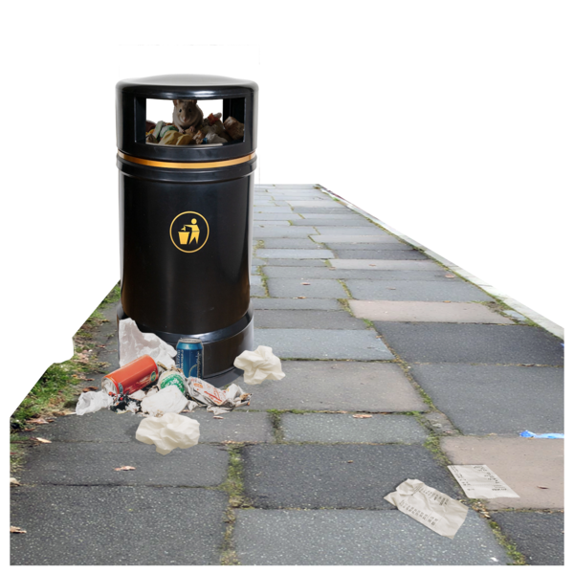 | There were too many things in the way on the road or bike lane. | ☐
 | Somebody was abusive or unkind to me. | ☐
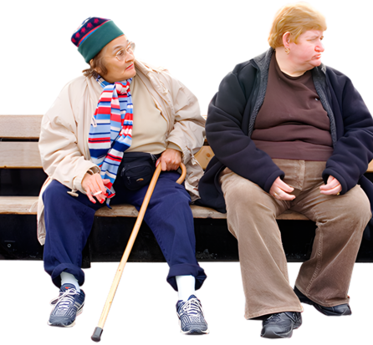 | The place I was going turned out to be too far away. | ☐
 | There were not enough seats for me to rest. | ☐
 | There was not enough shelter to take a break under. | ☐

 | I would rather not say. | ☐
 | I have never struggled to complete a journey by cycling. | ☐
 | I never make journeys by cycling. | ☐
 | Other.  Please tell us by typing or writing below: | ☐

Question 12

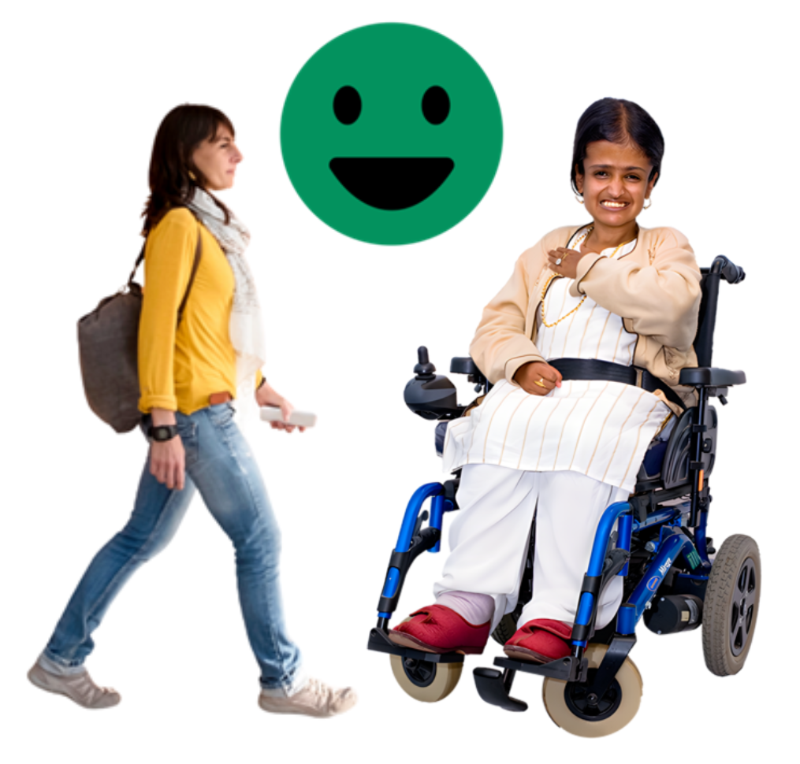 | What would make active travel better for you?  Please tell us by typing or writing below:

Question 13
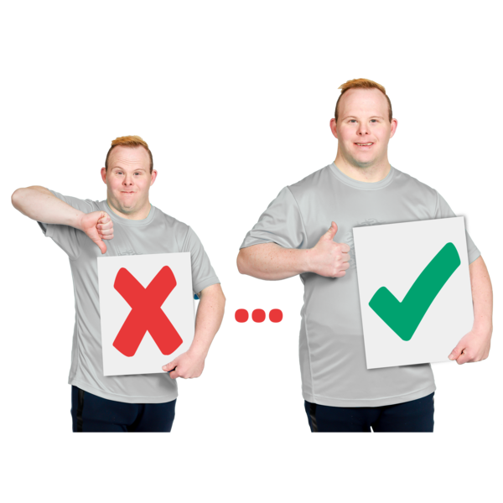 | Have you noticed any changes in your area that have made active travel better for you?  Please tell us by typing or writing below:

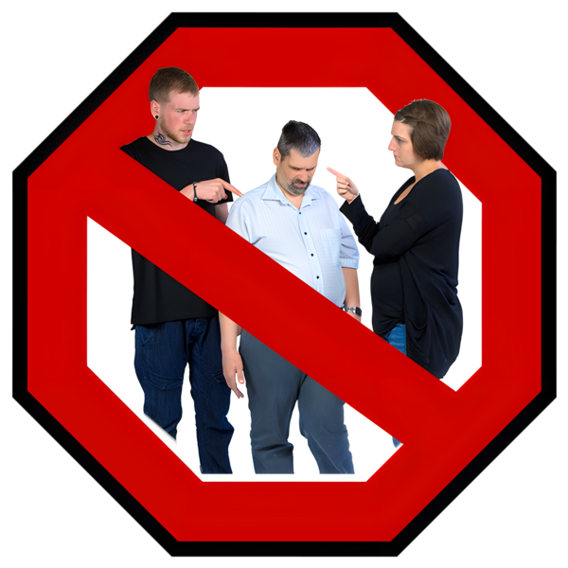 | Unkind or abusive behaviour from others when travelling is never okay, and it could be a hate crime. For information on where to get support and how to report a possible hate crime, visit disabilitysafety.scot

What to do next
 | Thank you for answering our questions.
 | Please send your answers to us by choosing 1 of these ways.
 | You can email them to transport@disabilityequality.scot
 | You can send them by post to:  Transport  Disability Equality Scotland  Norton Park  57 Albion Road  Edinburgh  EH7 5QY

In this Easy Read Survey we used images from:


