About this document
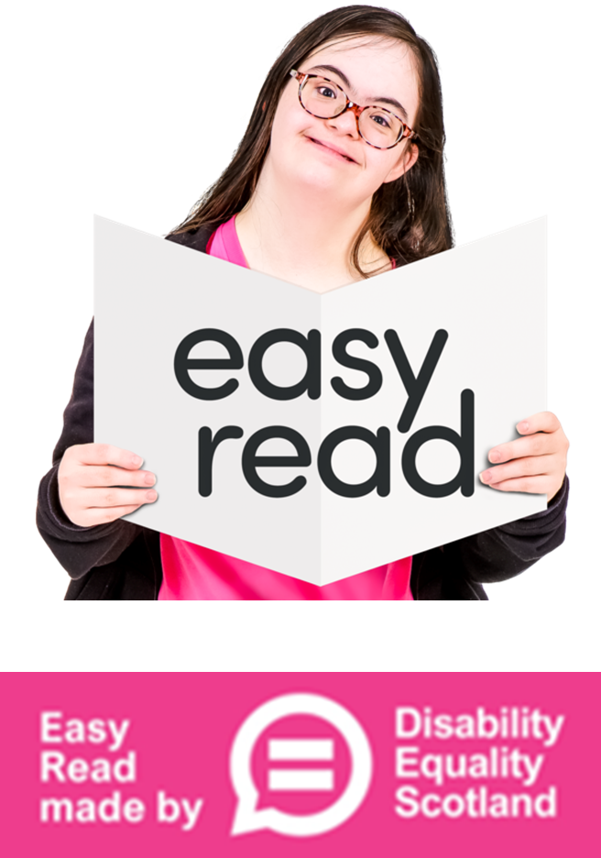 | This is an Easy Read letter to:  - our Easy Read feedback group  - everyone interested in Easy Read
 | This letter will tell you:  - what we did in 2025  - how to join our feedback group

Dear Easy Reader

 | At Disability Equality Scotland we have been writing Easy Read documents all through 2025.

 | We are very grateful to have a wonderful group.  They look at our Easy Read documents and give us feedback.
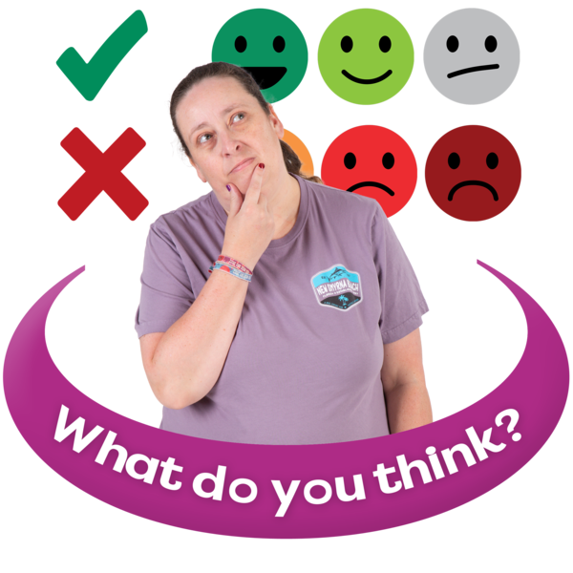 | Feedback means telling someone what:  - you like about something  - you do not like about something  - could be better
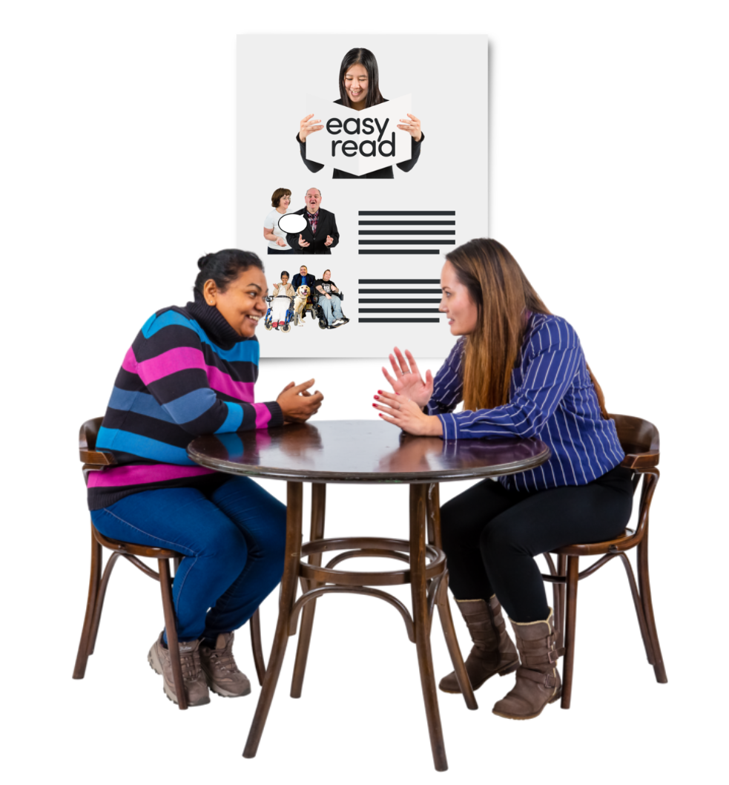 | This year we have:  - sent our group 7 different Easy Read documents  - had 1 meet and chat event in Edinburgh
 | Our group told us about things like:  - maps and directions  - reading numbers  - pictures and symbols  - lengths of documents  - things they liked  - things they did not like
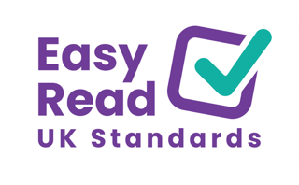 | We have also worked with a large group of Easy Read writers from across the UK.  Together we have written an Easy Read Standards document.
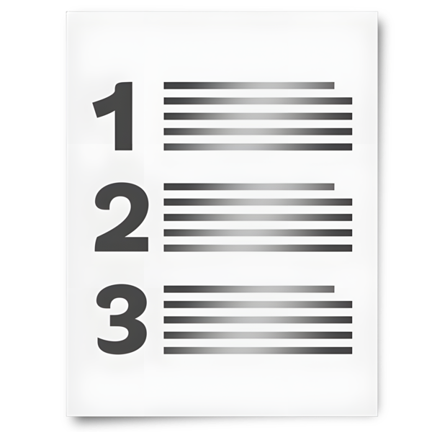 | Easy Read Standards means a list of useful rules about making Easy Read documents.

 | We listened to Easy Read users to be sure we are getting things right.
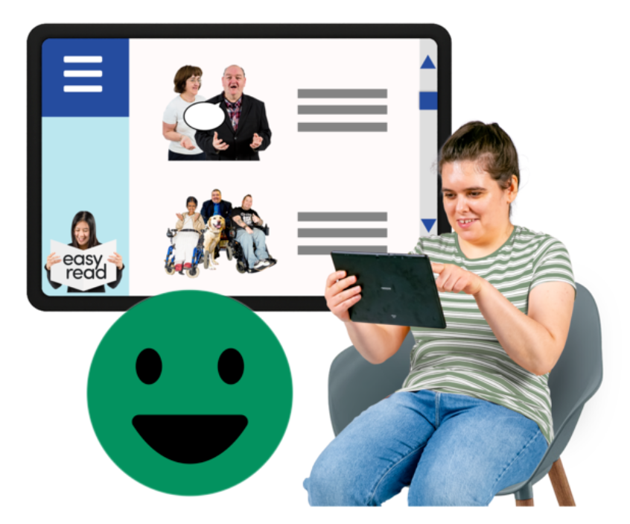 | We will use the new Easy Read Standards to help us write good Easy Read documents.

Things we have changed

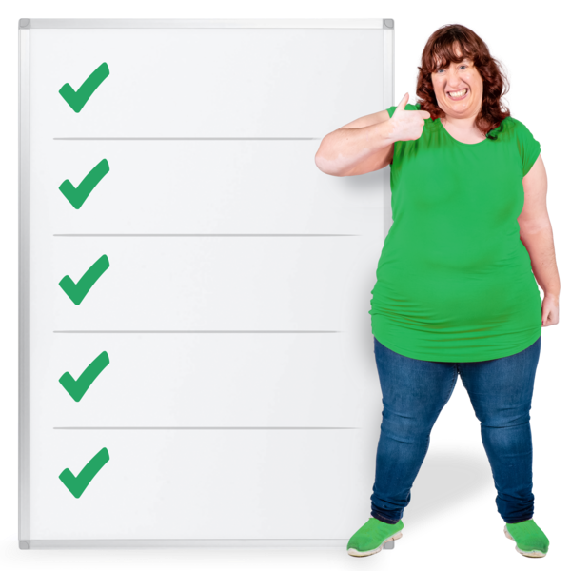 | We have listened to Easy Read feedback and we have made changes.  Some examples are:
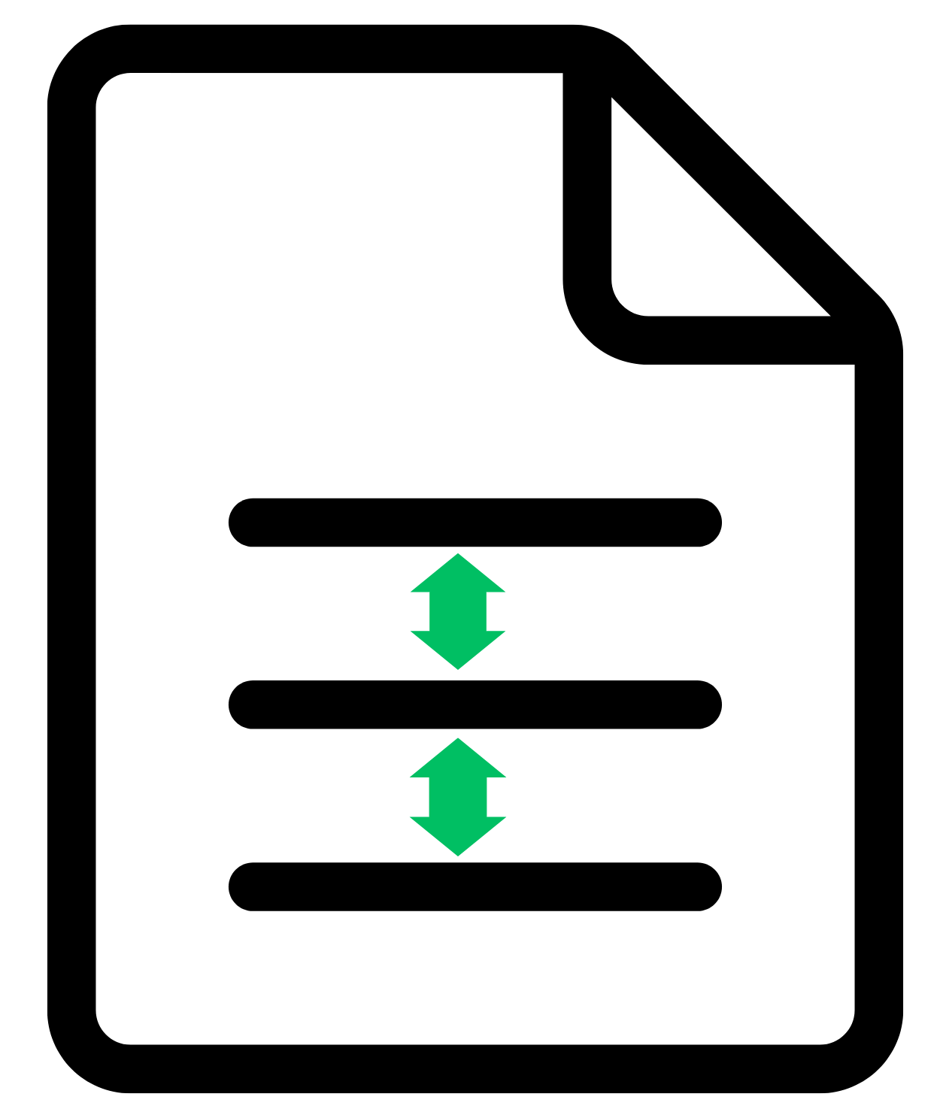 | We leave more space between lines now.  We made this change because people told us that words are easier to read when the lines are further apart.
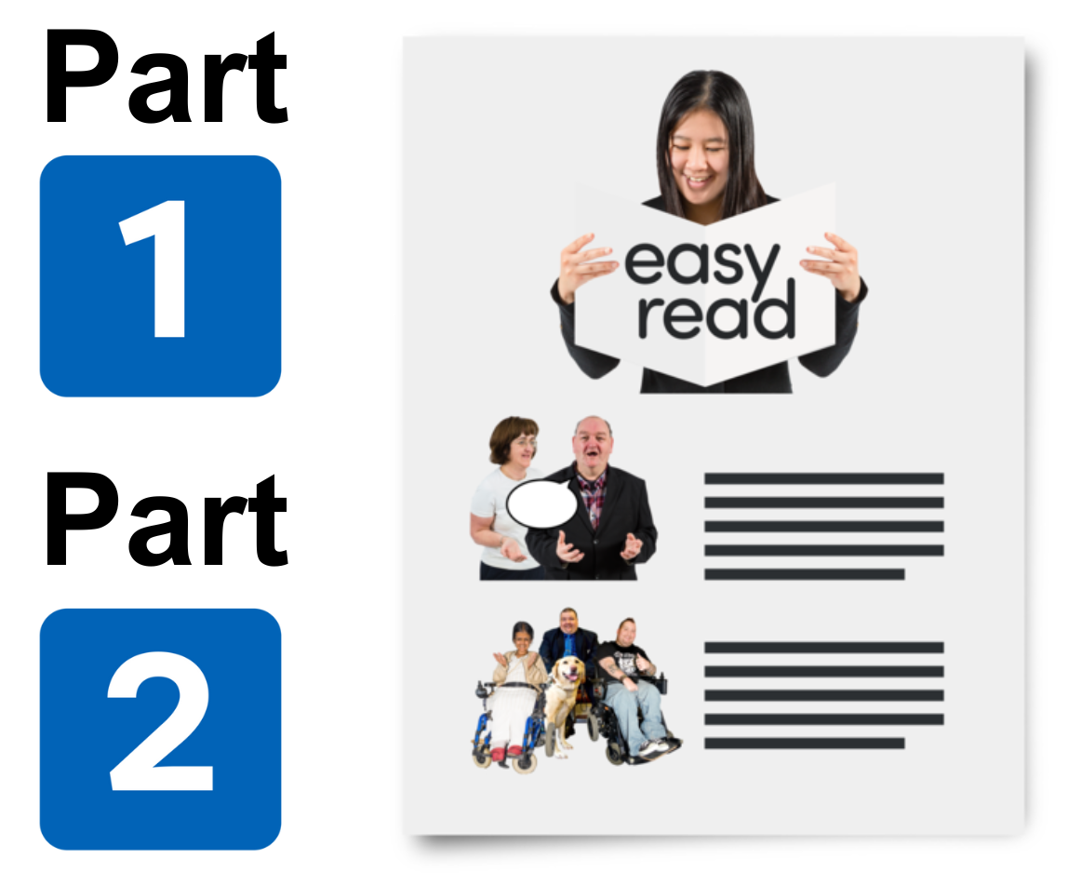 | We split longer documents into Part 1 and Part 2 now, so that there are 20 pages or less in each Easy Read document.  We made this change because the new Easy Read Standards say no more than 20 pages.  But our feedback group told us:  - 14 pages is enough  - it is better when Easy Read documents are as short as possible
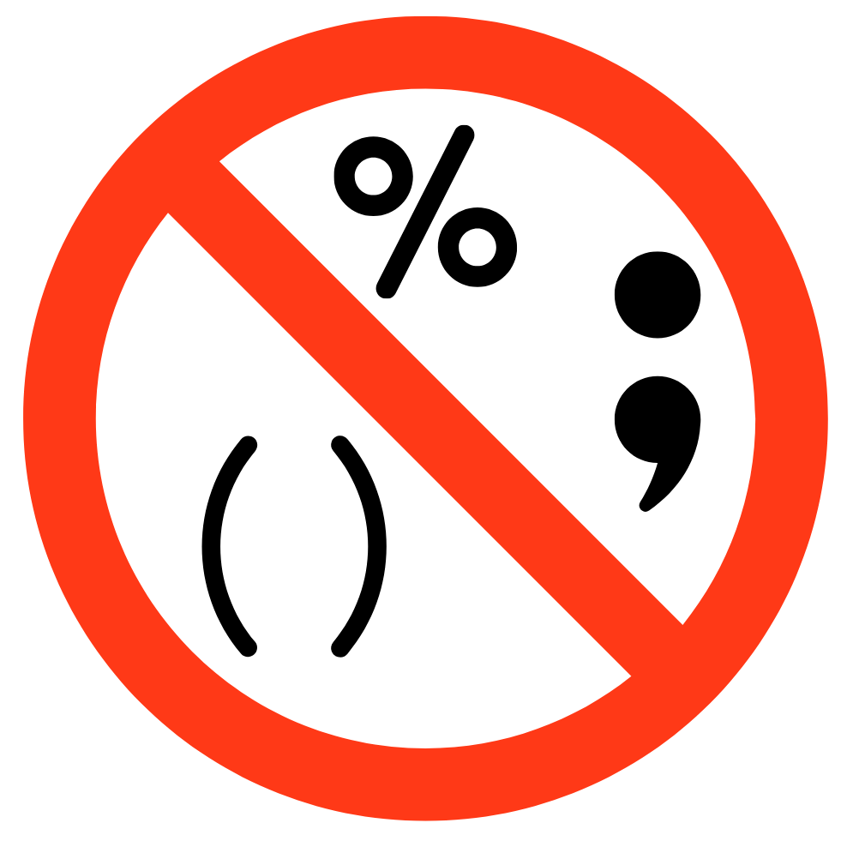 | We try to use just full stops and question marks and leave out trickier symbols.  We made this change because many Easy Read users say they find symbols like these tricky % “ ; ( -

 | We have stopped using question marks in headings.  We only use them where the reader is being asked a question.  We made this change because some Easy Read users said it is confusing to get a question which is not for answering.
 | We make sure that any blue links to other websites are named clearly instead of just click here.  We made this change because some people use screen readers.  A screen reader reads the text out loud.  If all the links say click here, people cannot tell which link goes to which website.

 | We try and stick to 3 or 4 chunks of Easy Read information on each page and not more.  We made this change because our feedback group told us that 5 or more chunks of information makes the page too cluttered.
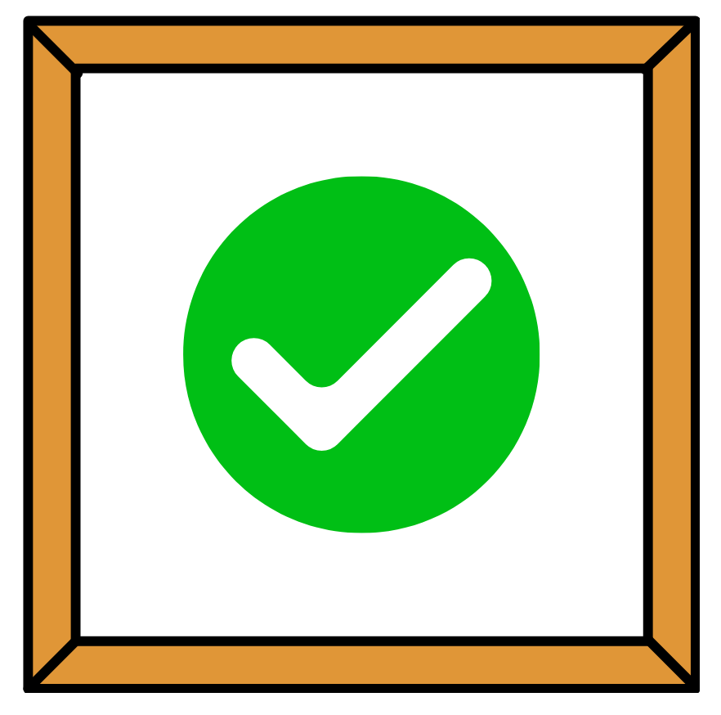 | We can use pictures that are not photos, as long as they are large and clear.  We made this change after our feedback looked at different types of images and told us what they liked.

Our feedback group in 2026

 | We want more people to join our feedback group.  Anyone who uses Easy Read is warmly welcomed.
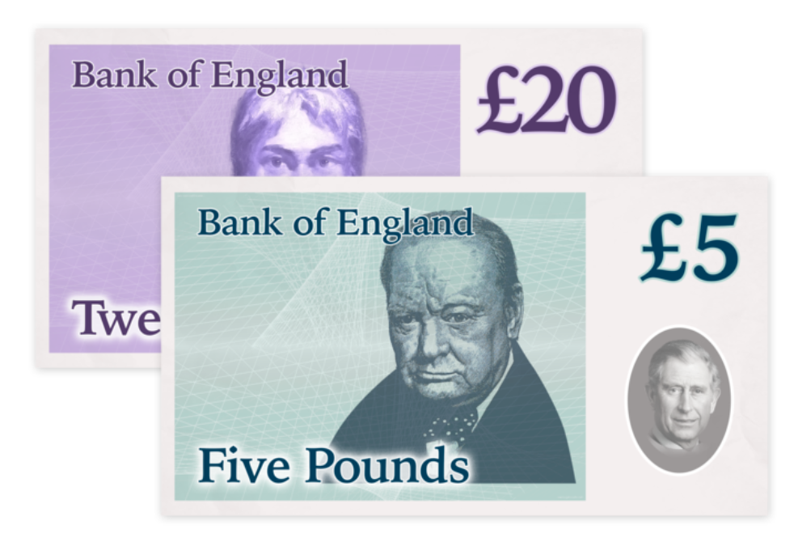 | We offer our feedback group members 25 pounds for every:  - document they look at  - meeting they come to or join online  This is to say thank you.
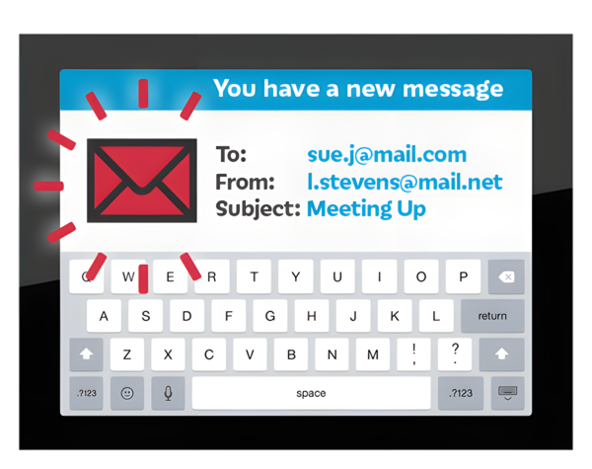 | Most of our communication with the feedback group is done by email, but you can also choose phone calls.
 | Sometimes we invite people to online group meetings.  Sometimes we invite people to meet face to face.  You can choose the ways that suit you best.

   | If you are interested in joining our feedback group please either:  - email us at easyread@disabilityequality.scot  - or phone us on 0141 370 0968

Thank you

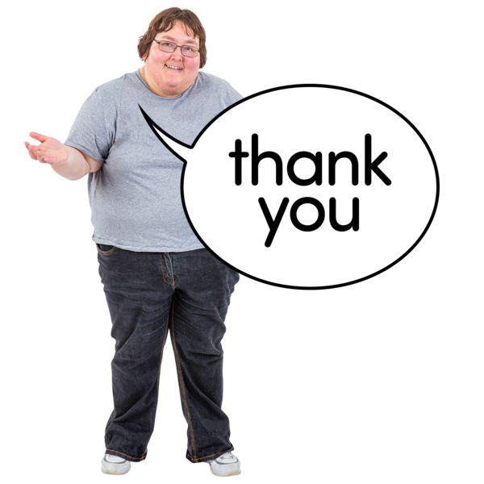 | Thank you from the Easy Read team,  Shona, Marit and Claire



