


Plane Survey

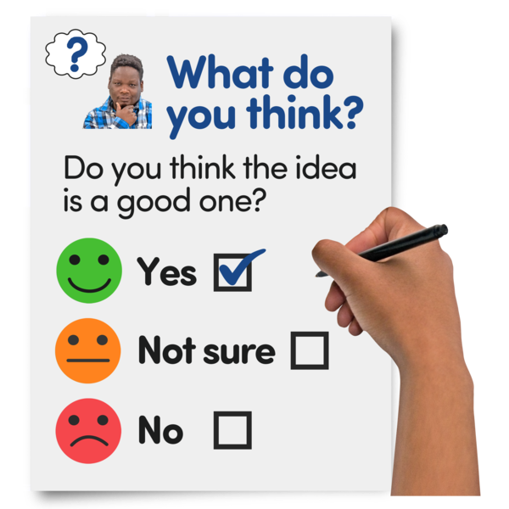
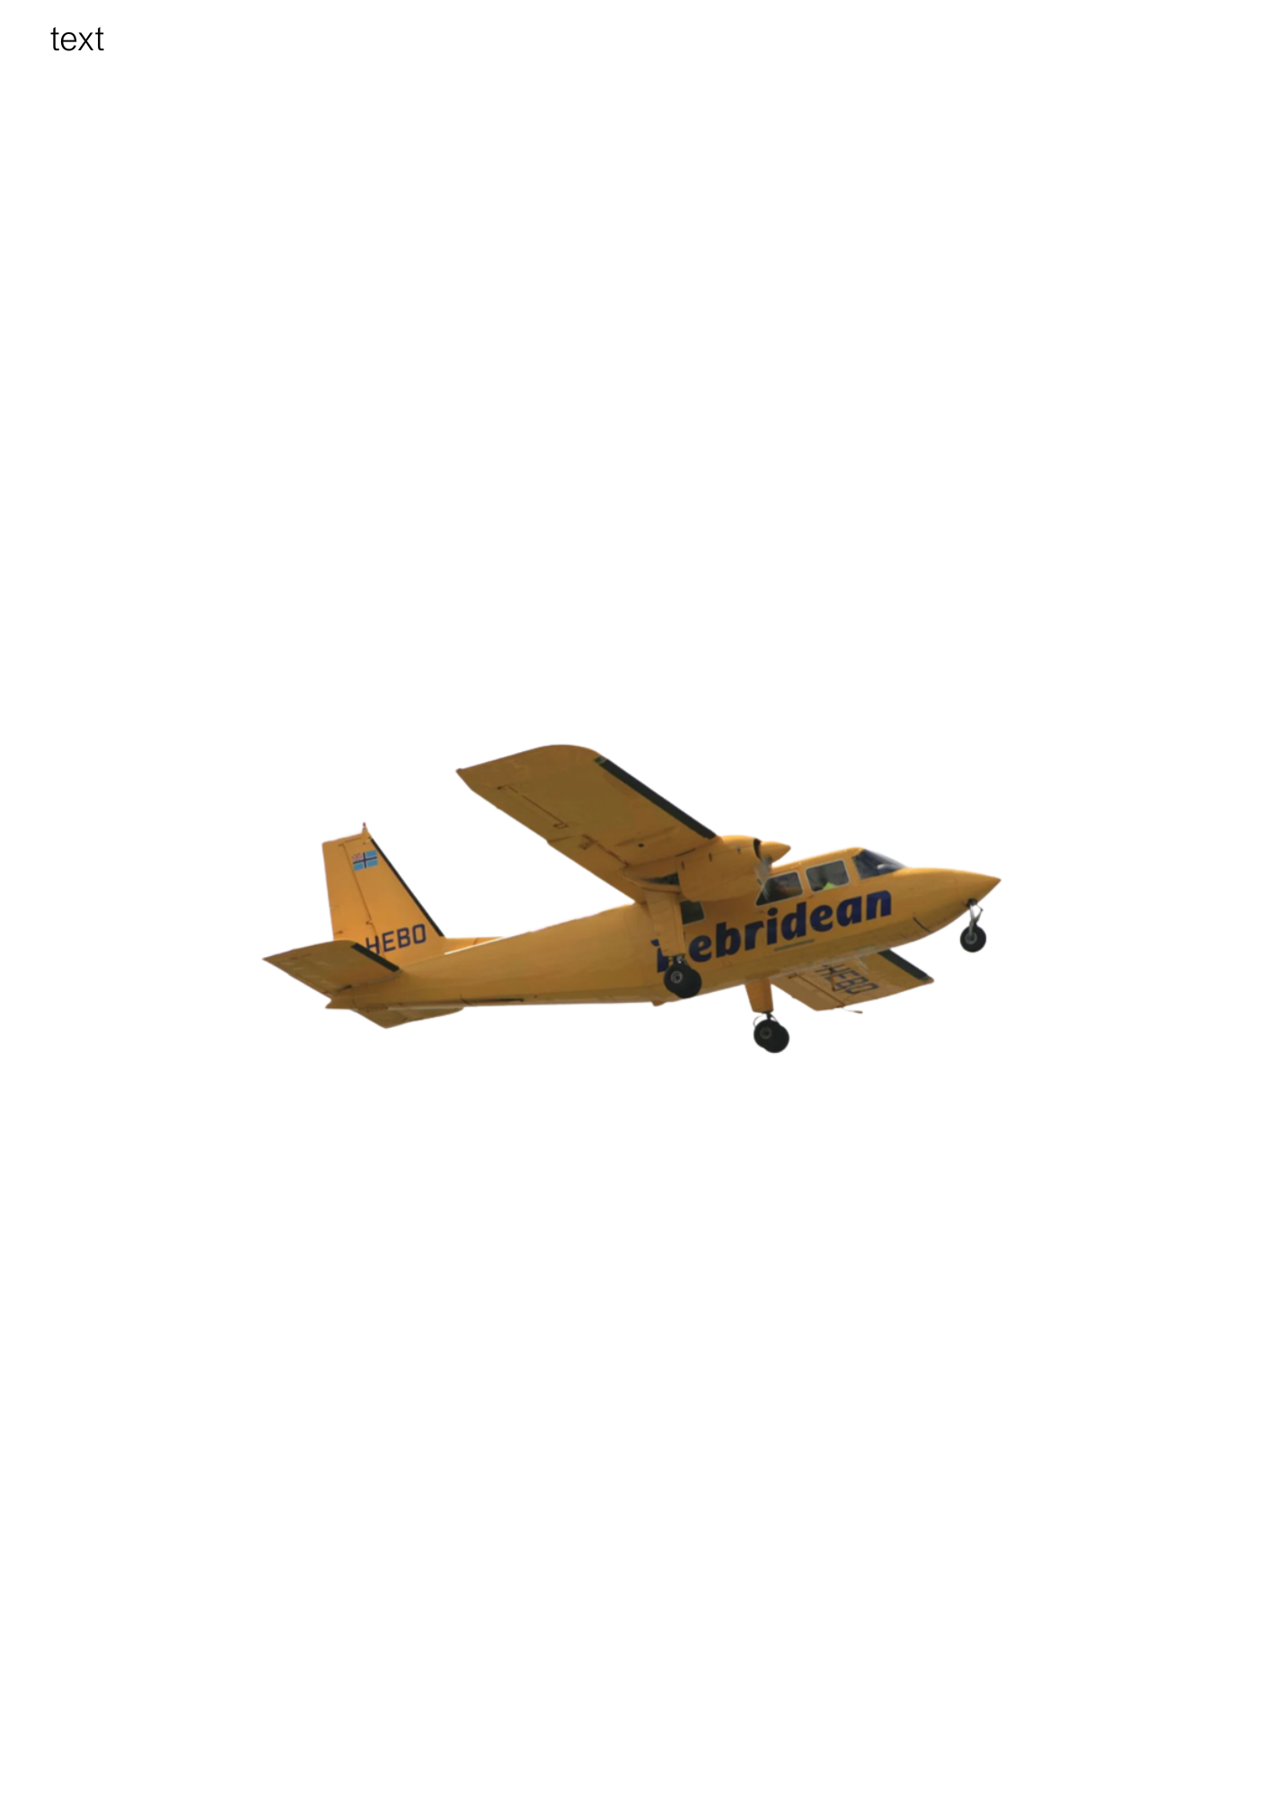

Easy Read


About this document

 | This is an Easy Read document.
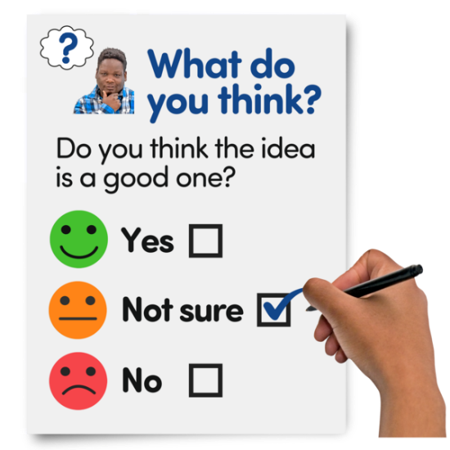 | It is a survey.  A survey means a set of questions.
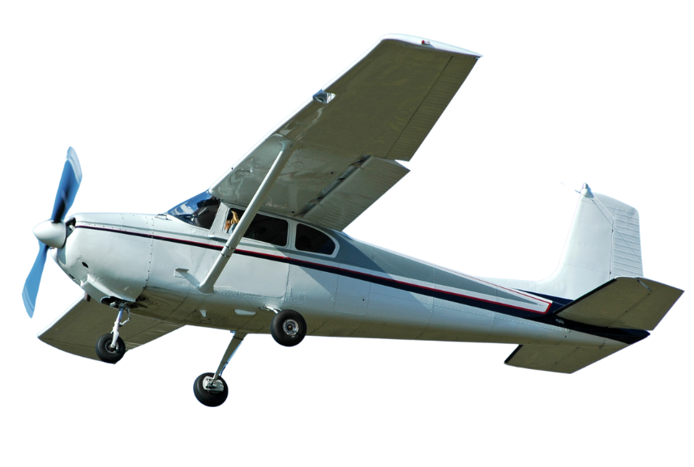 | The questions ask you about travelling by plane.

Our questions

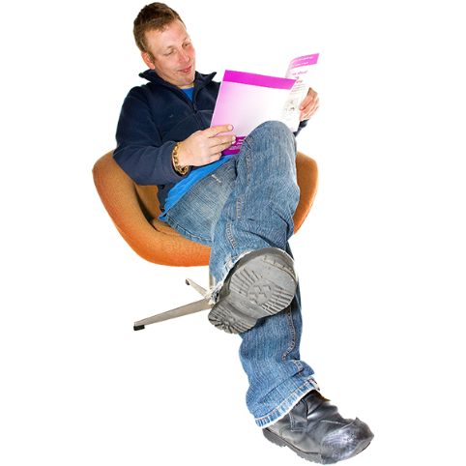 | Answer our questions to tell us what you think.
 | If you are answering on a screen, you can click the little box next to your answer.  A tick will appear.  If you change your mind you can click it again.
 | If you are typing your answers the space will grow as you type.
 | If you are writing your answers on a paper copy use the Enter button to grow the spaces before you print the pages.

Question 1

 | Are you answering this survey for yourself or for an organisation?
 | For myself | ☐
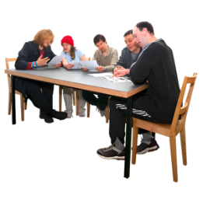 | For an organisation | ☐

Question 2

 | Which local council area do you live in?  If you are an organisation, please also tell us your organisation’s name.  Write or type your answer below.

Question 3

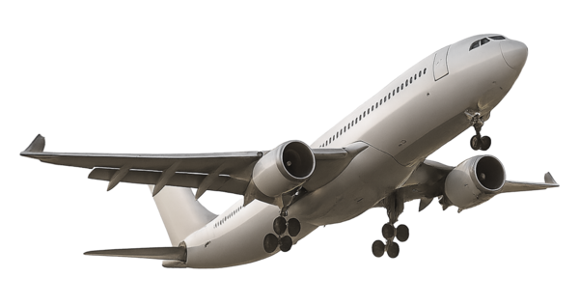 | How often do you normally travel by plane?
    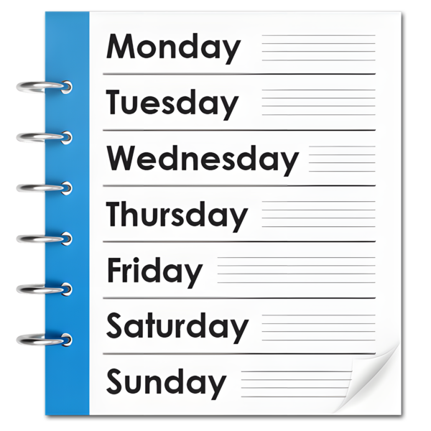 | Every day | ☐
 | 5 days a week | ☐
 | A few days every week | ☐
 | Once a week | ☐
 | Once every 2 weeks | ☐
 | Once a month | ☐
 | Once every few months | ☐
 | Once a year | ☐
 | Never | ☐

Question 4

 | Do you use any of these for plane travel?
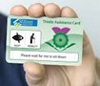 | Sunflower lanyard | ☐
 | Thistle Assistance | ☐
 | I do not use any of these | ☐
 | Other  Type or write it below: | ☐

Question 5

 | What are the most important things for you to think about when planning a plane journey?  Please tick your top 3 important things.
 | How much it will cost. | ☐
 | How long it will take. | ☐
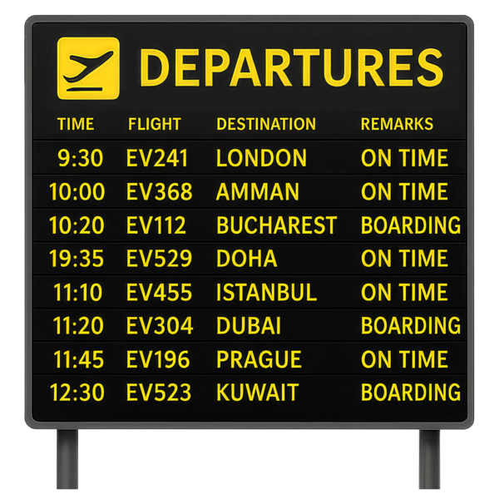 | If the flight will be on time. | ☐
 | If there is good space for me and my equipment on the plane. | ☐
 | If I can get on and off the plane easily. | ☐
 | If there is staff to help me. | ☐
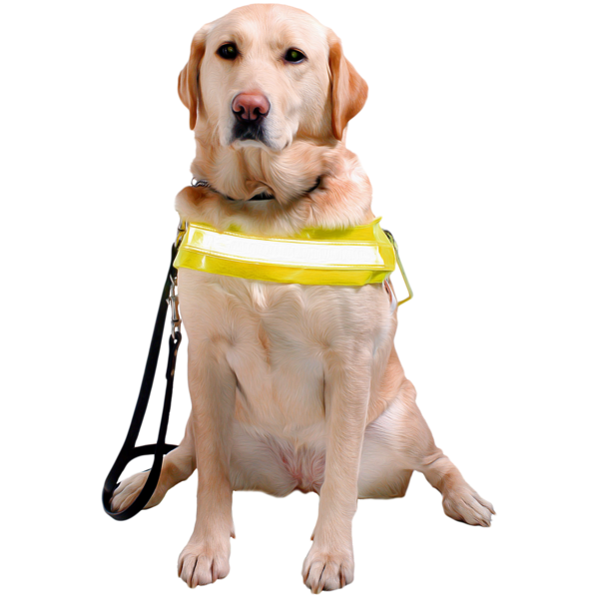 | If I can bring an assistance animal. | ☐

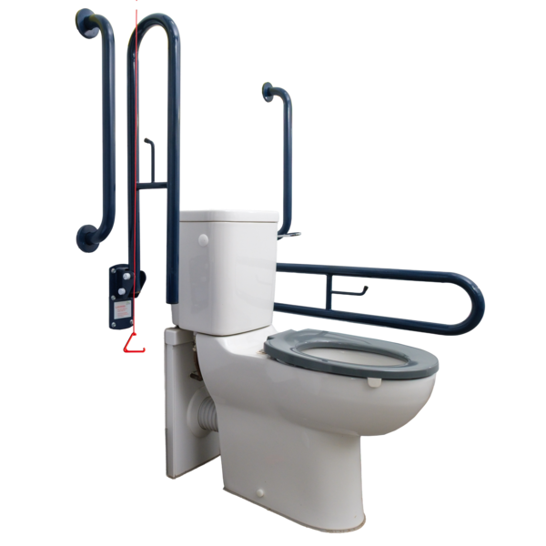 | If there are toilets on the plane or in the airport. | ☐
 | If there is a Changing Places toilet on the plane or in the airport. | ☐
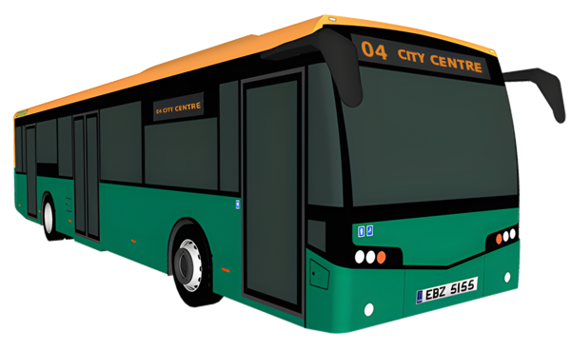   | If the airport is accessible. | ☐
 | If it is easy to get a bus, train or other public transport service to complete my journey. | ☐
 | If it is easy to get the information I need. | ☐
 | Other.  Please type or write it below. | ☐

Question 6

 | How do you normally get from your home to the airport?
  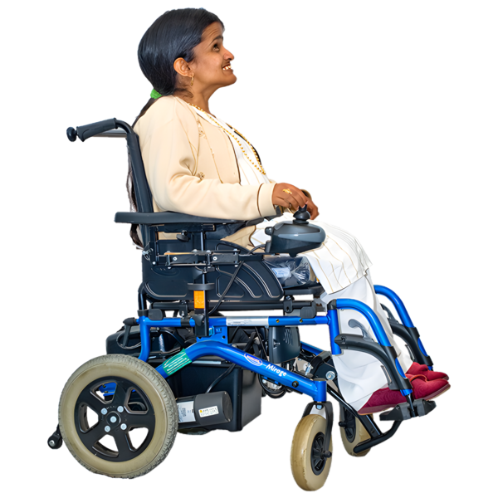 | I walk or wheel. | ☐
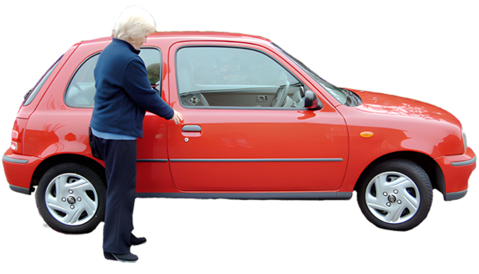 | I drive. | ☐
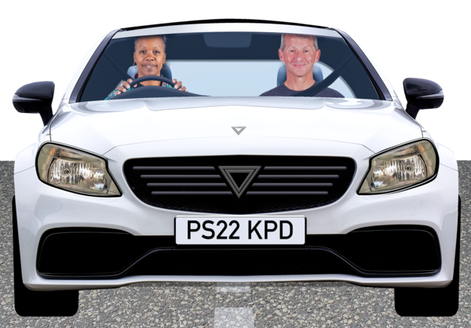 | I get a lift. | ☐
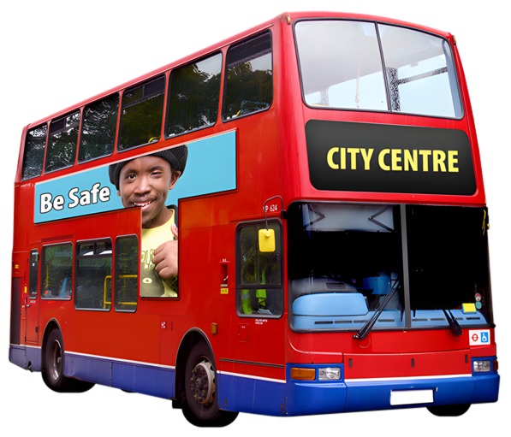 | I take a bus. | ☐
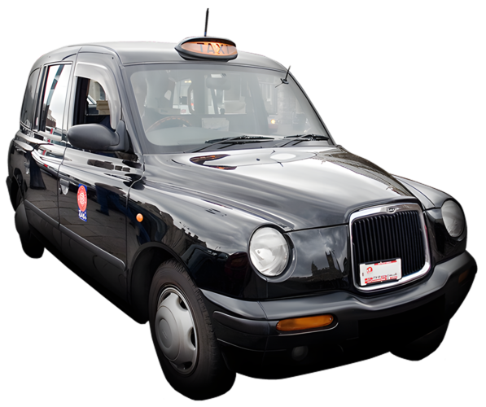 | I take a taxi. | ☐
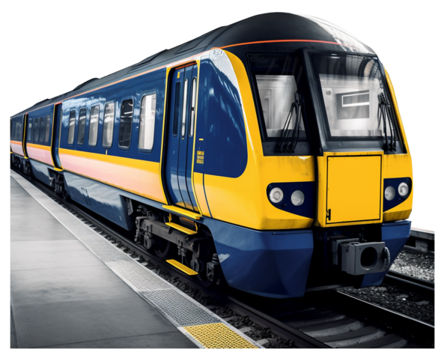 | I take a train. | ☐
 | Other. | ☐

Question 7

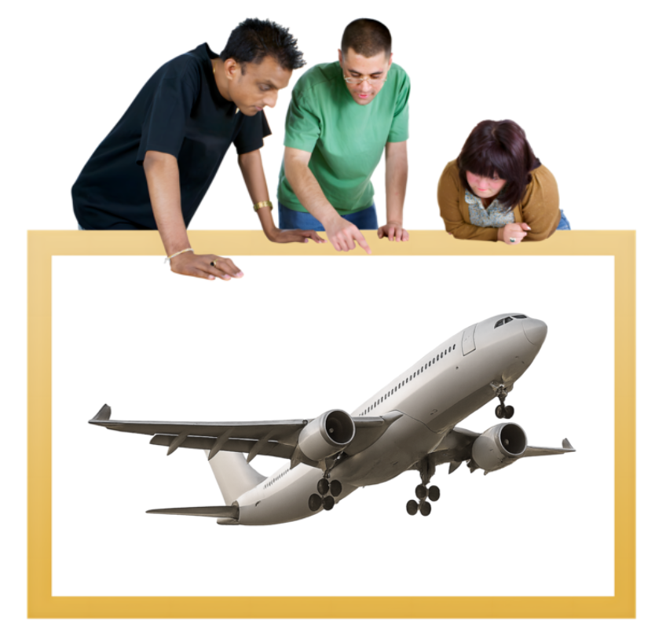 | What do you use to plan a journey by plane?  Tick as many options as you need.
 | Traveline Scotland call centre | ☐
 | Traveline Scotland website or app | ☐
   | Accessible Travel Hub website | ☐
 | Airline call centre | ☐
 | Airline website or app | ☐
 | I speak to staff at the airport | ☐
 | I am not sure | ☐

 | Other  Please type or write it below: | ☐

Question 8

 | Is information about travelling by plane easy to use?
 | Yes, very much. | ☐
 | Yes, mostly. | ☐
 | Yes, a little. | ☐
 | No, not at all. | ☐
 | I am not sure. | ☐

Question 9

 | Do airport and flight staff give you the support you need to travel?
 | Yes, very much. | ☐
 | Yes, mostly. | ☐
 | Yes, a little. | ☐
 | No, not at all. | ☐
 | I do not need support from staff. | ☐
 | I am not sure. | ☐

Question 10

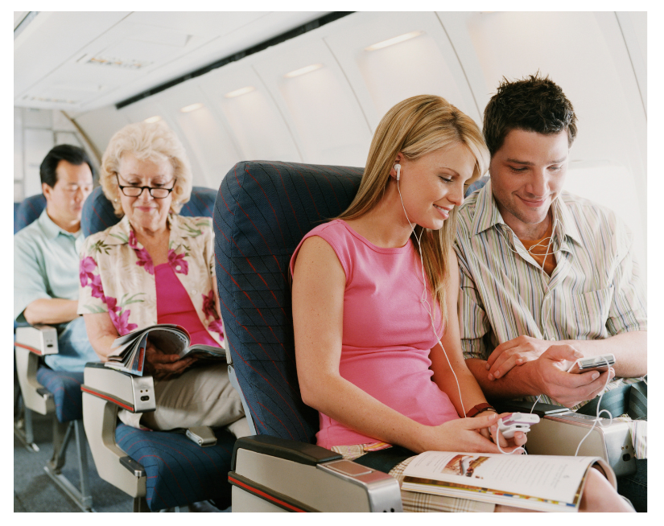 | Do you feel comfortable and safe around other passengers when travelling by plane?
 | Yes, very much. | ☐
 | Yes, mostly. | ☐
 | Yes, a little. | ☐
 | No, not at all. | ☐
 | I am not sure. | ☐

Question 11

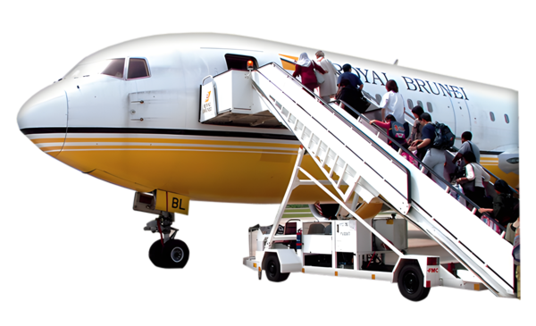 | Are planes and airports built in a way that works well for you?
 | Yes, very much. | ☐
 | Yes, mostly. | ☐
 | Yes, a little. | ☐
 | No, not at all. | ☐
 | I am not sure. | ☐

Question 12
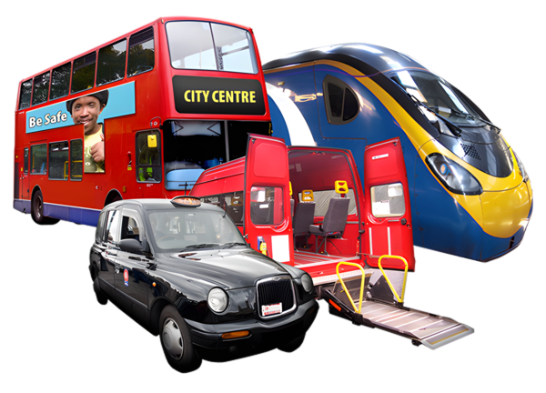 | Do you find it easy to get a bus, train or other public transport service to and from the airport?
 | Yes, very much. | ☐
 | Yes, mostly. | ☐
 | Yes, a little. | ☐
 | No, not at all. | ☐
 | I am not sure. | ☐

Question 13

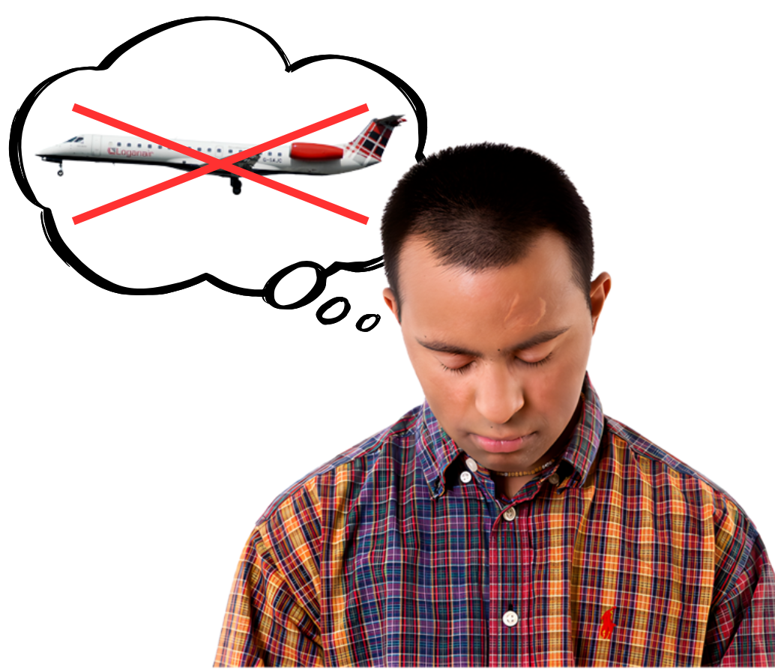 | The times when you have struggled to complete your plane journey, what were the reasons?  Tick as many options as you need.
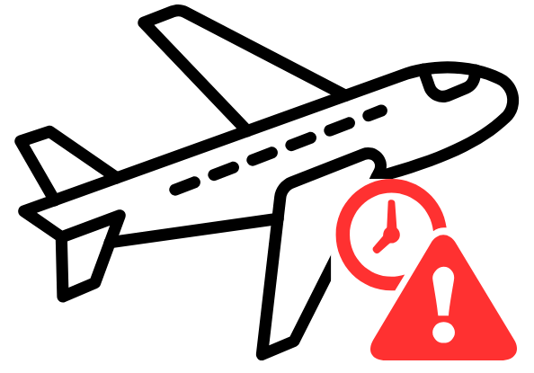 | I could not get to the airport. | ☐
 | My plane was delayed or cancelled. | ☐
 | I was unable to get onto the plane. | ☐
 | There was not a suitable space for me on the plane. | ☐
 | Other passengers were making me feel worried. | ☐
 | Somebody was abusive or unkind to me. | ☐

 | I was confused about what to do. | ☐
 | I could not get the help I needed from the staff. | ☐
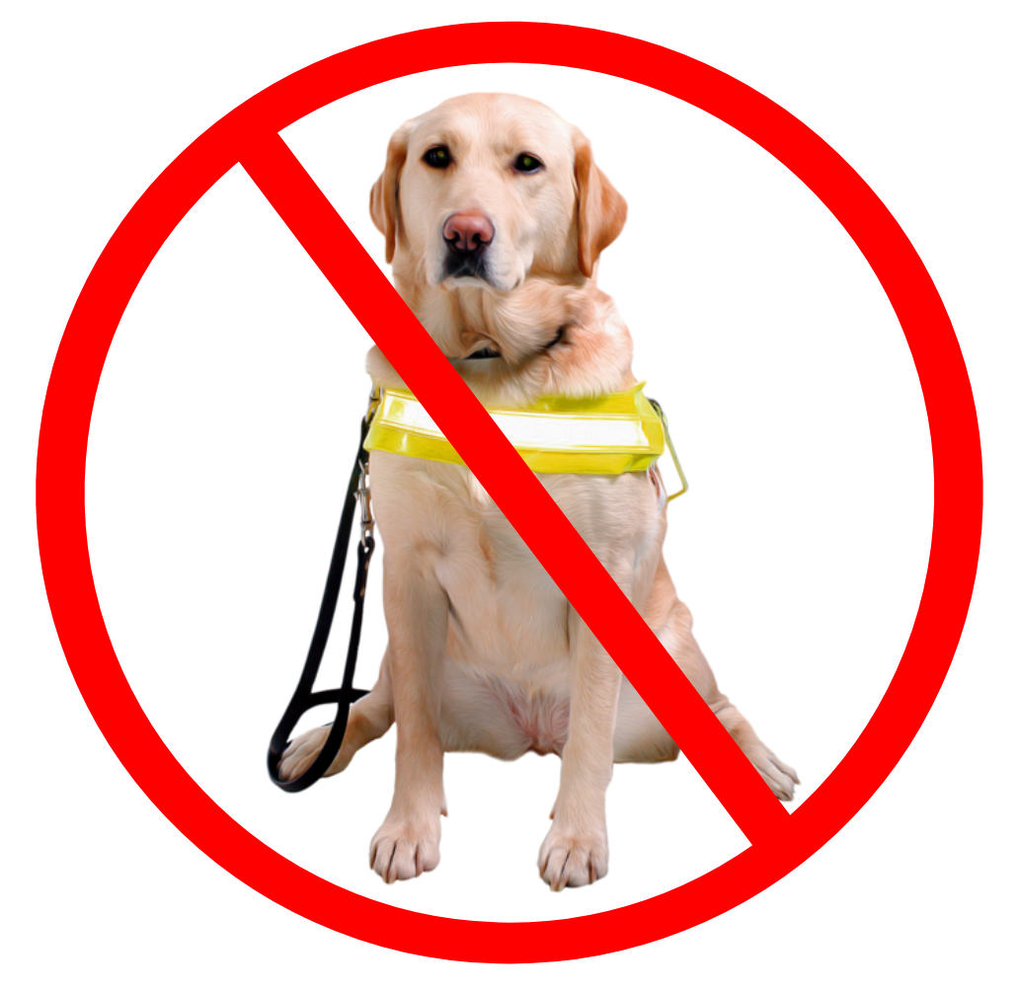 | I could not take my assistance animal. | ☐
 | I would rather not say. | ☐
 | I have never struggled to complete a journey by plane. | ☐
 | Other.  Please tell us by typing or writing below: | ☐

Question 14
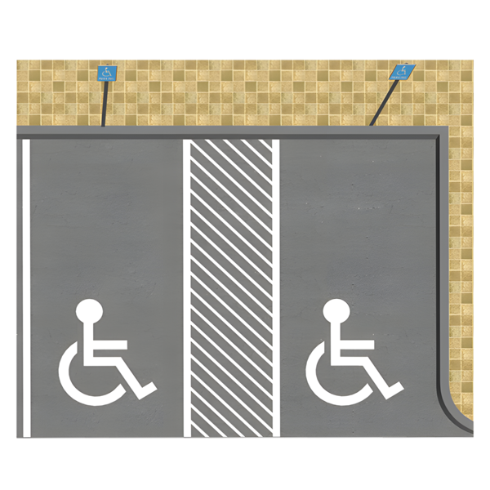 | Have you ever had problems with  getting to the airport or parking at  the airport?  Please tell us about it by typing or writing below:

Question 15

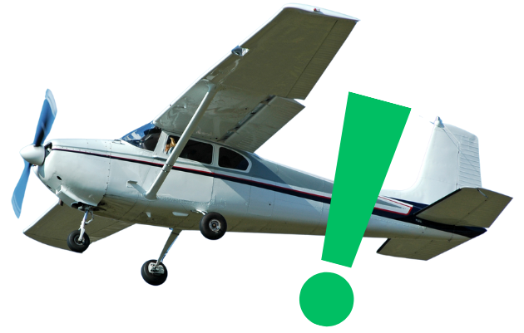 | Have you noticed any changes that has made travelling by plane better for you?  Please tell us by typing or writing below:

Question 16

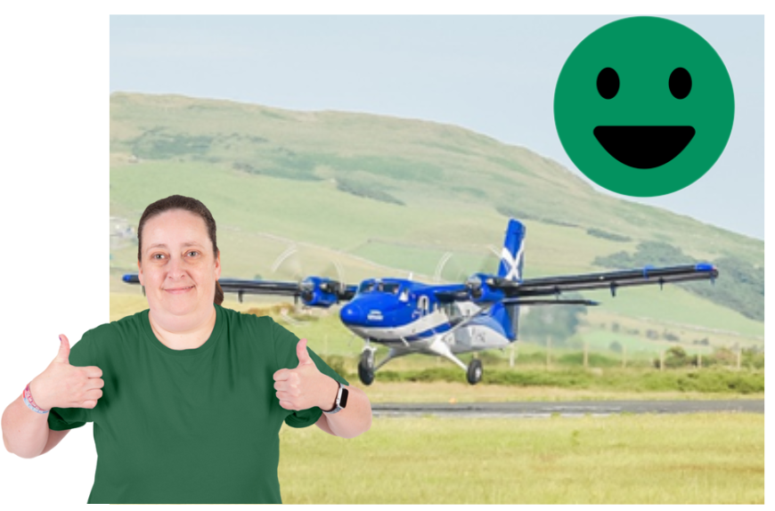 | What would make travelling by plane better for you?  For example, is there a problem with planes that makes them hard to use?  This might involve ramps or other equipment used to support your journey.  Please tell us by typing or writing below:

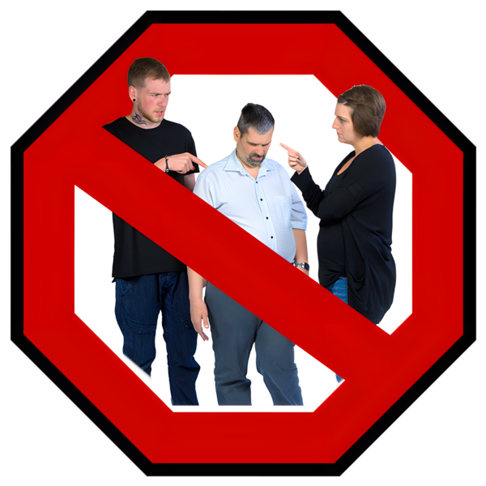 | Unkind or abusive behaviour from others when travelling is never okay, and it could be a hate crime. For information on where to get support and how to report a possible hate crime, visit disabilitysafety.scot
What to do next
 | Thank you for answering our questions.
 | Please send your answers to us by choosing 1 of these ways.
 | You can email them to transport@disabilityequality.scot
 | You can send them by post to:  Transport  Disability Equality Scotland  Norton Park  57 Albion Road  Edinburgh  EH7 5QY

In this Easy Read Survey we used images from:


