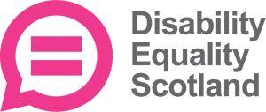

Information about a Special Resolution


Easy Read


Changing some of our words
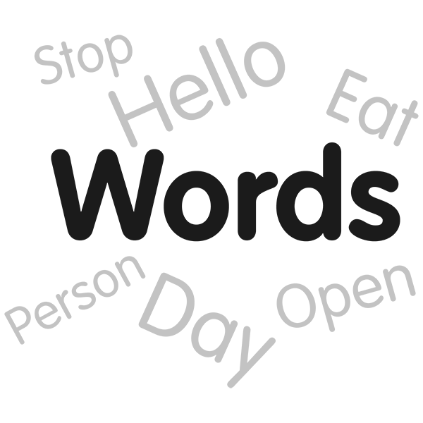 | Part of our Annual General Meeting is about changing some of our words.
 | Disability Equality Scotland’s rules are called the Articles of Association.
 | When we want to change some words in our Articles of Association, we call it a Special Resolution.
 | A Special Resolution needs 3 out of every 4 voting members to say yes.

About the 1 Special Resolution this year
 | We want to change some wording.
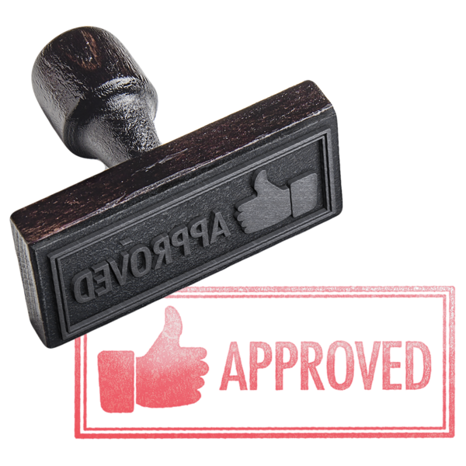  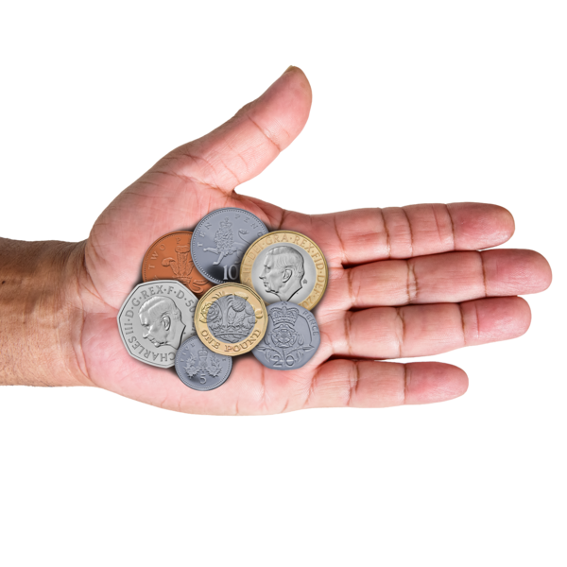 | In Article 9 the old wording says:  - Directors need to agree to allow all new members  - members pay fees that the Directors decide – at the moment the fee is 0 pounds
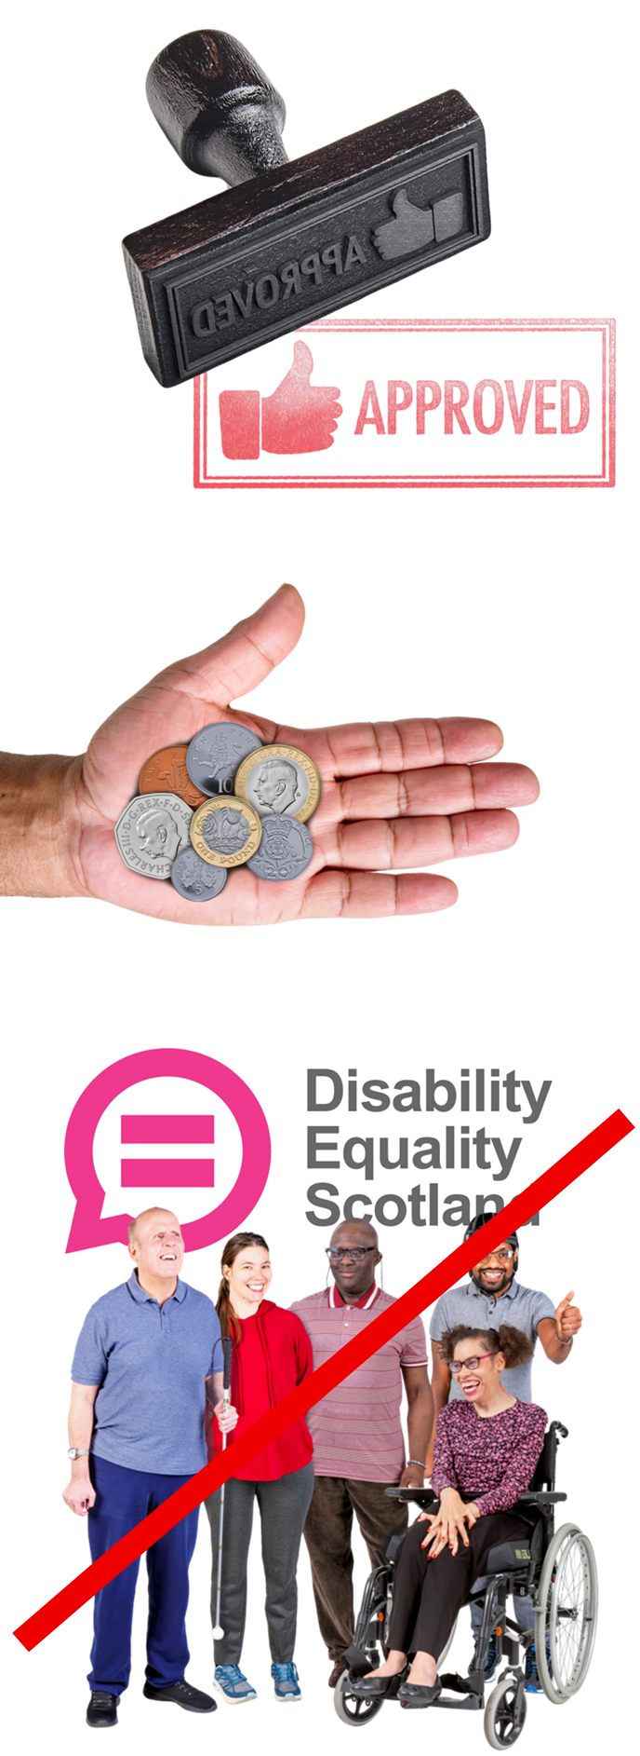 | We want to add the new red wording to say:  - Directors must agree to allow all new members  - members pay fees that the Directors decide – at the moment the fee is 0 pounds  - staff are not allowed to be members  - if someone joins the staff team they must stop being a DES member
 | These are the reasons we think these red words should be added:  - it means we are following charity guidelines  - it makes voting fairer

