

Voting Form


Easy Read


About voting

 | Part of our Annual General Meeting 2025 is voting.
 | Voting means deciding if we agree with something or not and saying our answer.
 | We can ask someone else to give our answer for us when we want to vote but we cannot come to the meeting,  This is called a proxy vote.
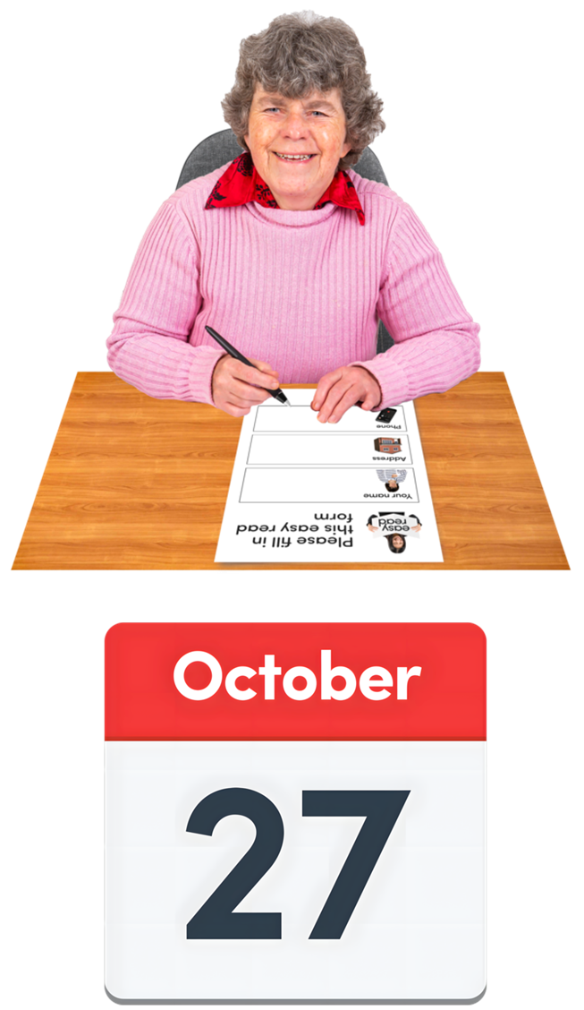 | If you want to give your vote by proxy, please fill in this form.  Send it back to us by  Monday 27 October 2025  before 12 noon.

Proxy Voting Form
 | You can tick the boxes below to get your proxy vote.  To tick a box, click on the right small box and a tick will appear.  If you change your mind, you can click the box again and the tick will disappear.
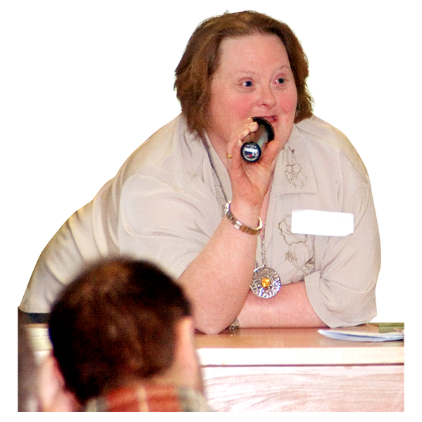 | Tick 1 box.  I want the Convener to give my proxy vote. ☐
 | OR  I want the person below to give my proxy vote. ☐  Their name: _____________________
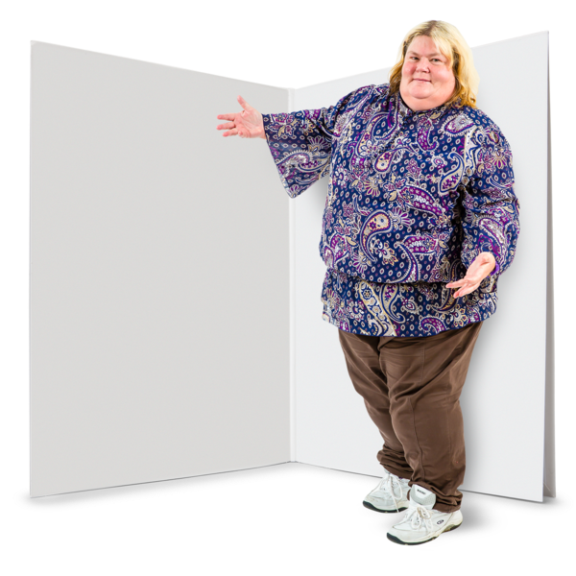 | Here are the resolutions to vote on.  Resolutions means the agreements or new changes at this meeting.
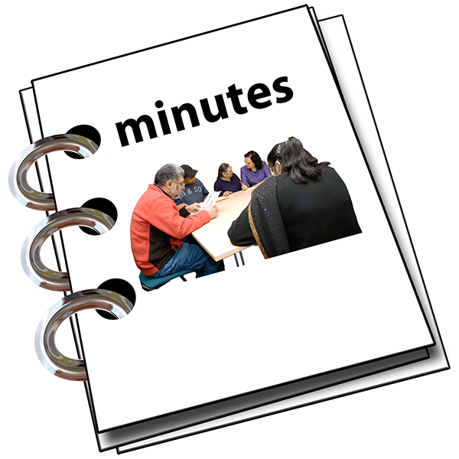 | Resolution 1  The Minutes from the last meeting on  9 October 2024 are true.

  Yes, I agree | ☐
  No, I don’t agree | ☐
  I am not voting for this resolution. | ☐
 | Resolution 2  The Trustees Report and the Accounts from the year ending 31 March 2025 are okay.

  Yes, I agree | ☐
  No, I don’t agree | ☐
  I am not voting for this resolution. | ☐
 | Special Resolution 3  I think the wording changes in the Membership part of the Articles of Association are okay.
 | Articles of Association are the agreements that Disability Equality Scotland has.
Yes, I agree | ☐
No, I don’t agree | ☐
I am not voting for this resolution. | ☐

 | Resolution 4  The new Independent Examiners can be Armstrong Watson LLP – used to be called Martin Aitken and Company.
Yes, I agree | ☐
No, I don’t agree | ☐
I am not voting for this resolution. | ☐

 | Resolution 5  Agnieszka Davren can be a Director at Disability Equality Scotland.  She joined in October 2024.
Yes, I agree | ☐
No, I don’t agree | ☐
I am not voting for this resolution. | ☐

Resolution 6

Kenneth Taylor can be a Director at Disability Equality Scotland.

He joined in February 2025.

Yes, I agree | ☐
No, I don’t agree | ☐
I am not voting for this resolution. | ☐

Resolution 7

Scott Stewart can be a Director at Disability Equality Scotland.

He joined in September 2025.

Yes, I agree | ☐
No, I don’t agree | ☐
I am not voting for this resolution. | ☐

Resolution 8

Helen Douglas can be a Director at Disability Equality Scotland.

Yes, I agree | ☐
No, I don’t agree | ☐
I am not voting for this resolution. | ☐

About counting the votes

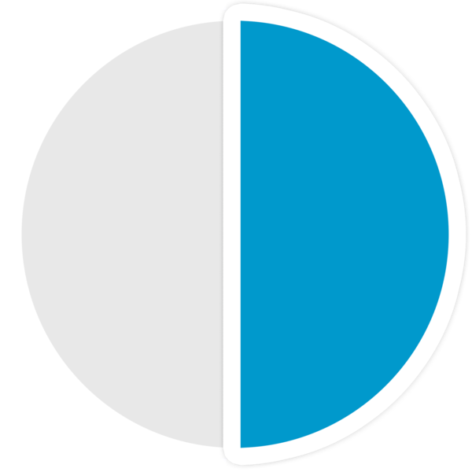 | Most of these resolutions need more than half the people to vote yes to let the change happen.
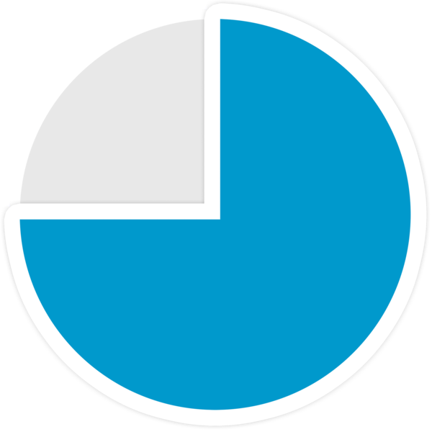 | But Resolution 3 is a Special Resolution.  This means it needs 3 out of every 4 people to vote yes to let it happen.

About you
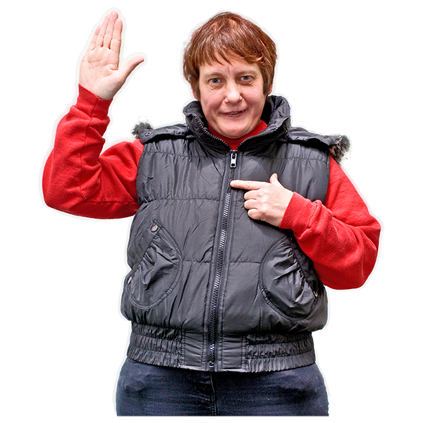 | My name:
 | My organisation – if I have one:
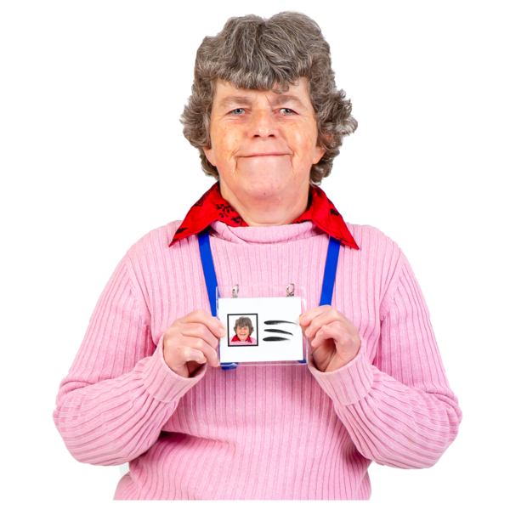 | My job name in my organisation – if I have one:
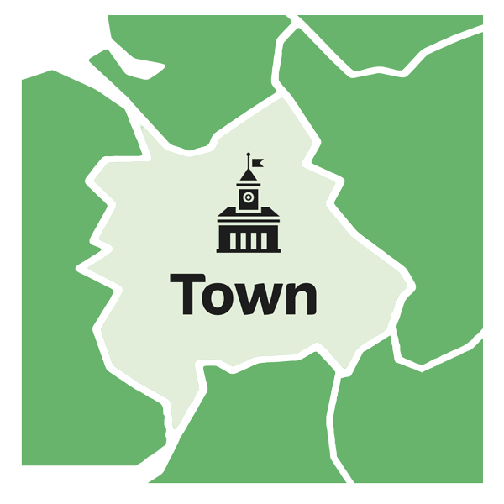 | My own address or my organisation’s address:
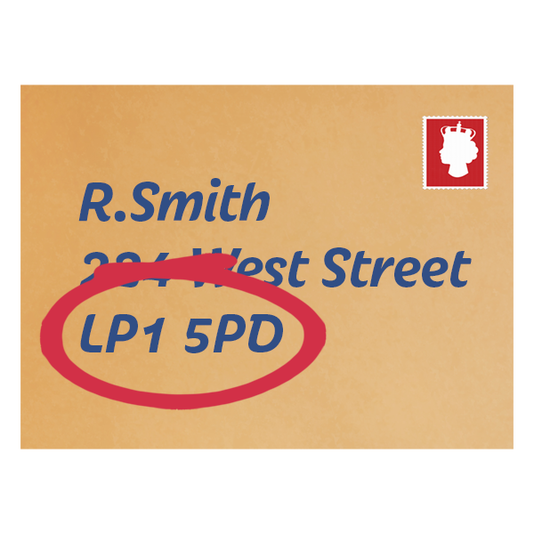 | The postcode:
 | My email address:
 | The date today:
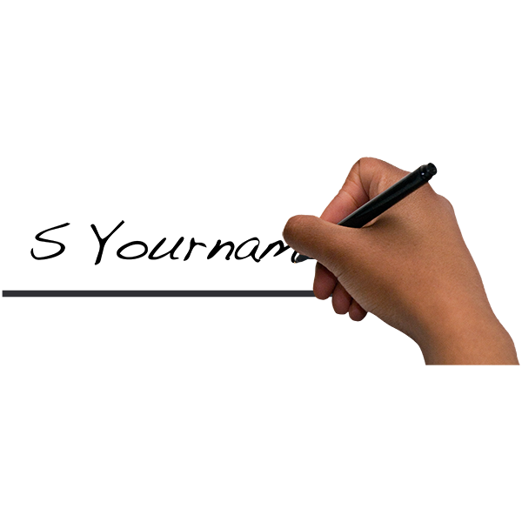 | My signature:
 | You can save your form and email a copy to membership@disabilityequality.scot
Or you can print and post your form to

Disability Equality Scotland
Norton Park
57 Albion Road
Edinburgh
EH7 5QY

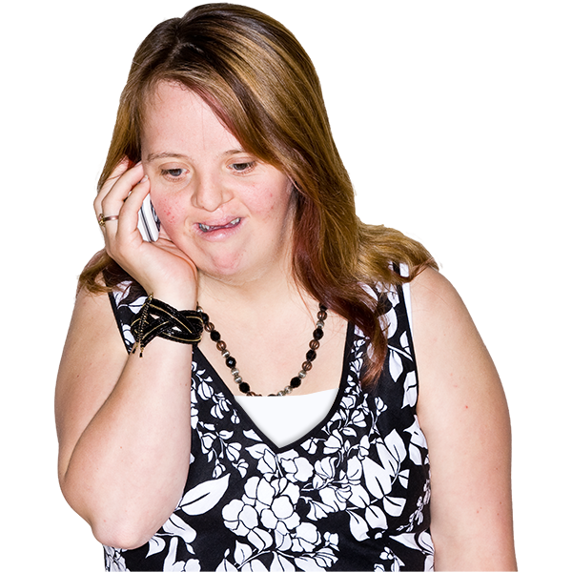 | If you need any help, you can phone Douglas on 0141 370 0968  Type in 314 when it asks you for the extension number.
 | We take great care with personal information and privacy.  If you want to know more about our privacy policy, please email james@disabilityequality.scot
  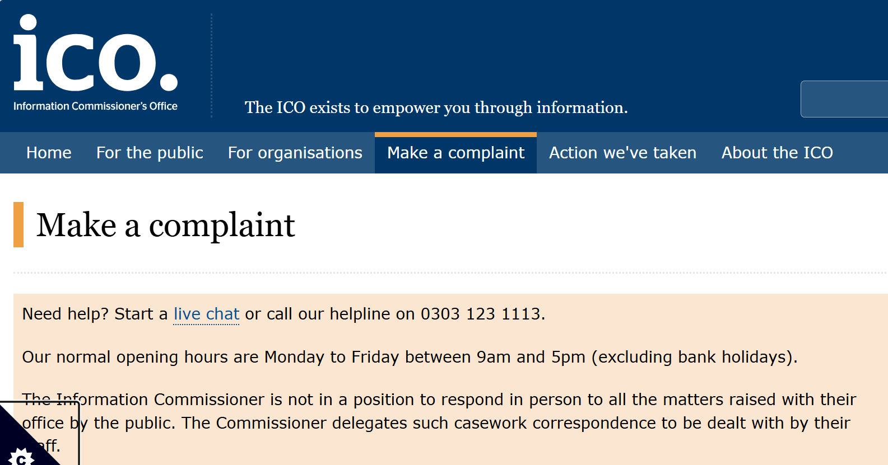 | You could also complain to the Information Commissioner’s Office by clicking on the website here https://ico.org.uk/concerns/
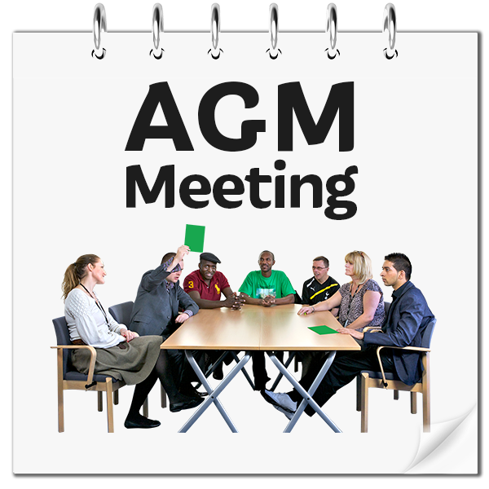 | The information you have given us on this form will let us collect your votes and make you a part of this AGM.
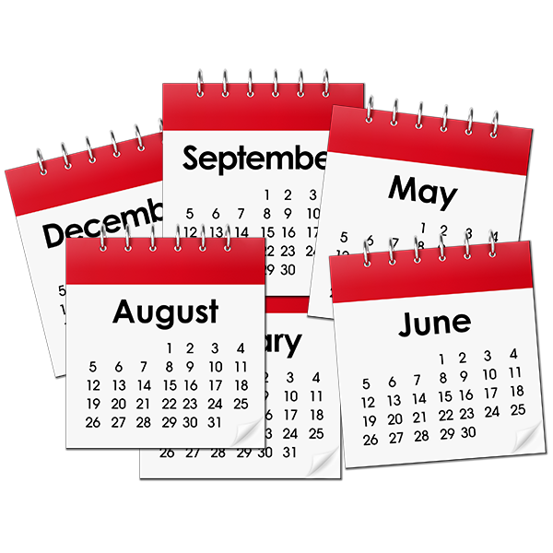 | We will keep the information for 1 year and then we will delete it.
 | When you sign the form, it means you let us use your information for this AGM.

