

Changes of Directors 2025


Easy Read



Changing Directors

 | Part of our Annual General Meeting is about changing Directors.
 | In charities, Directors are people who:  - plan new work  - help get more funding  - tell others about the charity’s work
 | Sometimes Directors:  - need to leave their role  - want to carry on with their role  - want to begin their role
 | Disability Equality Scotland has special rules called the Articles of Association.
 | 1 rule says that new Directors need to be agreed by the members.  This is called being elected.
First new Director
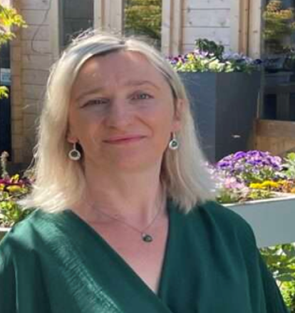 | 1 new Director joined Disability Equality Scotland on 14 October 2024.  Her name is Agnieszka Davren.  She wants to be elected at the Annual General Meeting.

Information about Agnieszka Davren
 | - she has worked in human resources for more than 20 years  - she lives in Renfrewshire with her family and pets  - she wants chances for everyone to achieve and live well

Second new Director
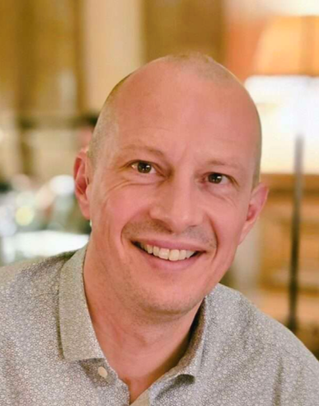 | 1 new Director joined Disability Equality Scotland on 1 February 2025.  His name is Kenneth McDonald.  He wants to be elected at the Annual General Meeting.

Information about Kenneth McDonald
- he has 25 years experience working in marketing and communications

- he has worked for many different organisations

- he wants:
    - change that makes life fairer
    - happier communities

Third new Director
 | 1 new Director joined Disability Equality Scotland on 30 September 2025.  His name is Scott Stewart.  He wants to be elected at the Annual General Meeting.

Information about Scott Stewart

- he works to change things that stop disabled people from living full lives

- he works with Age Scotland and has worked with Disability Information Scotland and local government

- he wants to support DES getting a better life for disabled people

Fourth new Director
1 new Director is asking to be elected at the Annual General Meeting.

Her name is Helen Douglas.

Information about Helen Douglas
- she is the Chair of Glasgow Access Panel

Photo credits – Photosymbols and LinkedIn

