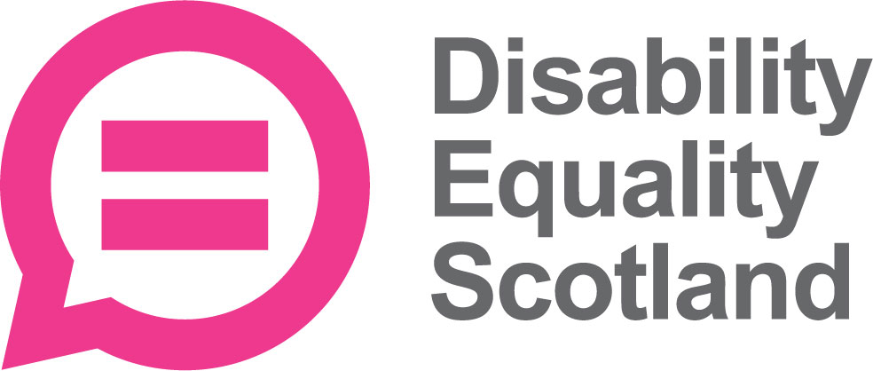

Our work from 1 April 2024 to 31 March 2025 Part 1

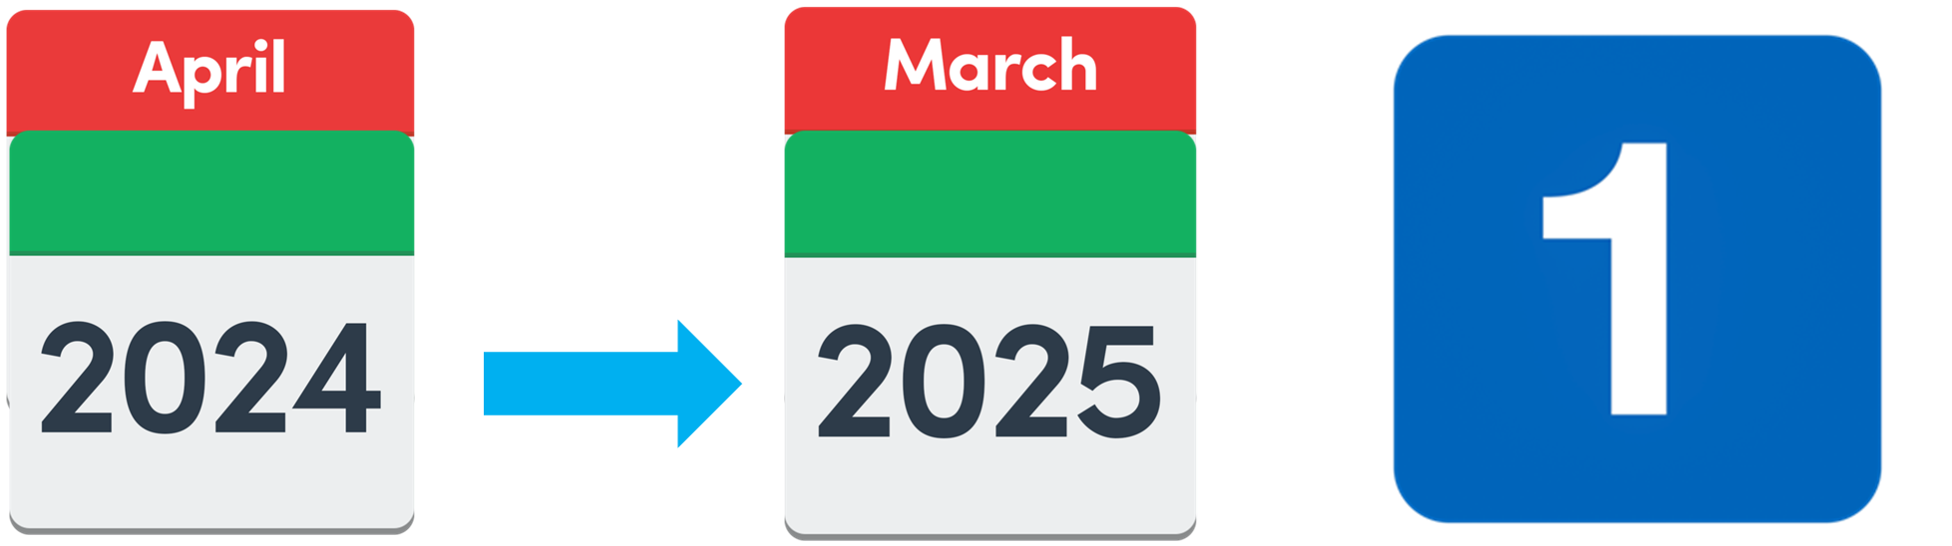

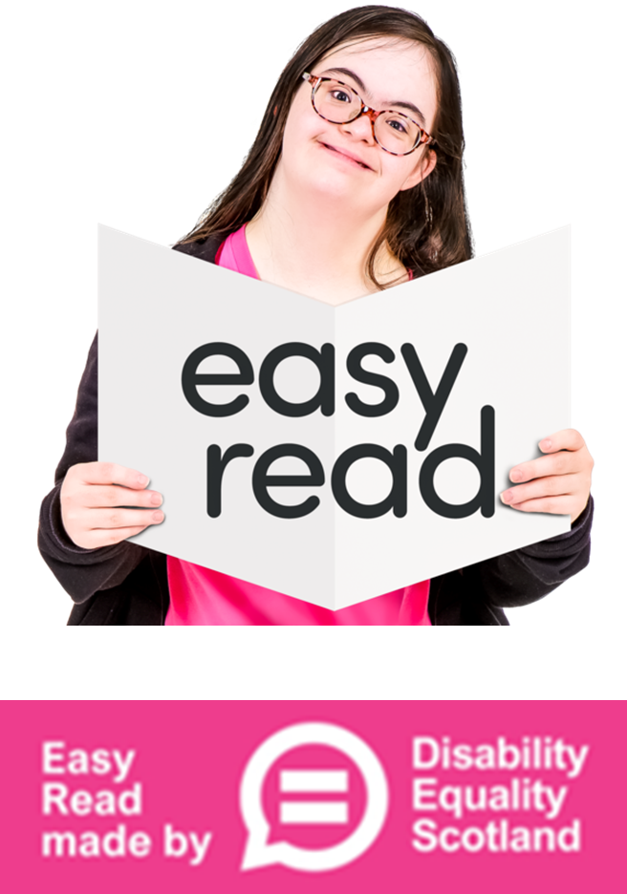

About this Easy Read document

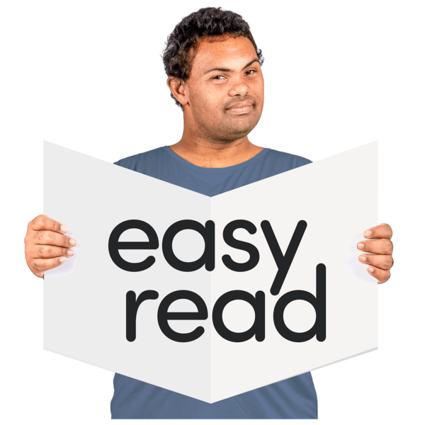 | This is an Easy Read document.
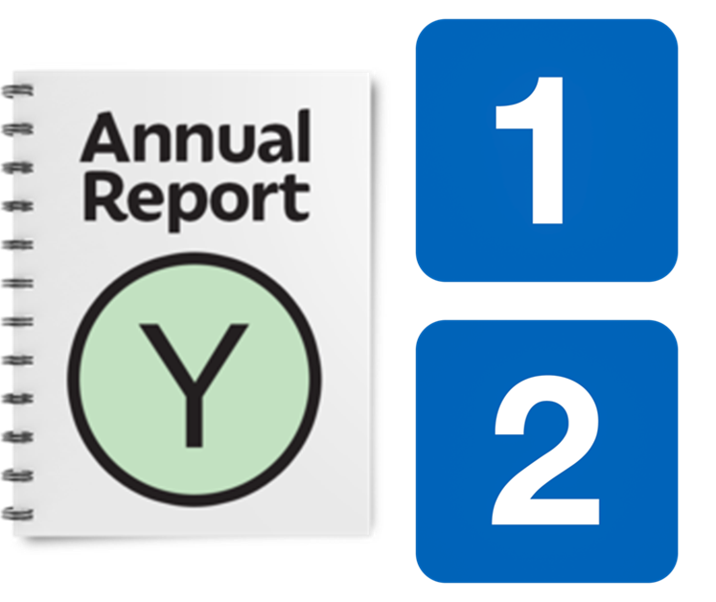 | It is our Annual Report.  There is a Part 1 and a Part 2.
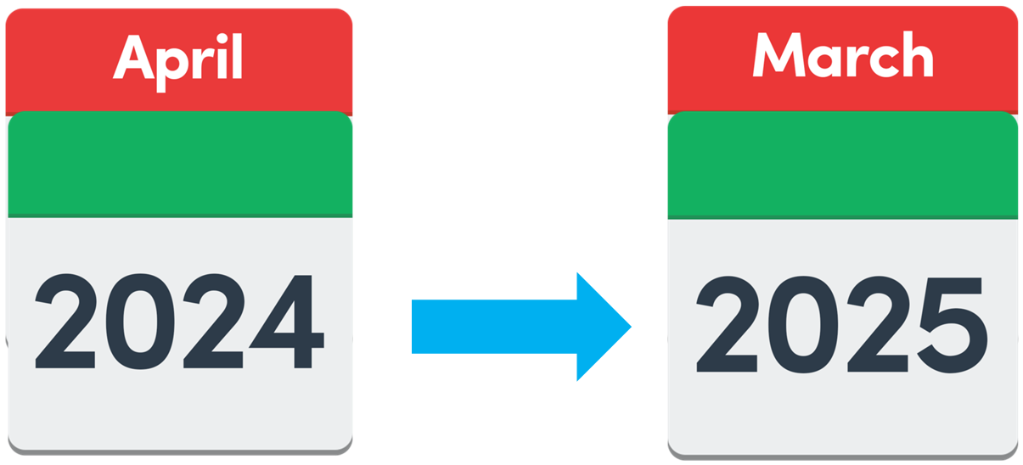 | It tells you about our work between 1 April 2024 and 31 March 2025.
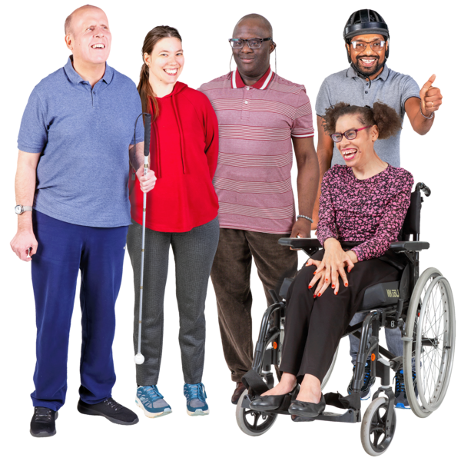 | Disability Equality Scotland is a charity that works to make life better for disabled people in Scotland.  We are also called DES for short.

What we want
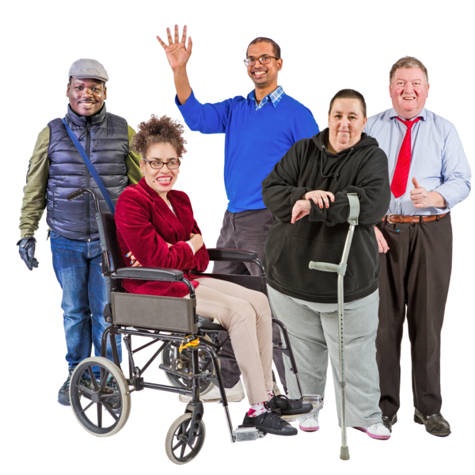 | Disability Equality Scotland wants these things for disabled people:  - equality – this means fairness and help to get the same chances  - inclusion – this means not leaving anyone out  - joining in with all parts of life
 | This is our vision – it is what we want to happen.
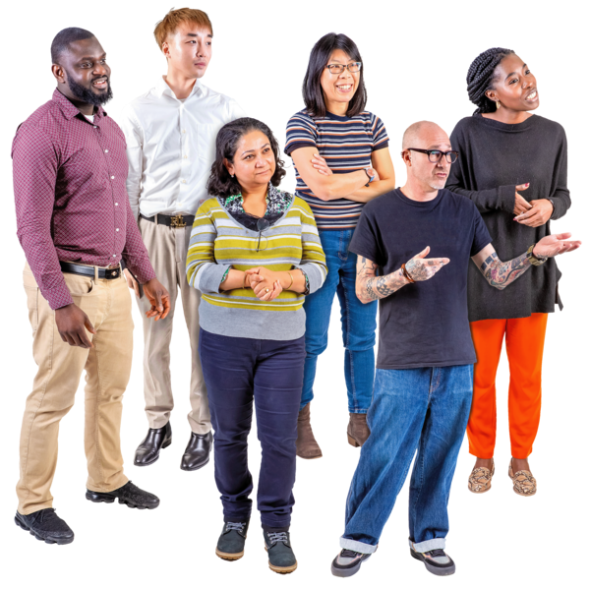 | We want every disabled person in Scotland to know they have:  - a voice – we will speak up for them  - trust  - care  - understanding and kindness  This is our mission – it is what we are trying to do.

Our 8 aims this year

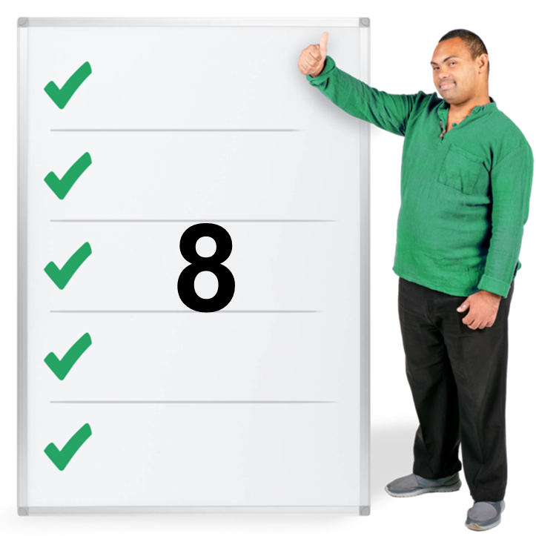 | This year we have had 8 aims.  Aims are our goals.  They are what we want to get done.
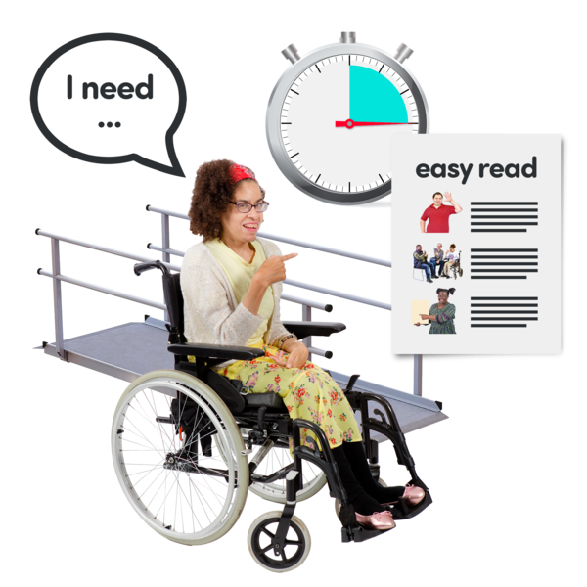 | 1. To make it easier and better for disabled people to join all parts of life.
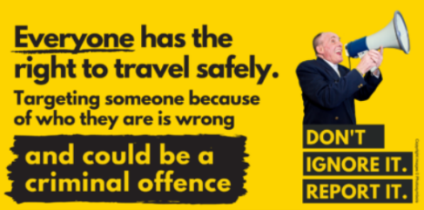 | 2. To help more people understand and report disability hate crime.
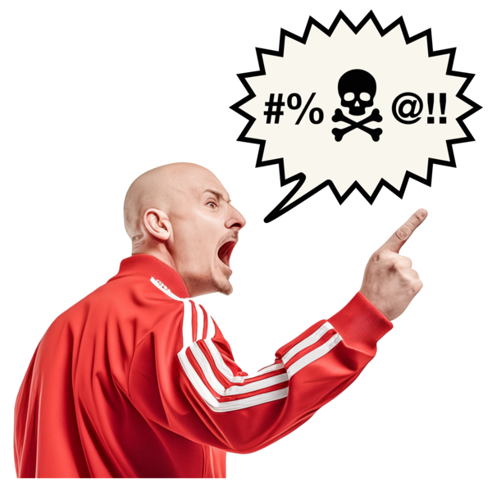 | A hate crime is when someone does something to hurt you because of who you are or who they think you are.
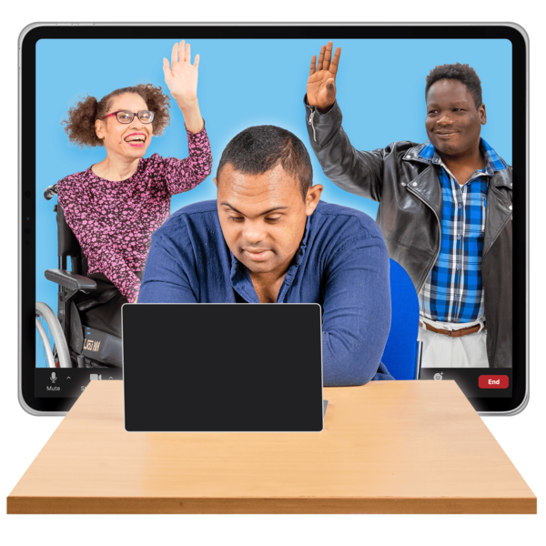 | 3. To help Access Panels chat with each other and share information.
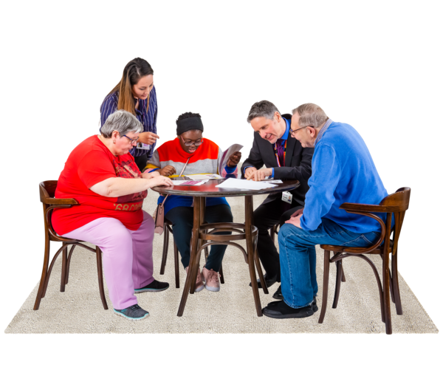 | 4. To help more people in our Access Panels to understand:  - access – getting to something  - equality  - inclusion
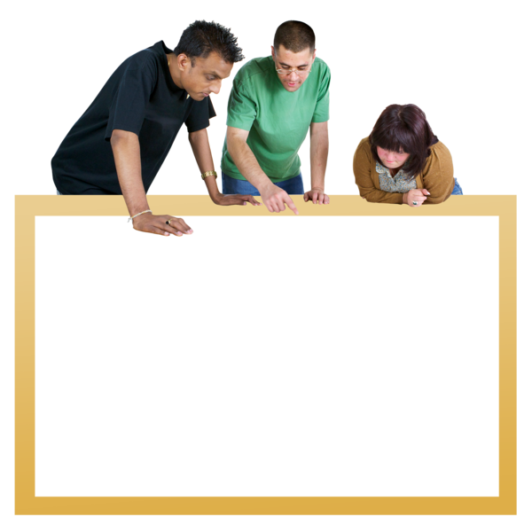 | 5. To advise people who plan spaces and buildings about making them easier for disabled people to use.
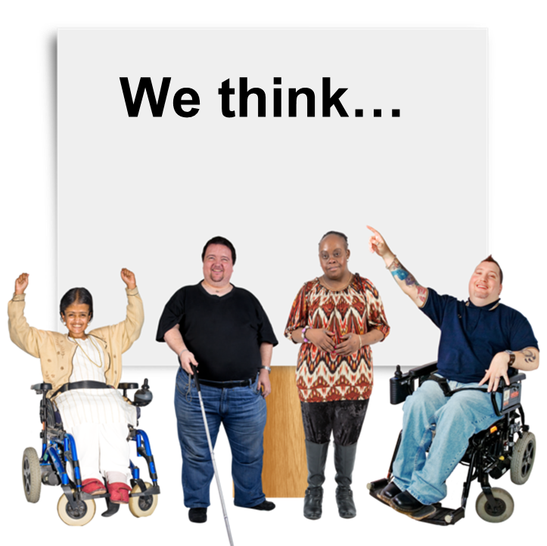 | 6. To help disabled people to have their thoughts heard about accessible travel.
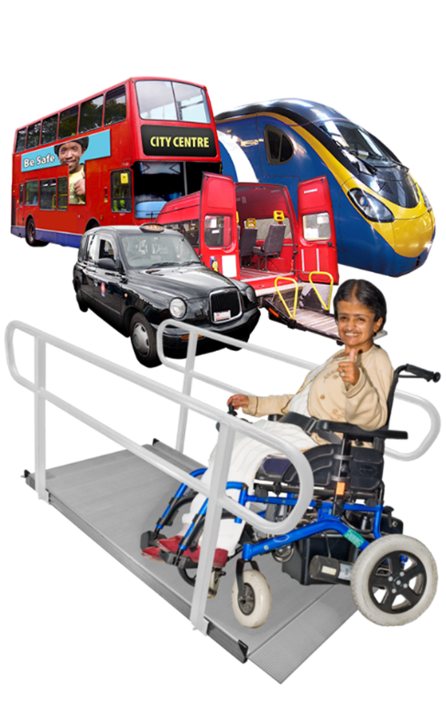 | Accessible travel is when transport is made so that everyone can use it.  This means things like pathways and toilets too.
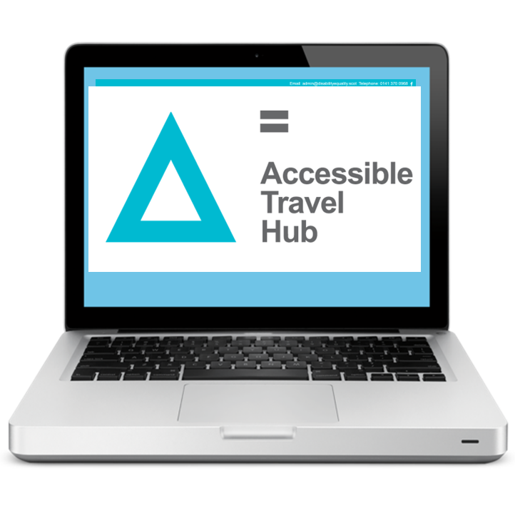 | 7. To make sure that everyone can get our guidance about accessible travel from our Accessible Travel Hub website.
 | 8. To help different travel organisations to work together to stop hate crime happening in Scotland.

Our members
People who join Disability Equality Scotland are our members.

We often ask our members what they think about lots of different things.

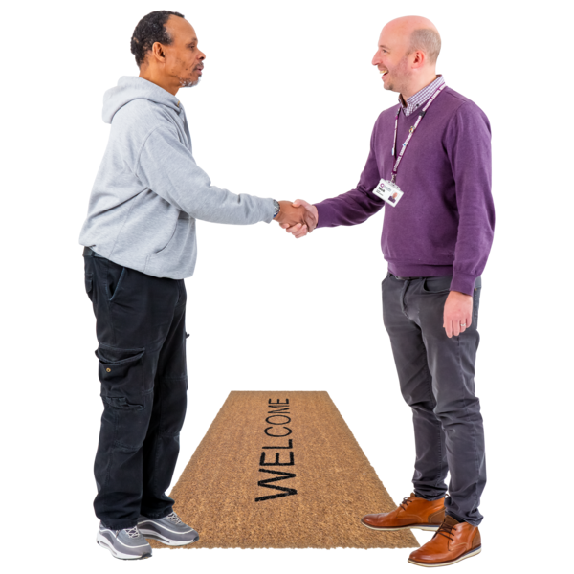 | This year we had 1 hundred and 12 new members joining us.  31 members have left.  In total we have 1 thousand 6 hundred and 9 members.
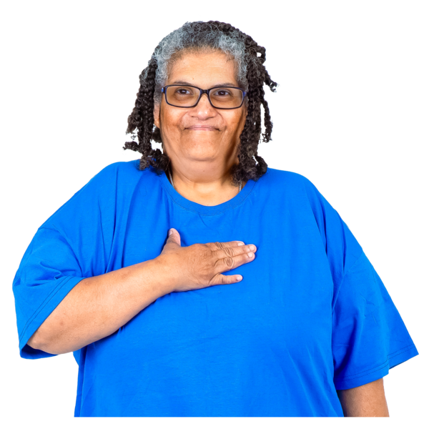 | Most of our members are people joining on their own.
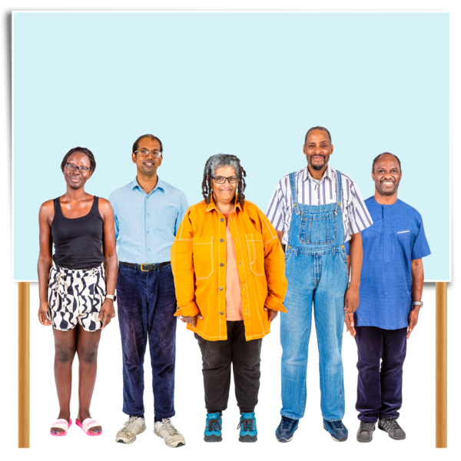 | Some of our members are organisational members.  Organisational members are organisations like charities and businesses.
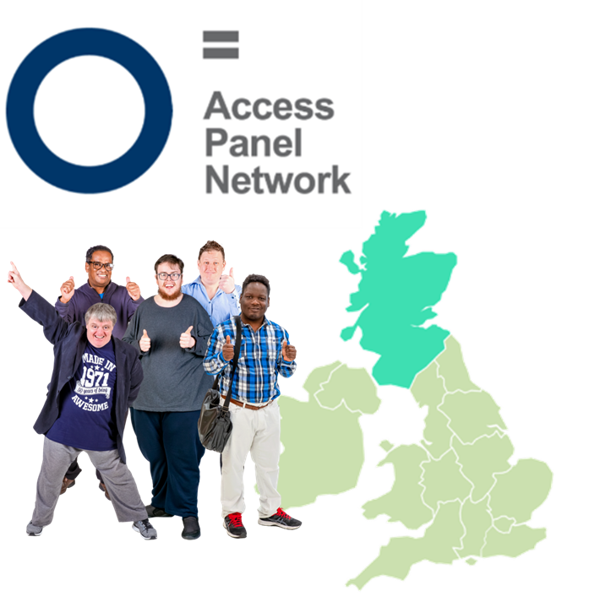 | Some of our members are Access Panel members.  Access Panels are groups of people across Scotland.  They help make their local area better for disabled people.
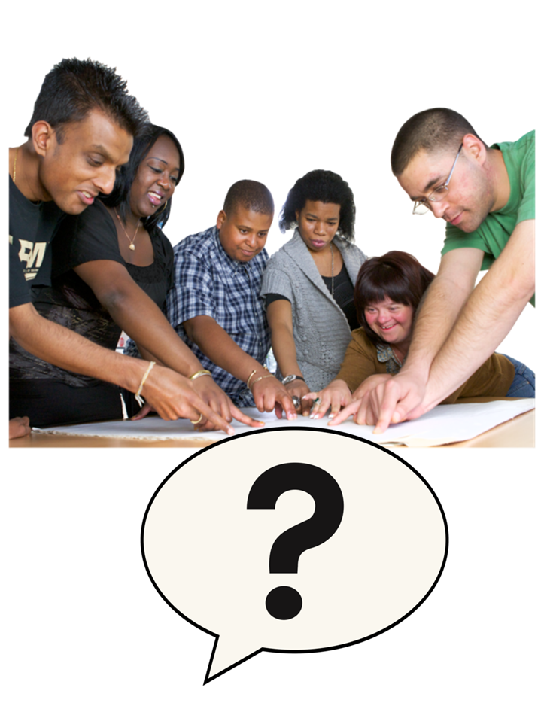 | Our members are at the centre of what we do.  We asked our members:  What work should we focus on this year?
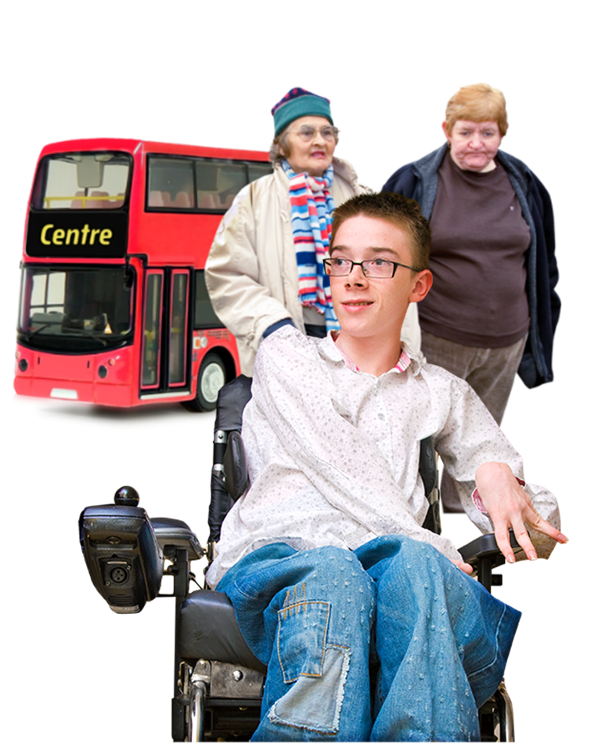 | Almost everyone said they wanted us to work on making accessible travel better.
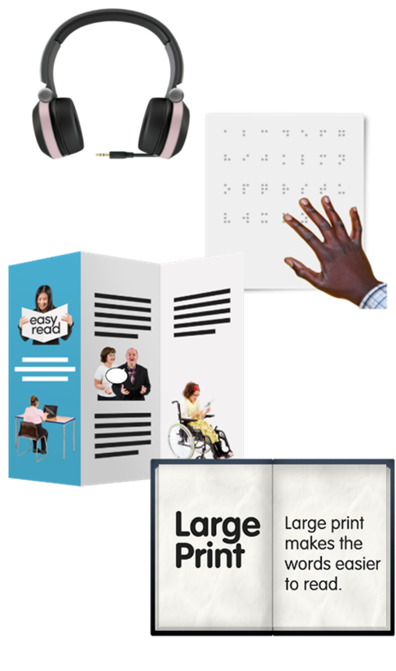 | They also said we should focus on these things:  - inclusive communication – this means making sure more people can get the information they want in the way they need it
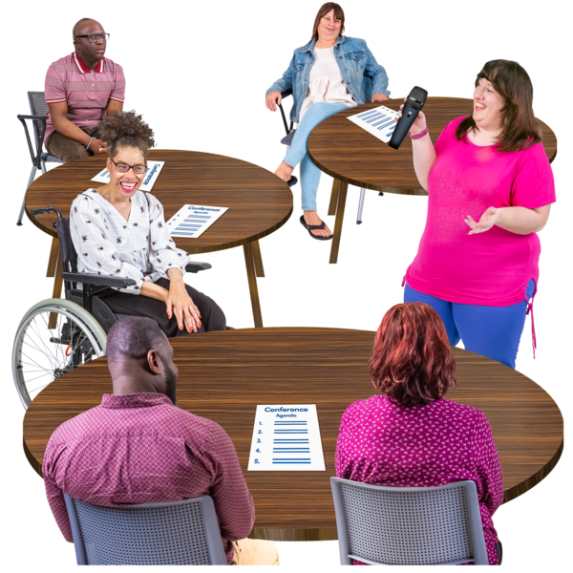 | - training to help other organisations be better at including disabled people
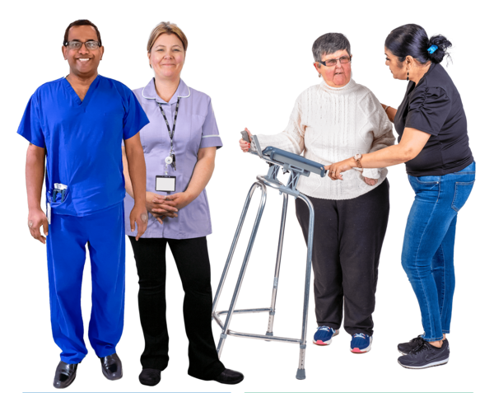 | - health and social care
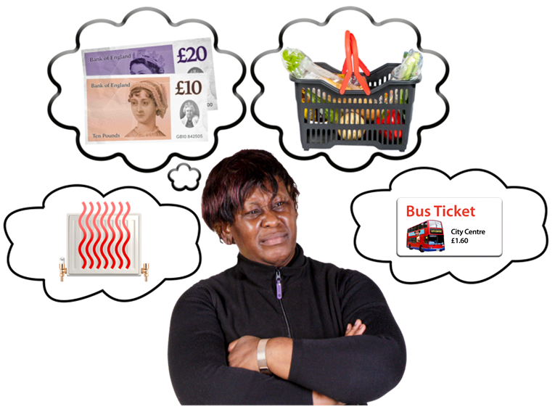 | - poverty and the cost of living – this means people not having enough money to pay for bills
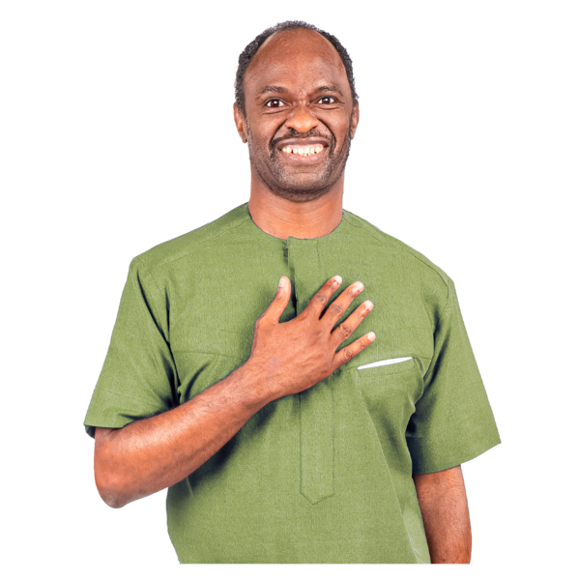 | - human rights – this means the basic rights and freedoms that belong to everyone in the world
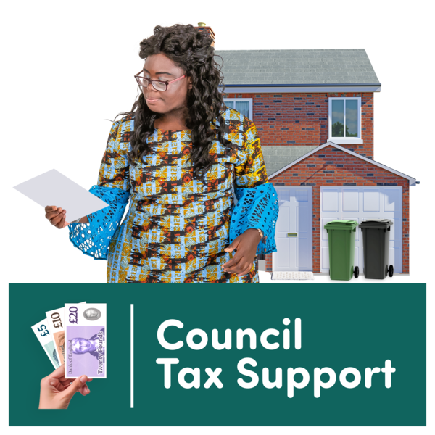 | - social security benefits – this means the money that a government gives people who need help paying for basic living expenses

Our newsletter

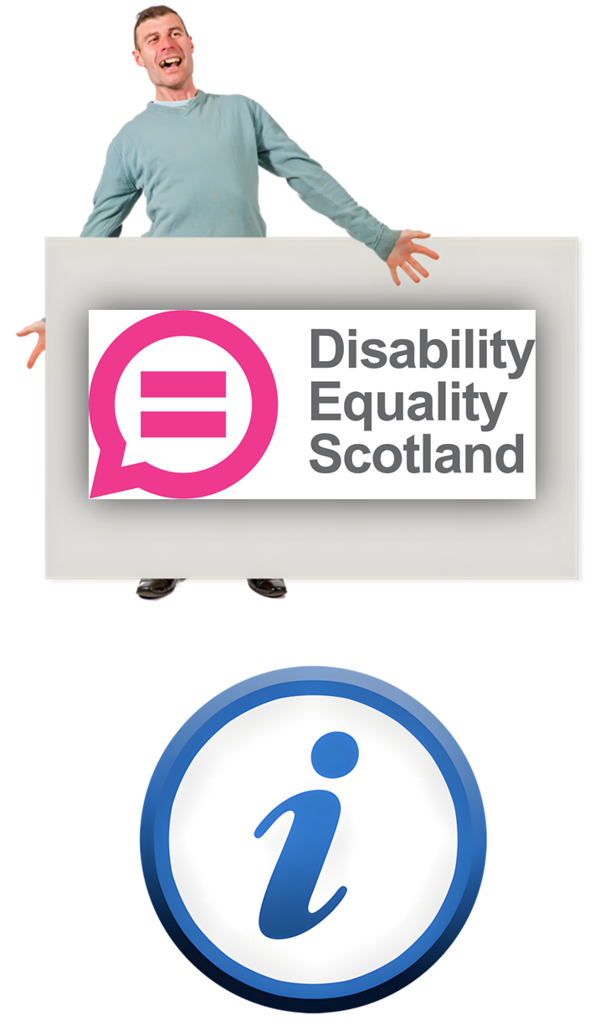 | We have shared our work and news in our newsletters.  We have shared information about:  - our training courses  - our Easy Read service  - what is happening in our Access Panel areas  - answers to consultations
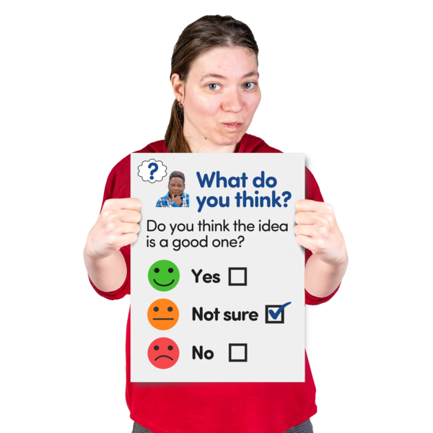 | Consultations are questions asked by the Scottish Government to find out what people think.

Online sessions
 | Online sessions are meetings and events which use Zoom or Teams.  People can join online sessions using their computer or smartphone.
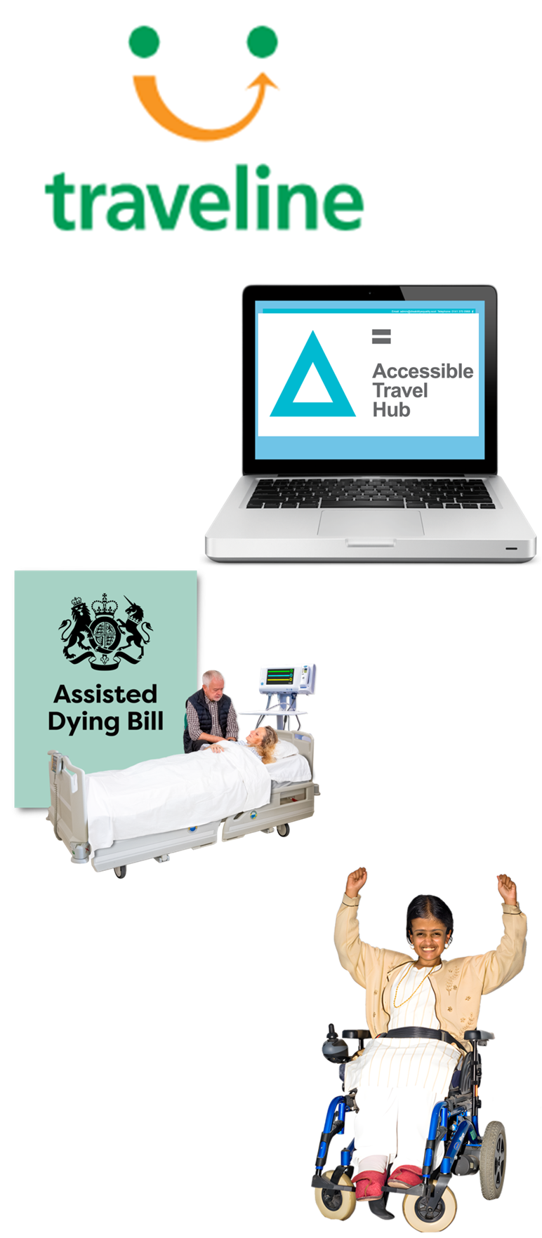 | This year we organised 4 online sessions about disability.  They were about:  - the Traveline App  - the Accessible Travel Hub  - the Assisted Dying Bill  - a Disability Commissioner
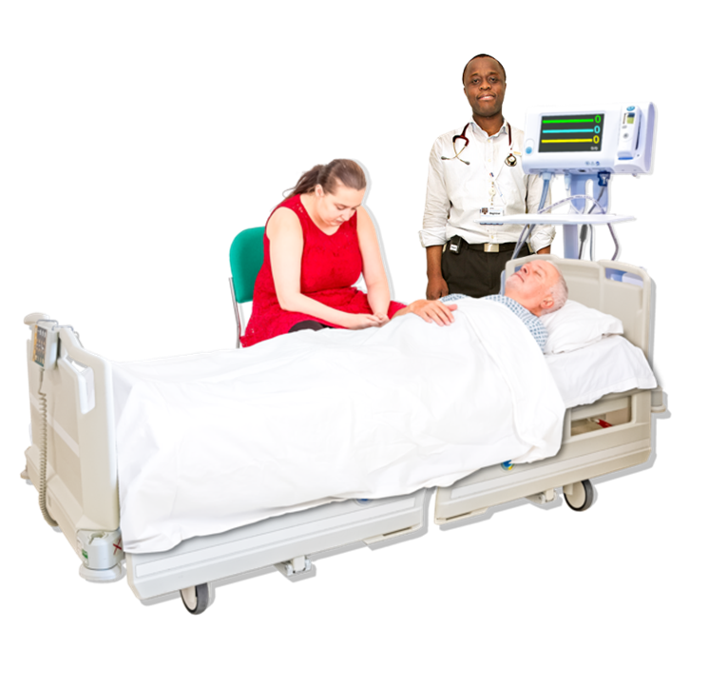 | The Assisted Dying Bill is a plan for a new law about having help to die if you have an illness that you can never get better from.
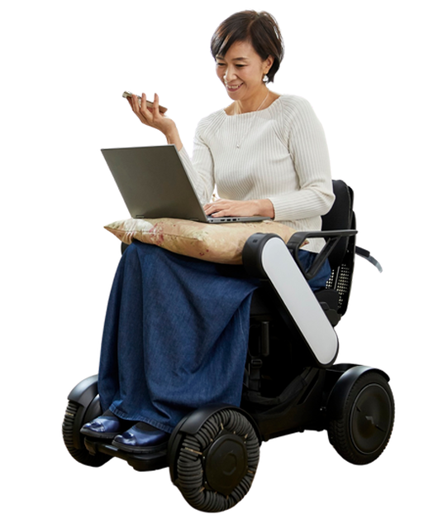 | A Disability Commissioner is someone who speaks up for disabled people and do work to protect their rights.

Inclusive Communication
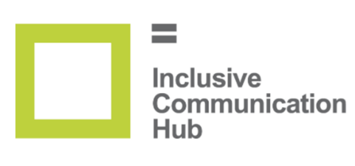 | We have a website called our Inclusive Communication Hub.
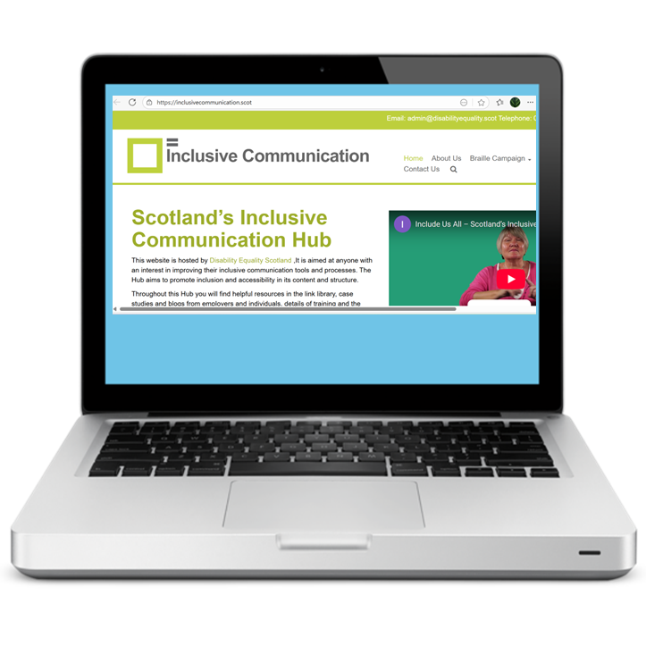 | You can find our Hub at www.inclusivecommunication.scot
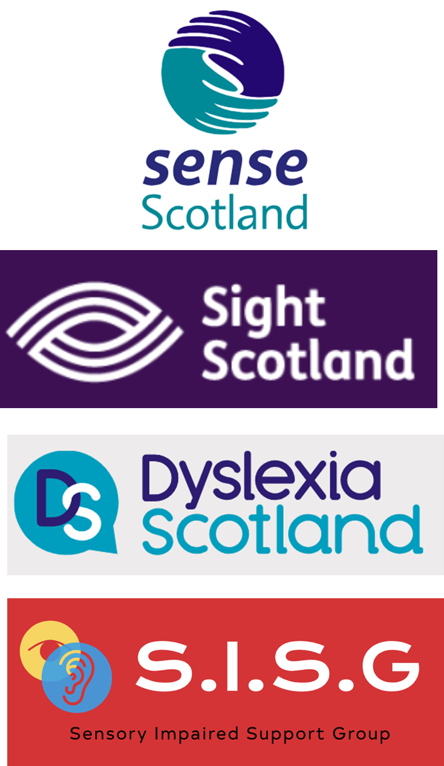 | This year we have worked with:  - Sense Scotland  - Sight Scotland  - Dyslexia Scotland  - the Sensory Impaired Support Group
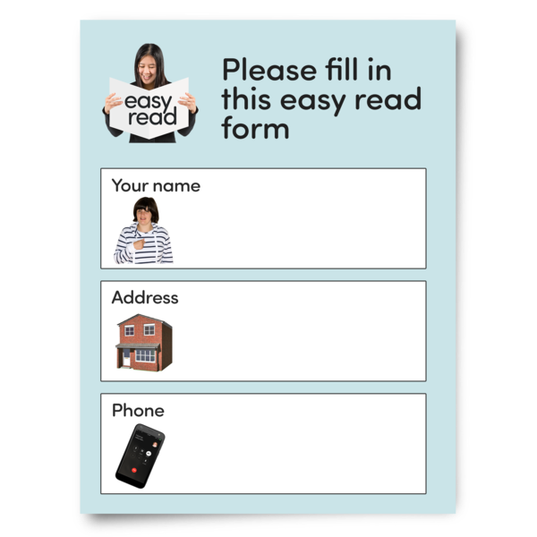 | We have worked together to make things better at including everyone.
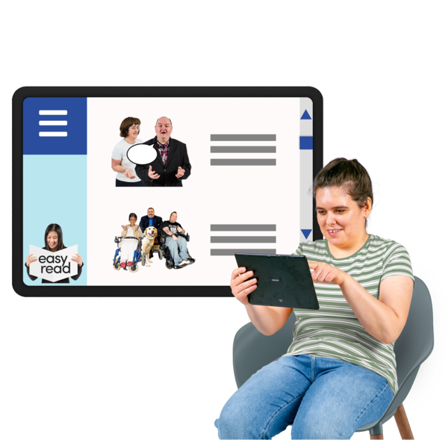 | We have trained organisations and made Easy Read documents.
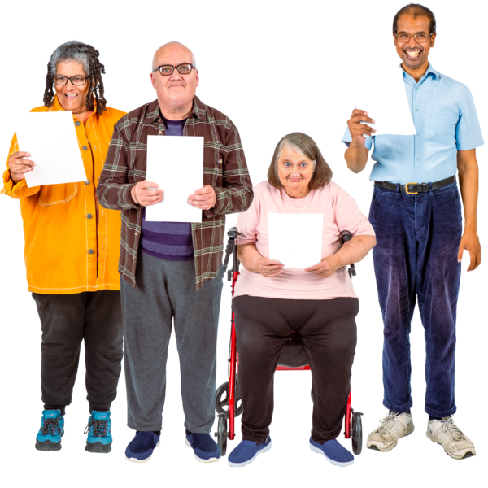 | We are working with Inclusive Communication People to make an Inclusive Communication Toolkit.
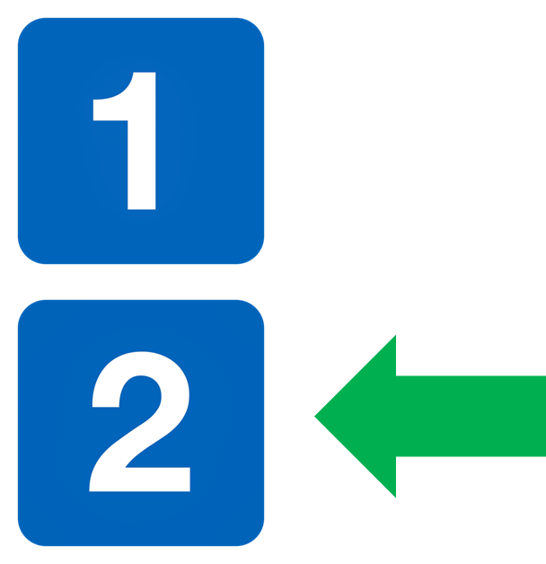 | Please now read Part 2.

