

Our work from 1 April 2024 to 31 March 2025 Part 2





About this Easy Read document

 | This is an Easy Read document.
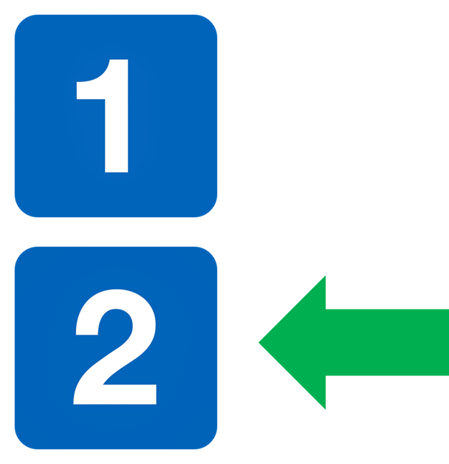 | It is Part 2 of our Annual Report.
 | Please read Part 1 first.

Easy Read

 | DES writes Easy Read documents, like this one.
 | This year we wrote 1 hundred and 14 Easy Read documents.
 | We will have a new Easy Read writer soon so that we can write more Easy Read documents.

Training

 | This year we offered more training courses.
 | This year we:  - had 4 Easy Read Training courses for anyone to join  - had 5 Easy Read Training courses designed for 4 organisations  - had 4 Inclusive Communication courses for anyone to join  - had 1 Disability Hate Crime course for anyone to join  - had 3 Disability Hate Crime courses for 3 transport organisations

Questions from members

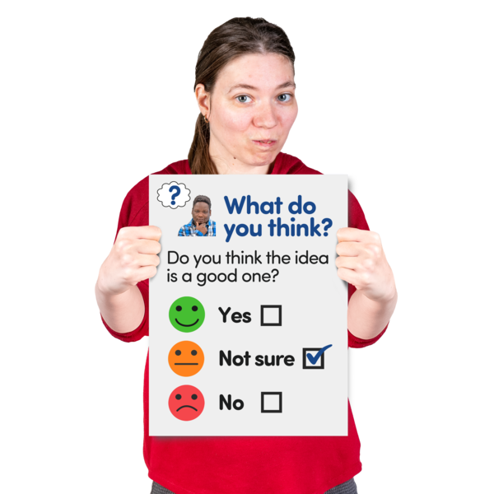 | We ask our members questions and we share Scottish Government consultation questions.
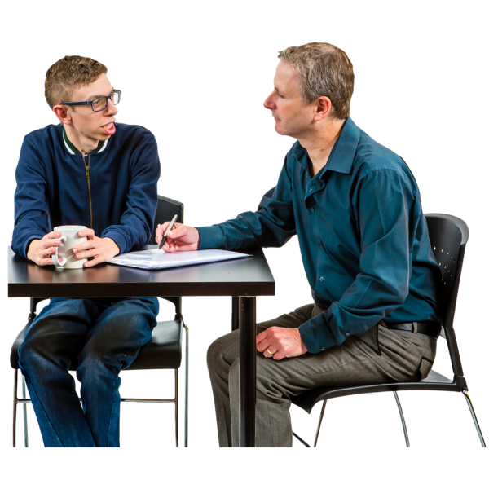 | This year we asked our members what they thought about:  - hate crime  - energy costs  - the Winter Fuel Allowance  - using taxis  - the Thistle Assistance Card  - having 1 type of charger for electric devices  - the cost of living
 | We also talked to Scottish Government groups about:  - the Disability Commissioner Bill  - the Assisted Dying Bill  - how the pandemic affected disabled people
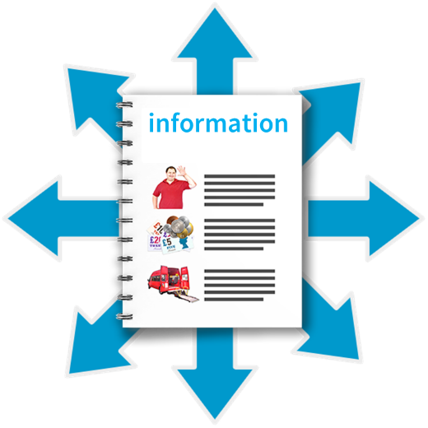 | We shared our members answers with:  - 16 national groups  - 3 Scottish Parliament Cross Party Groups
 | Cross Party Groups means groups of Members of Scottish Parliament and other organisations who are interested in the same thing.

Disability Hate Crime

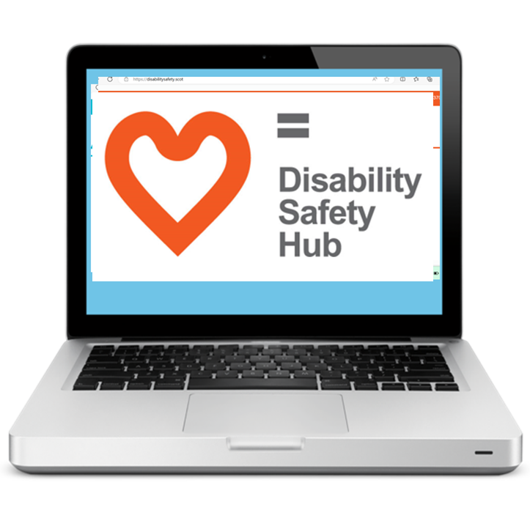 | Our website www.disabilitysafety.scot  is a Hub for disability hate crime.  A hub is a place which has lots of information all in 1 place.
 | We want this Hub to:  - tell more people about disability hate crime  - help more people report hate crime
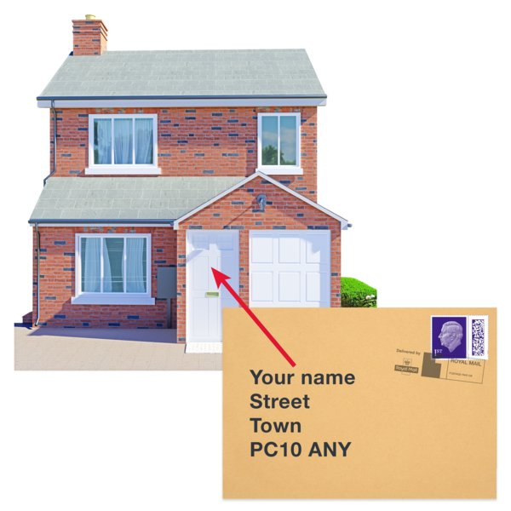 | We made and gave away nearly 1 thousand 5 hundred posters and stickers.
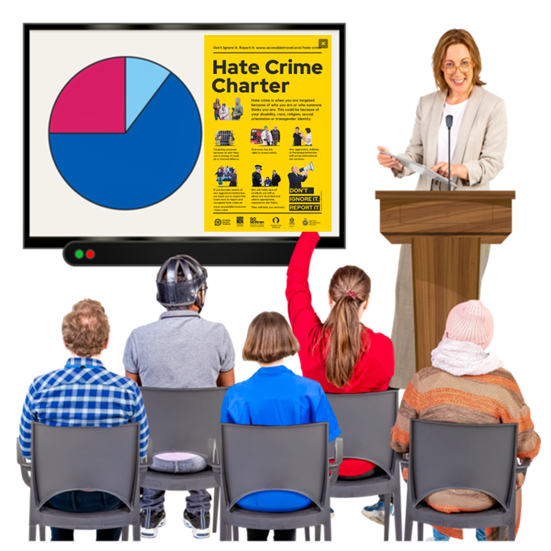 | We trained these transport organisations to spot and deal with hate crime:  - ScotRail  - Stagecoach  - Lothian Buses
 | We welcome City Cabs Edinburgh and Prestwick Airport.  They signed up to support the Hate Crime Charter.
 | 27 transport organisations now support our Hate Crime Charter.

Accessible Travel

 | Our website www.accessibletravel.scot is our Hub for transport and travel.
 | In March 2025 we worked with a small group of our members to make a new, better Hub.

Our Access Panels
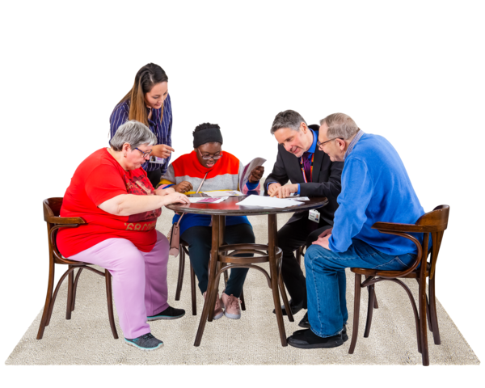 | Access Panels are local groups of volunteers who work to make their area better for disabled people.
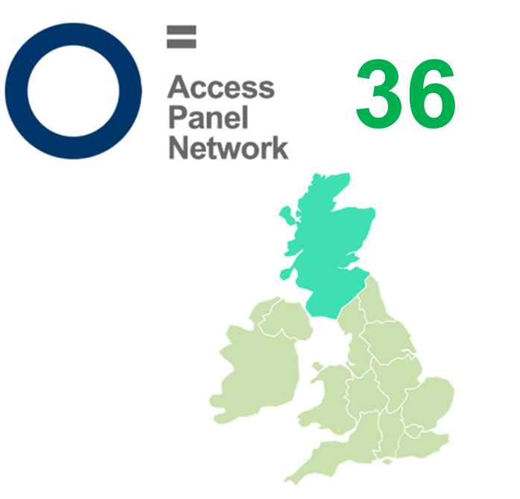 | We now have 36 Access Panels across Scotland.
 | Our Access Panel Conference in June this year went very well and people shared lots of good ideas.
 | We are very grateful to our Access Panel volunteers.

Our staff

 | Our staff team worked hard from home and from our new office in Edinburgh.
 | We believe in good jobs and fair pay.
 | We have carried on working with an organisation called We Are Brass Tacks to begin our new communication plan.  Our staff met together with We Are Brass Tacks in August 2024.
 | Our Board of Trustees from 1 April 2024 to 31 March 2025 were:  Lauren Asher  Kayla-Megan Burns (left in April 2025)  Rhianne Forrest (left in February 2024)  Carolyn Griffiths (left in October 2024)  Marie Harrower (left in April 2025)  Kenny Milne (left in October 2024)  Scott Stewart (left in October 2024 and joined again in September 2025)  Zara Todd  Agnieszka Davren (joined in October 2024)  Derek Taylor (joined in July 2024)  Matson Lawrence (joined in January 2025 and left in September 2025)  Kenny McDonald (joined in February 2025)
 | Our Independent Examiner is Gavin Curr.
 | Independent Examiners are people who check a charity’s money records and paperwork to make sure everything is right and fair.

Our funding

 | We got money in 5 different ways this year.
 | 1. Equality and Human Rights Fund from the Scottish Government  2. Section 10 fund from the Scottish Government
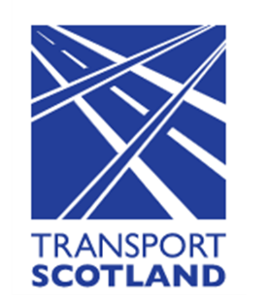 | 3. Transport Scotland
4. Our own funds from our Easy Read service

5. Our own funds from our Training courses

 | This year we brought in 4 hundred and 76 thousand and 44 pounds.
 | This year we spent 5 hundred and 11 thousand, 8 hundred and 24 pounds.
 | There are 2 hundred and 11 thousand, 9 hundred and 31 pounds saved in case we need them.
 | This is the end of the Annual Report.


