

Which things do disabled people think are the most important for the 2026 Scottish Parliament Election?
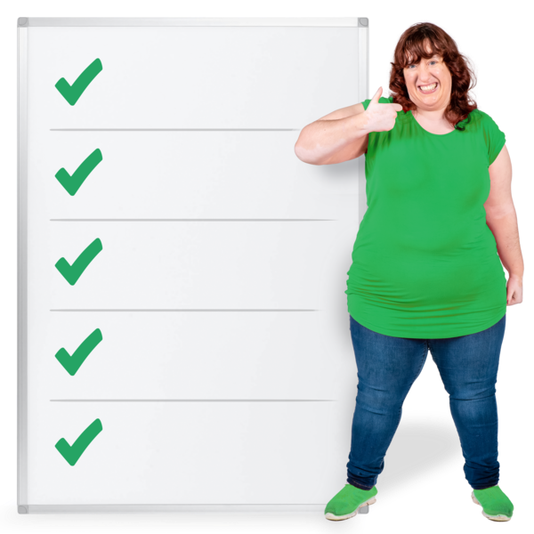




About this document

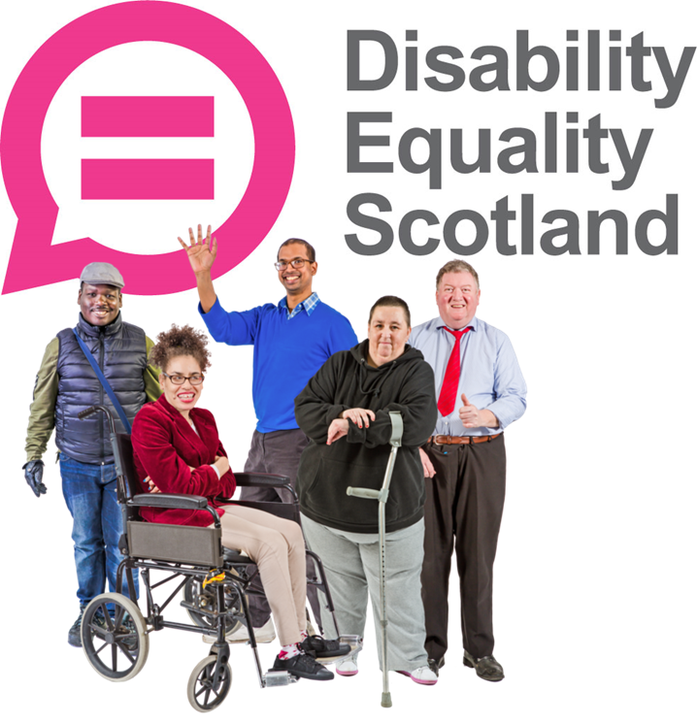 | We are Disability Equality Scotland.
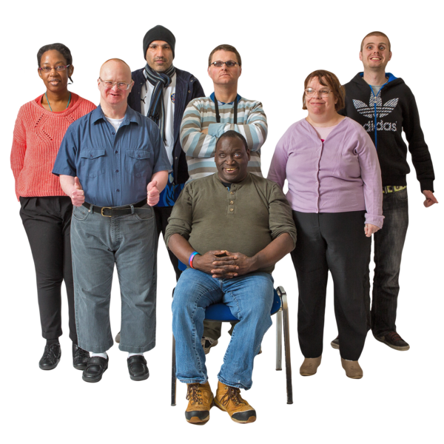 | Disability Equality Scotland is a charity with members.  It works to make the lives of disabled people in Scotland better.
 | This document will ask you which parts of life in Scotland are most important to you.
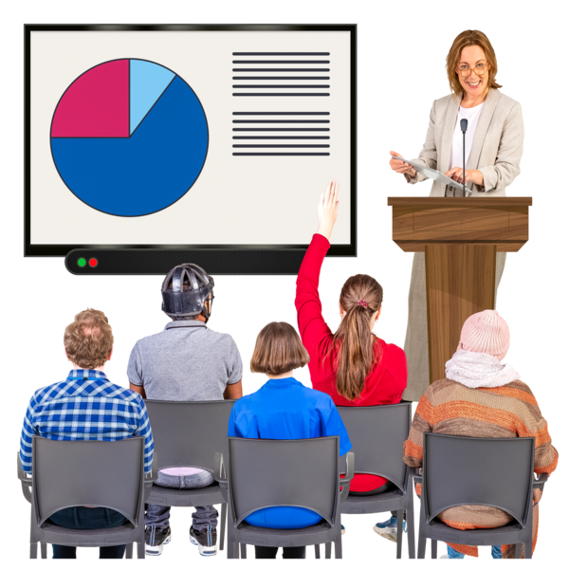 | Your answers will help us to tell everyone what is important to disabled people in Scotland.

What is a Parliament Election

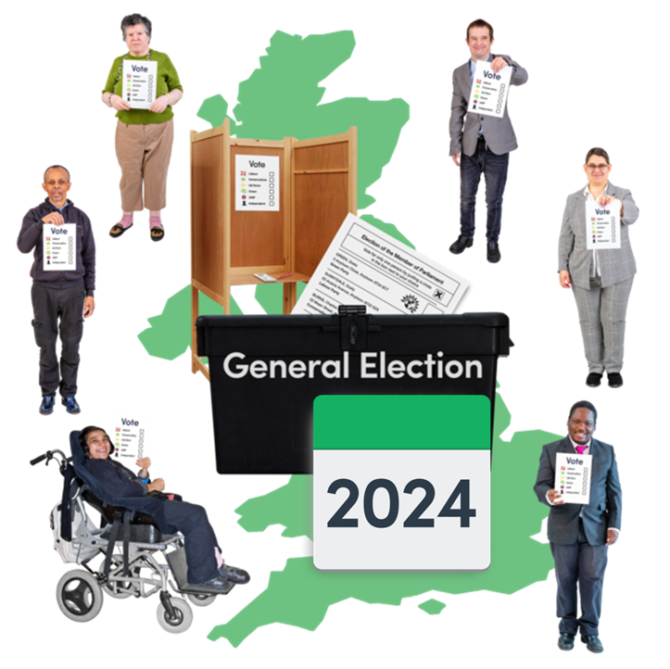 | The Scottish Parliament Election is where everyone is asked to vote for who they want as their local Member of Scottish Parliament for the Scottish government.
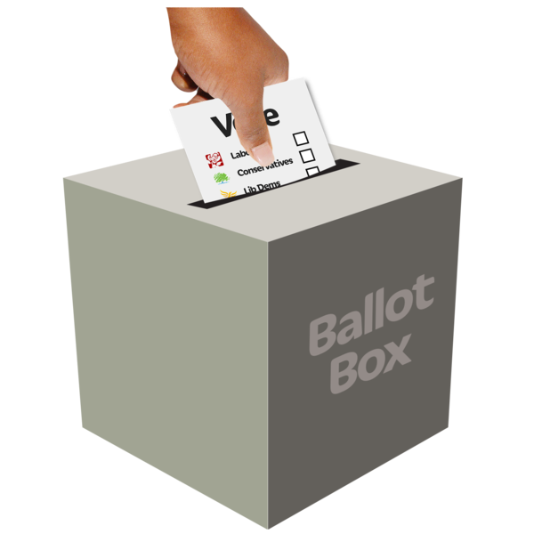 | Vote means to choose the person you think is best.
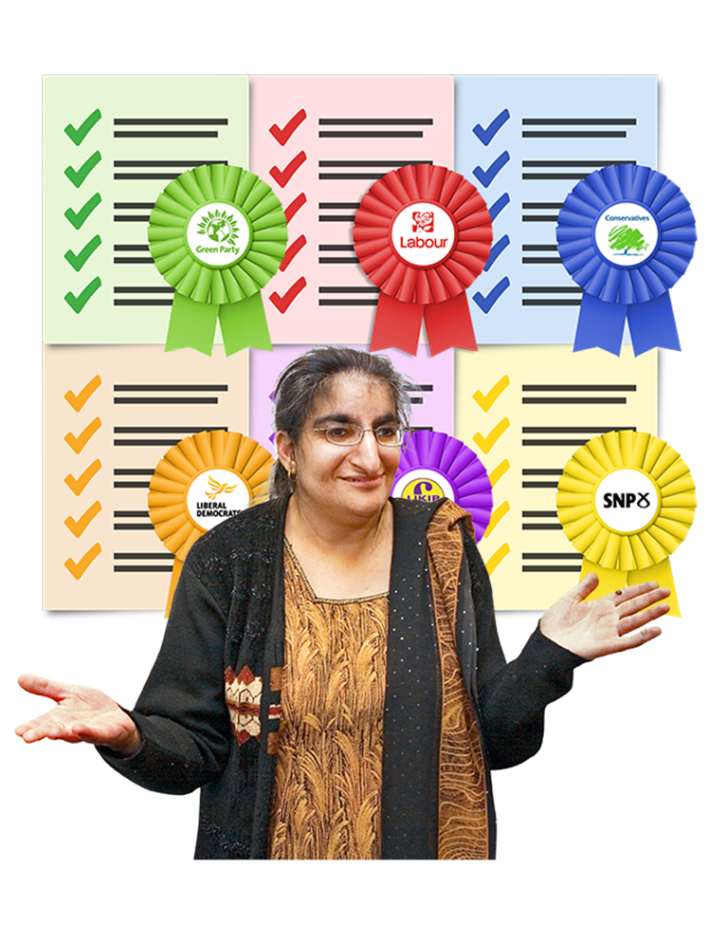 | The person who gets the most votes becomes the local Member of Scottish Parliament.  It is their job to work with the Scottish government to make life better in their local area.
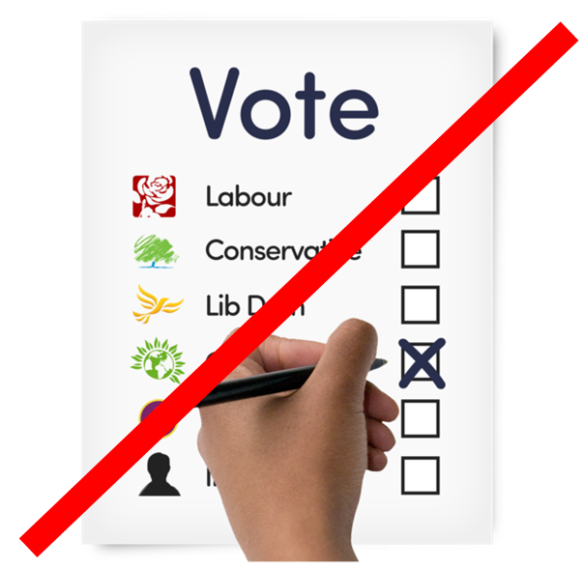 | Disability Equality Scotland are not asking you who you are voting for.  That is private to you.
We are asking you what the important things are for you, as you think about who to vote for.

These important things are also called priorities.

The priorities
 | Here is a list of 33 different priorities.  We will tell you what each one means.
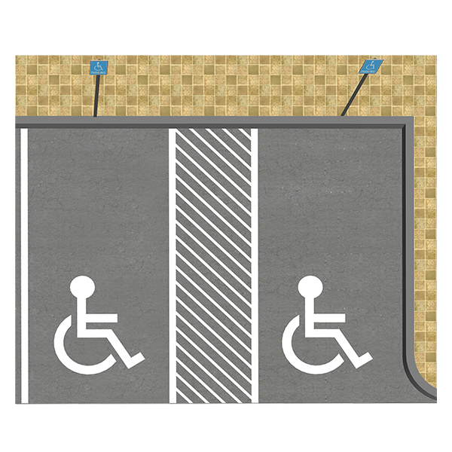 | Accessible Parking  This means parking spaces that everyone can get to and use.
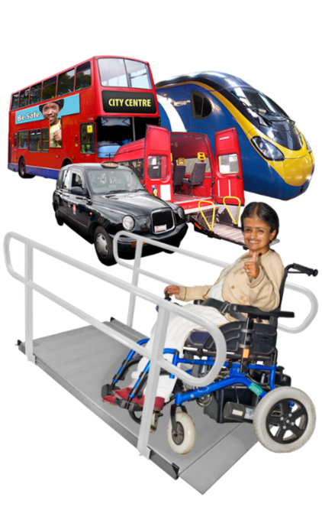 | Accessible Transport  This means ways of getting around – like buses, trams, trains, taxis, ferries and planes that everyone can get to and use.
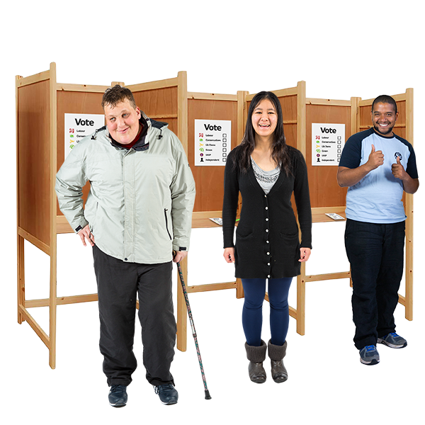 | Accessible Voting  This means that everyone can get to a voting centre and vote.  Voting centres are also called polling stations.
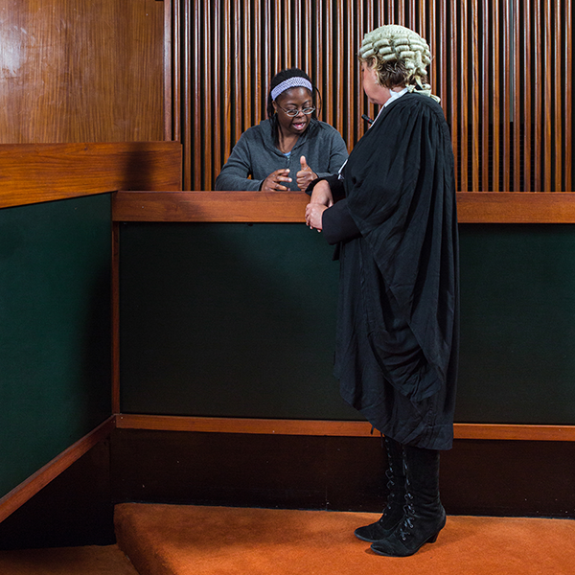 | Access to Courts and Justice Services  This means how easily everyone can get information about making things right when something has gone wrong.  It means how easily everyone can get to courts and justice services.
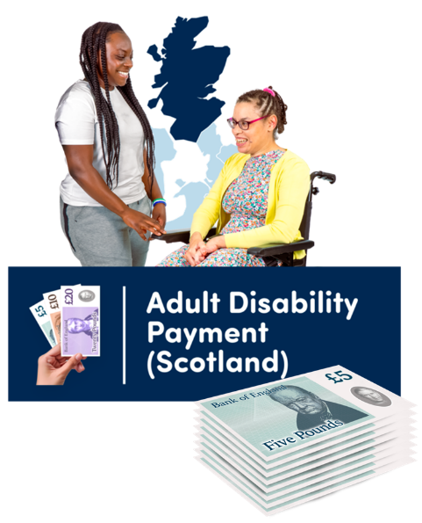 | Adult/Child Disability Payments  This is a money paid by the government to help someone with extra costs because of their health condition or disability.  It is also called ADP.
 | Apprenticeships  This means a type of training to learn the skills for certain jobs.
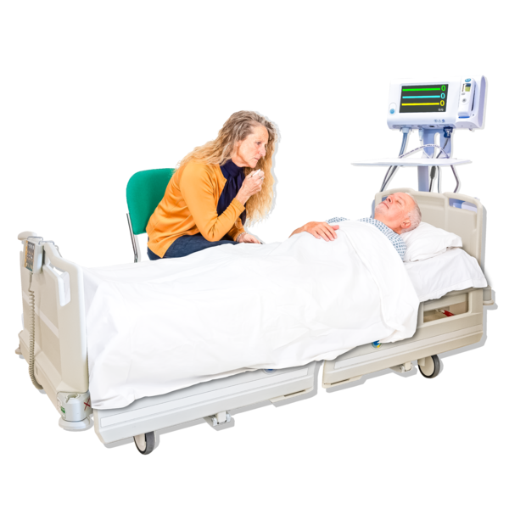 | Assisted Dying  This means when someone gets help to be allowed to die.  This choice belongs to the person asking for help.
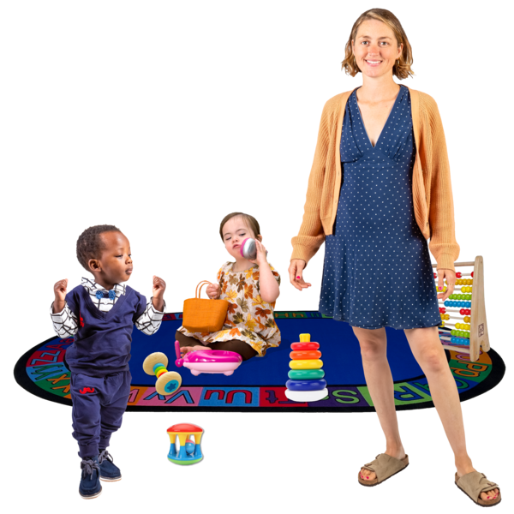 | Childcare  This means the staff, places and funding to look after babies and children.
 | Climate Crisis  This means the way the world’s weather and temperature are changing too fast because of human choices.  Climate crisis brings extreme weather and fast warming.
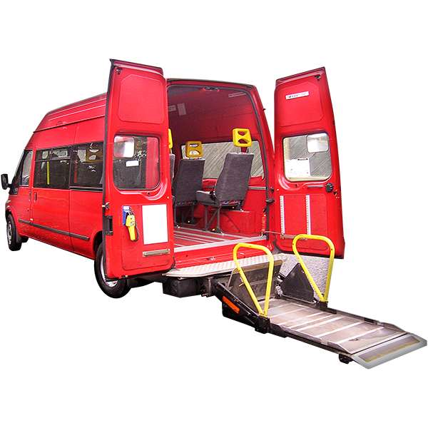 | Community Transport  This means ways to make sure that people can get around in their local area using transport like community minibuses.
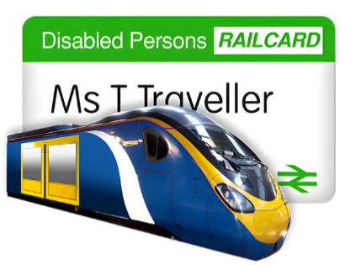 | Concessionary Travel  This is reduced costs when travelling on public transport for disabled people and older people.
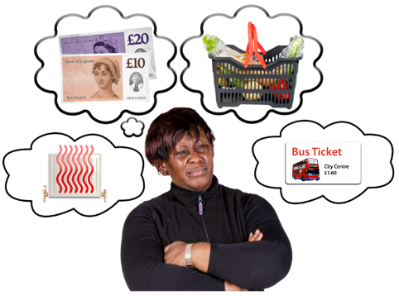 | Cost of Living  This includes things like household bills, mortgage or rent costs and food.
Disability Employment Gap

This is the difference between:
- the number of disabled people who have a job, and
- the number of people who are not disabled who have a job
 | Disability in Sport  This means how disabled people take part in sports.
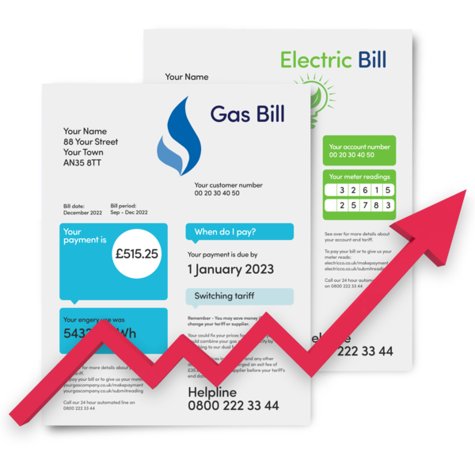 | Energy Bills  These are bills to pay for things like:  - gas or oil heating  - electricity  - petrol
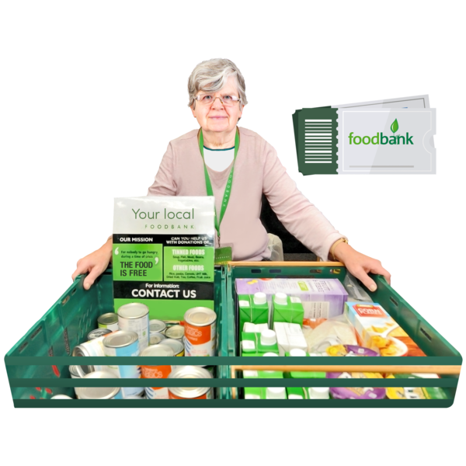 | Food Banks  These are places where groceries are given out free to anyone needing them.
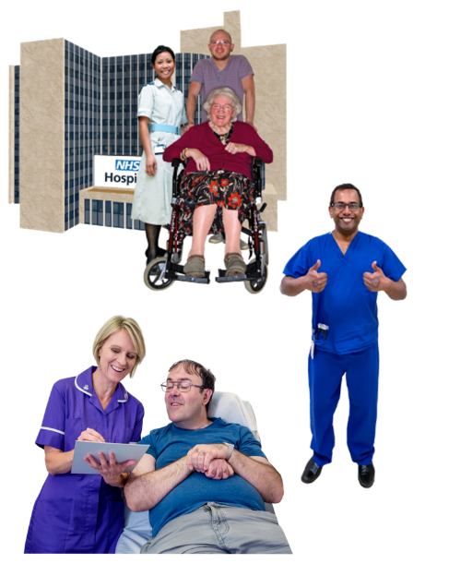 | Health and Social Care  This means mean services like:  - hospitals  - care homes  - specialist support – like physiotherapy  - district nursing  - care at home
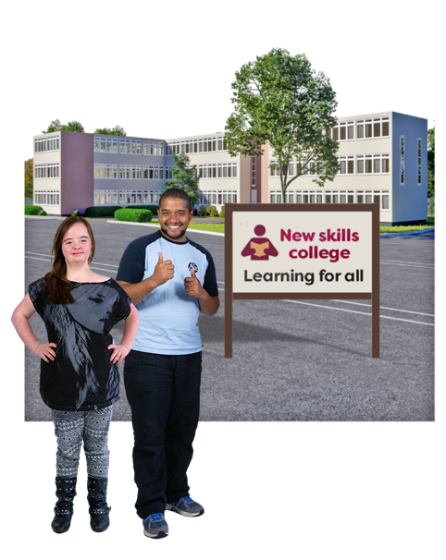 | Higher or Further Education  This means any study that is completed after high school.
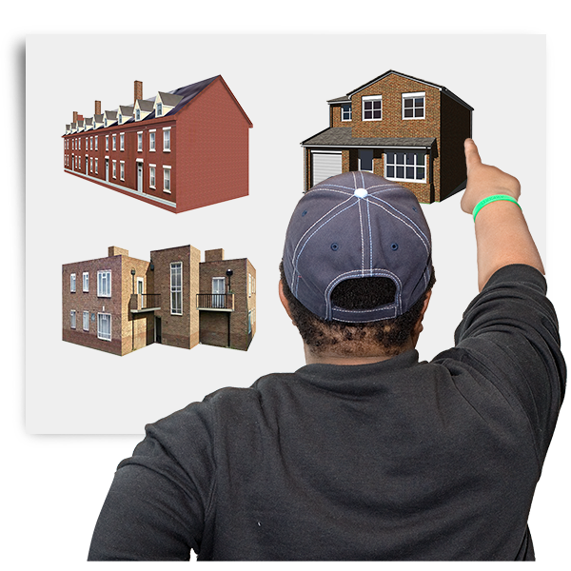 | Housing  This means all the ways that we make sure people have somewhere warm and safe to live.
 | Inclusive Design  This means building spaces and places that everyone can use.
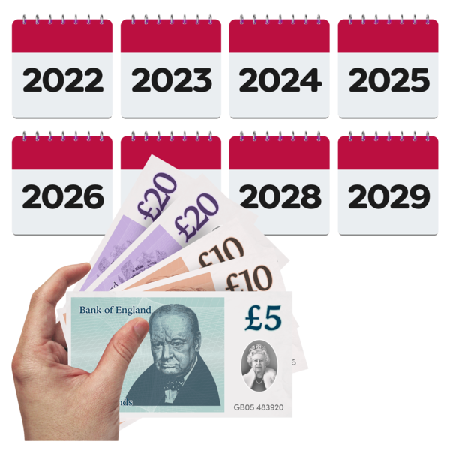 | Inflation and Prices  This means how prices for the same thing can go up or down.
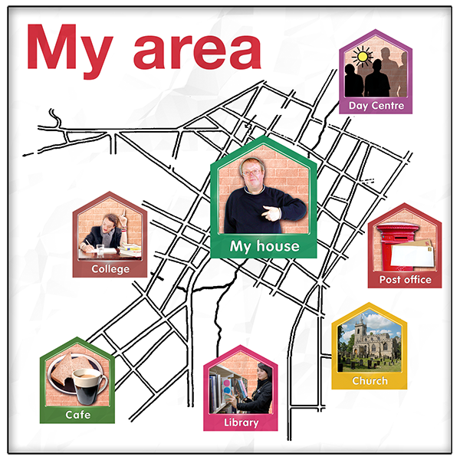 | Local Transport Provision  This means what kinds of transport each local area is offering to the people who live there.
 | Medical Cannabis  This means medicines which have some kind of cannabis in them.
 | Mortgage Rates and the cost of Renting  Mortgage rates mean the monthly costs of borrowing money to buy a home. They can go up and down.  Renting means paying a landlord so that you can live in their building.
 | Passenger Assistance at Airports  This means the extra help you can get at airports to help you get on and off your flight.
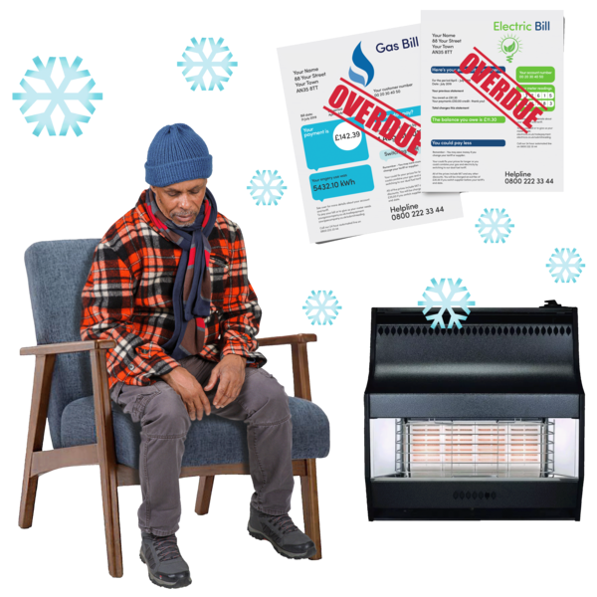 | Poverty and Inequality  Poverty is not having enough money to buy basic things like food or housing.  Inequality is when some people do not get the same chances or choices as other people.
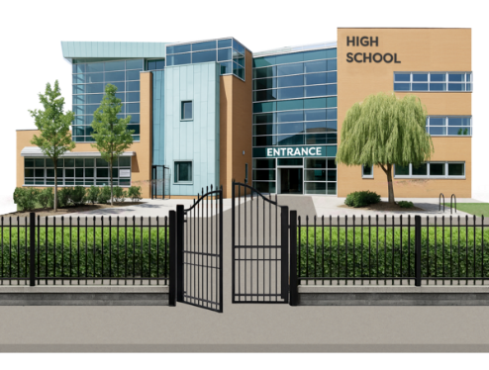 | Primary and Secondary Education  This means the learning that happens between 5 years old and 18 years old.
 | Privatising the NHS  This means letting companies take some NHS services and make them into businesses for making profit.  Profit means making more money than was put in.
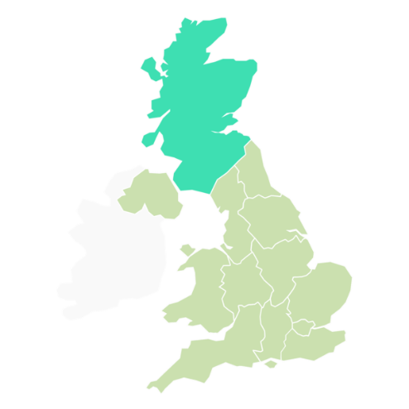 | Scotland’s Constitutional Arrangements  This means the relationship between Scotland and the other UK countries. And how Scottish Laws and policies are affected by the UK government.
 | Scotland’s relationship with the European Union  This means how we get on with the countries in the European Union. And how we get on with the European Union organisation itself.
 | Social Isolation and Loneliness  Social isolation means people finding it hard to meet other people.  Loneliness means feeling sad or depressed because you are not meeting other people.
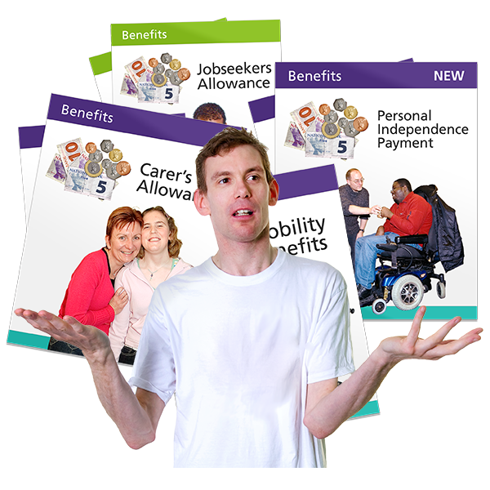 | Social Security  This means the benefits that we might need to be given to live on.  Benefits are often given as money.
 | Tax is extra money charged on things like our pay and our luxury goods by the government.

Our questions
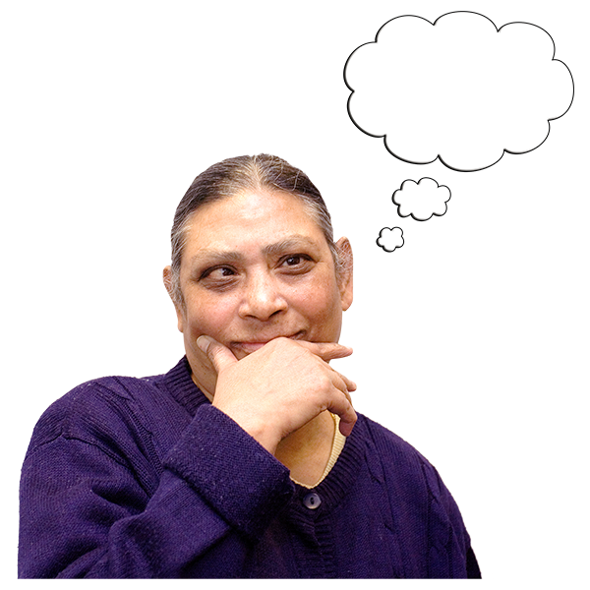  10 |  |  | Which 10 of the priorities are the most important for you?
  10 |  |  | We want to you to choose just 10 priorities.
 | 1  2  3  4  5  6  7  8  9  10 |  | Put the priority that is most important to you next to number 1.  Then the second most important thing to you next to number 2.  Then carry on with 3, 4, 5, 6, 7, 8 and 9.  Put your last top priority next to number 10.

Your top 10
 | You can write or type your answers in the space next to each number.
 | My top priority
 | 1
 | 2
 | 3
 | 4
 | 5
 | 6
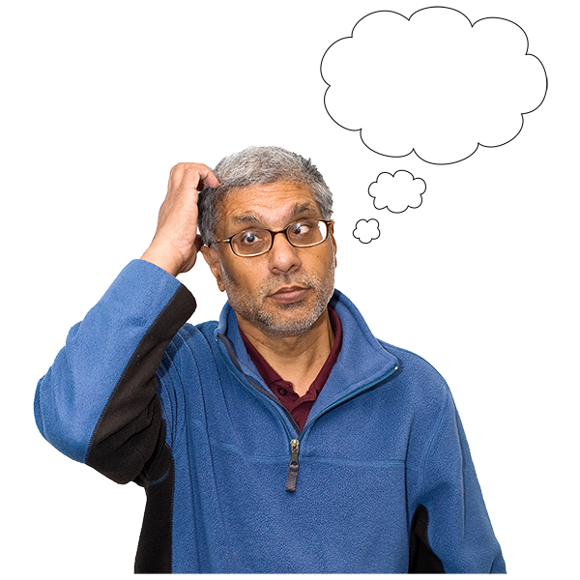 | 7
 | 8
 | 9
The last priority of my top 10.

10

Other questions
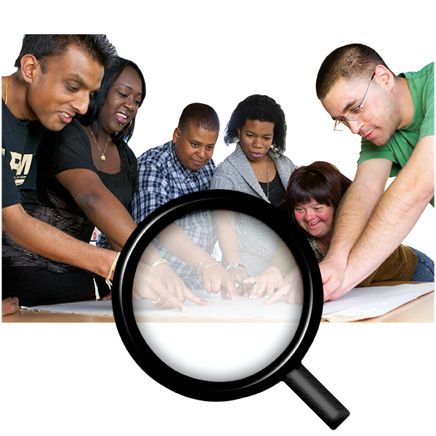 | Are there any other important priorities which will help you decide who to vote for?
If your answer is yes, please type or write them below.

The space will grow as you type.

Your goals
 | The priorities we asked you about can be broken down into smaller goals.
 | For example, for the priority “Disability employment gap”
 | A goal could be to make sure that disabled people have jobs.

What 3 goals you would like the Scottish government to get done?

1
2
3

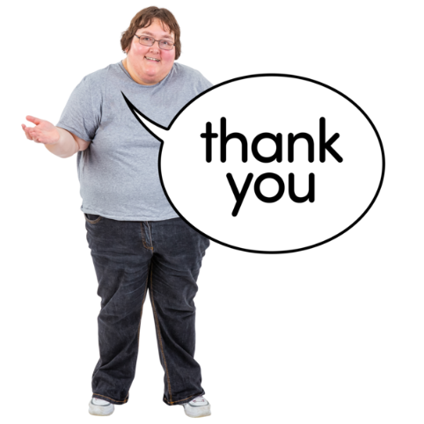 | Thank you for your answers.  Please send your answers back one of these ways:
 | Email them to  research@disabilityequality.scot
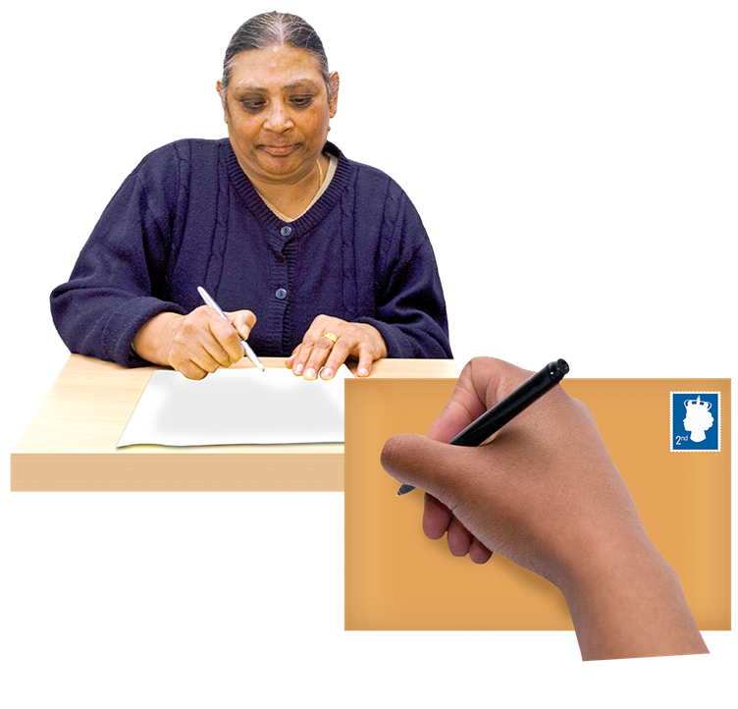 | Or post them to:  Research Team  Disability Equality Scotland  Norton Park, 57 Albion Road,  Edinburgh, EH7 5QY

