

What do you think about getting help with chronic pain in Scotland?

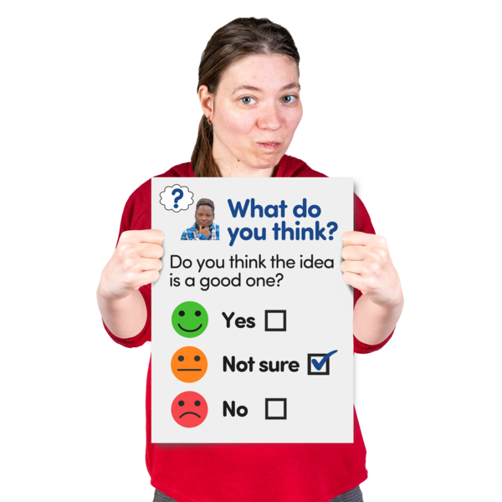




Easy Read

About this document
 | This is an Easy Read document.
 | It is a survey.  A survey means a set of questions.
 | The questions ask you what you think about how people who have chronic pain should be treated.

About the survey
 | The Scottish Government and NHS Scotland are going to give health workers new advice about helping people with chronic pain.
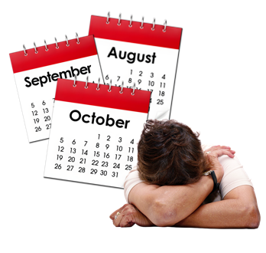 | Chronic pain is when someone has pain that lasts longer than 3 months.  This pain might be because of a disability but it does not have to be.
We at Disability Equality Scotland want to know your thoughts and ideas about the new advice.

We have 10 questions to find out what you think.

Please answer this survey if you have ever had chronic pain.

Our questions
 | Please answer our questions to tell us what you think.
 | If you are answering on a screen, you can click the little box next to your answer.  ☐  A tick will appear.  If you want to change your answer you can click it again.
 | If you are typing your answers the space will grow as you type.
 | If you want to write your answers on a paper copy use the Enter button to grow the spaces.  Then print the pages.

Question 1

     | The new advice will say that communication is an important part of treating chronic pain.  It says health workers should:  - listen to the patient carefully  - show that they understand how hard it must be to live with the pain  - make sure there is enough time to properly talk about the pain  - help the patient understand that chronic pain lasts a long time  - be honest about how medicine will not always help
   | 1. Do you agree that communication is an important part of helping people with chronic pain?  Tick 1 box.
    I agree a lot | ☐
    I agree a little | ☐
    I do not agree much | ☐
    I do not agree at all | ☐

Question 2

   | 2. How has communication with a health worker changed how you feel about chronic pain?  Type or write your answer below.  The space will grow as you type.

Question 3

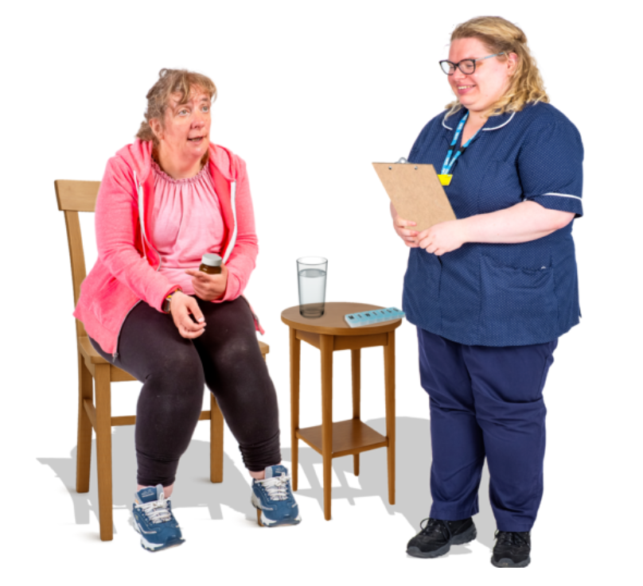     | People who have chronic pain can be given medicine but there are other things people can do to help.  The new advice says that health workers should help patients who have chronic pain do things like:  - eating healthy foods or doing more exercise  - doing things that help with sleep and relaxing  - doing hobbies or local group activities  - try not to do too many things at once  - talking to a therapist  A therapist is a trained person who helps people with their mental health and emotions and problems in life.
 | 3. Do you agree that these are good ways to help with chronic pain?  Tick 1 box.
  I agree a lot | ☐
  I agree a little | ☐
  I do not agree much | ☐
  I do not agree at all | ☐

Question 4

 | 4. Other than medicine have you found different types of help or activities useful for chronic pain?  Tell us about them.  Type or write your answer below.  The space will grow as you type.

Question 5

   | Medicine can help chronic pain but sometimes it can create other problems.  This is called a side effect.  Side effects can include:  - feeling tired  - feeling sick  - having problems going to the toilet
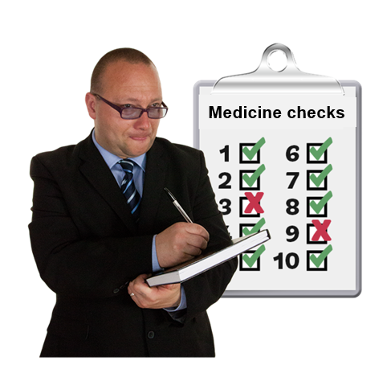   | The new advice says that health workers should:  - check often how well the medicine works and what side effects it is giving you  - make sure you have a say in changes to your medicines  - suggest painkillers like Paracetamol  - think about stopping or changing medicines that do not work  - make sure you know when a medicine might have side effects  - lower the dose of medicines bit by bit
 | 5. Do you agree that this is a good way to help people who take medicine for chronic pain?  Tick 1 box.
  I agree a lot | ☐
  I agree a little | ☐
  I do not agree much | ☐
  I do not agree at all | ☐

Question 6

6. Which of these is true for you?

Tick 1 box.

I have never taken medicine for chronic pain | ☐
I have taken medicine for chronic pain and did not get any side effects | ☐
Taking medicine for chronic pain helped so much that it was worth putting up with the side effects | ☐
Taking medicine for chronic pain was not worth it because the side effects were too bad | ☐

Question 7
7. How has taking medicine affected your own experience of chronic pain?

Type or write your answer below.

The space will grow as you type.

Question 8

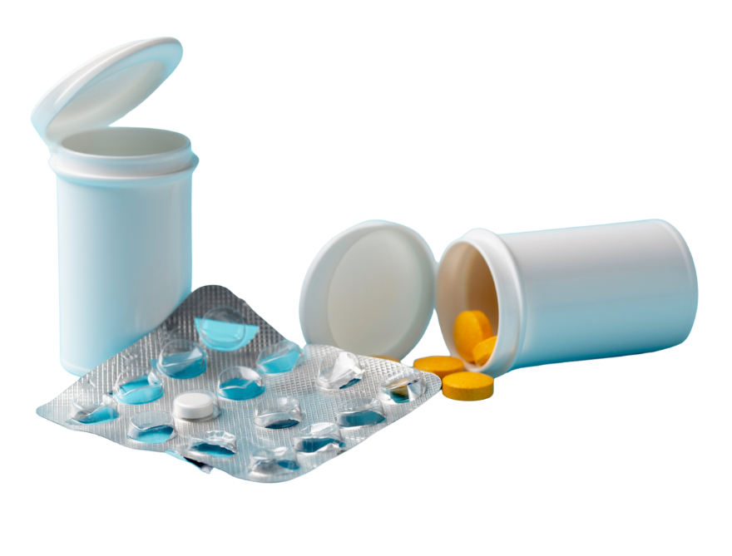  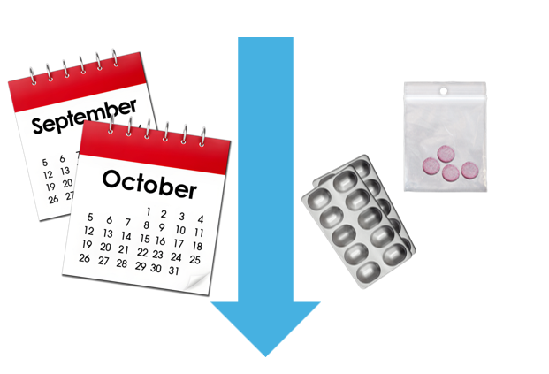 | Opioids are a type of drug that can help with pain.  They can also make people feel ill and people sometimes find it hard to stop taking them.  Studies show that opioid medicines like morphine and tramadol may not keep working for chronic pain.  After a while they can stop helping.  The new advice says health workers should talk to patients who take opioid medicines about possibly stopping them.  It also says that people who are stopping opioid medicines should get help to lower the dose of the medicine.  People should be given support if they do this.
8. Do you agree that this is good advice for health workers helping patients who take opioid medicines?

Tick 1 box.

I agree a lot | ☐
I agree a little | ☐
I do not agree much | ☐
I do not agree at all | ☐

Question 9

9. How has taking opioid medicines changed your own experience of chronic pain?

Type or write your answer below.

The space will grow as you type.

Question 10

   | 10. Please tell us the three things you think would help the most when getting help with chronic pain.  Type or write your answer below each number.  The space will grow as you type.
1

2

3

What to do next
 | Thank you for answering our questions.
 | Please send your answers to us by choosing 1 of these ways.
 | You can email them to research@disabilityequality.scot  or
 | You can send them by post to:  Research  Disability Equality Scotland  Norton Park  57 Albion Road  Edinburgh  EH7 5QY



