

A fact sheet about our research on the use of taxis

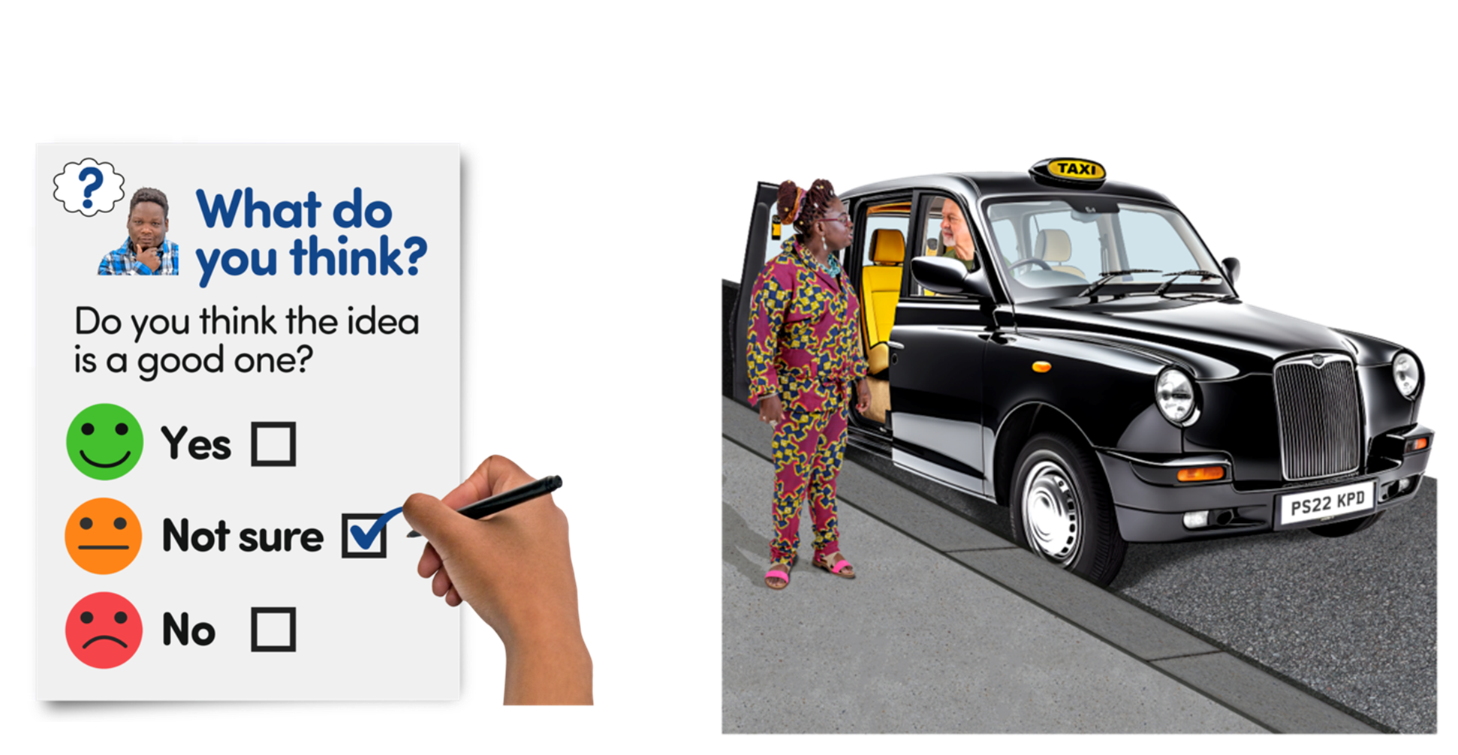

Easy Read


About this document

 | This is an Easy Read document.
 | It is a fact sheet.  A fact sheet is a document that helps you understand a topic better.
 | It will tell you what we found out when we looked at how disabled people use taxis.
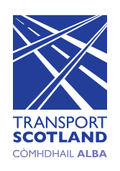 | Transport Scotland asked us to:  - look at how disabled people use taxis  - write a fact sheet  Transport Scotland organises transport in Scotland for the Scottish Government.
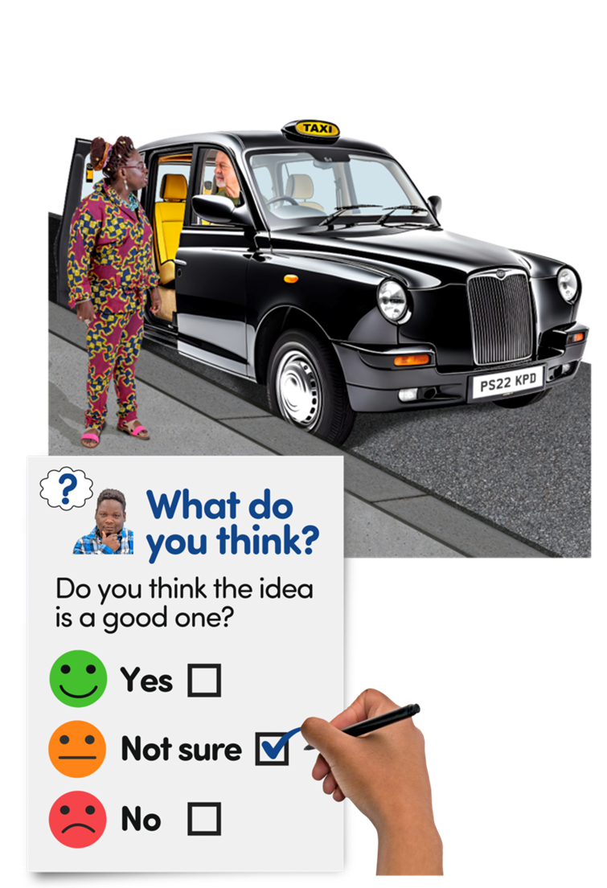 | We wanted to find out:  - how disabled people travel  - when disabled people use a taxi  - what is it like when disabled people use a taxi
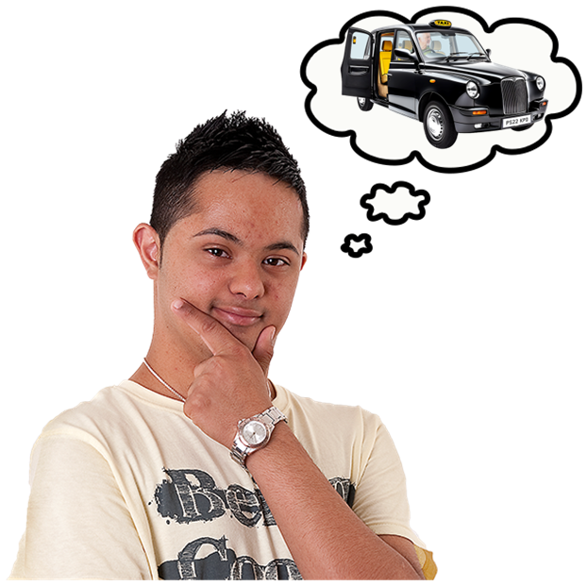 | We asked our members things like:  - how they use taxis  - what is it like to book a taxi  - how expensive or cheap it is to use a taxi  - how accessible it is to use a taxi
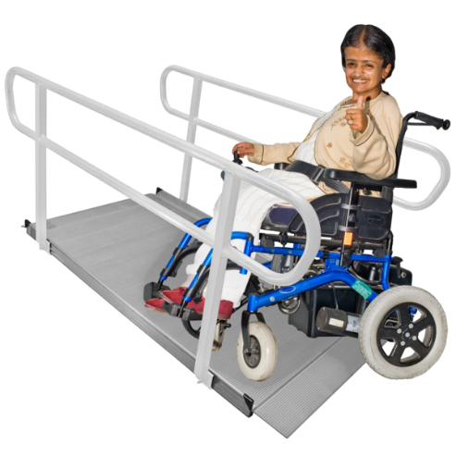 | Accessible means something that is easy to reach, use or get to.
 | We asked our members these questions and gave them 3 weeks to answer.  The last day to respond was 29 January 2025.

What we found out

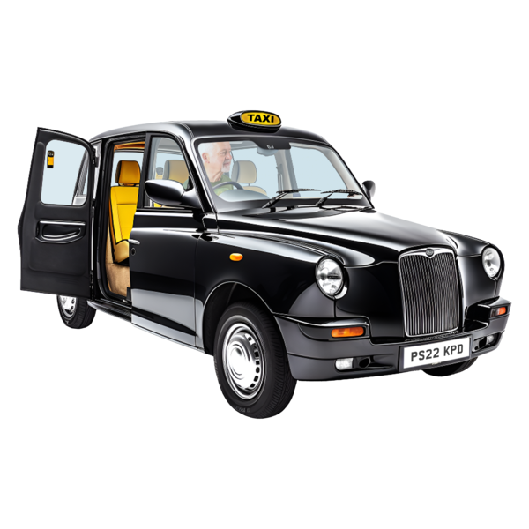 | The answers told us these things.  More than half of all disabled people use a taxi often.
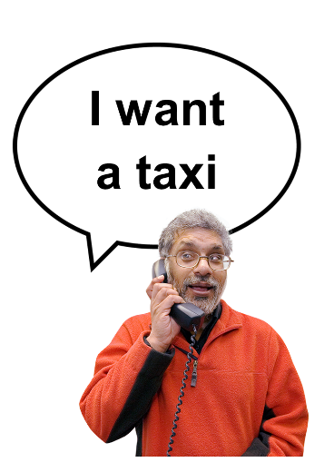 | To book a taxi:  - most disabled people call the taxi company  - 1 in 5 disabled people use the app  - hardly any disabled people book it another way
 | Half the disabled people said it is expensive to use a taxi.
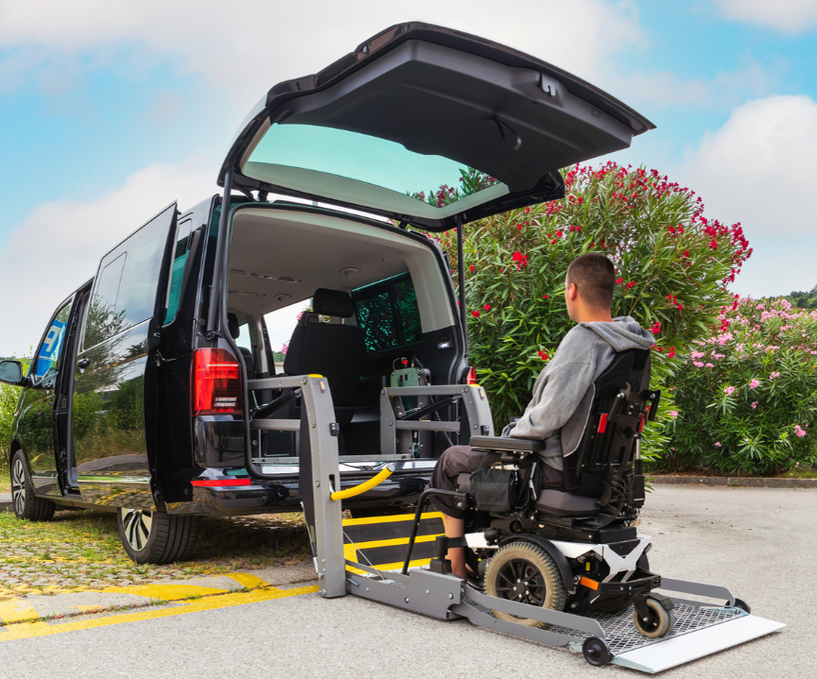 | Almost half the disabled people said the taxis were accessible.
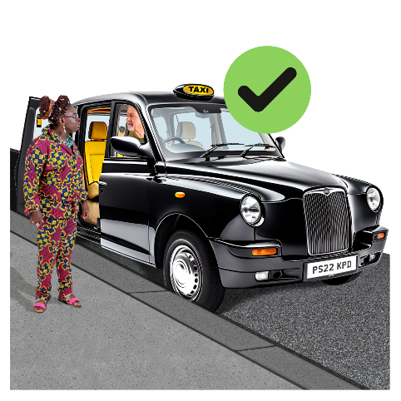 | Almost half the disabled people said drivers were quite helpful helping them get in and out of the taxi.

How disabled people travel
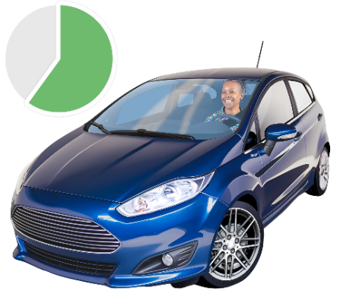 | More than half the disabled people we asked travel by car.
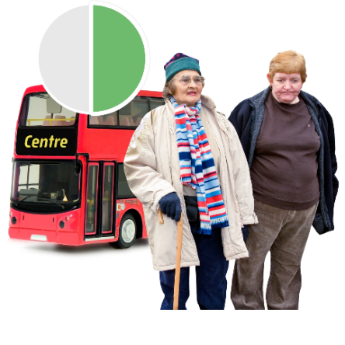 | Almost half the disabled people travel by bus or walk.
 | Very few disabled people travel by ferry or tram.
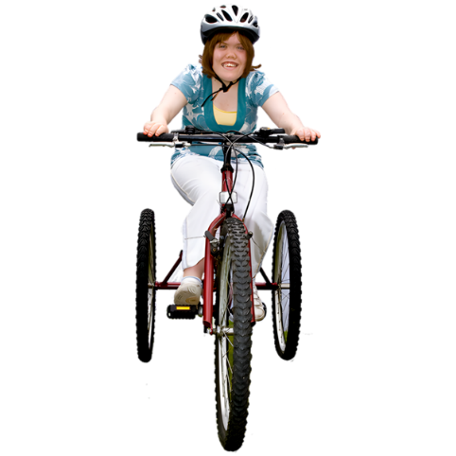 | Some disabled people travel by transport with wheels such as a bicycle.
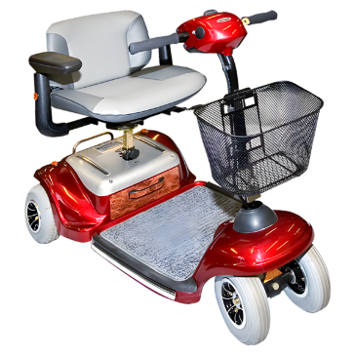 | Some disabled people travel with their mobility scooter.  A mobility scooter is an electric scooter that helps some people to move to places.
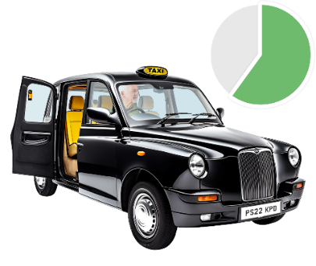 | More than half of all disabled people travel by taxi.

What disabled people need so they can travel
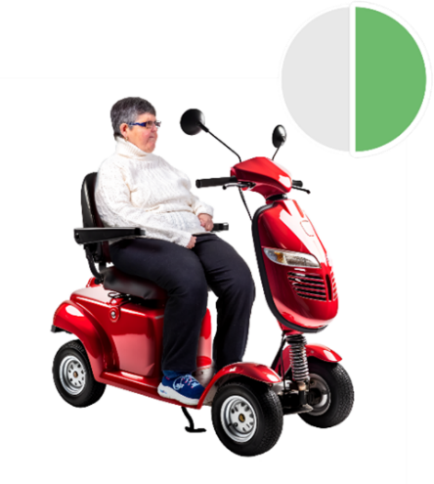 | Almost half the disabled people need a wheelchair or a mobility scooter to travel.
 | Some disabled people need a cane to get around.
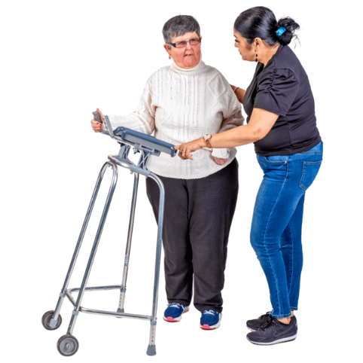 | A few disabled people need other things to travel, like:  - a rollator  - a walking frame  - crutches

Where disabled people live
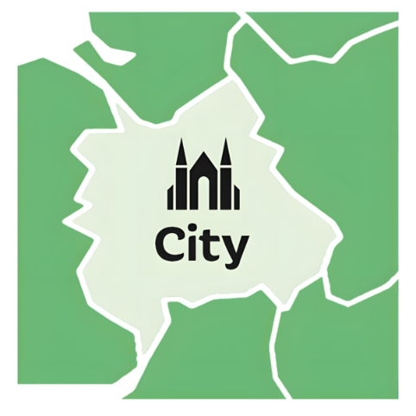 | Most disabled people live in a city with a lot of transport links.
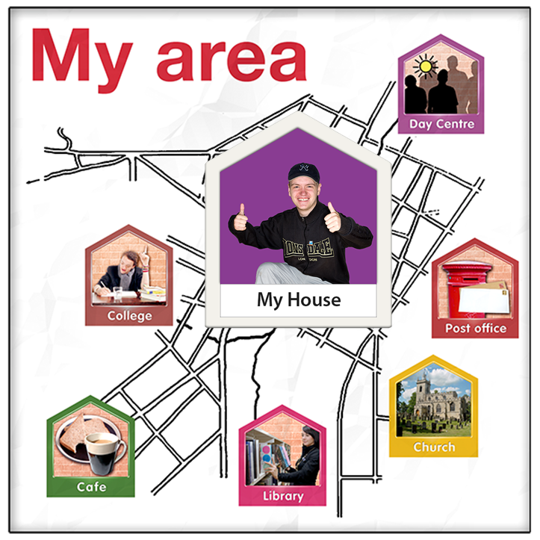 | Transport links mean ways to change between trains, buses, taxis, trams, ferries, pavement and cycle lanes.
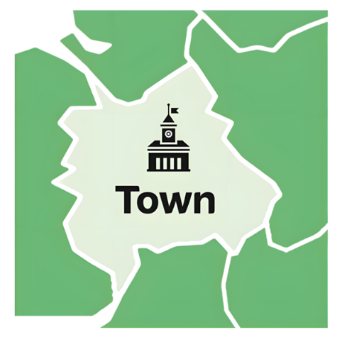 | Some disabled people live in towns with hardly any public transport available.
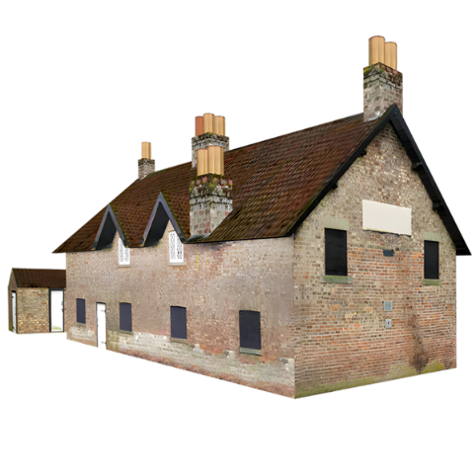 | A few disabled people live in rural areas with hardly any public transport available.  A rural area is far away from towns or cities.

How often disabled people use taxis
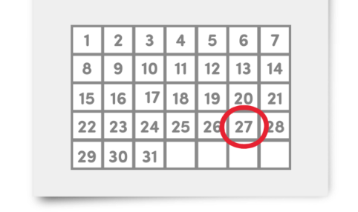 | Most disabled people use a taxi less than once a month.
 | Very few disabled people use a taxi every week.
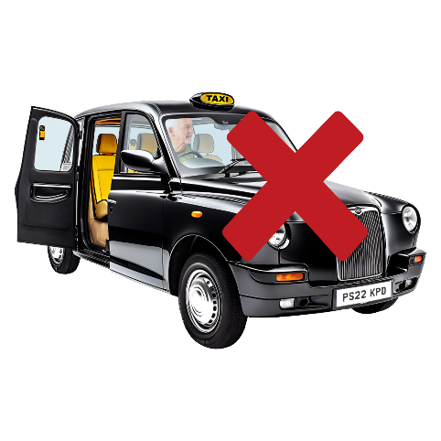 | Some disabled people never use a taxi.

How disabled people book taxis
 | Most disabled people call on their phone to book a taxi.
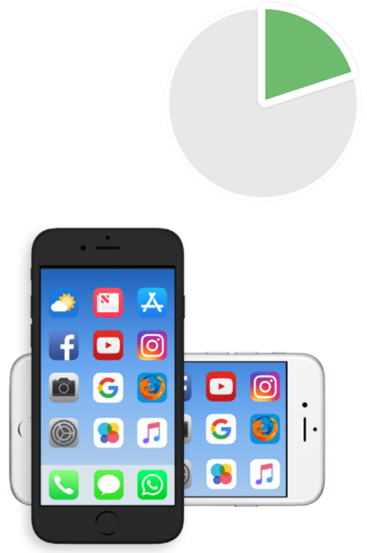 | Only 1 out of every 5 disabled people used an app to book a taxi.  An app is a tool you can download on your phone, tablet or computer that helps you do something, like booking a taxi.
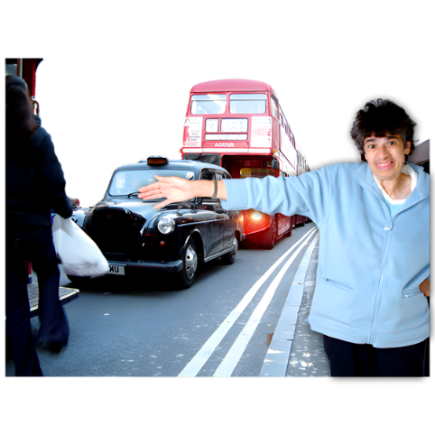 | A small number of disabled people use other ways to book a taxi such as using:  - a website  - an automated booking service  - signalling a taxi in the street
 | Automated booking services let people phone in and put a special caller ID code in.  The caller ID code tells the organisation who is phoning and knows their usual taxi pick up and drop off places.
 | Most disabled people had a good experience booking a taxi.
 | Only 1 person out of every 10 disabled people had a bad experience booking a taxi.

How cheap or expensive it is using a taxi
 | Each local authority decides how much it costs to travel by taxi.  A local authority is also called a local council. It makes decisions about things like schools, roads, and parks.
 | We asked disabled people if they think travelling by taxi is cheap or expensive.
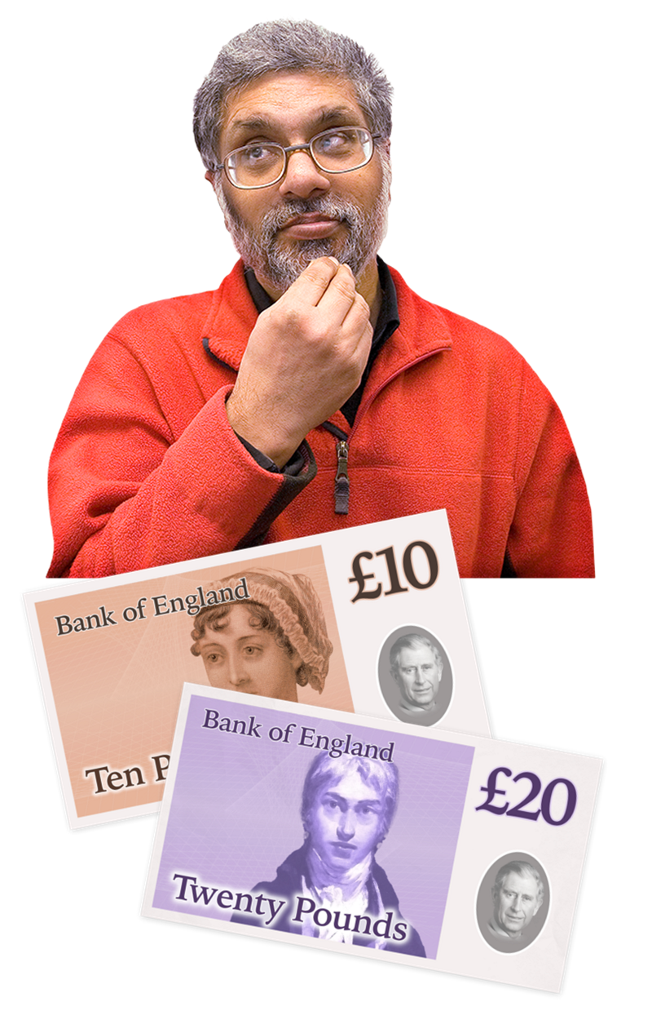 | We also asked disabled people how much money they get each year.
 | Almost half of all disabled people get less than 20 thousand pounds each year.
 | 1 in every 5 disabled people say that travelling by taxi is quite cheap.
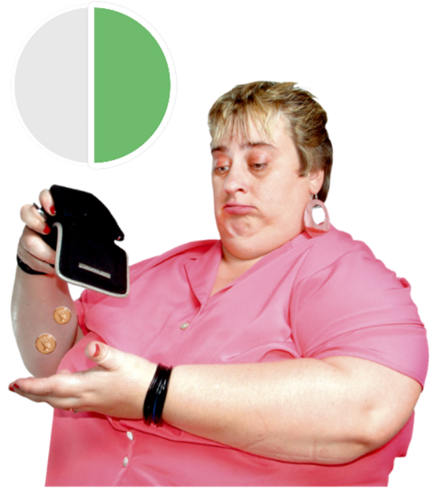 | Half of all disabled people say that travelling by taxi is expensive.
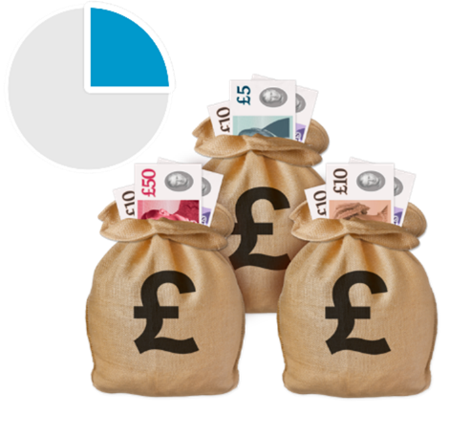 | 1 person out of every 4 disabled people say that travelling by taxi is very expensive.

What it is like travelling by taxi for disabled people
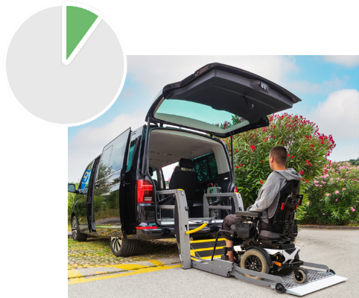 | 1 person out of every 10 disabled people said they were able to book the kind of vehicle they needed.
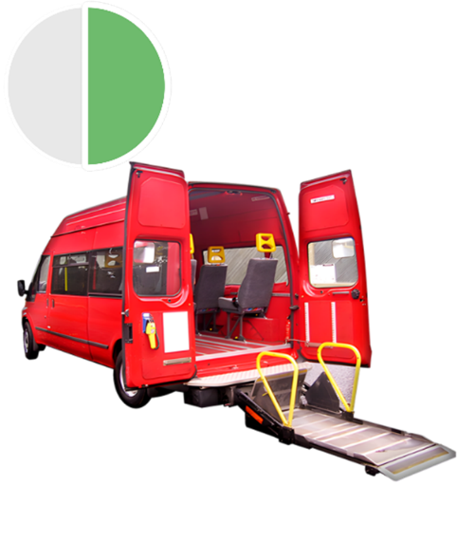 | Almost half of all disabled people said the accessibility using a taxi was good.  Accessibility means making things easy for everyone to use.
 | Most disabled people said they had a good experience when getting picked up or dropped off in a taxi.
 | Some disabled people said they had a bad experience when getting picked up or dropped off in a taxi.
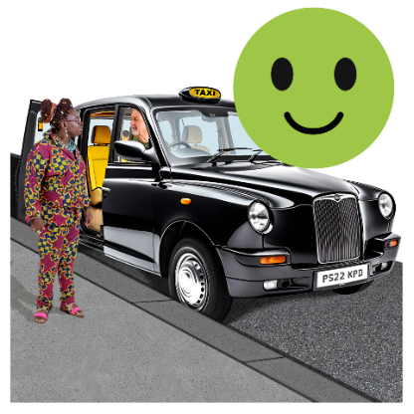 | Most disabled people said drivers were very good helping them get in and out of the taxi.
 | A few disabled people had some problems using a taxi, such as:  - issues when they wanted to get inside the taxi themselves instead of with the wheelchair  - the taxi had to drop them off or pick them up somewhere else because it was not able to get where they needed it to  - they had to wait a longer time for the taxi because of the accessibility
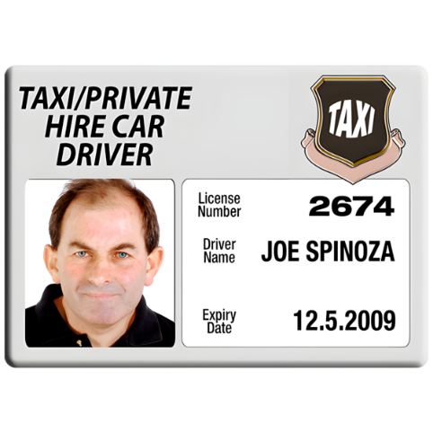 | 6 disabled people said that taxi drivers have different ways of doing things, which means every time they use a taxi it could be different.
 | 2 disabled people said some taxis didn’t let their assistance dogs get in the taxi.  Assistance dogs are trained dogs that help disabled people.
 | 2 disabled people said they used taxis to travel to the hospital.

For more information
 | If you want to know more information on this fact sheet, you can contact us:  - by email research@disabilityequality.scot
 | - by phone 01413 700968

Who we are
 | Disability Equality Scotland is an organisation with members and member organisations.
 | It works to speak up for disabled people in Scotland and make changes happen.

Most photos from Photosymbols
Photos on pages 6 and 15 of the accessible taxi from Canva.


