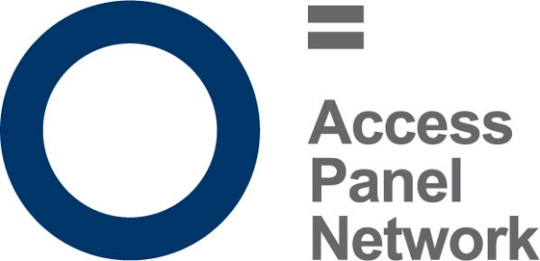
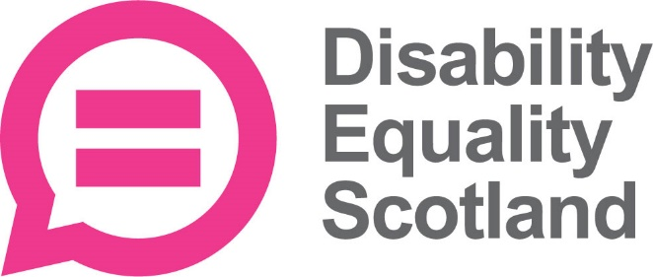

Access Panel Conference 2024
Summary Report

Foreword

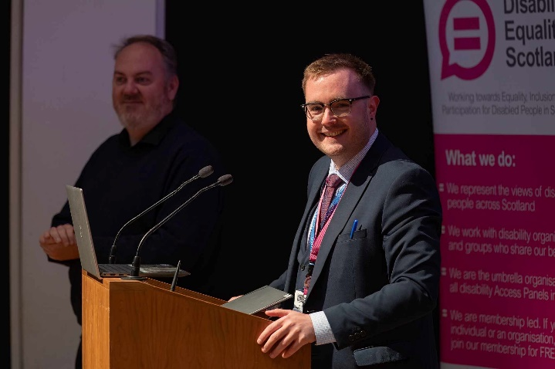
It is with great pleasure that I present the summary report of the Access Panel Conference 2024, held on June 28th at the Perth Concert Hall. This year's conference brought together a vibrant and diverse group of individuals, including Access Panels, disabled people, and stakeholders from across Scotland, all united by a common goal: to enhance inclusion and equality for disabled people within our communities.

I opened the conference by giving a talk on active community engagement and how important it is for disabled people to be engaged with meaningfully. Jane Moncrieffe from the Centre for Inclusive Living Perth and Kinross (CILPK) then provided our keynote speech, sharing what the Access Panel has been involved in and highlighting the impact they have on accessible taxis. We heard from the Braille labelling campaign and their efforts to make braille labelling mandatory on food packaging in Scotland and we had presentations from ScotRail on their planned engagement with Access Panels as well as Douglas Bryce Deputy CEO on the hate crime charter.

A particular highlight of the conference was the breakout discussion groups focused on Disability Equality Scotland’s (DES) strategic plan. These sessions provided a platform for Access Panels and members to explore the DES strategic plan in greater detail, particularly in relation to how it impacts Access Panels. The enthusiasm and commitment demonstrated by everyone involved were truly heartening, reinforcing the vital role that Access Panels play in making their communities more accessible.

This report aims to capture the essence of the day’s proceedings, encapsulating the key themes, discussions, and outcomes. I hope it will serve as a useful resource for all those who were there on the day and for those who couldn’t attend.

I would like to extend my gratitude to all who contributed to the success of the conference. Your passion and your dedication are the driving forces behind our continued progress towards a more inclusive future.

Warm regards,

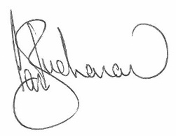

Ian Buchanan
Equality and Access Manager

Introduction

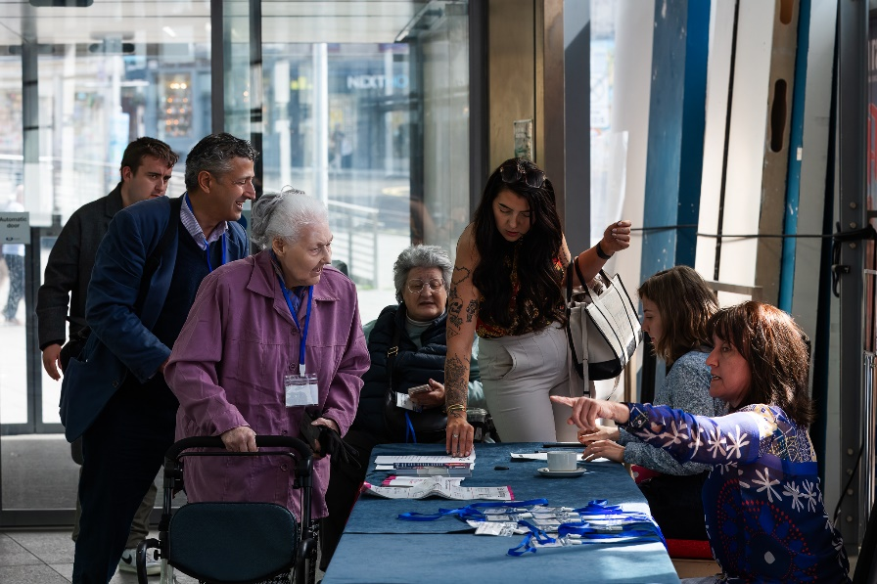
The Access Panel Conference 2024, held on June 28th at the Perth Concert Hall, marked a significant gathering of Access Panels, disabled people, and stakeholders from across Scotland. The conference aimed to advance the dialogue on inclusion and accessibility, focusing on active community engagement and collaborative efforts to enhance the quality of life for disabled people. The theme for this year’s conference was #LookingForward, which encouraged Access Panels and stakeholders to think not just about their short- and longer-term goals, but to consider the DES strategic plan and how that fits in with their Access Panel. The conference was held in person as well as online via Zoom, allowing people the opportunity to dial in from across Scotland.

This year’s conference was led by Ian Buchanan, Equality and Access Manager at DES, who opened the event. His speech highlighted the importance of community involvement in fostering a society that is inclusive and accessible for all and placed an emphasis on looking forward to how disabled people can be meaningfully involved in decisions about them. Ian emphasized that true inclusion is achieved not just through policy changes but through the active participation and engagement of the entire disabled community, particularly when it comes to designing the built environment and services.

The day was structured to provide a blend of presentations, discussions, and interactive breakout sessions. Attendees had the opportunity to participate in various sessions that covered a wide range of topics relevant to disability access and inclusion. These sessions featured notable speakers and experts who shared their knowledge and experiences, offering valuable insights and practical solutions to common challenges faced by disabled individuals.

Kaukab Stewart MSP was able to deliver a pre-recorded video message to the conference and underline the Scottish Government’s commitment to Access Panels and disabled people more generally.

A focal point of the conference was the breakout discussion groups dedicated to the DES strategic plan. These sessions were designed to facilitate a more in-depth discussion on, allowing participants to share their perspectives on how the strategic plan might impact Access Panels relating to a set of thematic pillars. The groups addressed key aspects of the DES strategic plan, including accessibility, community engagement, and policy advocacy. The discussions were robust and highlighted the collective expertise and dedication of all participants.

The feedback from these breakout groups, of which two were held in person and two were held online, is discussed in greater detail in the dedicated section below. In short however, the response was overwhelmingly positive, with many participants expressing appreciation for the opportunity to engage in meaningful dialogue and contribute to shaping the future of DES and its work in Scotland.
The insights and recommendations generated during these sessions will play a crucial role in informing future initiatives and strategies.

In addition to the formal sessions, the conference provided ample opportunities for networking and informal discussions. Attendees were able to connect with peers, share best practice, and build relationships that will support ongoing collaboration and mutual support. The sense of community and shared purpose was visible throughout the event, underscoring the importance of coming together to address common goals.

This summary report aims to capture the essence of the Access Panel Conference 2024, providing an overview of the key themes, discussions, and outcomes. The report includes detailed summaries of the sessions, highlights from the breakout groups, and feedback from participants, along with recommendations for future actions.

Conference Speakers

The Access Panel Conference 2024 featured a number of speakers from a diverse range of backgrounds. We were delighted that Jane Moncrieffe, manager at the Centre for Inclusive Living Perth and Kinross, was able to deliver this year’s keynote speech. We also heard updates from the Braille labelling campaign, ScotRail, and from Disability Equality Scotland on the topic of the hate crime charter for public transport. Below is a short summary of each presentation.

Keynote Speech – Centre for Inclusive Living Perth and Kinross (CILPK)

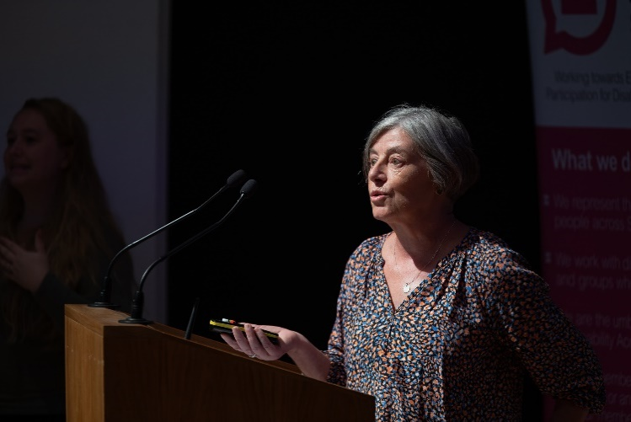
Jane Moncrieff from the Centre for Inclusive Living Perth and Kinross delivered a keynote speech that captivated the audience with a focus on the practical initiatives aimed at enhancing accessibility within Perth and Kinross. She began by providing a history of CILPK, sharing that the centre evolved from the Perth and Kinross Access Group which was established in 1982. In 2012 their name was changed to the current format, and they adopt a wide view of access and inclusive living and as such CILPK is a membership organisation which aims to represent the views of disabled people from across Perth and Kinross.

Jane went on to discuss the vital work that the centre is doing, particularly around the Keep Safe scheme, disability awareness training for local taxi drivers, and provision of access audits. CILPK established Scotland’s first safe place scheme for disabled people, before the nationwide Keep Safe scheme was established. The scheme aims to provide disabled people somewhere they can go (usually a shop, café, or restaurant) if they are feeling unsafe and where the venue will have had training on how to support disabled people.

CILPK has always provided taxi drivers in Perth and Kinross with both practical training and classroom-based disability awareness training. Jane was able to demonstrate the impact that CILPK has on raising awareness amongst taxi drivers through sharing some photographs of the training. Perth and Kinross Council expects every taxi driver to undertake the training with CILPK which means the lived experience of disabled people is put at the heart of their training.

Lastly, Jane finished her speech by reminding the conference that the power to make a difference, no matter how big or small, lies within each of us. She said that we should use the conference as an opportunity for progress and to champion the voices of disabled people, something that CILPK is already doing.

Braille Labelling Campaign Update - #JoinTheDots

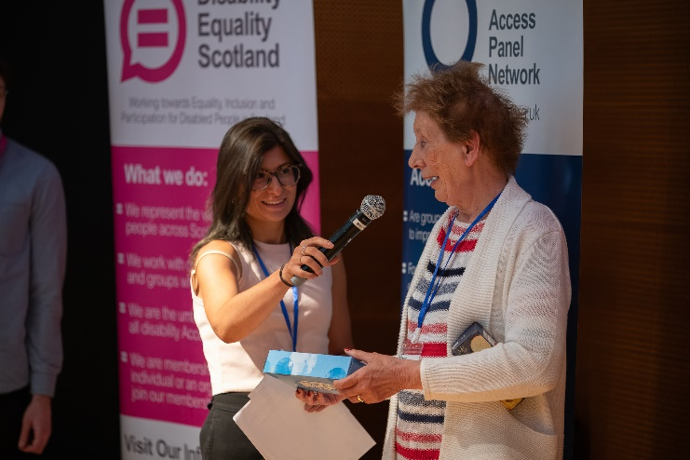
Disability Equality Scotland, in partnership with Sight Scotland and Oban Access Panel, provided an update on the progress made with the Braille labelling campaign. The campaign calls on the Scottish Government to introduce new requirements on retailers to provide braille labelling on food products. Currently, braille labelling is only required on medicines, leaving braille users at a disadvantage to sighted shoppers in identifying food products they wish to purchase and use.

James Davidson, Nicoletta Primo, and Marie Harrower gave a short presentation on the campaign in which they discussed the importance of braille labelling and showed a short video of Marie who is blind trying to ascertain the contents of different food products.

Responsibility for food labelling rests with the Scottish Government and the campaign is calling on everyone to get involved by signing the petition, a link to which can be found below. Braille labelling is important because it is vital for the inclusion of visually impaired people. Mandatory braille labelling will also help people to identify and organise items in the home, such as shopping, cooking ingredients, and knowing whether an item is safe to consume.

We would urge everyone to sign the petition if you haven’t already done so and to contact your local MSP and ask they support this vital initiative.

You can sign the petition by clicking this link which takes you to the Scottish Parliament petitions website - https://petitions.parliament.scot/petitions/PE1997

ScotRail Engagement – Ashley Murphy

The Access Panel Conference was joined by Ashley Murphy, Accessibility Coordinator for ScotRail, who spoke about the work ScotRail is doing to improve accessibility at stations and on trains across Scotland.

Ashley recognised that ScotRail still has work to do in terms of accessibility and inclusion but asked that Access Panels and disabled people work with them on this. Access Panels in the room were generally supportive of ScotRail’s efforts to improve accessibility but they wanted to see faster progress, particularly in relation to older rolling stock and issues where disabled people cannot cross platforms without long detours.

Ashley pledged to step up engagement with Access Panels and disabled people to make sure that their engagement is meaningful and can have the most impact on accessibility. DES can support this engagement by helping to organise meetings or focus groups.

Hate Crime Charter – Douglas Bryce

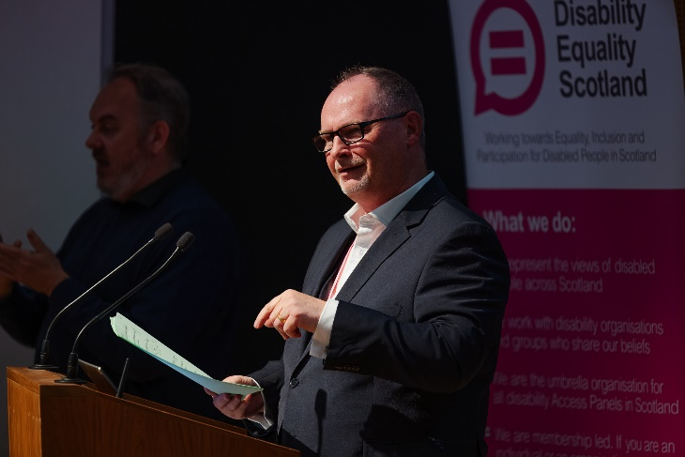
Douglas Bryce, Deputy CEO of DES, gave a presentation on the work that has been done on the hate crime charter for public transport. In March 2021 DES launched the national hate crime charter for public transport.

This was the culmination of four years’ worth of consultation and engagement with disabled people and other vulnerable groups. Douglas shared that up to 97% of disability related hate crime goes un-reported and the Crown Office and Procurator Fiscal Service (COPFS) data said that in 2023-2024 the total number of disability aggravated charges increased by 22% to 903. This is the highest annual number of charges reported since the legislation first came into effect inn 2010.

Doulgas also provided an overview of where DES is not in relation to the hate crime charter, and he provided some information on our next steps. He said that since the introduction of the charter DES has developed and delivered two hate crime workshops for the Pickaquoy leisure centre in Orkney as well as a pilot hate crime workshop for multiple transport providers. In terms of where we go next, Douglas asked for our members’ views as our research says hate crime is still a really important issue for disabled people. As a membership organisation, DES needs to hear directly from its members to help inform our work. Douglas said he would encourage everyone to have a look at the hate crime charter and to share their views directly with DES. You can find out more information on the hate crime charter by clicking the link below which takes you to the accessible travel hub.

https://accessibletravel.scot/hate-crime-charter/

Breakout Sessions

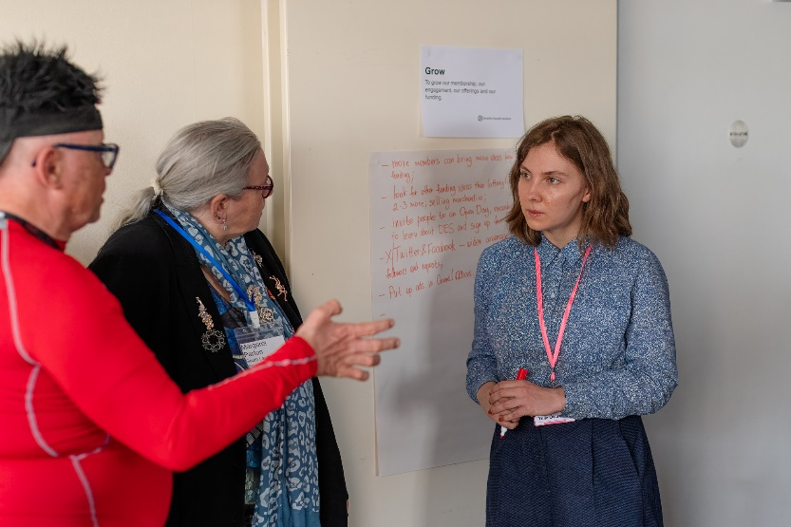
Our breakout sessions in-person and online provided delegates the opportunity to think about and discuss the DES strategic plan and its “five pillars”. Our strategic plan was released to members last year, but the Access Panel Conference provided us an opportunity to ask attendees to feedback on how the plan might impact Access Panels and Access Panel volunteers specifically. Those five pillars are:

- Strengthen - To strengthen our current position as a National DPO by raising awareness of our position, expertise, knowledge, and influence.
- Grow – To grow our membership, our engagement, our offerings, and our funding.
- Develop - Build our capacity internally, our training services and our Access Panels which will enable us to work alongside our partners in equality and accessibility matters.
- Value - Valuing our membership engagement in different ways to always share the true reality for disabled people.
- Lead - In a bold, confident, challenging, and inspirational manner, we will be a professional and change organisation for equality and inclusivity for all.

Below is a summary of the main points and themes raised under each pillar from all four of the breakout groups.

Strengthen
- DES needs to advertise itself more
- Younger members are key to ensuring this pillar especially for the future
- Shout about your successes, social media output is great but need more
- Get better at making connections with other groups
- Lobby and get involved / more visible at Parliament

Grow
- Hold more membership engagement events – colleges, universities, schools
- Use local councils to build a network of officials who can see DES as the “go-to” organisation for disabled people and their issues
- There are so many small pots of money out there so invest in a funding officer
- Diversify your funding – at the moment your funding is too narrow, and this worries Access Panels

Develop
- Continue providing access audit training for Access Panels. This is vital because it can provide an income stream for Access Panels.
- Support Access Panels as much as possible with things like funding applications to external funders
- Developing a list of resources or a database could be very useful – organisations to contact, funding pots, tool kits for membership
- Invest in Access Panels – they’re the cornerstone of DES and at the moment we feel forgotten about
- Not enough staff to support us all across Scotland – this has to change
- Cannot develop capacity if the resources aren’t there to support it

Value
- At the moment I struggle to see the benefit of DES membership – show the benefits!
- More work to raise the profile of Access Panels across Scotland
- At the moment we don’t feel valued – cuts to funding, no capacity, undervalued and no morale to keep going
- Struggle to feel valued when our funding has been slashed year on year
- I want to see DES getting back to basics, DES no longer feels like a grassroots organisation. Very little meaningful engagement with members; all seems to be about big government organisations

Lead
- DES must lead by lived experience. Inform by using people’s stories especially on the board
- Start challenging the Scottish Government more on our funding
- Could we start a disability pride march?
- Educate public bodies on the Equality Act 2010
- Live the values of the social model
Following on from the breakout groups, we can see that funding, awareness raising, and capacity were all common themes raised across each of the groups. Access Panels and disabled people shared that without proper investment we cannot meaningfully hope to enact change, and that Access Panels are reliant on DES for things like funding and national awareness raising.

All of this feedback helps to inform our own theme of #LookingForward and will be invaluable when reviewing our strategic plan as well as engaging with funders and government. We are keen to stress though that the conversation is continuous and should anyone have anything else they would like to contribute towards our “five pillars” then please do get in touch with us. Our Access Panels and our members are the lifeblood of the organisation, they are what make us a DPO. Thank you to all of those who took the time on the day to consider the questions and provide us with their views.

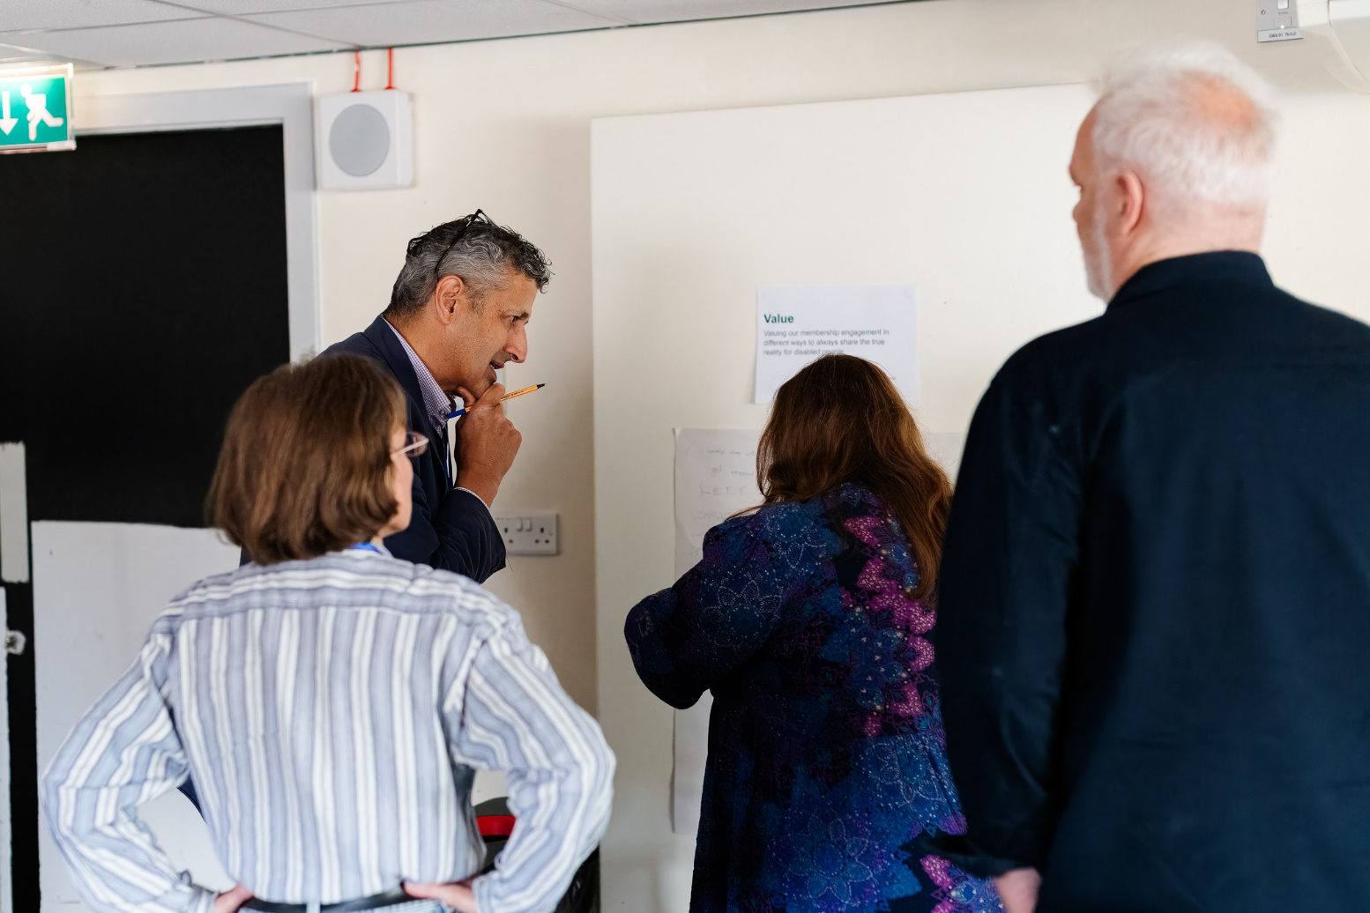

Conclusion

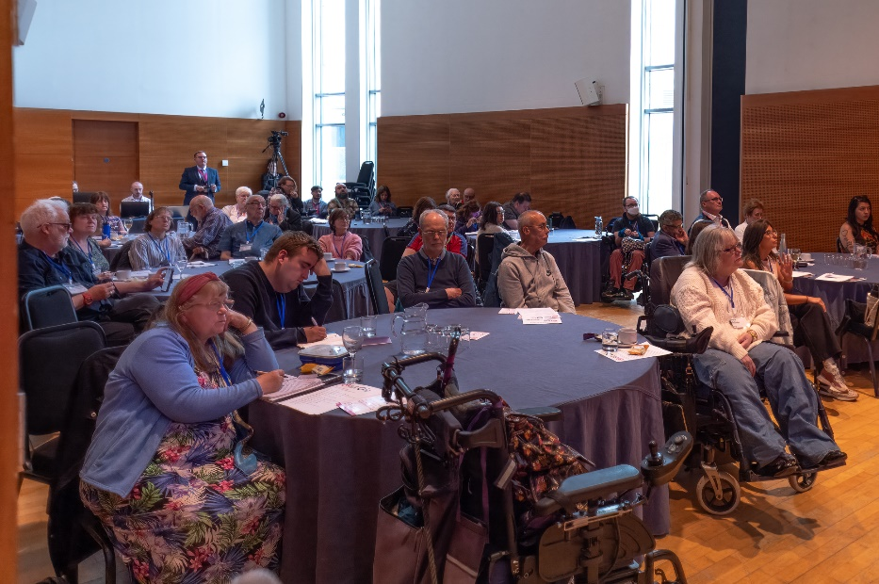
I would like to thank everyone who made the conference the success that it was. The discussion and engagement was brilliant, so too was the diversity of different Access Panels and disabled people represented in the room.

Networking and knowledge exchange were key components of the conference, leaving participants with a renewed sense of purpose and strengthened connections. The positive feedback from attendees underscored the event's success in fostering a platform for collaboration and dialogue. I was delighted to see so many people online and in-person, celebrating the uniqueness of our Access Panel network.

As we look ahead, the insights and outcomes from this conference will guide our ongoing efforts to promote access and inclusion. The dedication and passion demonstrated by all participants reaffirm our collective ability to build a more inclusive society. This summary report aims to capture the essence of the conference and to start a longer conversation between DES and Access Panels.

We extend our gratitude to everyone who attended and contributed to the success of the Access Panel Conference 2024. Together, we are making significant strides toward a future where everyone, regardless of ability, can fully engage in society in a meaningful and inclusive manner.

