Disability Equality Scotland

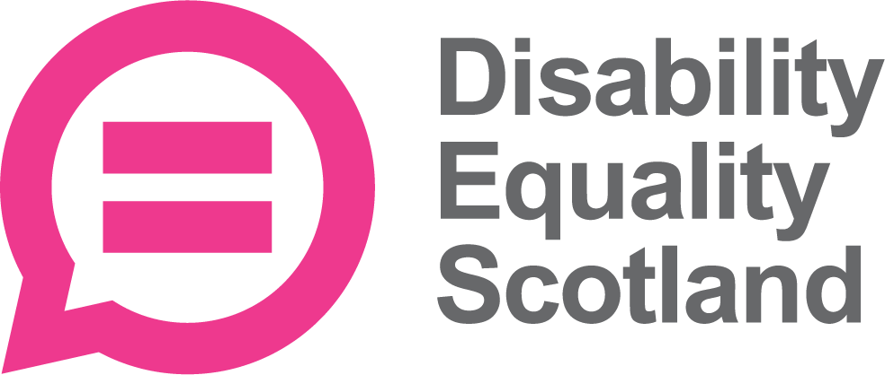


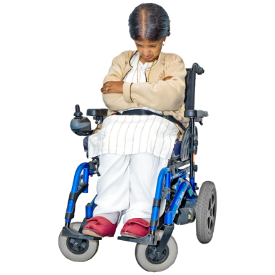
Disabled People in Ukraine

Easy Read


Copyright images © Photosymbols. Prepared by Disability Equality Scotland 

 | Some Scottish organisations and charities are members of the Scottish Independent Living Coalition. They are Disabled People Organisations.
 | The members of the Scottish Independent Living Coalition are very worried about the war in Ukraine.
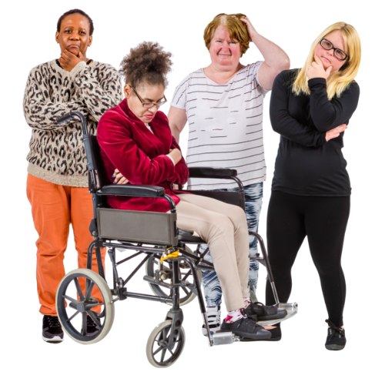 | They want support to make sure that disabled people in Ukraine are not left struggling.
  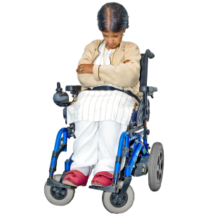 | There are about 3 million disabled people in Ukraine.
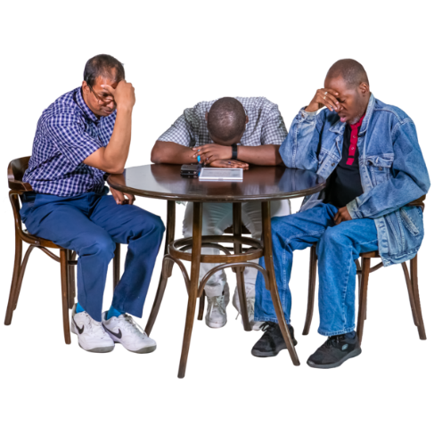 | Some reports say that many disabled people are finding it hard to leave their homes to find a safe place.
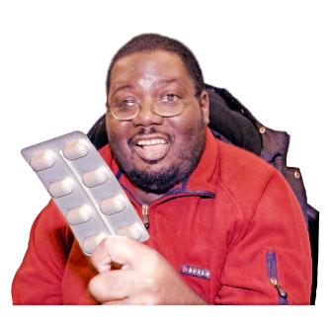   | When emergencies happen, disabled people can find it harder than most people to get things like:  - medicines  - equipment  - access to underground shelters  - information that they can access
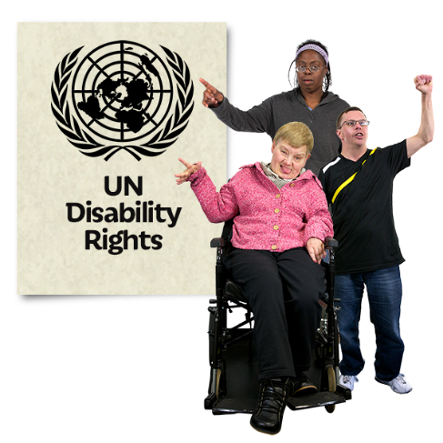 | There are laws about this.  Article 11 of the United Nations Convention about disabled people’s rights has been agreed by:  - Ukraine  - Russia  - United Nations
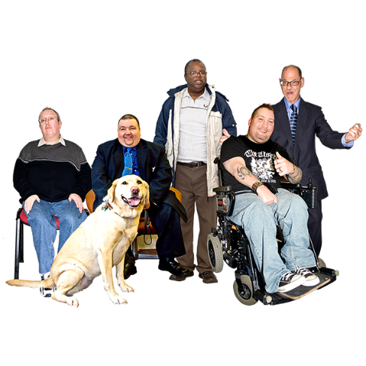 | It says that there must be equal protection and safety for disabled people, even in an emergency.
 | The Scottish Independent Living Coalition also wants disabled people in Ukraine to:
  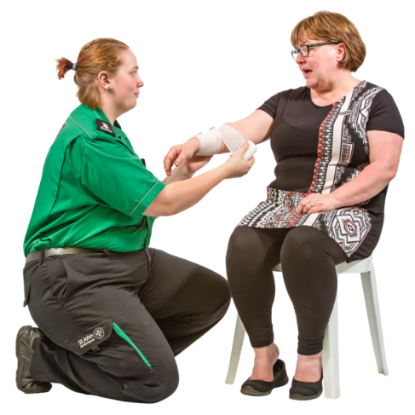 | - get every humanitarian aid  Humanitarian aid means emergency help to stay alive.
 | - be safe from violence and abuse
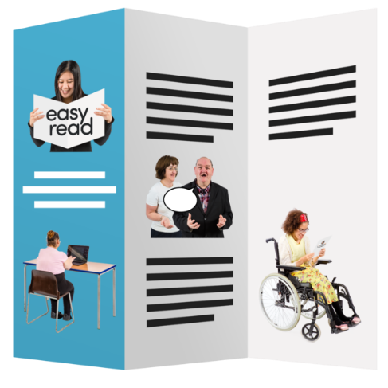 | - get accessible information about safety and support
 | - have good access to all these things:  - water  - social support  - education  - health care  - transport  - information
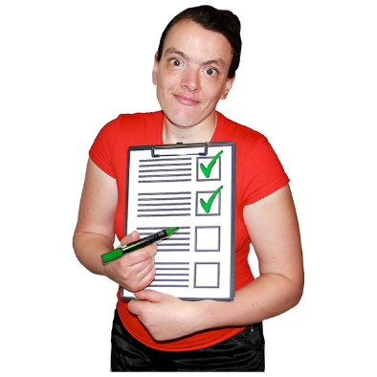 | - be counted and checked, and not left behind
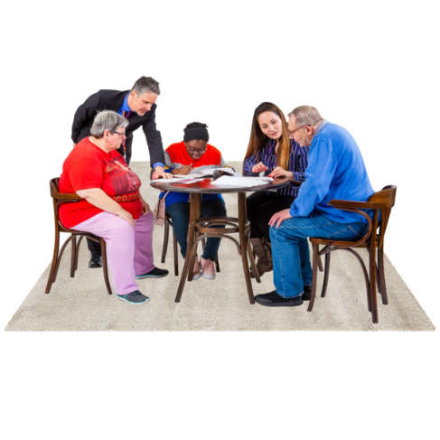 | - join in disaster planning by sharing their ideas with the organisations that speak for them
 | This list comes from the European Disability Forum.
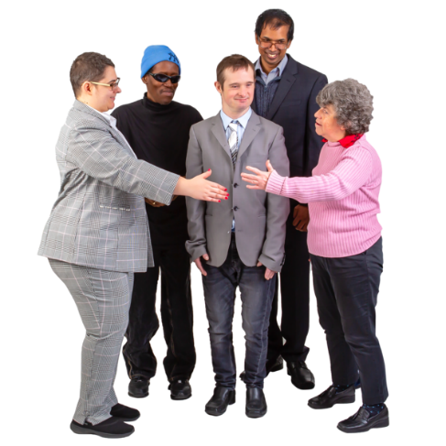 | The Scottish Independent Living Coalition supports everyone working in the European Network on Independent Living.
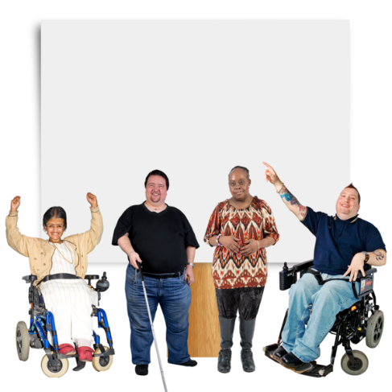  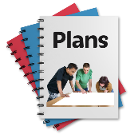 | There is a campaign called  Leave No-one Behind.  It asks the countries who take in people escaping war to ask their own disabled people for guidance in welcoming new disabled people.
 | The Scottish Independent Living Coalition stand by the people of Ukraine.
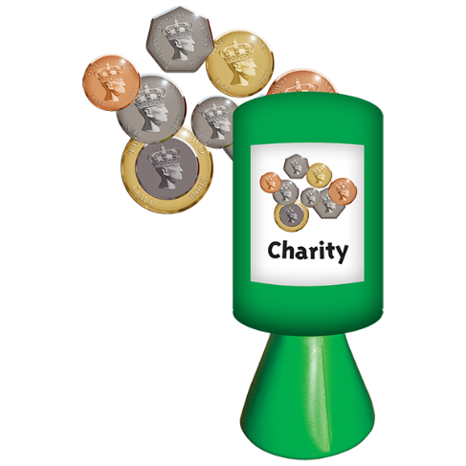 | If you want to give money to help Ukraine, you can click on the blue link to reach the UK’s Disasters Emergency Committee.  https://www.dec.org.uk/appeal/ukraine-humanitarian-appeal

