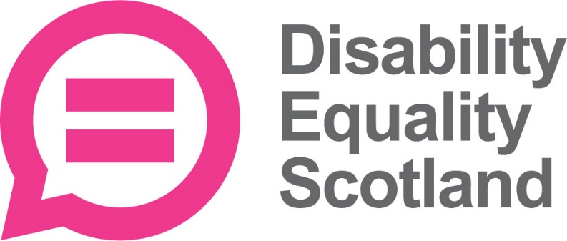

Disability Equality News

Issue 45 – August 2021

Disclaimer: The content of the newsletter is for information purposes only and is, to the best of our knowledge, correct at the time of issue. We are not responsible for the accuracy, timeliness, or the continued availability of information featured on external websites.

CEO Welcome

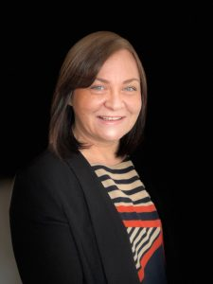
Dear Member

I would like to begin by thanking all members and Access Panels who attended and contributed to our Annual General Meeting (AGM), which took place on Wednesday 25 August. This was an opportunity to reflect on our key activities over the past year. We voted on resolutions, including the re-election of Board Directors and it was fantastic to engage directly with our members through a question-and-answer session. For members who were unable to attend the AGM, you can watch the recording back on our YouTube channel: youtu.be/nBK-Aj2DOoA

At the AGM, we also announced the launch of our annual members survey. This is a chance for you to share your views on the various project areas and activities that we are involved in. I would encourage all members to have your say and tell us what areas matter to you! You can complete the survey online: www.surveymonkey.co.uk/r/MembersSurvey21. You can also complete the survey in a range of accessible formats on our website: www.disabilityequality.scot/members-survey-2021

With best wishes

Morven Brooks, Chief Executive Officer

Contents Page

Ferries for All: NorthLink Customer Experience Survey 3
News: Easing Lockdown Restrictions 4
News: Vaccines for Young People 5
News: One-Stop Hub for Eye Care Health Launched 6
News: SCLD Launch Human Rights App 7
News: Euan’s Guide Access Survey 2021 8
News: Birds of Paradise Young Artists 2021 10
News: STV - Help Increase Disabled Representation 11
Event: Accessing Reasonable Adjustments for Disabled Pupils During the Pandemic 12
Event: Free Training to Stay Safe Online 13
Watch: Return to Public Transport Webinar 14
Your Say on Disability: Weekly Poll Results August 2021 15
Consultation: Scottish Social Housing Charter Review 17
Consultation: Proposed New ScotRail Timetables 18
Consultation: A National Care Service for Scotland 20
Survey: Scottish Social Care Users 21
Survey: Police Scotland ‘Your Police 2021-2022’ 22
Survey: Inclusive Communication 23
Face Covering Exemption Card www.exempt.scot 24
Young Membership with Disability Equality Scotland 25
Access Panel Network www.accesspanel.scot 26
Accessible Travel Hub www.accessibletravel.scot 27
Inclusive Communication Hub www.inclusivecommunication.scot 28
Easy Read Service www.easyread.scot 29
Disability Safety Hub www.disabilitysafety.scot 30

Ferries for All: NorthLink Customer Experience Survey


Feeling safe to travel and get around is essential if we are going to realise our rights and achieve our potential. That is why NorthLink Ferries and Disability Equality Scotland, with support from the Transport Scotland Ferries Accessibility Fund, are partnering to improve the experiences of disabled people onboard.

We will be working together to ensure that disabled people have safe and inclusive journeys. An important part of this is making sure that people know how to report any abuse or mistreatment.

This project builds on the success of the launch of the national Hate Crime Charter, which aims to encourage transport providers, members of the public and other services to support a zero-tolerance approach to hate crime on Scotland’s public transport network.

As with everything we do at Disability Equality Scotland, our voices, as disabled people, will be at the heart of our work. We can all play a part. To help us you can fill in this short survey to inform this important work.

Complete the survey online: www.surveymonkey.co.uk/r/NorthLinkCustomerHateCrimeSurvey

An Easy Read version of the survey is also available to download on our website.

If you have any questions, or if you require the survey in an alternative format, please contact Fiach O’Broin-Molloy (fiach@disabilityequality.scot)
who is responsible for the Ferries for All project.

News: Easing Lockdown Restrictions


On Monday 9 August, Scotland moved beyond COVID-19 Level 0 restrictions. The legal requirement for physical distancing and limits on gatherings has been removed and all venues such as nightclubs are able to re-open. Some protective measures remain in place such as the use of face coverings indoors (unless exempt) and the collection of contact details as part of Test and Protect. Capacity limits of 2,000 people indoors and 5,000 people outdoors will also remain in place although some exceptions may be possible on a case-by-case basis. These will be reviewed on a three weekly basis to ensure they remain proportionate.

Adults identified as close contacts of someone who has tested positive for COVID-19 will also no longer be automatically required to self-isolate for 10 days from 9 August. Anyone who is double vaccinated with at least two weeks passed since their second dose and who has no symptoms will be able to end self-isolation if they return a negative test. The same conditions will also apply to anyone aged between five and 17 years old, even if they have not been vaccinated. The requirement to take a test will not apply to children under the age of five.

Test and Protect will also implement revised guidance for under 18s. This means that the blanket isolation of whole classes in schools will no longer happen and a targeted approach, that only identifies children and young people who are higher risk close contacts, will be adopted. Fewer young people will have to self-isolate, and most will be asked to self-isolate for a much shorter period of time. To allow time to monitor the impacts of these changes, the majority of the mitigations that were in place in schools in the previous term will be retained for up to six weeks. This will help support a safe and sustainable return to education after the summer break.

For more information on current measures, visit: www.gov.scot/coronavirus-covid-19

News: Vaccines for Young People


From Friday 6 August, all young people 16 to 17 years of age will now be offered the COVID-19 vaccination in Scotland. In line with the latest advice from the Joint Committee on Vaccination and Immunisation (JCVI), they will be offered the Pfizer/BioNTech vaccine.

Anyone who doesn’t register an interest or attend a drop-in clinic, once open, will be sent an appointment invitation through the post. It is expected that everyone in this age group will have been offered a vaccination appointment by the end of September.

In addition, young people aged 12-15, with certain underlying health conditions will be invited for a vaccine. It will be offered to around 4,000 children and young people affected by severe neuro-disabilities, Down’s syndrome, underlying conditions resulting in immunosuppression, and those who have a diagnosis of Learning/Intellectual disability.

Young people with certain conditions are to be offered the Pfizer-BioNTech vaccine, in line with the latest advice from the Joint Committee on Vaccination and Immunisation (JCVI), before the majority of schools return on 16 August.

Also, to be invited are children and young people aged 12-17 who are household contacts of adults or children who are immunosuppressed. This is to provide indirect protection for that member of their household. A household contact is defined as someone living in the same house, or anyone the adult or child comes in to contact with face-to-face on most days of the week - such as a carer.

For more information, visit: www.nhsinform.scot/covidvaccinatingyoungpeople

News: One-Stop Hub for Eye Care Health Launched

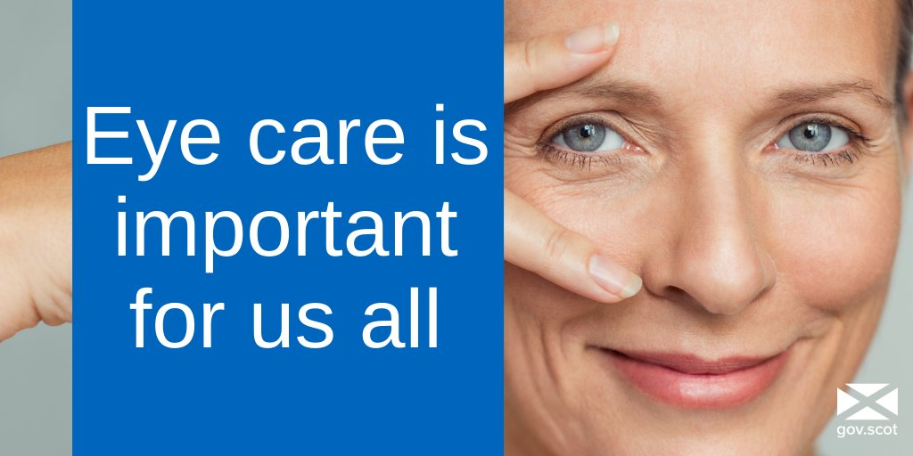
A new website has been launched for people wanting to find out more about eye conditions and the support available for those living with visual impairment. Eyes.Scot, developed by the Scottish government is described as ‘Scotland’s national website for eye care services and eye health information.’
The website features resources including a list of partner organisations, which members of the public can contact for reassurance and practical advice. It also includes a section for professionals, which features local NHS board information, COVID-19 guidance, legislation, and Scottish Government circulars, among other resources.
The Royal National Institute of Blind People (RNIB) Scotland, welcomed the launch of the website. James Adams, Director of RNIB Scotland commented on the launch:

"Around 170,000 people are currently living in Scotland who are blind or partially sighted. This will inevitably increase as we have an ageing population and a rising rate of sight-threatening conditions such as diabetes. So it's vital that we all understand how to maintain good eye-health, and that government and health services take the steps necessary to contain any increase as far as possible.
"The Eyes.Scot website will provide an invaluable one-stop hub from which people can access information on eye conditions, eye health, and the wide range of support services provided by bodies like RNIB Scotland throughout the country.”

News: Scottish Commission for People with Learning Disabilities (SCLD) Launch Human Rights App

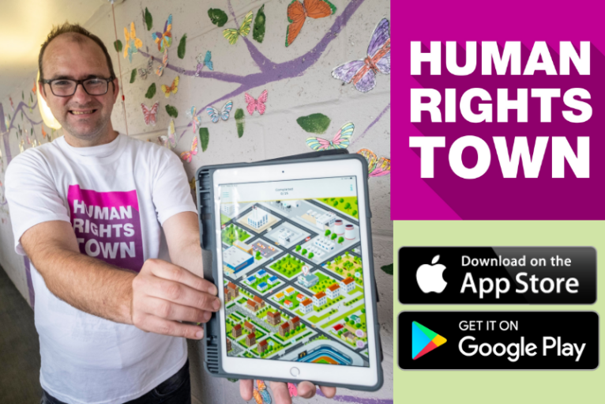
The Scottish Commission for People with Learning Disabilities (SCLD) has launched a new app, ‘Human Rights Town’, designed to help people with learning disabilities to understand their human rights. The development of the app has been led by a group of people with learning disabilities who have been working with SCLD and digital design company, Publishing Bureau, to create the finished product.

The app invites users to travel around a virtual ‘Human Rights Town’ where they encounter different scenarios at each location, such as using public transport or working at the supermarket.

Through practical examples ‘Human Rights Town’ introduces users to several of their human rights under the United Nations Convention on the Rights of Persons with Disabilities (UNCRPD) and asks them to choose whether they believe their rights are being respected or not in each scenario. Users have the option of further explanation at each location. Each scenario has been voiced over by a person with a learning disability who has helped to develop the app.

You can download Human Rights Town for free from Apple App Store and Google Play Store.

News: Euan’s Guide Access Survey 2021

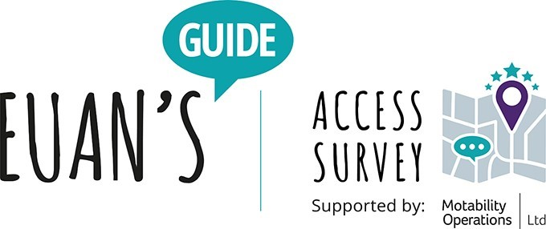
The impact of the pandemic on disabled access is going to be the key focus of the 2021 Euan’s Guide Access Survey, the UK’s largest and longest running survey of its kind. The survey, running in autumn 2021, will attempt to discover how lockdowns and COVID measures have impacted those with accessibility requirements.

For the first time, the survey will be supported by Motability Operations, the company behind the Motability Scheme. The Motability Scheme supports disabled people in achieving greater independence and everyday freedom through access to affordable, worry-free mobility. The organisations are uniting to ask everyone who has ever had to consider disabled access to share their opinion on accessibility in 2021. And with all the changes in this post-lockdown world it’s more crucial than ever that people take part this year.

The survey has previously found that respondents rate historic castles as more accessible than pubs, 93% of respondents try to find disabled access information before they visit somewhere new and 79% of respondents have had to change their plans at the last minute because of poor accessibility.

Euan MacDonald, co-founder of Euan’s Guide, said: “2020-21 has been a massive period of disruption for everyone, but it is particularly affecting disabled people, their friends, families and carers. From extended periods of shielding through to COVID-measures that make access more complicated, the pandemic has potentially pushed back the progress of accessibility by years.

“Our Access Survey asks people for their views of disabled access at all types of venues, from restaurants to theatres to stations to shops and many more. This will be the seventh year of the survey and we feel that it is important to find out just how the pandemic is impacting accessibility.

“It is fantastic to have support from Motability Operations and we look forward to hearing the views and opinions of their customers. We hope that this is just the start of a great partnership to amplify the voices and experiences of disabled people and their friends, families and carers.”

Delia Ray, Head of Marketing at Motability Operations said “Like Euan’s Guide we are great believers in the benefits of getting out and about, which is why we’re putting our support behind this year’s Access Survey. We hope our customers will enjoy sharing their thoughts and feedback to help venues enhance their accessibility, especially as the country begins to open up after the challenges of COVID-19.”

The Euan’s Guide Access Survey supported by Motability Operations will launch in the autumn, capturing the opinions of disabled people, their friends, families, and carers on disabled access across the UK. To learn more and register your interest, please visit:
www.Euansguide.com/AccessSurvey

Euan’s Guide ‘Red Cord Cards’

‘Red Cord Cards' help to improve safety in accessible toilets. The cards created by Euan's Guide are designed to be easily attached to emergency red pull cords in toilets. They inform people of the importance of leaving the cords untied and reaching all the way to the floor.

There have been over 70,000 requests for the charity's Red Cord Cards since the initiative was launched in 2015.

You can request Red Cord Cards on the Euan’s guide website: https://www.euansguide.com/campaigns/red-cord-cards

News: Birds of Paradise Young Artists 2021


Birds of Paradise (BOP) Young Artists is a new artist development initiative from Birds of Paradise Theatre Company, supported by The Robertson Trust, and led by BOP’s Development Officer, Morna McGeoch. It is aimed at young people who have experienced barriers in taking part in other artist development opportunities due to an impairment.

This project aims to provide a space where young people with a passion for the performing arts can learn skills and develop their own creative practice, so they are better able to apply and take part in future creative opportunities.

Birds of Paradise Theatre wants to help nurture the future generation of talented disabled creatives. They are seeking young disabled people from mixed heritage backgrounds and/or who could identify as a person of colour, to join their artist development opportunity.

The full selection criteria for people seeking to apply are:
- Must identify as Disabled
- Must identify as coming from a mixed heritage background and/or as a person of colour
- Must be based in Scotland
- Must be aged 16 - 30 (inclusive)
The closing date for applications is midnight on Sunday 5th September.

For full details about the opportunity, including how to apply, can be found on the Birds of Paradise website: www.boptheatre.co.uk/bop-young-artists-2021

News: STV - Help Increase Disabled Representation


STV has made a number of changes to improve diversity and inclusion, both on and off screen. The company has done a huge amount to boost gender equality, and, in the newsroom, we constantly strive to reach out to more women contributors, so our reports and studio discussions (for our current affairs programme “Scotland Tonight”) are more gender balanced. This year, STV has also been pushing hard to get more people of colour on-screen and that is going well too.

What we want to do now though, is continue to create a more inclusive culture and increase the representation of disabled people on “STV News”. We hope by doing that, we will give a true reflection of Scotland in the way we cover and report our news stories. We realise this will not be an easy task, but hopefully with the help of Disability Equality Scotland and some other charities, we’ll be able to make a difference.

What we aim to do:

- Create a list of news contributors to include disabled people: the idea being, for us to easily reach out to disabled people and interview them on their area of expertise for us to use as clips in news reports.
- Offer media training for disabled people: we recognise that speaking on camera can be a daunting prospect and, if you have a disability, there may be another layer of stress. We’d like to try alleviating that by offering a virtual training session on how to carry out media interviews.
If you would like to get involved, please email: james.davidson@disabilityequality.scot

Event: Accessing Reasonable Adjustments for Disabled Pupils During the Pandemic


The Equality and Human Rights Commission Scotland is hosting a free webinar on Thursday 9 September from 10:30 to 12:00 exploring reasonable adjustments for disabled pupils in education.

Schools and education authorities have a duty to make reasonable adjustments for disabled pupils under the Equality Act 2010. This means that they have to take positive steps to ensure that disabled pupils can fully participate in education and other aspects of school life.

In March 2020, schools, teachers, pupils, parents and carers had to rapidly adapt to online learning. This webinar explores the challenges of accessing Covid-safe reasonable adjustments in remote learning and in schools as we begin to emerge from the pandemic.

The webinar will cover:
- The legal framework with a focus on the reasonable adjustment duty in schools
- Reflections on the complexities of accessing and providing reasonable adjustments during the pandemic
- Presentations from services which offer advice and representation to disabled pupils and their parents and carers
- Equality and Human Rights Commission: powers, remit and how we can help
- There will be time for questions
Register to attend the webinar: www.eventbrite.co.uk/e/accessing-reasonable-adjustments-for-disabled-pupils-during-the-pandemic-tickets-167870145123

Event: Free Training to Stay Safe Online
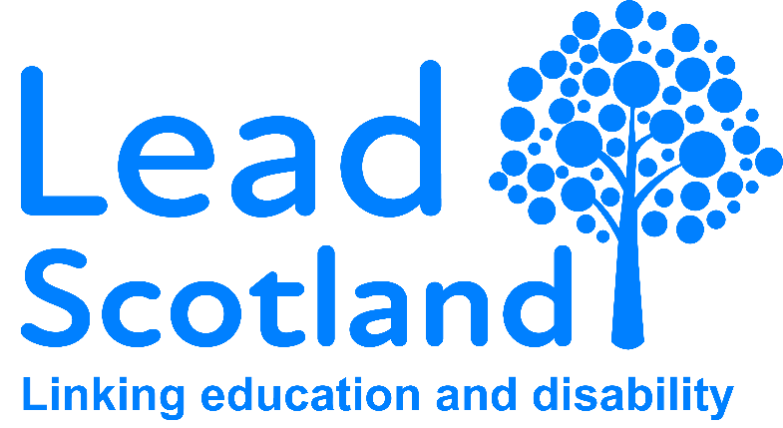
Lead Scotland is offering free training on Zoom this September for people wanting to get to grips with different areas of online safety and security. The charity is hosting 30 minute webinars (with extra time for activities and questions) on a range of topics:

- Protect yourself with strong passwords
- Remember your passwords using password managers
- How to use two-factor authentication
- How to update your digital devices
- How to back up your data
- Recognise email scams and fake emails
These topics were chosen in line with the National Cyber Security Centre Cyber Aware 6 Actions as part of their new project’s aim to widen access to online security messaging. Lead Scotland are commissioning and producing alternative formats including BSL, Braille, HTML, Polish, Urdu and Arabic amongst others.

The webinars will be especially useful for disabled people or those who might find it harder to use the internet safely, but they are open and suitable for everyone. They will also be handy for you if who care for someone who needs some extra support using their digital device safely. All classes are free and open to the public.

Lead Scotland is also offering 1 hour ‘Training for Trainers’ lunchtime sessions are for practitioners, volunteers or others who support people with low digital confidence.

For information on dates and time, as well as to sign up, go to the Lead Scotland website: www.lead.org.uk/webinars

Watch: Return to Public Transport Webinar

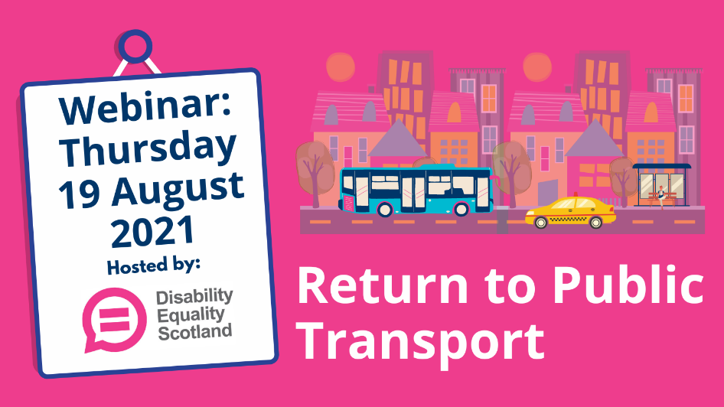
On Thursday 19 August, Disability Equality Scotland hosted a webinar discussion on the return to public transport. As restrictions ease even further, disabled people shared their thoughts and concerns about returning to public transport. During the webinar representatives from ScotRail, First Bus and NorthLink Ferries explained what disabled passengers can expect from their service and what measures are in place to keep passengers safe.

This was a great opportunity to highlight what can be done to ensure disabled people feel confident and supported throughout their return to public transport.

You can watch the webinar back on our YouTube channel: youtu.be/Wwc4XSQRrOo

COVID-19: Your Say on Disability

Please share any comments or concerns you have by responding to our weekly polls. Your comments are shared directly with policy officials and decision makers at the Scottish Government to help inform their response to the pandemic.

You can also share your views by contacting us by emailing: admin@disabilityequality.scot or calling us on 0141 370 0968

Your Say on Disability: Weekly Poll Results August 2021


The Weekly Poll is a simple YES/NO question that is shared each week with our members. There is also an opportunity to leave a comment on the chosen topic. Thank you to everyone who completed our Weekly Poll during the month of August. Below is a summary of the questions that we asked. Please note that all poll questions remain open if you would like to submit any additional comments. You can do so by emailing admin@disabilityequality.scot or calling our office on 0141 370 0968.

Return to Public Transport (Week Beginning 26 July 2021)
Question: Do you feel confident to use public transport as COVID-19 restrictions begin to ease?

Your feedback: Yes - 28% (41 respondents) No – 72% (104 respondents)

Your comments: “I refused to get on a bus recently as there were passengers standing as all seats were full. I did get some verbal abuse for this, but feel it was the bus company at fault for permitting this.”

Read our summary on the return to public transport

Vaccine Passports (Week Beginning 2 August 2021)
Question: Do you think vaccine passports should be introduced in domestic settings, such as nightclubs, sporting and business events, music venues and festivals?

Your feedback: Yes - 54% (84 respondents) No - 46% (74 respondents)

Your comments: “There are many people who are unable to have the vaccine due to medical conditions. It is up to individuals to make their own informed decision to have or refuse the vaccine. A two-tier system will be the result of domestic vaccine passports.”

“People who are at high risk from COVID are more cautious about now going out into society with places getting busier, physical distancing being done away with, so a passport would give a bit of reassurance that people in that particular environment were double jagged.”

Read our summary report about vaccine passports

COVID-19 Vaccination Programme (Week Beginning 9 August 2021)
Question: Are you satisfied with the COVID-19 vaccine rollout in Scotland?

Your feedback: Yes – 73% (68 respondents) No – 27% (25 respondents)

Your comments: “As a disabled person with an autoimmune condition I was invited by letter and phone call to attend for both my vaccines at my local surgery, which is fully wheelchair accessible. Everything was very organised.”

Read our summary report on the vaccination programme

Junk Food Promotions (week beginning 16 August 2021)
Question: Do you think a Bill to ban multi-buy offers on junk food will help tackle obesity in Scotland?
Your feedback: Yes – 36% (37 respondents) No – 64% (65 respondents)

Your comments: “I do think stopping adverts for junk food during children’s viewing time is important, as this can stop the children getting into the habit of eating the foods in the first place.”

Read our summary report on Junk Food Promotions

Consultation: Scottish Social Housing Charter Review


The Scottish Government is carrying out a review of the Scottish Social Housing Charter.

The Charter was introduced by the Housing (Scotland) Act 2010, which requires Ministers to set standards and outcomes that social landlords should be achieving for tenants and other customers through their housing activities. It also requires Ministers to review the Charter standards and outcomes from time to time with the last review being undertaken in 2016.

The purpose of the Charter is to:

- Give tenants, homeless people and other customers a clear understanding of what they should expect from a social landlord.
- Give landlords a clear understanding of what they should be delivering through their housing activities.
- Give landlords the information they need to achieve continuous improvements in their performance and in the value for money they provide.
- Give tenants and other customers information on how their landlord is performing in relation to other landlords, so that they can actively engage with their landlord in discussions about performance.
Your response will help to make changes to the Charter which will encourage social landlords to continue building on the improvements they have made so far delivering the high-quality services that tenants and other customers want and expect.

You can respond on the Scottish Government Consultation Hub: www.consult.gov.scot/social-housing-services/scottish-social-housing-charter-review

The consultation closes on 9 September 2021.

Consultation: Proposed New ScotRail Timetables


ScotRail is unveiling plans for new timetables from May 2022, showing that it is ‘Fit For The Future’. It’s part of a public consultation, as customers return to using Scotland’s Railway. It comes almost 18 months after Scotland went into its first COVID-19 lockdown, leading to the worst financial crisis the rail industry has experienced as passenger numbers dropped by 90 per cent.

During the COVID-19 pandemic, the train operator responded to shifting travel patterns and demand as lockdown restrictions were revised and adjusted. ScotRail made twelve timetable changes during a period when normally there would only be three, giving the train operator concrete evidence upon which to base its timetables going forward.

There has been a gradual increase in the number of customers returning to the railway due to the easing, and now the ending, of the majority of coronavirus restrictions. Passenger journeys have risen to around 50 per cent of their pre-COVID levels, however, evidence shows that, in future, customers will be using the railway in different ways by travelling at different times and for different purposes.

The train operator is proposing a new, better performing, timetable operating around 2,100 services per weekday as the foundation to encourage a return to public transport following the pandemic. Most customers will find the number of calls at their station and the destinations served are similar to today. However, there are some areas where there is greater change, which is being done for several important reasons.

ScotRail analysis shows prior to the pandemic, on a number of routes across the country, significantly more seats were being provided than were required for the number of passengers travelling.
For example, under five and a half million passenger journey miles were completed on a typical weekday, which was just 23 per cent of the available number of seats. In other words, seats were empty for 77 per cent of the distance that was travelled.

The proposed new timetable will also focus on improved punctuality and reliability of services, building on the record punctuality delivered during the pandemic. Research from Transport Focus has highlighted this is a key priority for customers.

New services are being added on some routes, such as Dundee to Glasgow which will benefit from an hourly service calling at all stations between Dundee and Stirling. On other routes there may be slightly longer journey times, as it is more efficient to operate one long train calling at all stations, than have two shorter ones which split the calls between them, for example between Kirkcaldy and Edinburgh. Many routes will see little change compared to the current timetable.

The proposed new customer focused timetable will reflect predicted levels of service as well as the need to provide the best value for money for taxpayers. ScotRail said the proposals are a new starting point, and in the future, new methods of analysis developed during COVID-19 will refine and improve the service offer as the operator learns more about how customer travel behaviours are changing.

As Scotland works towards becoming a net-zero society, ScotRail will continue to work with the Scottish Government to ensure that rail can play its part in decarbonising Scotland’s transport network.

The consultation is open from 20 August to 1 October 2021, to seek opinions on the proposed timetables.

The ScotRail website, www.scotrail.co.uk/fit-for-the-future, has more information and includes a link to a survey where customers and communities can give their views.

Consultation: A National Care Service for Scotland

The Scottish Government has launched a consultation on a National Care Service, setting out their proposals to improve the way social care is delivered in Scotland.

The consultation comes after the Independent Review of Adult Social Care in Scotland found that current structures have not fully delivered the improvements intended to be achieved by integration of health and social care and recommended the creation of a National Care Service.

This three-month consultation is focused on exploring the suggestions for significant cultural and system change that will need to be supported by primary legislation and new laws, to ensure the governance and accountability across the system to deliver successfully for people.

Consultation events

A series of online engagement events are being held in September and October to allow stakeholders, individuals and communities to come together to share their views on the National Care Service.

You can respond to the consultation and sign up to the events on the Scottish Government Consultation Hub: www.consult.gov.scot/health-and-social-care/a-national-care-service-for-scotland

The consultation closes on 2 November 2021.

Survey: Scottish Social Care Users

The Equality and Human Rights Commission in Scotland is working to make sure that equality is a fundamental part of Scotland’s new National Care Service.

As part of their programme of work, the Commission has launched a survey to gather the experiences of adults who are accessing or have tried to access social care or support, including unpaid carers requiring support for their caring role.

The Equality and Human Rights Commission want to know whether:

- The existing ways of challenging decisions are effective and accessible.
- People are given enough information about their rights to care and support, and how they can challenge decisions.
- People can access high quality advocacy support to help them challenge decisions.
- Local councils and other bodies learn from challenges to improve decision-making in future.
- There are effective systems in place to check that decisions are made well the first time round.
The survey is open until 15th September 2021.

Complete the survey online: www.smartsurvey.co.uk/s/SIB3VC

If you require the survey in Easy Read or a different format or would like to talk to the team, you can get in touch by email ScotlandSC@equalityhumanrights.com or call 0141 228 5923.

Survey: Police Scotland ‘Your Police 2021-2022’
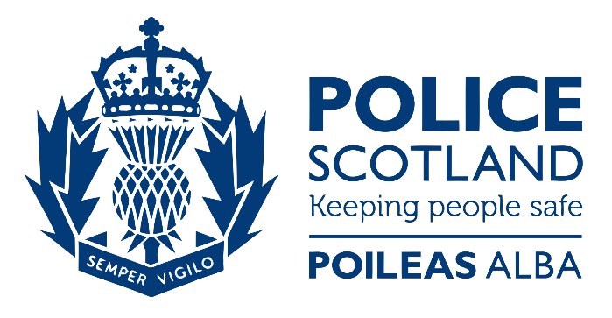
Understanding the views and priorities of Scotland's diverse communities has played a vital role in shaping our response to the Coronavirus (COVID-19) pandemic. Public feedback has driven positive changes to operational policing across Scotland during the most challenging of times.

As the country moves out of lockdown, we continue to recognise the importance of understanding the views and priorities of Scotland's diverse communities. It is vital, especially as Scotland rebuilds from the effects of COVID-19 that we listen, understand, and respond to the views of the people who live here. This survey is one of the ways we listen to the views of those we keep safe.

Complete the survey online: www.consult.scotland.police.uk/surveys/your-police-2021-2022

You can also download the survey in alternative formats, including Easy Read. A BSL version is currently being developed.

Please let us know if you want to complete the survey in a different way (for example, over the phone): consultations@scotland.pnn.police.uk.

The consultation closes on 30 April 2022

Please note that this platform is not for reporting crime, providing information about an incident, or asking us for help. To find out ways to contact the police, please visit our website. If you or someone else needs urgent police assistance, please dial 999 immediately.

Survey: Inclusive Communication


Inclusive communication is an approach to communication which enables as many people as possible to be included. It allows the largest number of people in the population to take part in communication with services. It does this by allowing and enabling individuals to use whatever ways of understanding and expressing themselves which they find easiest.

Inclusive communication is relevant to all forms of communication:

- Printed information, including leaflets, posters, letters and appointment cards
- Online materials such as information websites and online contact forms
- Telephone helplines and telephone interviews
- And Face to face interactions such as advice sessions, assessment interviews and appeal panels
At Disability Equality Scotland, we work in partnership with Sense Scotland to host the Inclusive Communication Hub (www.inclusivecommunication.scot), a website dedicated to inclusive communication information and resources, featuring case studies, blogs, details of training and the latest news on inclusive communication.

We have created a survey which will help us to understand your awareness and experiences of inclusive communication. We also feature a series of questions about the Inclusive Communication Hub, which will help to shape and grow the website going forward.

Take part in the online survey: www.surveymonkey.co.uk/r/InclusiveCommunicationHub

You can also access the survey in various alternative formats on our website: www.inclusivecommunication.scot/survey

Face Covering Exemption Card www.exempt.scot

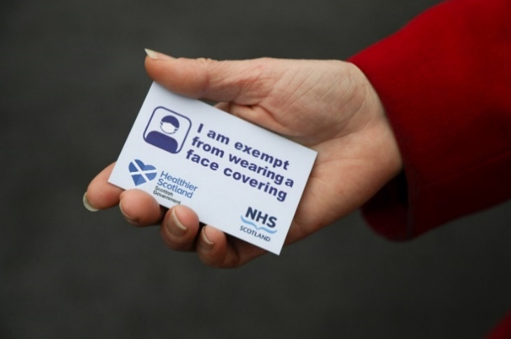
Disability Equality Scotland is working with the Scottish Government to distribute face covering exemption cards. The Scottish Government mandate the wearing of face coverings on transport, most indoor public places, and communal areas in workplaces. Face coverings play a role in preventing the transmission of COVID-19. There are situations where some people are unable to, or it would be inappropriate for them, to wear a face covering.

You do not need to provide written proof that you are exempt, but if it would make you feel safer and more confident in public and when accessing and using public spaces and services, you can download a face covering exemption card.

You can download a face covering exemption card from the website www.exempt.scot or request a card by calling a free helpline on 0800 121 6240, which is open 10am to 3pm, Mondays and Thursdays. Please note that due to extremely high demand, estimated delivery times for physical cards are between 21-28 days.

Retailers must also recognise that other face covering exemption cards have been produced such as those found below. These cards can still be used. This list is not exhaustive.
- Alzheimer Scotland Face covering exemption card
- deafscotland Communication Card
- Euan’s Guide Free Exemption Badges
- First Bus Exemption Card
- Hidden Disabilities face covering exempt card
- Scottish Autism Alert Card
- The Thistle Assistance App
- Welfare Scotland
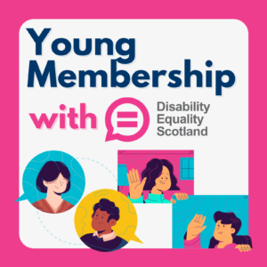
Young Membership with Disability Equality Scotland
At Disability Equality Scotland we have a young membership category for people aged 12-17. This community is a space for young people to share and discuss issues that matter to them, such as:

- Support for young carers.
- Accessibility of buildings and public transport.
- Communication barriers.
- Raising awareness of school bullying.
- Transitions to further education and employment.
Through starting discussions relating to the experiences of young disabled people in Scotland, we hope to provide a space to learn about the positive change that we are working towards.

What will young people get?

Young people receive the same benefits as individual and corporate members:

- A membership welcome pack with lots of information on what we do.
- A monthly newsletter with the latest disability information, surveys, events and much more.
- Take part in our weekly poll to help improve access and inclusion for disabled people across Scotland.
We are constantly listening to the views and experiences of disabled people to improve the way we do things. We need the voices of young people to help us do that.

More information about our young membership, including how to sign up, can be found on our website: www.disabilityequality.scot/young-membership

Access Panel Network www.accesspanel.scot

We are the umbrella organisation for all disability Access Panels in Scotland, providing them with support and guidance to improve the lives of disabled people at a local level throughout Scotland.

What is an Access Panel?

Access Panels can be found in all regions and are made up of groups of disabled volunteers who work together to improve physical access and wider social inclusion in their local communities. We offer support and training opportunities to help them operate efficiently, link together as a network and learn from each other.

Get Involved!

Joining your local Access Panel is easy and a great way to help improve accessibility in your community. You can learn new skills, help with promotional campaigns or give support at events, help with research and publicity. Give the time and commitment with which you feel comfortable and help to make a difference in your community.

To find out more about the Access Panel Network and how to join your local Access Panel contact us: Telephone: 0141 370 0968 Email: access@disabilityequality.scot Website: www.accesspanel.scot

Accessible Travel Hub www.accessibletravel.scot

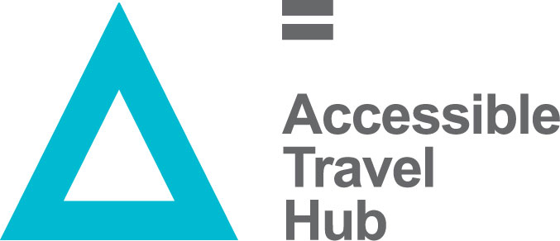
The Accessible Travel Hub is a website for you to find information, articles, and guidance on Accessible Travel in Scotland. The Hub launched alongside the Accessible Travel Framework, a ten-year plan by Transport Scotland to improve travel access for disabled people.

What Can I Find on the Hub?

- Articles and Information on accessible transport in Scotland; including the rules and responsibilities of transport providers.
- Dedicated Transport Mode page for Transport providers /operators to promote good practice in access-related work.
- Links to resources, including PAMIS’ map of Changing Places toilets, Radar keys, Thistle Cards, Traveline Scotland, Hate Crime Reporting.
- Signpost to relevant training courses, including disability awareness and inclusive communication.
- News and blog featuring up to date accessible travel news in Scotland.

Latest News and Blog Posts

- Watch Now: Return to Public Transport Webinar
- Online Event: Lothian Buses and MS Society – Driving Accessibility Standards
- Electric Vehicle Charge Points: Have Your Say on Accessibility

Inclusive Communication Hub www.inclusivecommunication.scot

Supported by the Scottish Government, we are working with Sense Scotland and other partners to host the Inclusive Communication Hub; a website that has been developed for anyone with an interest in improving their inclusive communication tools and processes.

What Is Inclusive Communication?

Inclusive communication means sharing information in a way that everyone can understand. For service providers, it means making sure that you recognise that people understand and express themselves in different ways. For people who use services, it means getting information and expressing themselves in ways that meet their needs. Throughout this Hub you will find helpful resources such as case studies and blogs from employers and individuals; details of training and the latest news on Inclusive Communication.

It is vital that information about the COVID-19 pandemic is available to the public in a variety of accessible formats, such as: Easy Read, audio, British Sign Language, braille, clear print, and plain text. We are updating the Inclusive Communication Hub with the latest accessible information and guidance relating to COVID-19.

Latest News and Blog Posts:

- Sense Scotland – Communication Approaches and Systems
- Deaf women in prison and should they be there?
- Scottish Commission for People with Learning Disabilities (SCLD)

Easy Read Service www.easyread.scot

Disability Equality Scotland provide a professional and efficient Easy Read service to all sectors, as part of our commitment towards improving access to information for all.

What is Easy Read?

Easy Read is an accessible format that makes written information easier to understand. The Easy Read format is easy to understand because it uses simple, jargon free language, shorter sentences and supporting images.

Why produce Easy Read documents?

Easy Read documents make information more accessible to people with learning disabilities. They can also be useful for people with other communication difficulties including:
- acquired brain injury
- dyslexia
- people with hearing impairment whose first language is British Sign Language (BSL)
- people who do not speak English as their first language
- people who find reading difficult
- people with cognitive impairments such as dementia.

The Equality Act

The Equality Act (2010) requires organisations to produce information in an accessible format. Easy Read can ensure that disabled people have equal access to information and are not discriminated against.

Who do I contact?

For more information about our Easy Read service, including examples of our work, please visit our website: www.easyread.scot You can also contact us by telephone: 0141 370 0968 or email: easyread@disabilityequality.scot

Disability Safety Hub www.disabilitysafety.scot

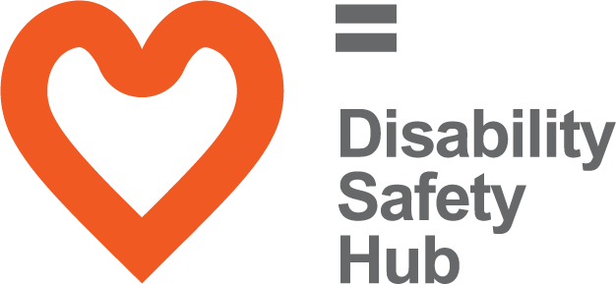
Funded by the Scottish Government, we worked in partnership with Police Scotland to develop the Disability Safety Hub; a website to help you identify hate crime and how to report it. The website contains a wealth of resources, including videos, case studies and useful numbers and contacts to help you stay safe.

What is Hate Crime?

The Scottish Government defines Hate Crime as crime committed against a person or property that is motivated by ‘malice or ill-will towards an identifiable social group’. In Scotland, the law currently recognises hate crimes as crimes motivated by prejudice based on:
- race
- religion
- sexual orientation
- transgender identity
- disability

COVID-19 Resources

It is important to look after your mental health as well as your physical health during uncertain and stressful times. We are updating the Disability Safety Hub with information to help you stay safe and well during the coronavirus (COVID-19) outbreak:
- We have produced a mental wellbeing guide that provides links to useful information on how to maintain good mental health.
- We are continuing to post the latest guidance on our news and blog.
- For more resources visit The Scottish Association for Mental Health (SAMH) mental health information hub.

Our Sponsors
Disability Equality Scotland is grateful for the generosity of its sponsors and their ongoing support as we work together toward achieving the goals of the organisation.



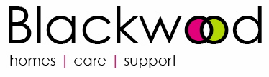
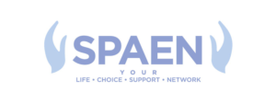
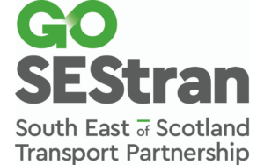


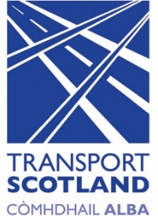

Disability Equality Scotland is funded by:



Connect with us... Disability Equality Scotland

@DEScotTweets

Copyright © 2021 Disability Equality Scotland, All rights reserved.
Our mailing address is:
Suite 204B, The Pentagon Centre, 36 Washington Street, Glasgow, G3 8AZ
Telephone: 0141 370 0968, Email: admin@disabilityequality.scot
Website: www.disabilityequality.scot
